4. April 2016

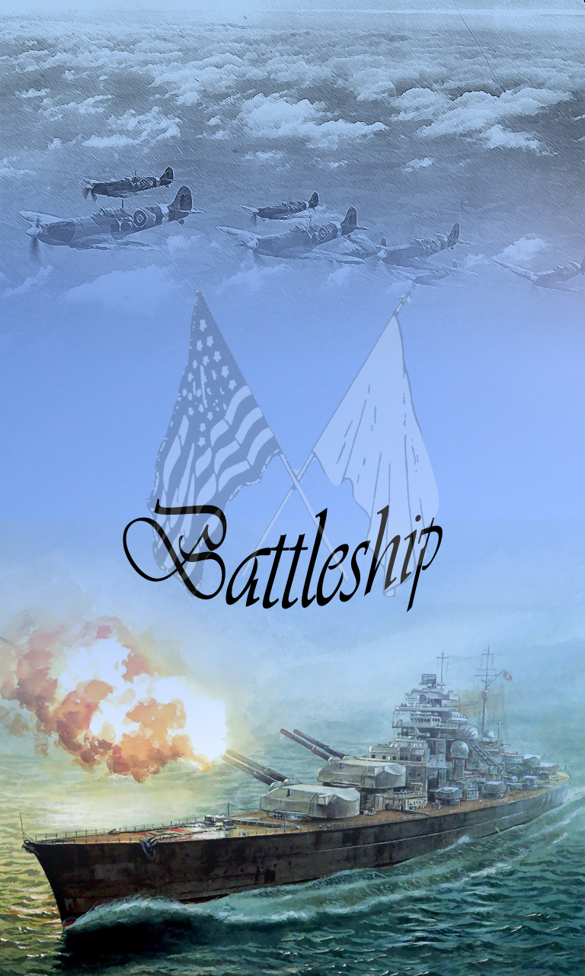

Project Proposal - Battleship

# App name

Battleship

# Team setup

# Julia Müllner – S1510631012

# S1510631012@students.fh-hagenberg.at

Sebastian Huber – S1510455010

# S1510455010@students.fh-hagenberg.at

Ralf Kralicek – S1510455017

# S1510455017@students.fh-hagenberg.at

Konrad Deubler – S1510455005

S1510455005@students.fh-hagenberg.at

# Project idea

# Our goal is to recreate the classic game „battleships“, which should be well known. The game is settled in a modern environment with contemporary graphics and game mechanics. We plan to implement a singleplayer-, as well as a multiplayer-part.

Therefore, the game should consist of the following parts:

* Singleplayer-mode: Fight against an AI with two or three different difficulties.
* Multiplayer-mode (BL): Connect to a second device via Bluetooth and fight against other humans (cross-platform)
* Multiplayer-mode (Network, optional): We provide a backend web service which allows playing games via the internet (cross-platform)

The rules of the game follow the basic battleships game, so you have two enemies fighting against each other in a turn-based manor.

Each player has the same amount of ships which have different sizes and can be placed at the beginning of the game. After the ships have been positioned, the players fire alternating at the enemy board. If a ship gets hit, that player can fire again.

The game ends when the whole fleet of a player has been sunken.

# Target platforms

# Android

# iOS

* Windows Mobile 10 (optional)

# Target technology

Apache Cordova

# Parts to be implemented

# As stated in “project idea”, the core game has at least a singleplayer part (against AI) and the multiplayer part over Bluetooth.

If time is sufficient, the multiplayer via internet will also be implemented as well as a Windows Mobile 10 version.

# Monetarization

# Some possible In-App purchases could be:

* New skins for ships
* New backgrounds for the game board
* Special Items / Special Abilities
  + 2 shots a round
  + Invulnerability
  + Repair a ship