**Literature Sources**

1. Unreal Engine 4 Game Development in 24 Hours

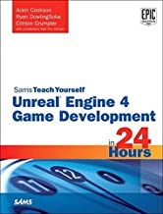

1. Unreal Engine 4 for Design Visualization: Developing Stunning Interactive Visualizations, Animations, and Renderings

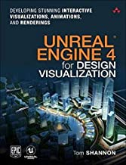

1. (Chinese)

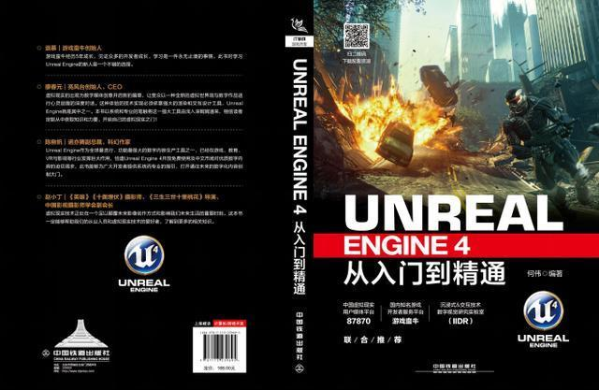

1. (Chinese)



1. Unreal Engine 4 Documentation

<https://docs.unrealengine.com/en-US/index.html>

UMG UI Designer

<https://docs.unrealengine.com/en-US/Engine/UMG/index.html>

1. Thesis * 7

**Projects**

1. Car Configurator App (code incl.)

<https://darulsolutions.com/Downloads/Interactive-Realtime-Car-Configurator>

1. Porsche 911 GT3RS Car Configurator (code incl.)

<https://www.youtube.com/watch?v=i6lPzV__uDs>

1. Real Time Porsche 911 Car Configurator

<https://www.youtube.com/watch?v=wKojev7xhKQ&t=2s>

1. Variant Management Official Tutorial

<https://www.youtube.com/watch?v=VHQdS3QnMow>

1. Speaker Configurator

<https://learn.unrealengine.com/home/LearningPath/90587?r=False&ts=637180770131693608>