**Proje2**

**Q1) [16,21,11,8,12,22]**-> Merge Sort

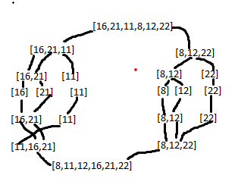

* Big-O = Best,Average,Worst case = O(n*logn)