
ALPHA ARTS AND SCIENCE COLLEGE
PORUR, CHENNAI

A PROJECT REPORT ON
AI ASSISTANT FOR SMARTER LEARNING
AND STUDY SUPPORT
[ AI STUDY BUDDY ]
Submitted in partial fulfilment of the requirements under the
NAAN MUDHALVAN (NM) SKILL DEVELOPMENT PROGRAMME
SUBMITTED BY
Student Name | NM ID
AYISHA. H. T | 2EAEA304FCE0E4BB62E47BCA747E5F34
SAHIRA SAFRIN M | D3B674070861B90AFAF42C0F116F9DA6
ASHWITHA V | 9241E54E2BC5BFF9B5C4529E243A635C
SUJATHA S | 70F1119D2E7659487DA49024278EA5AC

DEPARTMENT OF [BACHELOR OF COMPUTER APPLICATION]
[MADRAS UNIVERSITY]
ACADEMIC YEAR: [2024 – 2027]

CERTIFICATE
This is to certify that the project report entitled "AI ASSISTANT FOR SMARTER LEARNING AND STUDY SUPPORT [STUDY BUDDY]" is a bonafide record of work carried out by AYISHA. H. T, SAHIRA SAFRIN M, ASHWITHA V, and SUJATHA S under the Naan Mudhalvan (NM) Skill Development Programme, in partial fulfilment of the requirements for the award of the [Degree/Programme Name] of [University Name], during the academic year [2024to2027].
This project report has not been submitted previously for the award of any degree, diploma, or similar title of this or any other institution.

DECLARATION
We hereby declare that the project report entitled "AI ASSISTANT FOR SMARTER LEARNING AND STUDY SUPPORT [STUDY BUDDY]" is an original record of work carried out by us under the guidance of [Guide Name], [Designation], Alpha Arts and Science College, Porur, Chennai, and that it has not been submitted, either in part or in full, for the award of any other degree or diploma of this or any other institution.

AYISHA. H. T
SAHIRA SAFRIN M
ASHWITHA V
SUJATHA S

Date: 26_09_2026

ACKNOWLEDGEMENT
We express our sincere gratitude to the Tamil Nadu Naan Mudhalvan (NM) Skill Development Programme for providing us with the opportunity and platform to design, develop, and document this project.
We are deeply thankful to our Faculty Guide, [Guide Name], for the valuable guidance, continuous encouragement, and constructive feedback extended throughout the course of this project.
We would also like to thank the Head of the Department and the management of Alpha Arts and Science College, Porur, Chennai, for providing the necessary infrastructure and resources that made this work possible.
Finally, we thank our family and friends for their constant support and encouragement during the successful completion of this project.

AYISHA. H. T
SAHIRA SAFRIN M
ASHWITHA V
SUJATHA S

ABSTRACT
AI StudyBuddy is an AI-powered learning assistance platform developed to simplify the study process for students by leveraging modern web technologies and Generative AI. The application provides an intelligent backend system that enables students to upload study materials, generate concise summaries, create flashcards, produce quizzes, and receive personalized study plans through AI-generated responses.
The backend is developed using Node.js and Express.js, following a RESTful API architecture that ensures scalability, maintainability, and secure communication between the frontend and backend services. MongoDB serves as the primary NoSQL database, while Mongoose ODM provides schema validation, data modeling, and efficient database interactions. To secure user information and protected resources, the application implements JWT (JSON Web Token) based authentication along with Role-Based Access Control (RBAC). Passwords are securely encrypted using bcryptjs, preventing unauthorized access to user credentials.
One of the key highlights of AI StudyBuddy is its integration with the Google Gemini AI API, which enables the application to perform advanced natural language processing tasks. Instead of relying on predefined templates, the backend dynamically communicates with the Gemini model to generate high-quality educational content based on the study material provided by the user, thereby reducing manual preparation time and supporting personalized, effective revision for academic examinations and competitive assessments.

Keywords: Artificial Intelligence, Node.js, Express.js, MongoDB, JWT Authentication, Google Gemini API, RESTful API, E-Learning.

TABLE OF CONTENTS
CERTIFICATE i
DECLARATION ii
ACKNOWLEDGEMENT iii
ABSTRACT iv
LIST OF FIGURES vi

1. INTRODUCTION 1
1.1 Overview 1
1.2 Scenario-Based Case Study 1
1.2.1 Background 1
1.2.2 Problem 2
1.2.3 Solution 2
1.2.4 Usage 2
1.2.5 Outcome 3
2. SYSTEM REQUIREMENTS 4
2.1 Software Requirements 4
2.2 Hardware Requirements 4
3. SYSTEM DESIGN 5
3.1 Roles and Responsibilities 5
3.2 User Flow 5
3.3 Mongoose Schema Definitions 6
4. SYSTEM IMPLEMENTATION 7
4.1 API Route Interface Endpoints 7
4.2 Project Execution 7
5. TESTING AND RESULTS 9
5.1 User Registration 9
5.2 User Login 9
5.3 Upload Study Material 9
5.4 Retrieve Study Material 9
5.5 Generate AI Summary 10
5.6 Generate AI Flashcards 11
5.7 Generate AI Quiz 11
5.8 Generate AI Study Plan 12
6. CONCLUSION 13
6.1 Project Links 13

LIST OF FIGURES
Figure 1: AI StudyBuddy — Student Dashboard Interface 6
Figure 2: Backend Project Structure and Server Startup (VS Code) 8
Figure 3: API Testing — Retrieve Single Study Material 10
Figure 4: API Testing — AI Study Plan Generation 12
Figure 5: API Testing — Retrieve All Study Materials 10
Figure 6: API Testing — AI Quiz Generation (Request Configuration) 11
Figure 7: API Testing — AI Quiz Generation (Server Response Log) 12
Figure 8: Backend Route Configuration — index.js 8

01

Introduction

1.1 Overview
AI StudyBuddy is an AI-powered learning assistance platform developed to simplify the study process for students by leveraging modern web technologies and Generative AI. The application provides an intelligent backend system that enables students to upload study materials, generate concise summaries, create flashcards, produce quizzes, and receive personalized study plans through AI-generated responses.
The backend is developed using Node.js and Express.js, following a RESTful API architecture that ensures scalability, maintainability, and secure communication between the frontend and backend services. MongoDB serves as the primary NoSQL database, while Mongoose ODM provides schema validation, data modeling, and efficient database interactions.
To secure user information and protected resources, the application implements JWT (JSON Web Token) based authentication along with Role-Based Access Control (RBAC). Users are authenticated before accessing AI-powered features, ensuring that only authorized users can utilize premium learning services. Passwords are securely encrypted using bcryptjs, preventing unauthorized access to user credentials.
One of the key highlights of AI StudyBuddy is its integration with the Google Gemini AI API, which enables the application to perform advanced natural language processing tasks. Instead of relying on predefined templates, the backend dynamically communicates with the Gemini model to generate high-quality educational content based on the study material provided by the user.

1.2 Scenario-Based Case Study

1.2.1 Background
Rahul is a second-year engineering student preparing for multiple semester examinations while simultaneously learning new technical skills for internships and placement opportunities. His study materials are scattered across lecture notes, PDFs, textbooks, online articles, and handwritten notes, making it difficult to organize and revise effectively. Due to the large volume of content and limited preparation time, Rahul often struggles to identify important concepts, create revision notes, and evaluate his understanding before examinations.
Traditional study methods require significant manual effort to summarize lengthy materials, prepare practice questions, and create revision schedules. This process is repetitive, time-consuming, and often results in inconsistent learning outcomes.

1.2.2 Problem
Rahul encounters several challenges during his preparation:
- Difficulty understanding lengthy study materials within limited time.
- Manual preparation of notes consumes a significant amount of study time.
- Creating flashcards and revision questions is repetitive and labour-intensive.
- Lack of personalized study plans based on available time and examination schedules.
- No centralized platform to securely store AI-generated learning resources.
- Difficulty assessing knowledge through self-generated quizzes.
- Switching between multiple applications for note-taking, quizzes, and scheduling reduces productivity.

1.2.3 Solution
The AI StudyBuddy backend provides a centralized, AI-powered learning platform that automates several academic tasks through intelligent content generation. The system enables authenticated users to upload or enter study materials and leverage the Google Gemini AI API to generate educational resources automatically. The backend processes incoming requests through secure RESTful APIs and performs the following operations:
- Authenticates users using JWT-based security.
- Stores user information and study resources in MongoDB.
- Sends study content to the Google Gemini AI model through dedicated AI service modules.
- Generates concise summaries for faster revision.
- Creates flashcards for active recall learning.
- Produces multiple-choice quizzes for self-assessment.
- Generates personalized study plans based on user preferences and examination timelines.
- Stores generated learning resources for future retrieval and continuous learning.

By separating authentication, business logic, database operations, and AI processing into modular components, the backend ensures maintainability, scalability, and efficient request handling.

1.2.4 Usage
Student Usage
Students register and log in to the application before accessing AI-powered learning features. After authentication, they can upload study material or provide textual content and choose the desired AI functionality, such as generating summaries, quizzes, flashcards, or personalized study plans. The generated content can be reviewed immediately and stored for future reference.
Administrator Usage
Administrators manage registered users, monitor application activity, oversee system usage, and maintain platform integrity. Administrative privileges include managing user accounts, monitoring AI service utilization, reviewing system logs, and ensuring smooth backend operations.

1.2.5 Outcome
By integrating artificial intelligence with a secure backend architecture, AI StudyBuddy significantly improves the learning experience for students. Manual preparation time is reduced through automated content generation, allowing students to focus more on understanding concepts rather than organizing study materials.
The implementation of JWT authentication, MongoDB data management, and Google Gemini AI integration ensures that educational resources are generated securely, efficiently, and consistently. The modular backend architecture further supports future enhancements, enabling additional AI-powered learning capabilities to be integrated with minimal architectural changes.
As a result, AI StudyBuddy serves as a scalable and intelligent educational platform that enhances productivity, promotes effective revision, and supports personalized learning for students preparing for academic examinations and competitive assessments.

02

System Requirements

2.1 Software Requirements
Component | Specification
Operating System | Windows 10/11, macOS, or Linux (cross-platform support)
Runtime Environment | Node.js (v16 or above)
Package Manager | npm (v8 or above)
Web Framework | Express.js — lightweight routing framework for RESTful endpoints
Database | MongoDB — document NoSQL engine for users, posts, categories, comments and analytics metrics
API Verification Tool | Postman — verifies schema validation responses across administrative route shields
Code Editor | Visual Studio Code or similar IDE

2.2 Hardware Requirements
Component | Specification
Processor | Intel Core i5 (8th Gen or above) / AMD Ryzen 5 or equivalent
RAM | 8 GB minimum (16 GB recommended for concurrent MongoDB, processing and execution nodes)
Storage | 1 GB of available disk workspace

03

System Design

3.1 Roles and Responsibilities

3.1.1 Student
Students are the primary users of the system. They can register, log in securely, upload study materials, and utilize AI-powered features such as summary generation, flashcard creation, quiz generation, and personalized study plans. Students can also view and manage their previously generated learning resources.

3.1.2 Administrator
Administrators manage the overall system and ensure its smooth operation. They monitor registered users, manage user accounts, oversee application usage, maintain system integrity, and ensure that AI-powered services function correctly. Administrators also have permission to perform system-level management tasks and resolve user-related issues.

3.2 User Flow
The AI StudyBuddy application begins with the user registering or logging into the system. After successful JWT-based authentication, the user is redirected to the dashboard, where they can upload study materials and access AI-powered features. Based on the uploaded content, the system generates summaries, flashcards, quizzes, or personalized study plans using the Google Gemini API. All generated resources are displayed to the user and can be saved for future reference. Users can also manage their profile and view their previously generated learning resources through the dashboard.
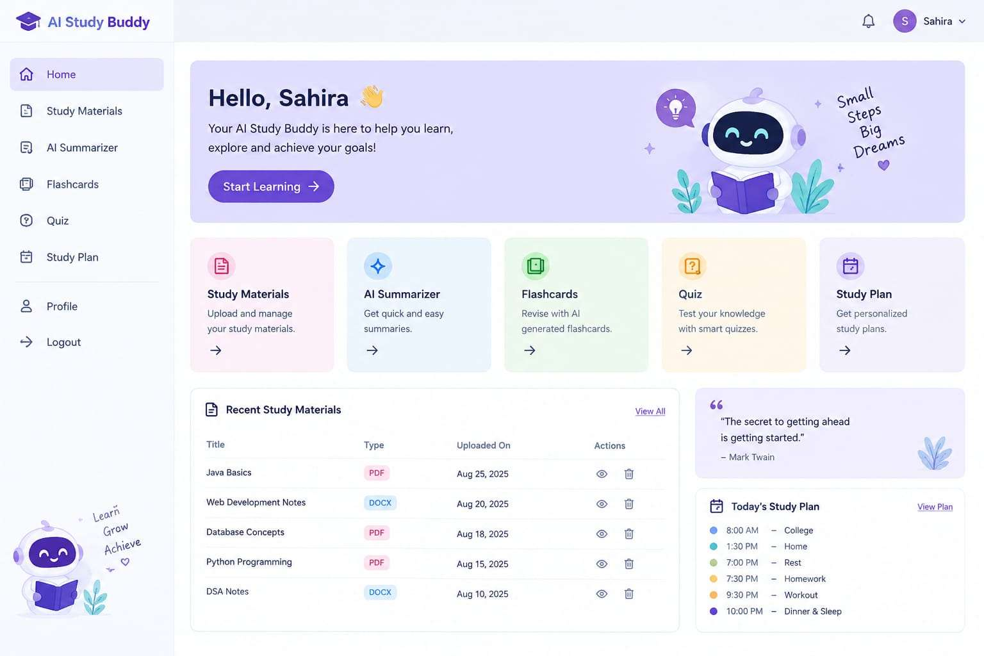
Figure 1: AI StudyBuddy — Student Dashboard Interface

3.3 Mongoose Schema Definitions

3.3.1 User Schema (models/User.js)
The User schema stores authentication and profile information for registered users. It includes fields such as name, email, password, and role. Passwords are securely encrypted before being stored in the database.

04

System Implementation

4.1 API Route Interface Endpoints
The backend exposes RESTful APIs to interact with the database and AI services.

4.1.1 Authentication APIs
Handles user registration, login, JWT authentication, and protected route access.

4.1.2 Study Material APIs
Allows users to upload, retrieve, update, and manage study materials.

4.1.3 AI Feature APIs
Provides endpoints for:
- AI Summary Generation
- AI Flashcard Generation
- AI Quiz Generation
- AI Study Plan Generation

4.1.4 Administrative APIs
Provides administrator-only endpoints for managing users and monitoring system activities.

4.2 Project Execution
The AI StudyBuddy backend can be executed locally using Node.js. Before running the application, ensure that MongoDB is running and the required environment variables are configured correctly. The backend exposes REST APIs that can be tested using Postman or Thunder Client.

4.2.1 Running the Backend Server
Install all required dependencies:
npm install

Start the development server:
npm start

After successful execution, the server connects to MongoDB and starts listening for incoming API requests, as shown in Figure 2.
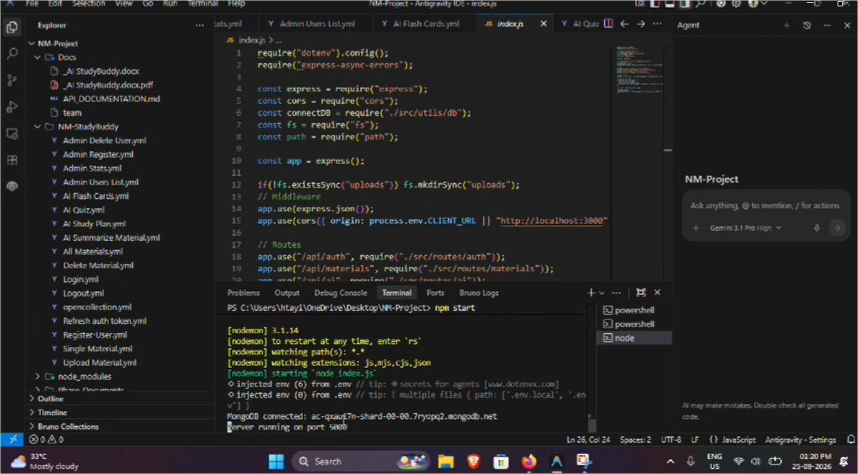
Figure 2: Backend Project Structure and Server Startup (VS Code)
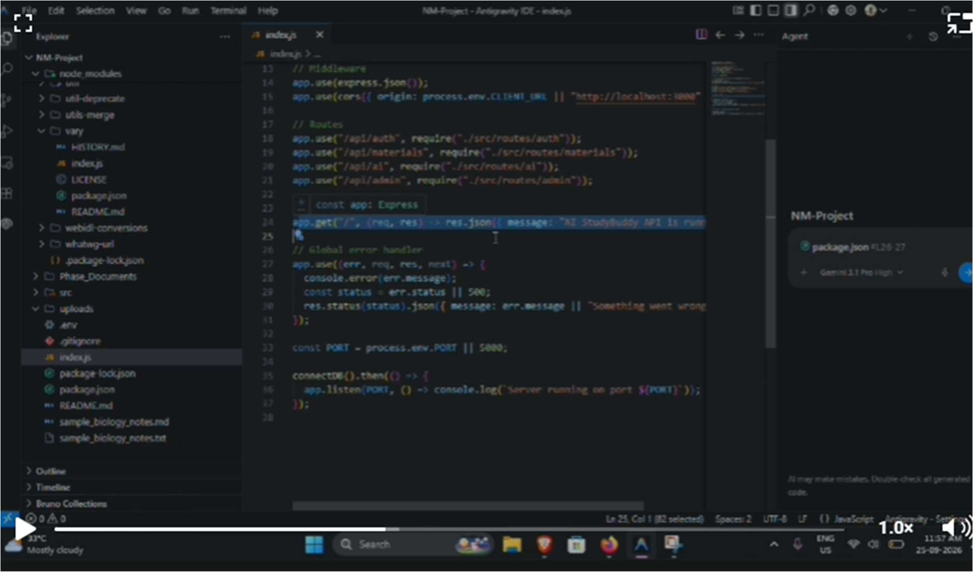
Figure 8: Backend Route Configuration — index.js

05

Testing and Results

The backend APIs were tested end-to-end using Postman and Bruno API clients to verify authentication, data handling, and AI-integration workflows.

5.1 User Registration
Registers a new user by accepting the required details and securely storing the encrypted password in the MongoDB database.
Method / Endpoint | POST /api/auth/register

5.2 User Login
Authenticates the registered user and generates a JWT access token for accessing protected APIs.
Method / Endpoint | POST /api/auth/login

5.3 Upload Study Material
Allows authenticated users to upload study material that will be used as input for AI-powered content generation.
Method / Endpoint | POST /api/material/upload

5.4 Retrieve Study Material
Retrieves a single stored study material record and lists all study materials belonging to the authenticated user, verifying secure, authorized data access.
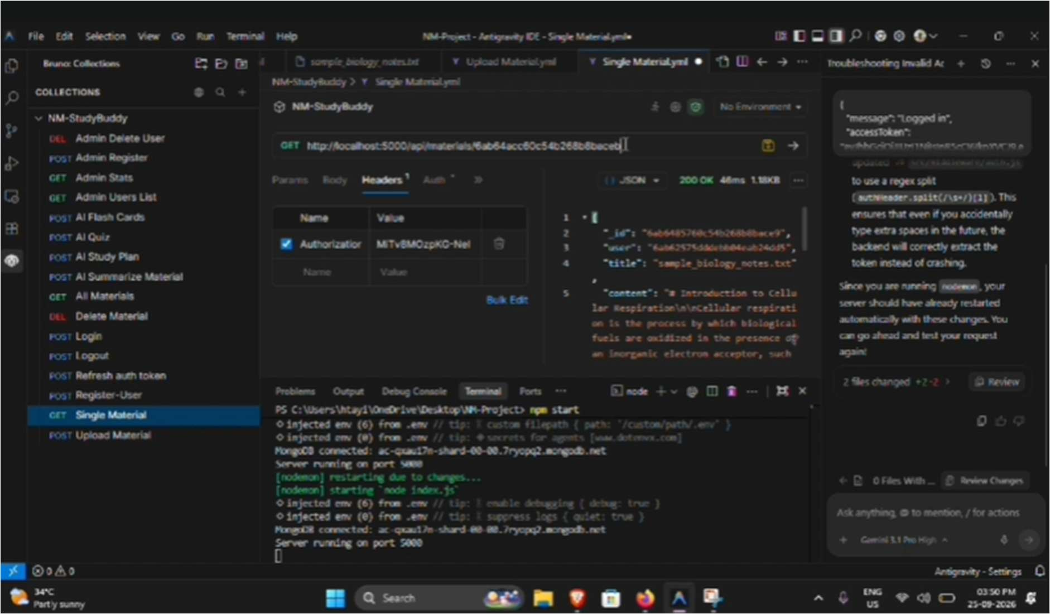
Figure 3: API Testing — Retrieve Single Study Material
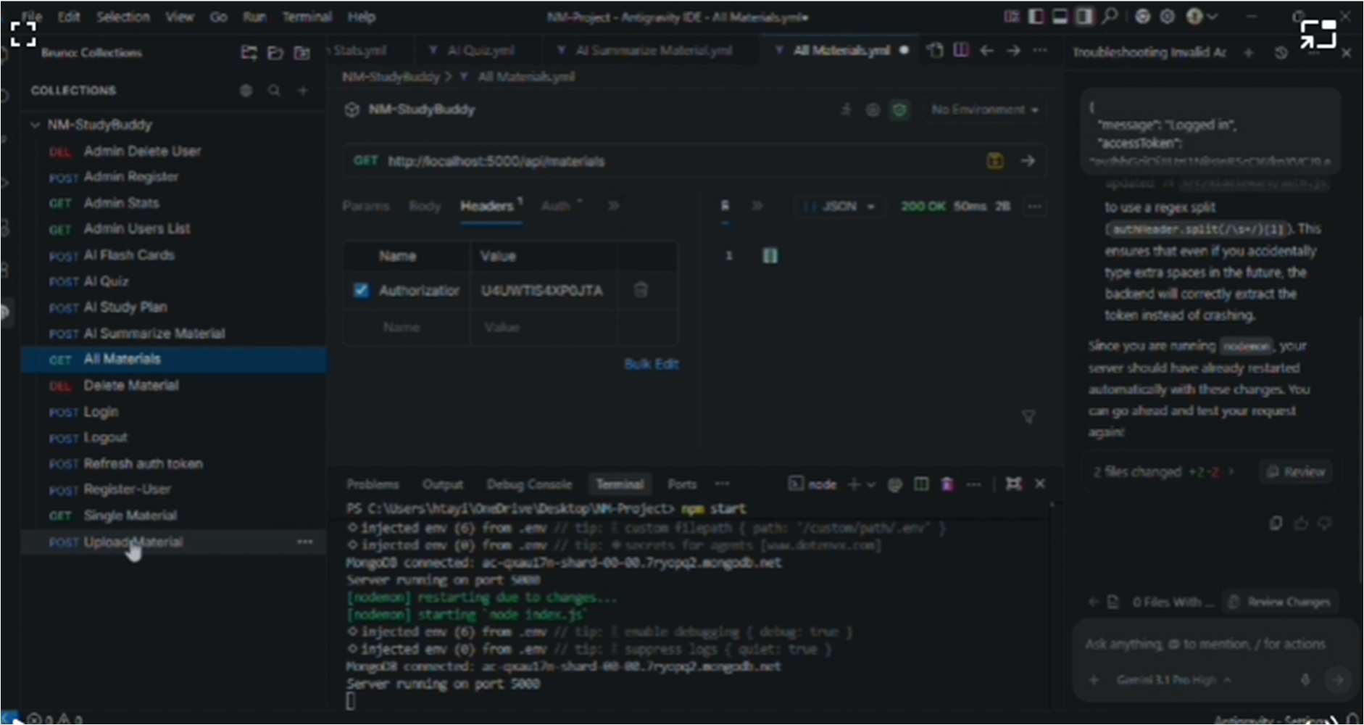
Figure 5: API Testing — Retrieve All Study Materials

5.5 Generate AI Summary
Sends the uploaded study material to the Google Gemini API and generates a concise summary.
Method / Endpoint | POST /api/materials/:id/summarize

5.6 Generate AI Flashcards
Creates AI-generated flashcards from the uploaded study material for effective revision.
Method / Endpoint | POST /api/ai/flashcards

5.7 Generate AI Quiz
Generates a set of multiple-choice questions from the uploaded study material to help students self-assess their understanding.
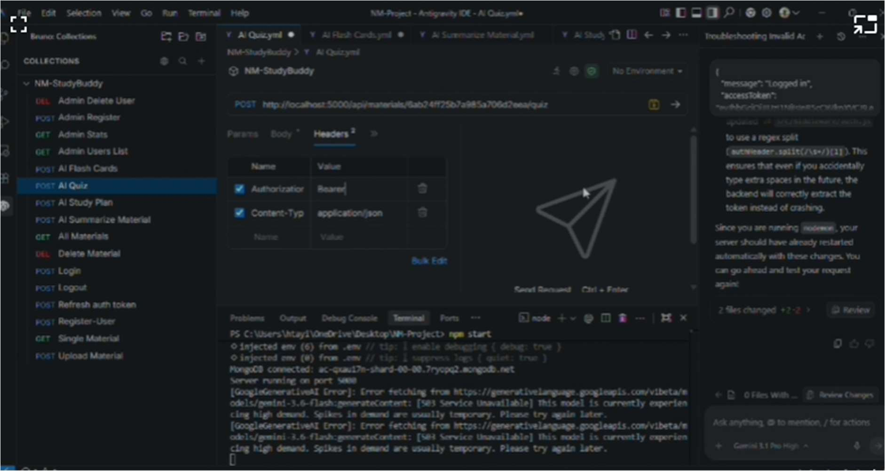
Figure 6: API Testing — AI Quiz Generation (Request Configuration)
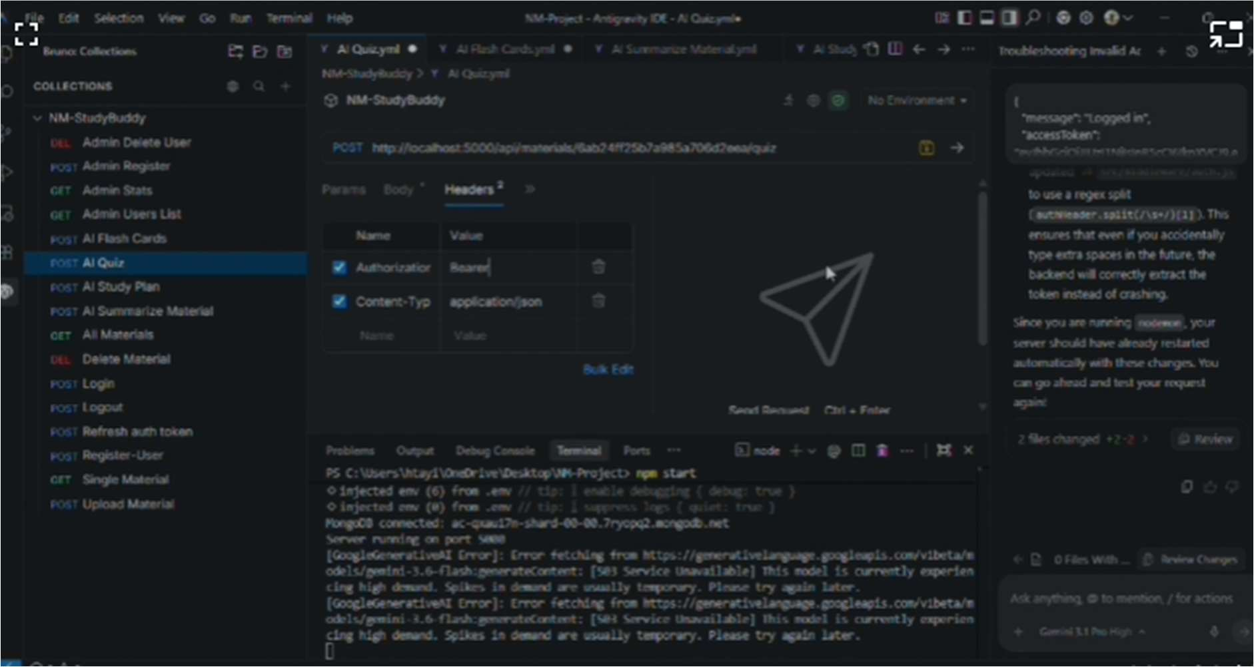
Figure 7: API Testing — AI Quiz Generation (Server Response Log)

5.8 Generate AI Study Plan
Generates a personalized, day-wise study plan for the user based on the provided study goal, available hours per day, and number of days.
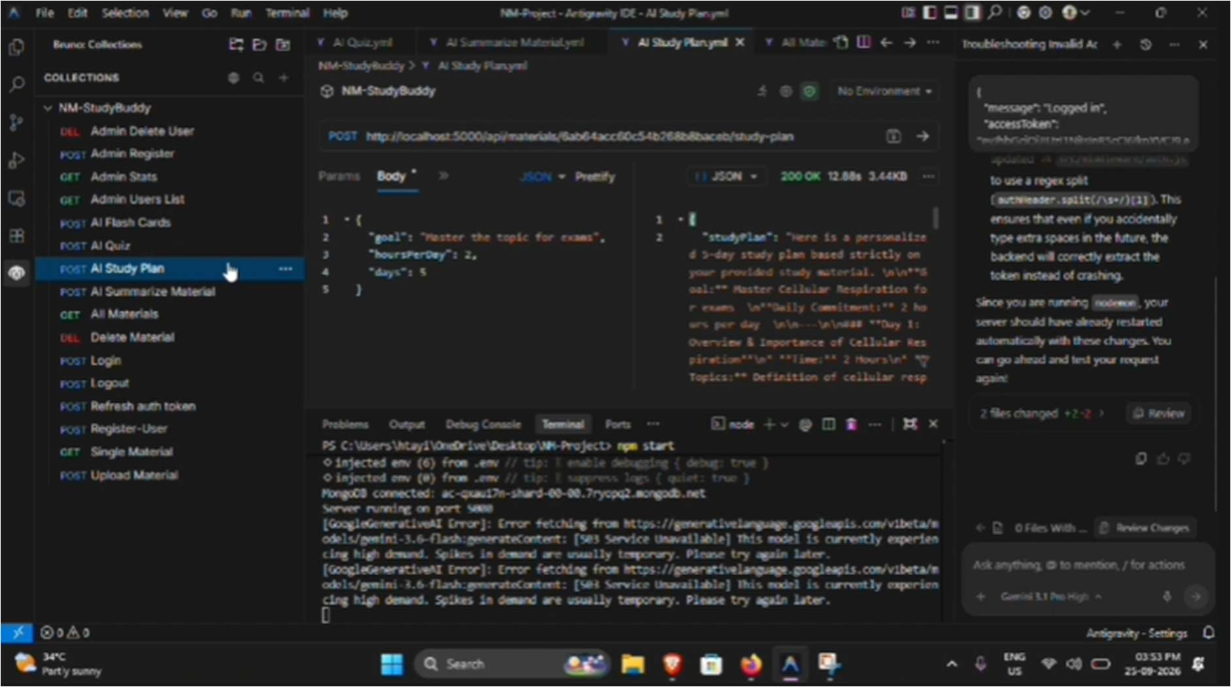
Figure 4: API Testing — AI Study Plan Generation

06

Conclusion

AI StudyBuddy successfully demonstrates how Generative AI can be integrated into a secure, modular backend architecture to address real academic challenges faced by students. By combining Node.js, Express.js, MongoDB, JWT-based authentication, and the Google Gemini AI API, the platform automates time-consuming study tasks such as summarization, flashcard creation, quiz generation, and personalized study planning.
The testing phase confirmed that all core API endpoints — covering authentication, study material management, and AI-powered content generation — function correctly and return the expected responses. The modular design of the backend ensures that the system can be extended with additional AI-powered learning features in the future with minimal architectural changes.

6.1 Project Links
GitHub Repository: https://github.com/ht-ayisha-25/AI_StudyBuddy_NM.git
Demo Video: https://drive.google.com/file/d/11ShkBRp-qSXogvOqFn4InZa3CQok1GFr/view?usp=drive_link

