Development of a Guitar Learning Application, 2023-2024

The application utilizes SQL databases, Kotlin, Jetpack Compose, and machine learning for Optical Music Recognition (OMR) and audio processing.

Key Features

User Accounts & Progress Tracking: Users can register, log progress, and track accuracy in a structured database using MySQL.

Song Database & Searching: A local and global song repository allows users to search, filter, and sort songs using Firebase and SQL queries.

Song Input & Processing: Users can upload song information, including tablature, sheet music, and audio. Images are processed using OMR to convert notes into digital format.

Gaming Mode & Real-Time Feedback: The app analyzes user-played notes via Fast Fourier Transform (FFT) and provides instant feedback.

Playback & Recording: Songs can be played back, recorded, and stored using MIDI processing and Kotlin’s AudioRecord class.

Exercise & Non-Instrument Mode: Users can practice finger movements and notation through custom exercises and notation-matching games.

Additional Features:

Tuner for string adjustments using sound-to-MIDI transformation.

Metronome for tempo training with AudioManager class.

Progress tracking with ranking and streaks using Firebase analytics.

Implementation & Impact

The app leverages Jetpack Compose for UI, Kotlin APIs for real-time processing, and database synchronization for seamless operation. It provides an interactive and engaging learning experience, making guitar practice efficient and enjoyable.
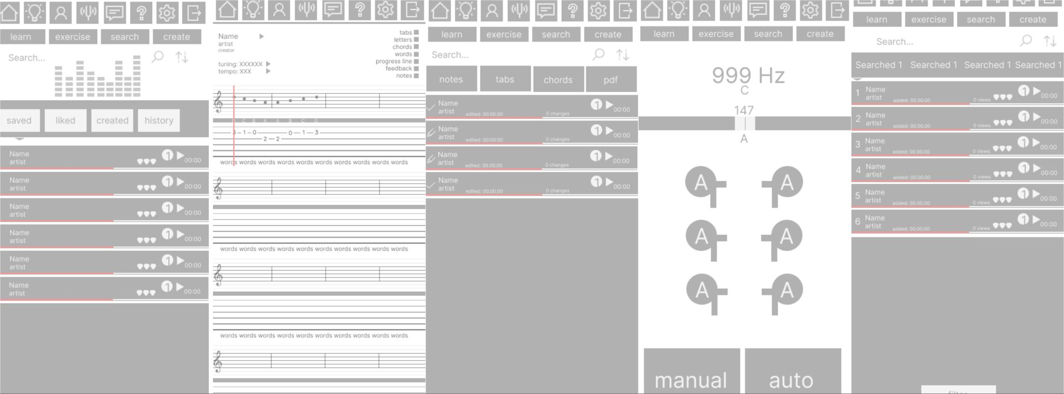

Mobilized Technology for the Production of Paper-Cellulose Fiber from Non-Wood Raw Materials, 2021-2022

This study develops an energy-efficient and mobile technology for producing cellulose material from alternative raw materials, particularly tree leaves and waste paper. The goal is to create an environmentally friendly process that reduces raw material, energy, and water consumption, making cellulose production more sustainable.

Key Findings

Current non-wood cellulose production is inefficient, requiring excessive processing.

Optimized method eliminates unnecessary grinding and chemical processes, lowering electricity consumption.

Innovative pressing technique: Heating cylinders above lignin’s melting point strengthens paper while eliminating a separate drying stage.

Process sequence: raw material cleaning, fiber separation using a refiner, conversion to pulp with chemical treatment, pressing and drying with heated cylinders, production of finished paper fiber.

Impact & Future Improvements

The developed technology enhances energy efficiency in paper production while utilizing non-wood raw materials. The resulting cellulose fiber can be used for office paper, wrapping paper, packaging, and disposable tableware, contributing to sustainable and mobile paper production.

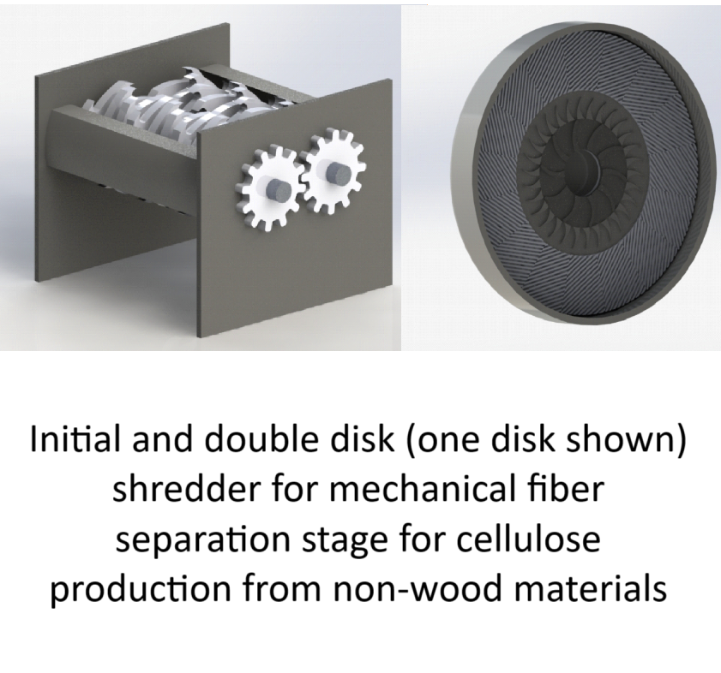

Remote Monitoring System for Indoor Microfarms, 2020-2021
This study develops an Arduino-based remote monitoring system for indoor microfarms, improving plant growth by tracking soil moisture, lighting, and temperature. The system uses IoT technology for remote control and phytomonitoring to assess plant health.

Key Findings
- Optimal soil moisture: 60% (550 standard units).
- Lighting threshold: ≥650 standard units for proper growth.
- Automated monitoring: Sensors collect and analyze data, displayed via LED indicators; designed IoT client-server system.
- Successful testing: Cress and bean plants showed improved health.

Impact & Future Improvements
The system enhances indoor farming efficiency and can be improved with full autonomy and additional environmental controls.
