lar: (1) providing an in-depth understanding of its unique business model to a wide range of readers around the world, (2) effectively explaining the pro- cesses and potential forITOCHU to achieve sustainable growth in corporate value over the long term, and (3) by organizing our management policies and financial and non-financial capital and communicating them to intemal and external stakeholders, fostering the virtuous cycle of culivating mutual under- standing through dialogue and achieving a greater level of management sophistication for the Company. Annual Report 2020 was compiled based on this focus with consideration paid to the disclosure framework of the International Integrated Reporing Council (liRC). Special emphasis was also placed on connectivity as well as the sustainabilty and future of our strategy and business model. ITOCHU aims to steadily address social isues and rapid changes in the business environment, including its response to the COVID-19 pandemic, while being guided by its Group corporate mission, "Sampo-yoshi," an ideals Reporting Scope and Other Items Reporting Period: April1, 2019 to March 31, 2020 (Certain sections includ activities occurring in or after April 2020.) Reporting Scope: ITOCHU Corporation and the ITOCHU Group Accounting Standards: Unless otherwise noted, this annual report is Terminology: Throughout this report,“consolidated net proft is used to refer to net profit atributable to ITOCHU. Unless otherwise indicated, FamilyMart refers to both FamilyMart Co., Ltd. and FamilyMart convenience stores, and CITIC refers to CITIC Limited.

Editorial Policy

numerous hardships in its more than 160-year history. Furthermore, ITOCHU intends to build a foundation for sustainable growth and enhance corporate value, by ！ targeting growth and further progress in both financial and Guidancefor Collaborative non-financial capital that it has refined and accumulated ValueCreatior to date, while moving to pursue both economic and social value. In compiling this annual report, in addition to these points, we focused on giving explanation especially for the relationship between “corporate value based on the perspective for investment decisions,” as it relates to the Company's shares, and "the pursuit of capita efficiency," one of the Company's management strategies. Going forward, we intend to further improve our annual report as a medium for dialogue with a variety of stakeholders through reflecting their opinions. Detailed Financial Information - For detailed financial information for FYE 2020, please see the Financial Section https://www.itochu.co.jp/en/ir/doc/financial_section/

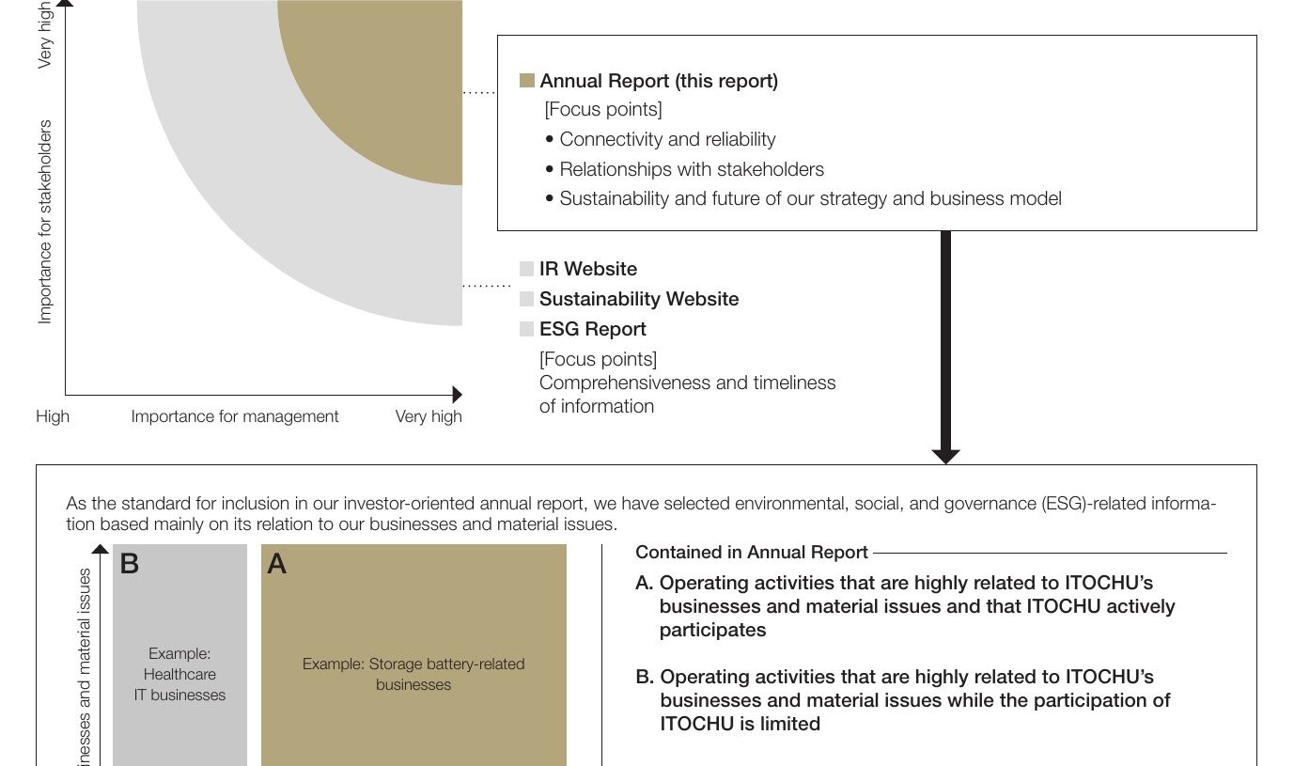

Topcommitment · Sustainability at the ITOCHU Group · ESG Report (Environment, Society, Governance Icontributionactivitie

8