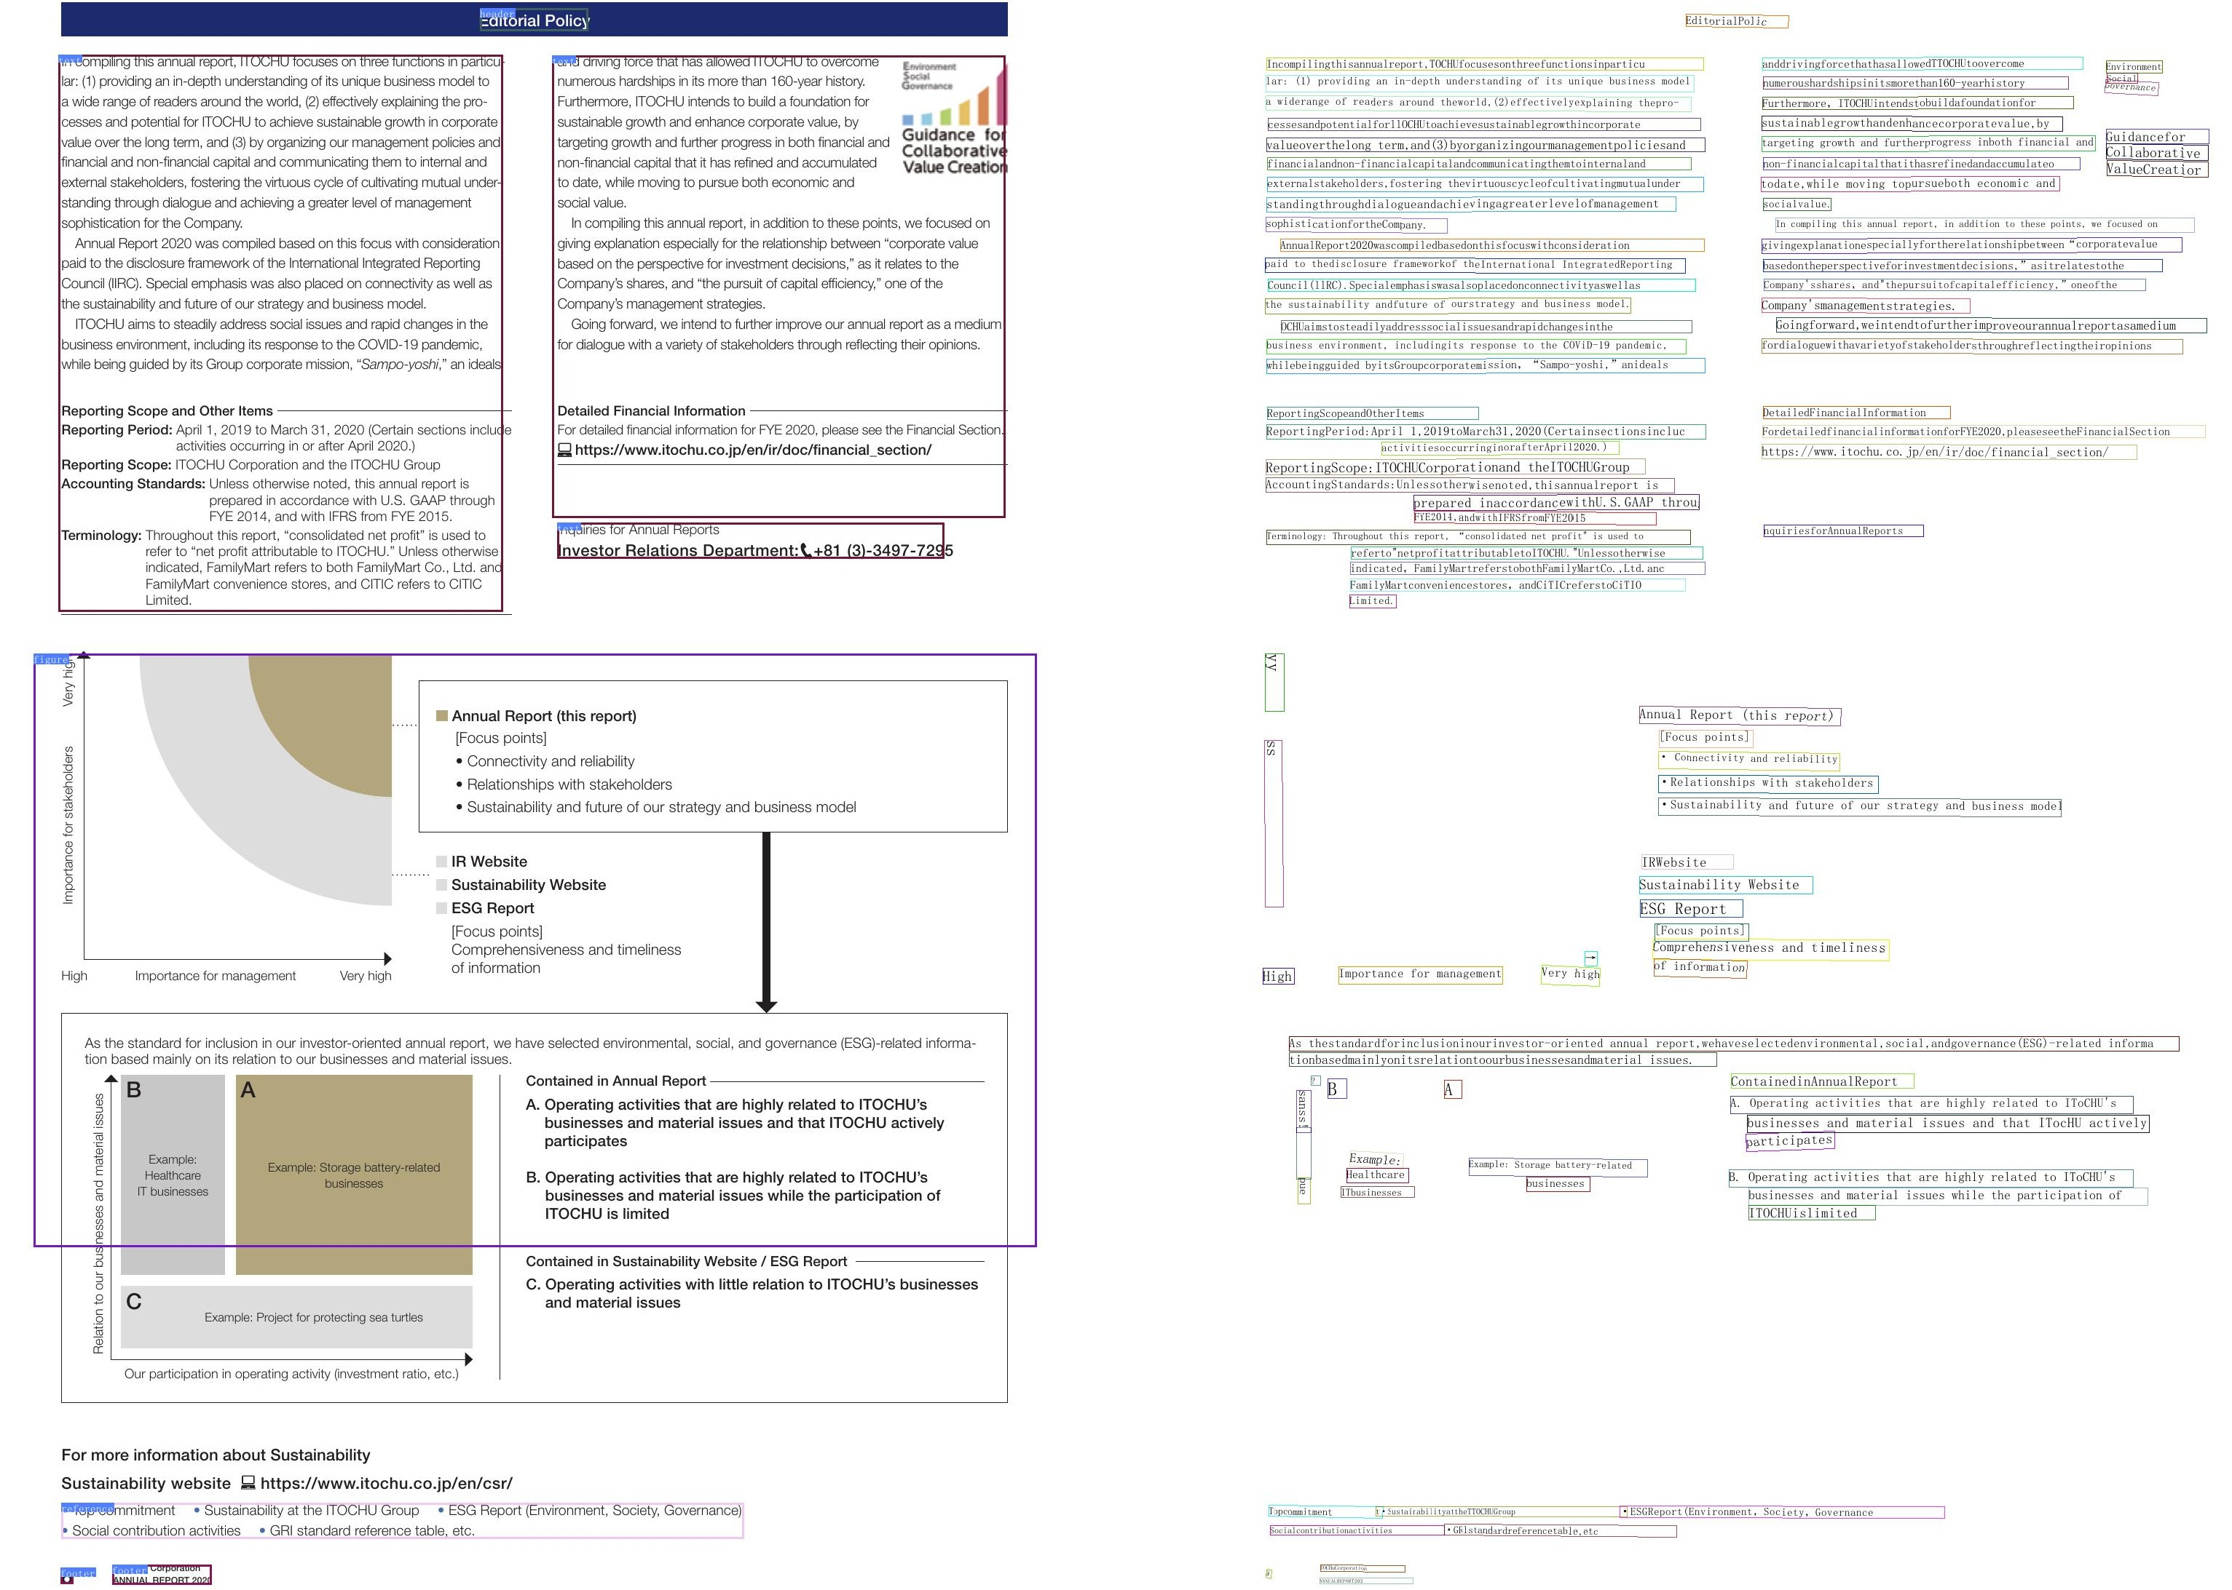

Sustainabilitywebsitehttps://www.itochu.co.jp/en/csr/ · Sustainabity at the ITOCHU Group i ·ESG Report (Environment, Society, Governanc

CARTOAL REPOET20