CONTENTS

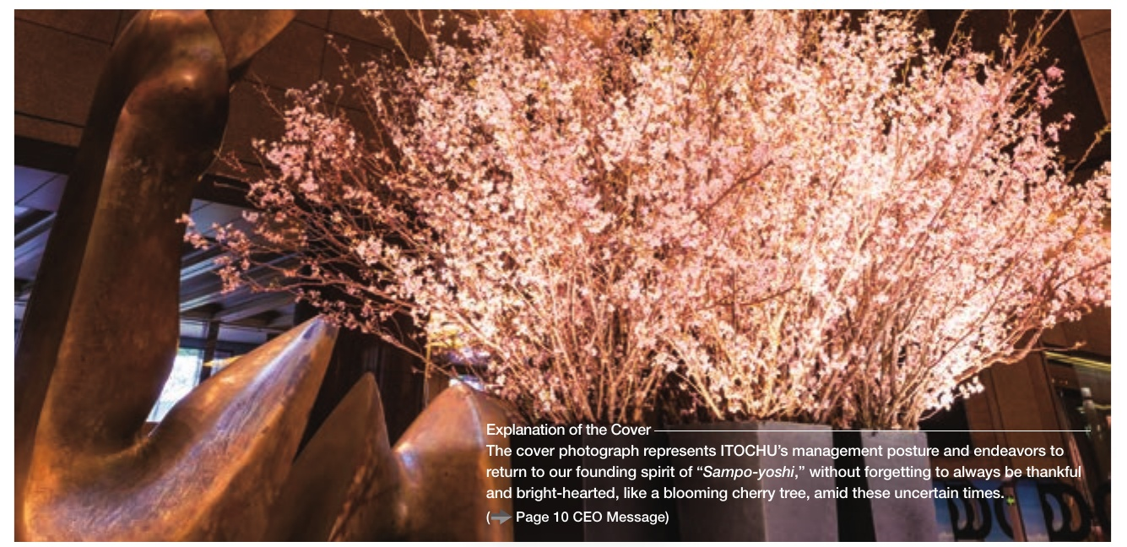

|  |  |  |  |
| --- | --- | --- | --- |
| 10 | Management Messages | 62 | Initiatives and Systems Supporting Sustainable Growth |
| 10 16 | CEO Message COO Message |  | (Environment, Society, Governance) |
| 20 | Driving Force for Sustainable | 62 | Relationship between a Logic Tree, Non-Financial Capital, and Material lssues |
| 20 | Value Creation Staying True to “the Way of the Merchant" for | 64 | Sustainability Initiatives for Sustained Corporate Value Creation |
| 26 | More Than 160 Years | 66 | Addressing Climate Change |
|  | Dialogue: “Sampo-yoshi" and ITOCHU | 68 | Sustainability in the Value Chain |
| 30 | The “Merchant" Business Model | 69 | ESG Risk Evaluation in Business Investment Human Resource Strategy |
| 32 | Our Business Model, as Seen through Business Development | 70 72 | Transition of the Corporate Governance System |
| 36 | Macroenvironmental PEST Analysis | 74 | Overview of the Corporate Governance System |
| 38 | Sustainable Value Creation through | 76 | Maintaining and Improving the Effectiveness of |
|  | Capital Accumulation | 77 | the Board of Directors ITOCHU's Policy on the Governance of |
| 40 44 | CFO Interview |  | Its Listed Subsidiaries |
| 47 | Business Investment Risk Management | 78 | Corporate Officer Remuneration |
| 48 | The Positive Cycle of Dialogue and Enhancing | 80 | Members of the Board, Audit & Supervisory Board |
|  | Corporate Value |  | Members, and Executive Officers |
| 50 | Achievement of Short-Term Targets | 82 | Business Portfolio |
| 50 | The Trajectory for Enhancing Corporate Value | 82 | Financial Summary |
|  | under the “Brand-new Deal" Strategy (Management Plan) | 84 | Performance Trends by Segment |
| 52 | Business Results for FYE 2020 | 86 88 | Net Profit by Major Group Companies |
| 54 | FYE 2021 Management Plan |  | Textile Company |
| 56 | COVID-19's Impact on the Company and | 90 | Machinery Company |
|  | Status of Initiatives | 92 | Metals & Minerals Company |
| 58 | Steppingstones to Medium- to | 94 | Energy & Chemicals Company |
|  | Long-Term Value Creation | 96 | Food Company |
| 58 | Building on Our Existing Strengths | 98 | General Products & Realty Company |
| 59 | Viewing Environmental Issues as | 100 | ICT & Financial Business Company |
|  | Business Opportunities | 102 | The 8th Company |
| 60 | Realizing Our "Sampo-yoshr" Philosophy through the Largest Multifaceted Development in Japan | 104 | IR Activities |

UCorporation