vanagement Messages

CEO Message

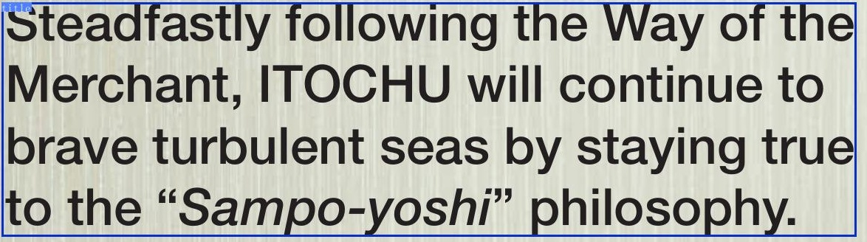

# Steadfastly following theWay ofthe

YE 2020 was themost fruitful year of ITOCHU'smore than60-yearhistory.We successfulycarried out forward looking measures and achieved record-high profits forthe fourth consecutive year. We fullylivedup to our com mitment o "turning words into accomplishments." In FYE 2021, we willresolutely temper overconfidence.

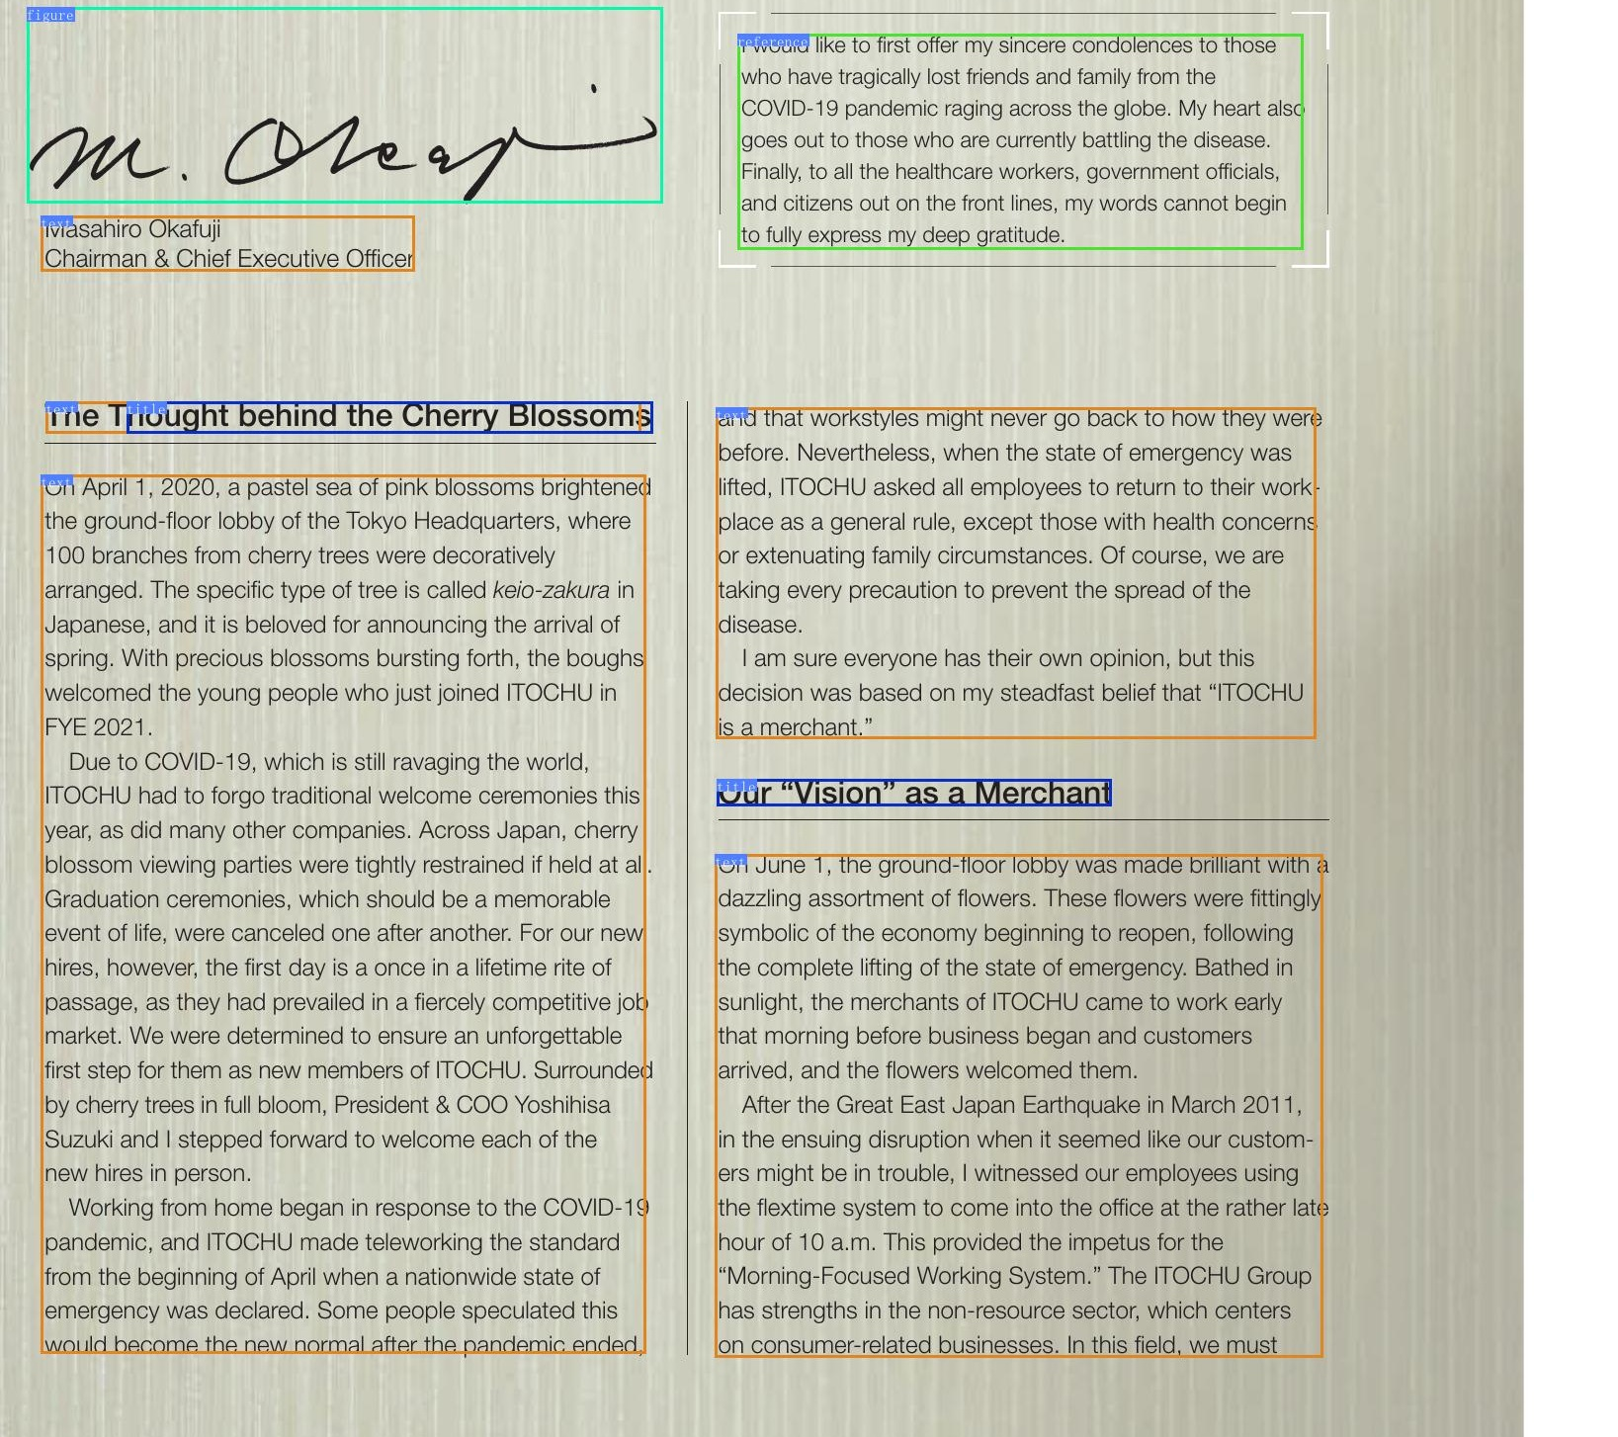

Steadfastlyfollowing theWayofthe Merchant, IToCHU wii1 continue to brave turbulent seas by staying true tothe"Sampo-yoshi" philosophy.

# Steadfastlyfollowing theWayofthe

fecure like to first offer my sincere condolences to those who have tragical lost friends and famil from the COVID-19 pandemic raging across the globe. My heart alsc goes out to those who are currently batting the disease.

