COo Message

COO Message

# By keeping our focus firmly fixed beyo

# By keeping our focus firmly fixed beyond

Amid this unprecedented phase brought about by CoVID-19 and other recent developments, we will unflinch market-oriented perspective, we will perceive changes in customers and industry structure to steadily seize

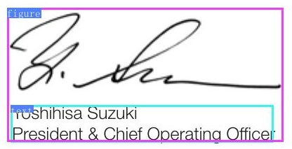

# E

By keeping our focus firmly fixed beyond the current difficulties and taking forward-looking preparations, we aim to

# By keeping our focus firmly fixed beyond

harket-orientedperspective,wewillperceivechangesincustomersandindustrystructuretosteadilyseize

amilyMartwhichwasmadeasubsidiarynFYE29,an trengthen theGroup's value chain by using the consum- rs perspective, a“market-oriented perspective,” rather n our conventional product-oriented perspective.Final arning from our lesson of not using excessive selection dconcentration, wedid not alter the Division Companie at comprise our existing profit pillars. In the summer of 2019, the stock market tookaturn, hich had until thenbeensteadlyadvancing. It statd ith the worsening of the U.S.-China trade friction, which aused a drop that some said could make for another unlucky August." As the Company was strengthening its arning about the eventual collapse of the long sustained eriod of global economic growth, ITOCHU used this arket shift, under the guidance of its Chairman &CEO lasahirokafuj, toredule itsefrs ontheeant, vent" principles, which form the foundation of ITOCHU lanagement. Specifically, we redoubled efforts to uncove otential concerns andthoroughly practice our“prevent" rinciple.To prepare forfurther economic deterioration, e also decided to switly shift toward lean management veraging our "cut”" principle. We began to take countermeasures ahead of other con anies. For example, we conducted an interim review of e management plan on September 9, a month earlier usual. We also instilled a feeling of restraint during nmer vacation. This was because ITOCHU, which had rown dramatically over the course of adecade,determine hat it was facing amajor challenge about whetherit coul eep its commitment of achieving the promised ￥500.0 ilionincethen,thestockmarket fortunatelyrecovere nd ITOCHU's share price set 22 record highs. The prepa madeforthattimehelped Iusbereadywhe

strengthen the Group's value chain by using the consum- April 2019, as we were almost sure about achieving an ers' perspective, a “market-oriented perspective,” rather historic￥500.0 bilion in consolidated net profit, we hld a than our conventional product-oriented perspective. Finall Special Headquarters Management Committee meeting to learning from our lesson of not using excessive selection iscuss the FYE 2020 management plan.Rather than revel and concentration,wedid not alter the Division Companie n our major 500.0 billion achievement, we honed our that comprise our existing profit pillars. gaze on the trajectory beyond ￥500.0 bilion. Our discus- In the summer of 2019,the stock market took a turn, sionfocused on how ITOCHUcould continue to steadily which had until thenbeensteadily advancing. It startd row and what actionswereneeded withourrganizationa with the worsening of the U.S.-China trade friction, which systems and human capitalWestarted themeting reet- caused a drop that some said could make for another ng on the many ups and downs the Company has experi- “unlucky August." As the Company was strengthening its nced and what lessons could be learned We narrowed warning about theeventual cllapseof thelong sustained hese down to three major lesons. The first is not to for- period of global economic growth, ITOCHU used this nulate long-term management plans on hypotheticals. In market shift, under the guidance o its Chairman &CEO herwordsweshould nt announcebaselessquantitati Masahiro kafujl,tredouble its efforts on the“ean, ut rgets, and management should emphasize its commit- prevent" principles, which form the foundation of ITOCHU'$ ents. The second is not to conduct management through management Secificlly, we redoubled efforts to uncover xcessiveselction and concentration.The third is that the potential concerns and thoroughly practice our"prevent”" usiness environment willalways change: Overconfidence principle.o prepare forfurther economic deterioration, forbidden. “The higher the peak, the lower the valley" we also decided to swiftlyshift toward lean management leveraging our“cut” principle. lated net profit plan at 500.bilion, or about the same We began to take countermeasures ahead of other com astheFE 2019 results, and maintained our progressive panies. For example, we conducted an interim review of ividend policy with a dividend of ￥85, an increase of ￥2. the management plan on September 9, amonth earier his was a result of emphasizing our commitment to than usual.We also instiled a feeling of restraint during achieving the numbers we promised whil first establishing summer vacation. This was because ITOCHU, which had firm foothold amid an uncertain economic outlook. growndramaticallyover thecourseof a decade,determine nother contributing factor was the establishment of The that it was facing amajor challengeabout whetherit could Bth Company as a new Division Company with the purpose keep its commitment of achieving the promised ￥500.0 bilion Sincethen, the stockmarket fortunatelrecvred f securing resilience against volatile business environments and withdrawing frm legacy businesses. One goalof the and ITOCHU's share priceset 22 recrd highs.The pra

Aprl 2019, as we were almost sure about achevng an historic00.blionincnsolidated et proft,wed a Special Headquarters Management Committe meeting to discuss the FYE 2020management plan.Rather than revel n our major500.0bilion achievement, we honed our gaze on the trajectory beyond ￥500.0 bilion. Our discus- sion focused onhow ITOCHU could continue to steadily growandwhat actionswereneeded withourorganizationa systems and humancapitalWe stared themeeting reflect ing on the many ups and downs the Company has experi- nced and what lessons could be learned.We narrowed hese down to three majorlessons. The frst is not to for- mulate long-tem management plans on hypotheticals. In otherworehulnt aaselessquantitat argets, and management should emphasize its commit- ments. The second is not to conduct management through excessiveselction and concentration.The third is that the ousiness environment illalways change: Overconfidence Sforbidden. The higher the peak, the lower the valley" Based on these lessons, we set the FYE 2020 consoli- dated net pofit plan at 500.bilion, or about the same asthe FYE 2019 results, and maintained ourprogressive dividend policy with a dividend of￥85, an increaseof ￥2. his was a result of emphasizing our commitment to achieving thenumberswe promised whil first establishing a firm foothold amid an uncertain economic outlook. Another contributing factor was the establishment of The 8th Company as a new Division Company with the purpose ofsecuringresilience againstvolatilebusiness environments and withdrawing from legacy businesses. One goal of the Division Company is to enhance the corporate value of

oterANNUALREPORT2

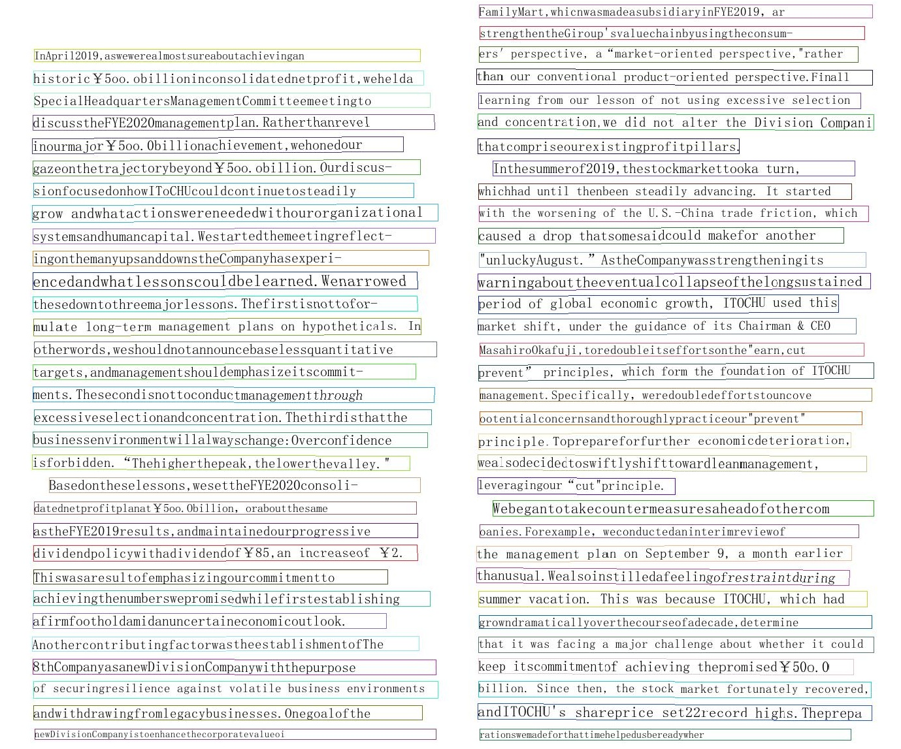

|  |
| --- |
| FamilyMart,whicnwasmadeasubsidiaryinFYE2019, ar |
| strengthentheGiroup'svaluechainbyusingtheconsum- |
| ers'perspective,a“market-oriented perspective,rather |
| than our conventional product-oriented perspective.Finall |
| learning from our lesson ofnot usingexcessive selection |
| and concentration,we did not alter the Division Compani |
| thatcompriseourexistingprofitpillars, |
| Inthesummerof2019,thestockmarkettooka turn, |
| Whichhad until thenbeen steadily advancing. It started |
| with the worsening of the U.S.-China trade friction,which |
| caused a drop thatsomesaidcould makefor another |
| "unluckyAugust."AstheCompanywasstrengtheningits |
| warningabouttheeventualcollapseofthelongsustained |
| period of global economic growth, ITOCHU used this |
| market shift,under the guidance of its Chairman & CEO |
| Masahirookafuji,toredoubleitseffortsonthe"earn,cut |
| prevent" principles, which form the foundation of ITOCHU |
| management.Specifically,weredoubledeffortstouncove |
| ootentialconcernsandthoroughlypracticeour"prevent" |
| principle.Toprepareforfurther economicdeterioration, |
| wealsodecidedtoswiftlyshifttowardleanmanagement, |
| leveragingour“cut"principle. |
| Webegantotakecountermeasuresaheadofothercom |
| oanies.Forexample,weconductedaninterimreviewof |
| the management plan on September 9,a month earlicr |
| thanusual.Wealsoinstilledafeelingofrestraintduring |
| summervacation. .This was because ITOCHU, which had |
| growndramaticallyoverthecourseofadecade,determine |
| that it wasfacinga major challenge about whether it could |
| keep itscommitmentof achieving thepromisedY50o.0 |
| billion. Since then, the stock market fortunately recovered, |
|  |
| andITOCHU's shareprice set22record highs.Theprepa rationswemadeforthattimehelpedusbereadywher |

historic Y5oo. obillioninconsolidatednetprofit,wehelda SpecialHeadquartersManagementCommitteemeetingto discusstheFYE2020managementplan.Ratherthanrevel inourmajorY5oo.Obillionachievement,wehonedour gazeonthetrajectorybeyondY5oo.obillion. Ourdiscus- sionfocusedonhowIToCHUcouldcontinuetosteadily grow andwhatactionswereneededwithourorganizational ystemsandhumancapital.Westartedthemeetingreflect ingonthemanyupsanddownstheCompanyhasexperi- ned.Wen rowed hesedowntothreema jorlessons. Thefirstisnottofor mulatelong-term otherwords,weshouldnotannouncebaselessquantitative tshouldemphasizeitscommit- ments. Thesecondisnottoconductmanagementthrough excessiveselectionandconc ntration.Thethirdisthatthe businessenvironmentwillalwayschange:Overconfidence sforbidden.“Thehigherthepeak,thelowerthevalley." Basedontheselessons, wesettheFYE2020consoli- astheFYE2019results,andmaintainedourprogressiv dividendpolicywithadividendof Y85,an increaseof Y2. Thiswasaresultofemphasizingourcommitmentto achievingthenumberswepromisedwhilefirstestablishing afirmfoothol dami danuncertaineconomicoutlook. SthCompanyasanewDivisionCompanywiththepurpose of securingresilience against volatile business environments andwithdrawingfromlegacybusinesses. Onegoalofthe