Driving Force for Sustainable Value Creatio

# The Story of Merchant

The Story of Merchants

More than 160 years have passed since ITOCHU's establishment in 1858. Like our founder, Chubei Itoh I who crossed rugged mountain passes and paved the ways for peddling his wares throughout Japan, we have overcome numerous difficulties during the ensuing years. Despite these difficulties we have remained true to our identity as a merchant, “supplying the needs of the society”" as well as to the business philosophy of Chubei Itoh I, “Sampo-yoshi." This identity and philosophy have constantly underscored our actions and served as the driving force for transforming ourselves.

# True to

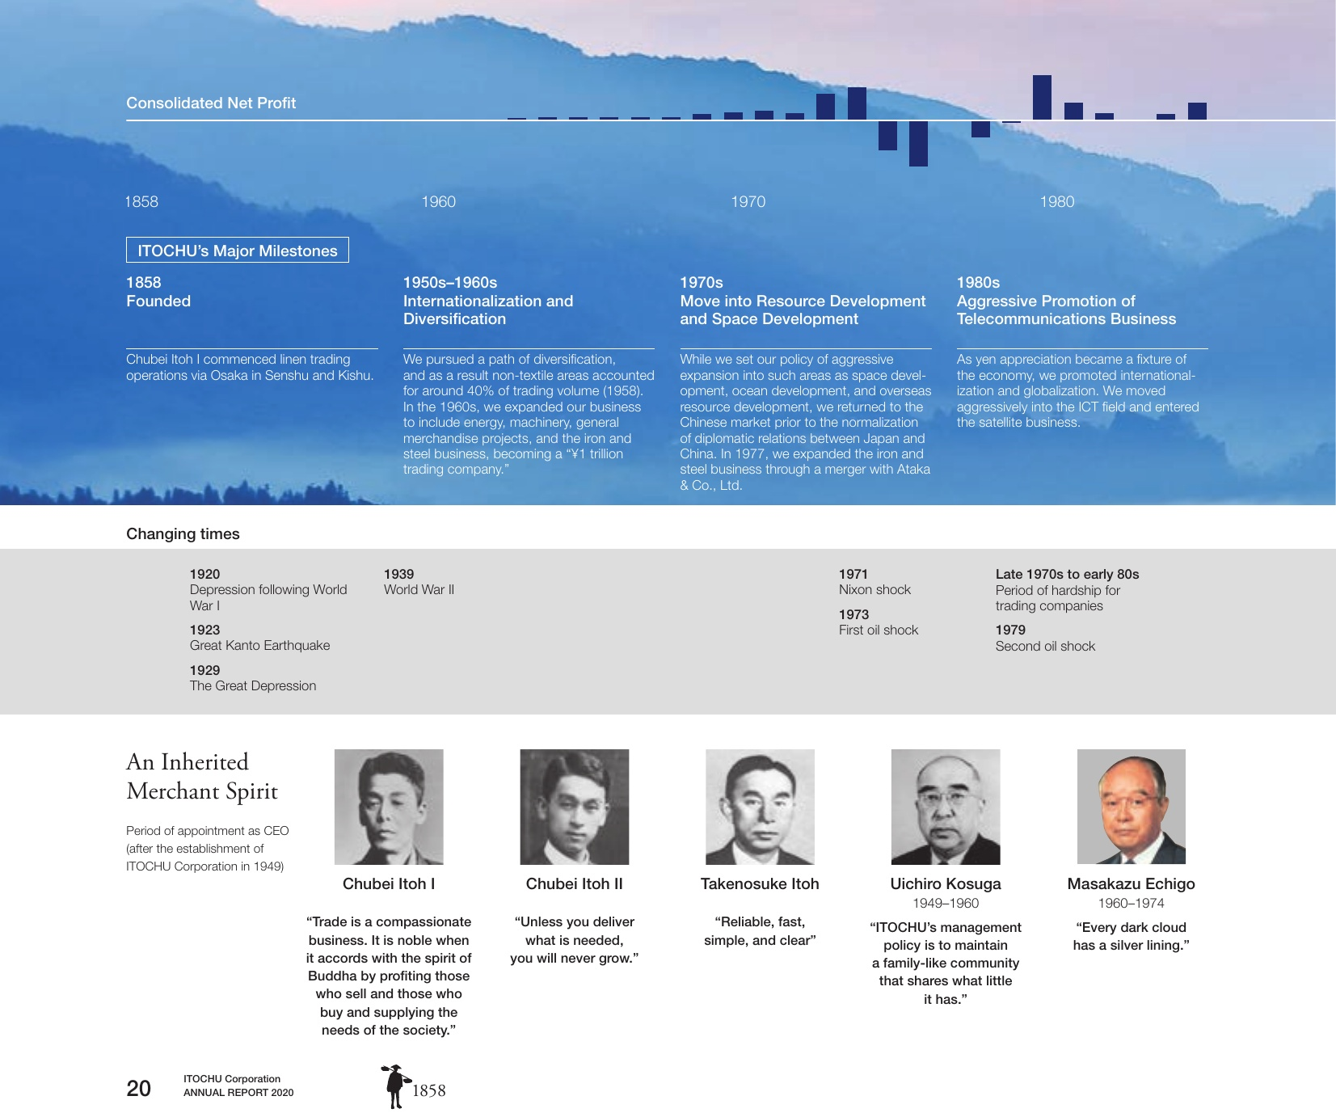

20