# Explanation of OurBusinessModel

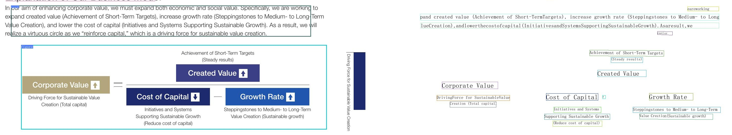

usinessFundamentalsandUniversalMeansasaMerchant

|  |  |  |
| --- | --- | --- |
| able BusinessFundamentals | | |
| EARN | | |
| Conduct trade aligning with changes in the world and customerneeds | CUT PREVENT Reduce expenses that are not cost effective, reduce unnecessary meetings and documents | |
| Universal Means | | |
| Creating Added Value We strive tostabilizecommercial rights,expand trade,and increase the value of businesses including the companies that | Prevent outflows due to losses on receivables and impairment losses Asset Strategies With the strategic importance of business investment increas- ing, we have developed and are steadily implementing asset | |
| wehave invested in,byleveragingthedistinctivefunctionsof a general tradingcompanycontinuallycreatingaddedal fromtheviewpointofourcustomersand themarket-oriented perspective. Coordination In addition to the traditional functions of a general trading company, we aim to leverage client and partner assets to find optimal way of sales and cultivatesalesroutes andprocure- ment partners as we respond to various customer needs and strive to expand trade. Promoting Business Management In addition to leveraging the various functions and manage- ment know-how we have accumulated as a general trading company, we take the initiative in forming business combina- tions and alliances with Group companies, enhancing the competitive advantage of our investees. Generating Synergies among Businesses Byleveraging theGroup'smanagementresources,wemaximize synergies between existing businesses and Group companies, increasing the Group's overall corporate value. | strategies that emphasize investment in areas of strength, thorough riskmanagement, and the pursuit of asset efficiency. InvestinginAreasofStrength We emphasize investment in areas where we have strength, such as the non-resource sector, centered on consumer- relatedbusinesses,and inChinaandotherpartsofAsia. On this basis,we are working to furtherreinforce our com- petitive edge. RiskManagement In addition to managing total amount of riskby utilizing risk assets, we are also conducting risk management on a project-by-project basis through evaluation of investment effi- ciency using a hurdle rate based on the cost of capital. In this manner, we also work to analyze and control the various risks surrounding ourbusinesses. Pursuing Asset Efficiency Weexitfrominvestmentsthataredeterminedtobelow- efficiency assets from such perspectives as scale of earnings, investmentfciencyand strateic significanceIthiswa we are working to maximize free cash flows by increasing asset efciency and strengthening cash generation power. | |