Force for Sustainable Value Cre

Our Business Model, as Seen through Business Development

# Expanding Our Multifaceted Businesses and

We are expanding our multifaceted businesses through a chain reaction by leveraging functional areas of strength. At the same time, we are combining existing businesses, shifting to a market-oriented perspective, and investing in new fields. Through such efforts, we continue to upgrade our business model and pursue a new vision of what a trading company can achieve.

Advancing into Areas Where We Can Leverage OurDistinctiveStrengths

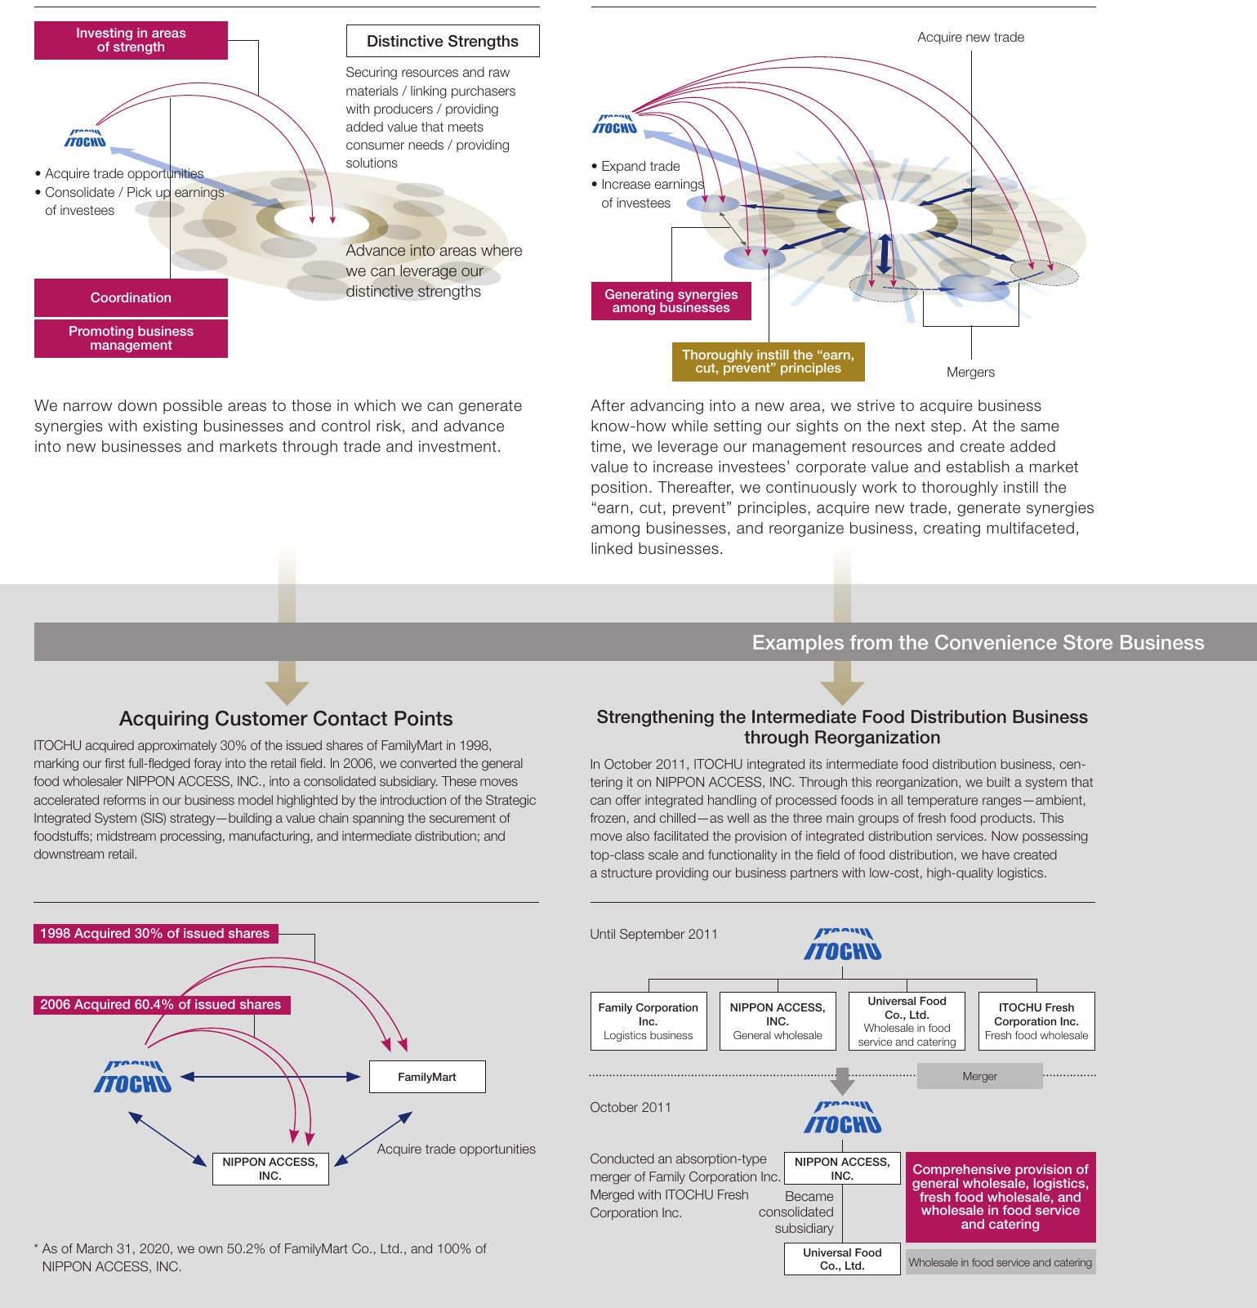

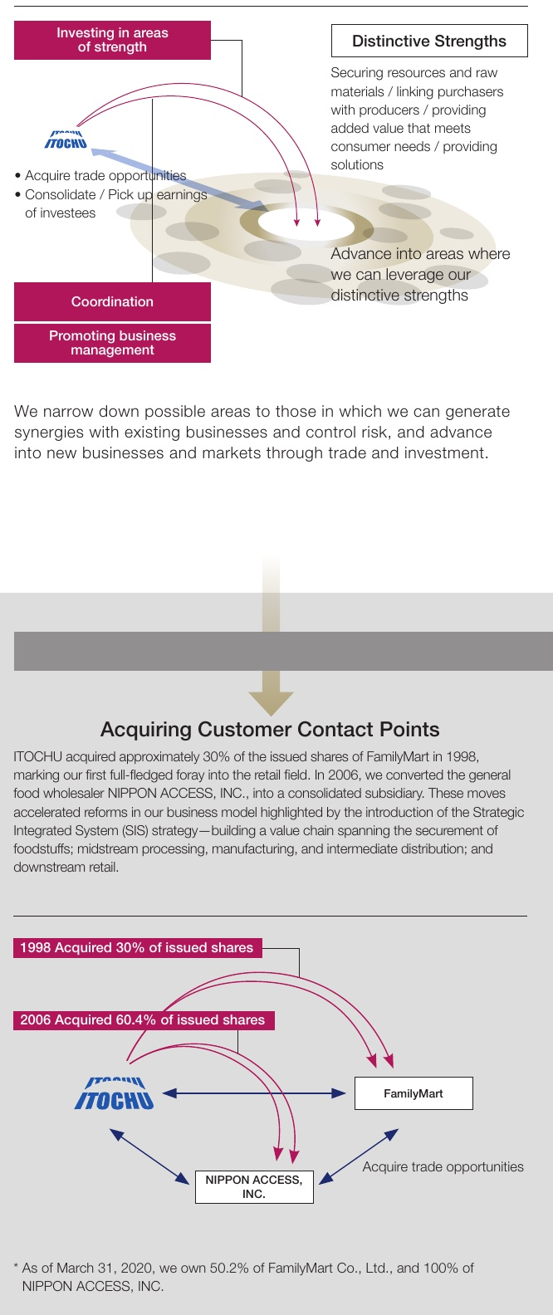

32