ForceforSustainableValueCre

# MacroenvironmentalPESTAnalysis

MacroenvironmentalPESTAnalys

The business environment surrounding IToCHU is changing day by day, while uncertainties increase. Through a PEST analysis, we adequately assess the risks and opportunities related to non-financial capital in the context of macroeconomic factors, including the CoviD-19 pandemic and trade friction between the United States and China. We use this assessment to build a stronger competitive edge while flexibly responding and adapting to changes in thebusinessenvironment.

|  |  |  |  |  |  |  |  |  |
| --- | --- | --- | --- | --- | --- | --- | --- | --- |
| (Political / Legal) | | | | | | | | |
|  | | | | | | | | |
| Risks | | | | | | | | |
|  |  |  |  |  | Political Trends |  |  | Opportunities |
| Global economic stagnation; decrease in trade |  |  | U.S.-China Conflict | 4 | 5 |  |  | Supply chain revisions |
| volume; stricter export and investment regulations Decrease in trade volume and movement; |  | (Trade disputes,forced technology transfer) Anti-globalization Movement | | | | | Greater complexity in food and resource procurement; | |
| destabilization of financial markets Coercive political management | (Brexit and protectionism) Elections (U.S.presidential and Lower House elections) | | | | | | supply chain revisions Economic stimulus | |
| Economic stagnation due to terrorism and armed conflict;: | Geopolitical Risks (Middle East, North Korea, etc.) | | | | | | Increase in crude oil prices | |
| disorder in financial markets | Changes in Tax Code and Regulations | | | | | |  | |
| 4 5 | 1 3 2 | | | | | | 6 |  |
| Decrease in trade volume | Trade Talks and Trade Agreements (Japan-U.S.,U.S-EU,USMCA,tc.) | | | | | |  | Supply chain revisions |
| Existing energy market shrinkage | Greenhouse Gas Containment Regulations (Paris Agreement, etc.) | | | | | | Expansion of new energy market | (wind power, solar power,et.) |
| (coal and crude oil) Rising costs, such as those for establishing data governance; | Tightening Regulations on | | | | | |  | End of data monopolies held by existing platformers; expansion of open data availability |
| damageanddeclineof reputation | Handling of Personal Data International Tax Trends (Measures to address | | | | | |  | Improvement in corporate performance; optimized taxation |
| Decrease in existing business transactions | tax avoidance and platformers) Economic Policy Trends | | | | | |  |  |
|  | 1 2 | 3 | 4 |  | 5 | 6 |  |  |
| Destabiization of financial markets | ContinuationofMonetary EasingPolicy |  |  |  |  |  | Stable low cost of fundraising |  |
| Upward pressure on interest rates; higher taxes | Change in Expansionary Fiscal Policy | | | | | | Expectations for private sector to drive economic growth; faster pace of deregulation |  |

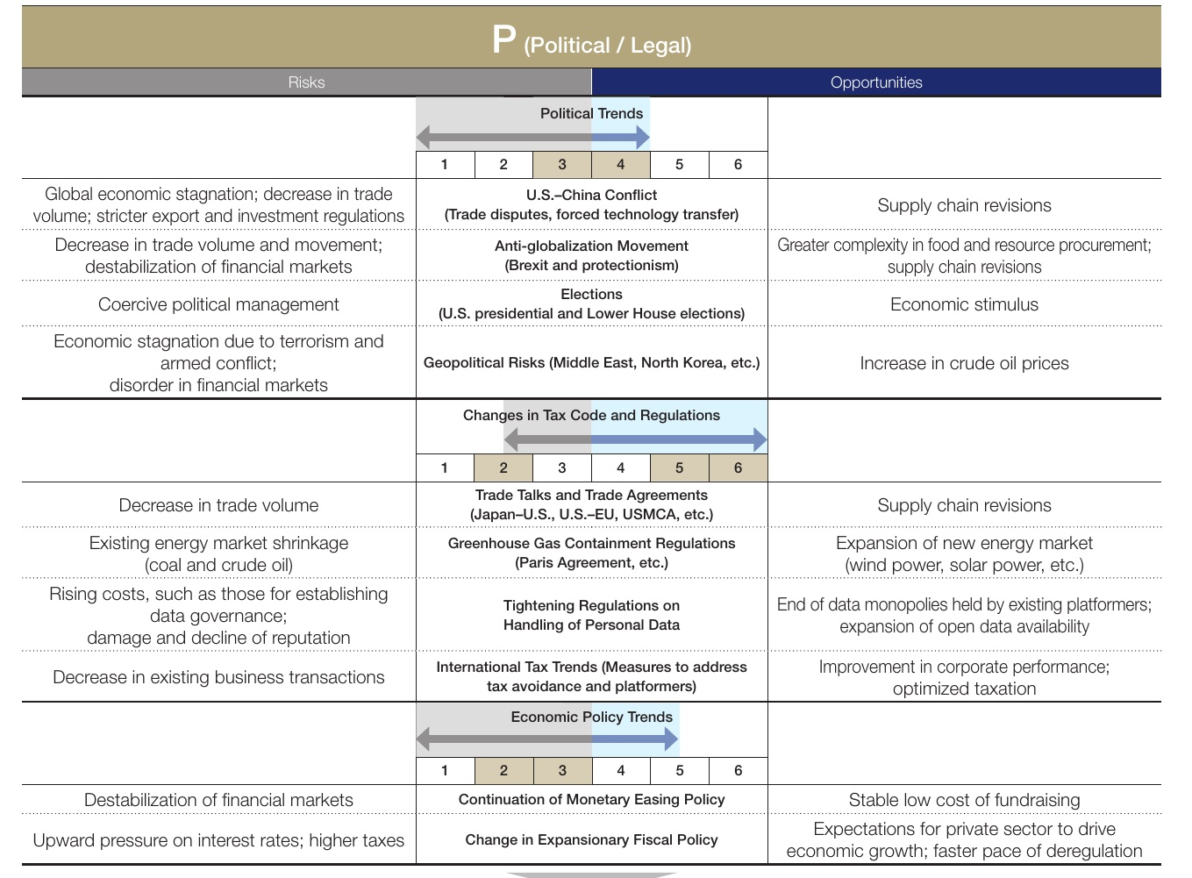

|  |  |  |  |  |  |  |  |
| --- | --- | --- | --- | --- | --- | --- | --- |
| Risks | | |  | | | | |
| Decrease in business opportunities and trade volume | Economic Slump in Developed Countries | | | | | | Opportunities Emergence of new demand from changes in consumer and corporate behavior |
| 2 |  |  | 3 4 | 5 6 |  |
| Emergence of non-performing assets due to economic and social deterioration | Greater Disparities in Economic Growth in Emerging Countries | | | | | | Increase in consumer spending as standard of living improves; increase in demand for infra- structure and foodstuffs as population grows |
|  | 2 | 3 | 4 | 5 | 6 |
|  |  |  | Dollar Appreciation |  |  |
| Decrease in currencies of emerging countries; increase in overseas investment costs |  |  | | | |  | Improvement in earnings environment due to yen depreciation |
|  | 2 | 3 | 4 |  | 5 6 |
|  | Asset (stocks, real estate) and |  |  |  |  |
| Formation and collapse of asset bubbles in specific fields and products |  | ResourcePrice Increase | | | |  | Increase in fundraising capacity due to higher value of existing assets; growth in earnings from trading Increase in expected returns as growth |
|  | 2 |  | 3 4 |  | 5 6 |
|  |  |  | Change in Investment Environment |  |  |
| Excessive swings in project prices |  |  |  |  |  |  | rebounds; more investment opportunities in fields of strength in accordance with restructuring |
|  |  | 3 | 4 | 5 |  |
|  | 2 |  |  |  | 6 |

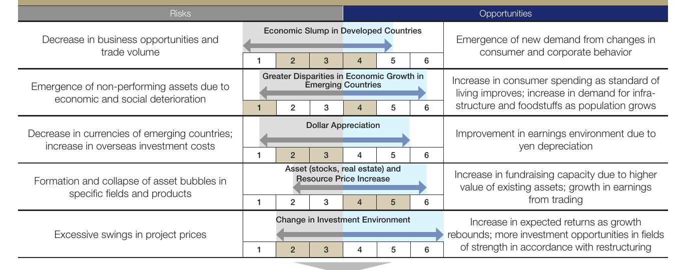

With only moderate recoveries in the economies of developed countries, and widening disparities in the economic growth potential of emerging countries, monitor the balance between growth fields and fields peakin

36