viacroenvironmentalPEST Analvsis

Viacroenvironmental PEST Analvsis

le business environment surrunding IOCHU is changing day by day, while uncertainties increase.Through a PEST analysis,we adequatelyassess the risks and opportunities related tonon-financial capital in the context of macroeconomic factors, including the CoVID-19 pandemic and trade friction between the United States and China.Weuse this assessment to build a stronger competitive edge while flexibly responding and adapting to changes inthebusinessenvironment

me business environment surroundingITOCHU is changing dayby day,while uncertaintiesincrease.Through PEST analysis, we adequately assess the risks and opportunities related to non-financial capital in the context of macroeconomic factors,including the CoVID-19 pandemic and trade friction between the United States and China. We use this assessment to build a stronger competitive edge while flexibly responding and adapting to

|  |  |  |  |  |  |  |
| --- | --- | --- | --- | --- | --- | --- |
| (Political / Legal) | | | | | | |
|  | | | | | | |
| Risks |  | | | | Opportunities |  |
| 2 | 3 | Political Trends 4 | 5 | Supply chain revisions |
| Global economic stagnation; decrease in trade volume;stricterexport and investment regulations Decrease intradevolumeandmovement; destabilizationof financialmarkets Coercive political management | U.S.-China Conflict (Trade disputes,forced technology transfer) | | | | | |
| Anti-globalizationMovement Greatercomplexity in food and resource procurement; | | | | | |
| (Brexit and protectionism) Elections (U.S.presidential andLowerHouse elections) | | | | | |
| Economic stagnation due to terrorism and Geopolitical Risks(Middle East,NorthKorea,et.) | | | | | |
| armed conflict; disorderinfinancial markets | | | | | |  |
|  | | | | | |  |
| Decrease in trade volume | Changes in Tax Code and Regulations 2 TradeTalks and Trade Agreements | 3 | 4 | 5 | supply chain revisions Economic stimulus Increase in crude oil prices Supply chain revisions |  |
| Existing energymarket shrinkage | (Japan-U.S.,U.S.-EU,USMCA,etc.) | | | | | |
| (coal and crude oil) Rising costs, such as those forestablishing | Greenhouse GasContainmentRegulations Expansionof new energy market (Paris Agreement,etc.) (wind power, solarpower,etc.) | | | | | |
| data governance; damage and declineof reputation | Tightening Regulations on End of datamonopoliesheldbyexisting platformers; Handling of Personal Data expansion of open data availability | | | | | |
| Decrease in existing business transactions | International TaxTrends(Measurestoaddress Improvement in corporateperformance; taxavoidance and platformers) optimized taxation Economic Policy Trends | | | | | |
|  | | | | | |  |
|  | 2 | 3 | 5 |  |  |  |
|  |  | 4 ContinuationofMonetary EasingPolicy |  |  | Stable lowcostoffundraising |  |
| Destabilization of financial markets |  |  |  |  | Expectationsforprivatesector to drive economic growth; faster pace of deregulation |  |
| Upward pressure oninterest rates;highertaxes | Change inExpansionaryFiscalPolicy | | | | | |

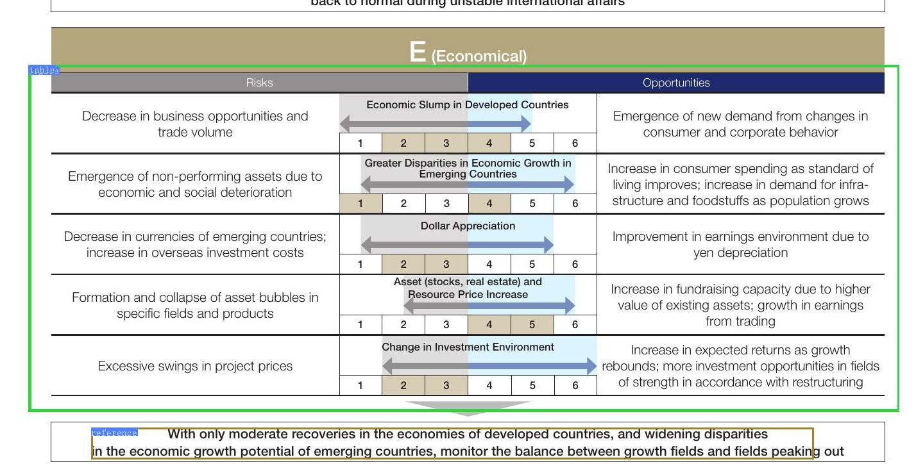

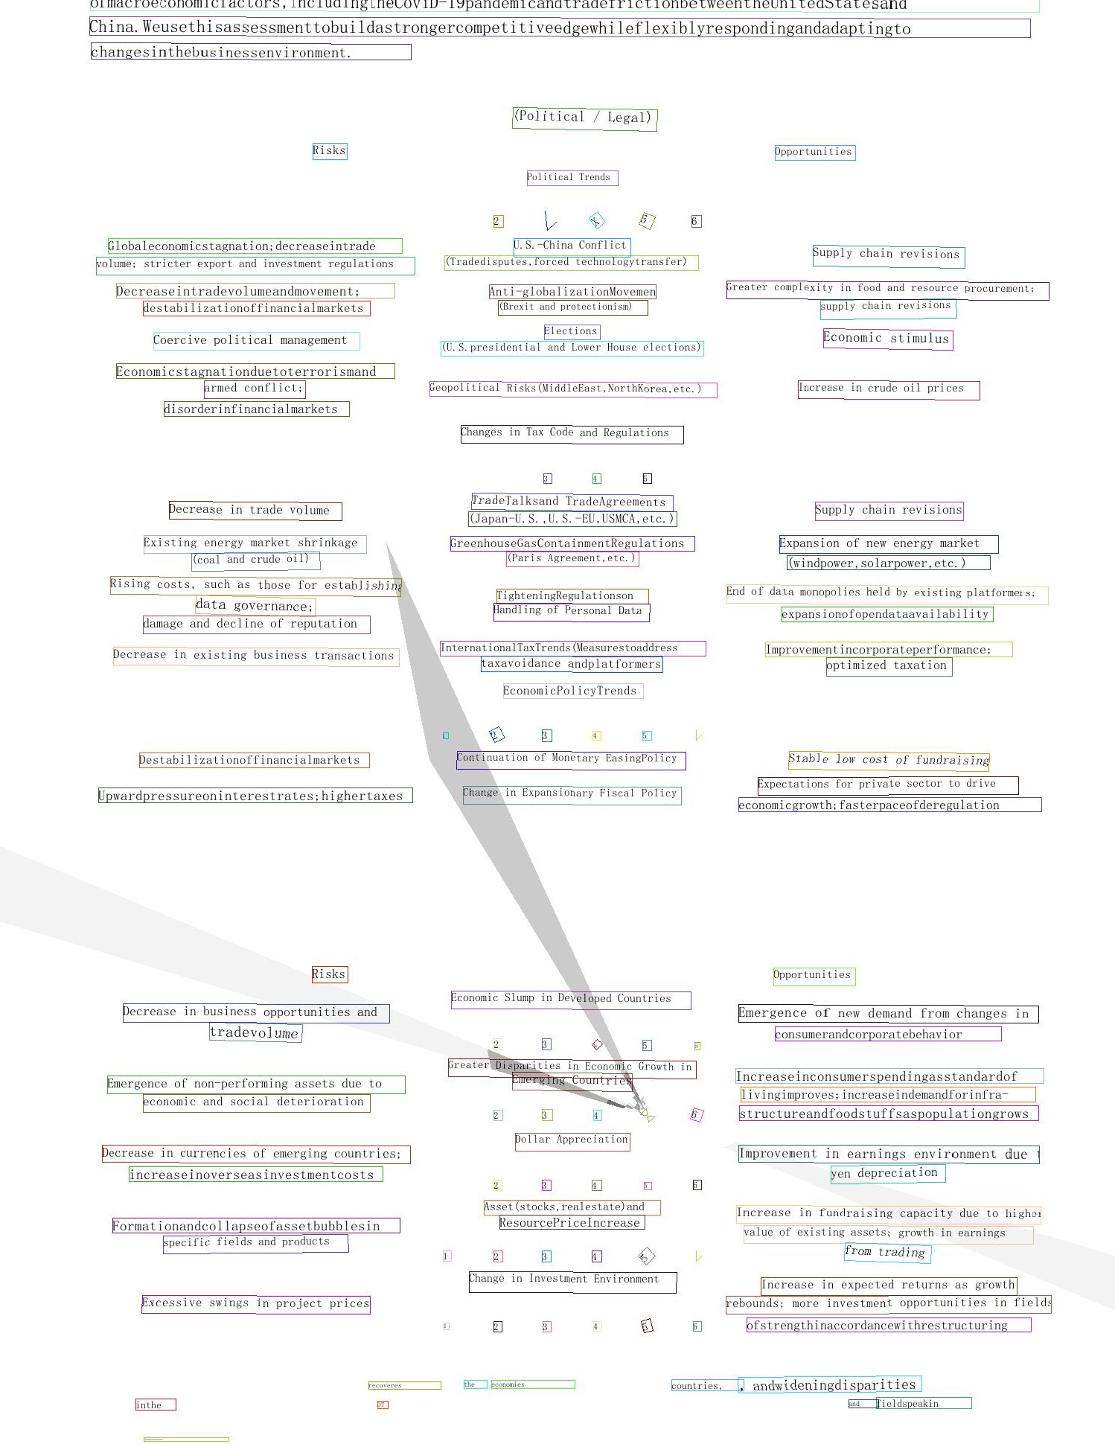

[71

BANIAL REPORT20