“Sampo-yoshi,” Our Values for Creating the Future

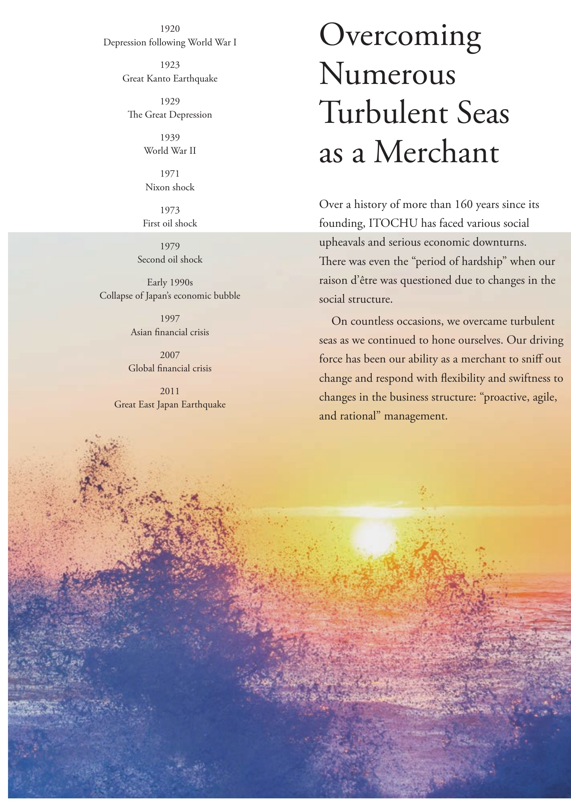

# Overcoming

Over a history of more than 160 years since its founding, ITOCHU has faced various social upheavals and serious economic downturns. There was even the “period of hardship” when our raison d'etre was questioned due to changes in the social structure. On countless occasions, we overcame turbulent seas as we continued to hone ourselves. Our driving force has been our ability as a merchant to sniff out change and respond with Hexibility and swiftness td changes in the business structure: “proactive, agile, and rational" management.