Force for Sustainable Value Cre

SustainableValueCreationthroughCapitalAccumulation

The IToCHU Group conducts its business through both trade and business investment. In the course of its history over 160 years, we have steadily accumulated internal capital such as human capital and business know-how. Meanwhile, we believe that trust and creditworthiness are extremely important for achieving enhancement of interaction between internal and external capital. By always remaining cautious of trust and creditworthiness in our management practice, we aim to realize increases in economic and social value, and to continuously expand ourcorporatevalue.

The IToCHU Group conducts its business through both trade and business investment. In the course of its history over 160 years, we have steadily accumulated internal capital such as human capital and business know-how. Meanwhile, we believe that trust and creditworthiness are extremely important for achieving enhancement o interaction between internal and external capital. By always remaining cautious of trust and creditworthiness i our management practice, we aim to realize increases in economic and social value, and to continuously expal ourcorporatevalue.

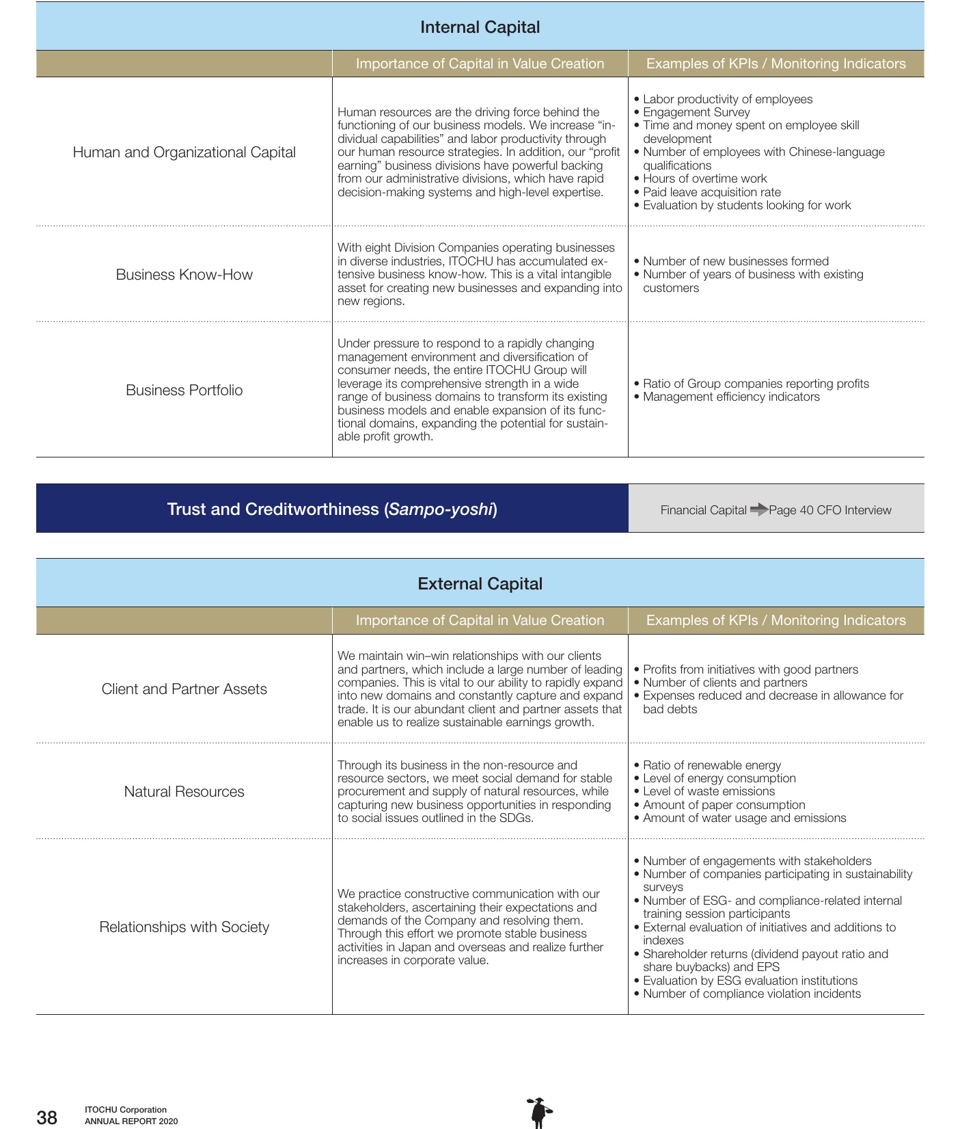

|  |  |  |
| --- | --- | --- |
| Internal Capital | | |
|  | Importance of Capital in Value Creation | Examples of KPls / Monitoring Indicators |
| Human and Organizational Capital | Human resources are the driving force behind the. functioning of our business models. We increase “in- dividual capabities" and labor productivitythrough our human resource strategies.In addition,ourprofit earningbusinessdivisions have powerful backing fromouradministrative divisions,whichhaverapid decision-making systems and high-level expertise. | · Labor productivity of employees ·Engagement Survey ·Time and money spent on employee skill development ·Number of employees with Chinese-language qualifications ·Hours of overtime work Paid leave acquisitionrate · Evaluation by students looking for work |
| Business Know-How | With eight Division Companies operating businesses in diverse industries, ITOCHU has accumulated ex- tensive business know-how. This is a vital intangible asset for creating newbusinesses and expanding into new regions. | · Number of new businesses formed Numberof years of business withexisting customers |
| Business Portfolio | Under pressure to respond to a rapidly changing management environment and diversification of consumereedstheentreTOCHUGrouwill leverage its comprehensive strength in a wide range of business domains to transform its existing business models and enable expansion of its func- tional domains, expanding the potential for sustain- able profit growth. | · Ratio of Group companies reporting profits ·Management fficiency indicators Financial Capital =>Page 40 CFO Interview |
| Trust and Creditworthiness (Sampo-yoshi) | | |
| External Capital | | |
| Importance of Capital in Value Creation | | |
| Client and Partner Assets | We maintain win-win relationships with our clients and partners,whichinclude a large number of leading companies.This is vital to our ability to rapidly expand | Examples of KPls / Monitoring Indicators · Profitsfrom initiatives with good partners ·Number of clients and partners |
| Natural Resources | into new domains and constantly capture and expand trade. It is our abundant client and partner assets that enable us to realize sustainable earnings growth. Through its business in the non-resource and resource sectors,we meet social demand for stable procurementandsupplofaturaresourceshile | ·Expenses reduced and decrease in allowance for bad debts · Ratio of renewable energy. ·Level of energy consumption ·Level of waste emissions · Amount of paper consumption · Amount of water usage and emissions |
| capturing new business opportunities in responding to social issues outlined in the SDGs. | | |
| Relationships with Society 38 ITOCHU Corporation ANNUAL REPORT 2020 | We practice constructive communication with our stakeholders, ascertaining their expectations and demands of the Company and resoling them. Through this effort we promote stable business activities in Japan and overseas and realize further increases in corporate value. | Number of engagements with stakeholders ·Number of companies participating in sustainability surveys · Number of ESG- and compliance-related internal training session participants · External evaluation of initiatives and additions to indexes · Shareholder returns (dividend payout ratio and share buybacks) and EPS ·Evaluation by ESG evaluation institutions · Number of compliance violation incidents |

38

i

T