ForceforSustainableValueCre

# ThePositiveCycleof DialogueandEnhancingCorporate

PositiveCycleofDialogueandEnhancingCorporateValue

ITOCHU emphasizes dialogue with its shareholders, investors,and other stakeholdersfrom the perspective achieving sustainable growth and enhancing corporate value over the medium to long term. After announcing "Brand-new Deal 2020,” which failed to give due consideration to market expectations, the Company's share price plunged. Learning from this experience, we now strive to reflect input obtained in investor meetings, general meetings of shareholders, and one-on-one meetings into our management strategies and financial and capital policies. Through commitment-based management, we are striving to expand corporate value and sustain a positivecycle througheffective engagement.

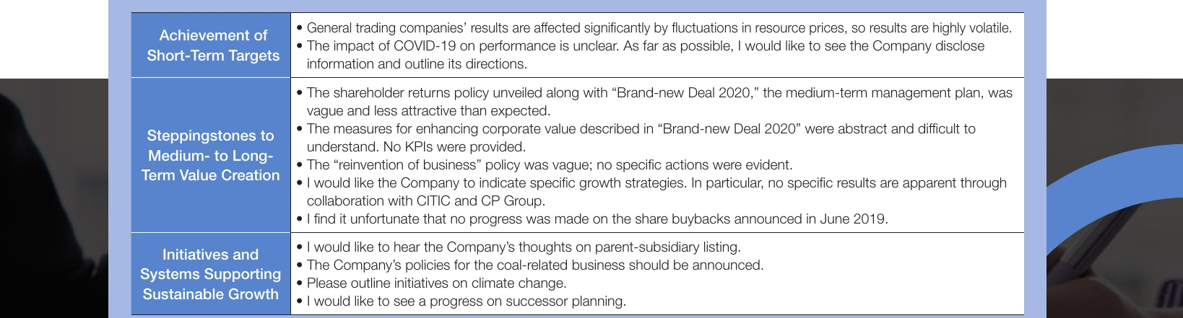

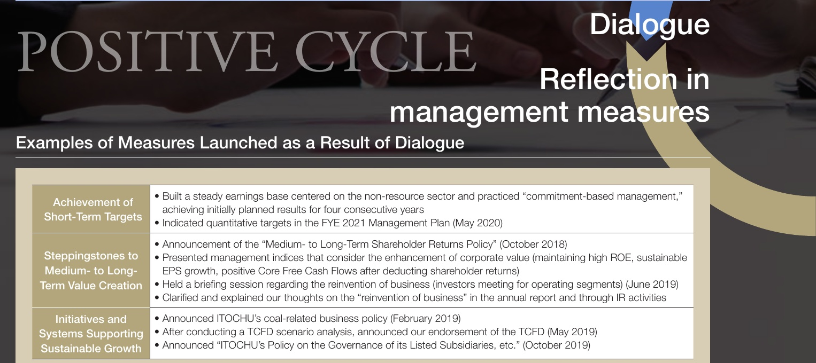

· Buit a steady earnings base centered on the non-resource sector and practiced “commitment-based management," Achievement of hort-Term Targets achieving initially planned results for four consecutive years · Indicated quantitative targets in the FYE 2021 Management Plan (May 2020) · Announcement of the “Medium- to Long-Term Shareholder Returns Policy" (October 2018) teppingstonesto · Presented management indices that consider the enhancement of corporate value (maintaining high ROE, sustainable Medium- to Long- EPS growth, positive Core Free Cash Flows after deducting shareholder returns) rm ValueCreation · Held a briefing session regarding the reinvention of business (investors meeting for operating segments) (June 2019) · Clarified and explained our thoughts on the “reinvention of business" in the annual report and through IR activities Initiatives and · Announced ITOCHU's coal-related business policy (February 2019) stems Supporting · After conducting a TCFD scenario analysis, announced our endorsement of the TCFD (May 2019) ustainable Growth · Announced “ITOCHU's Policy on the Governance of its Listed Subsidiaries, etc." (October 2019)

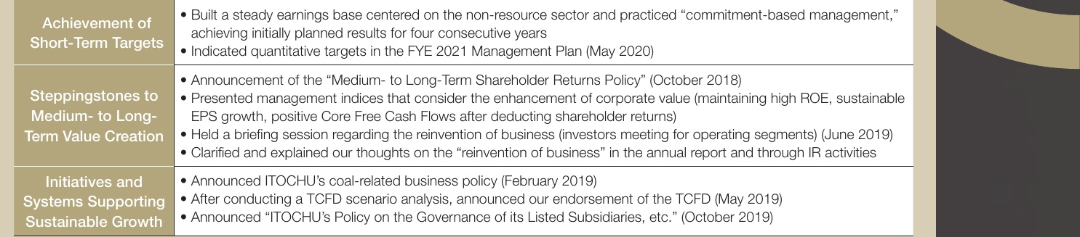

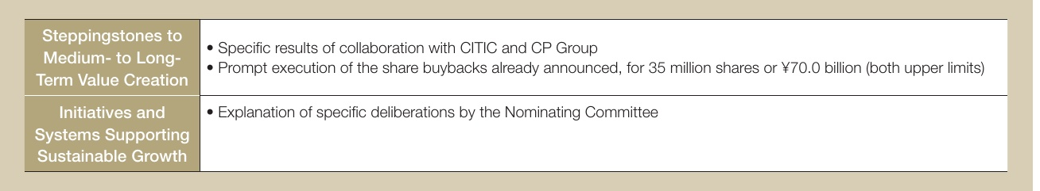

Specific results of collaboration with CITIC and CP Group Prompt execution of the share buybacks already announced, for 35 million shares or 70.0 bilion (both upper limits Explanation of specific deliberations by the Nominating Committee

· Specific results of collaboration with CITIC and CP Group Prompt execution of the share buybacks already announced, for 35 milion shares or ￥70.0 billion (both upper limits) Explanation of specific deliberations by the Nominating Committee

48