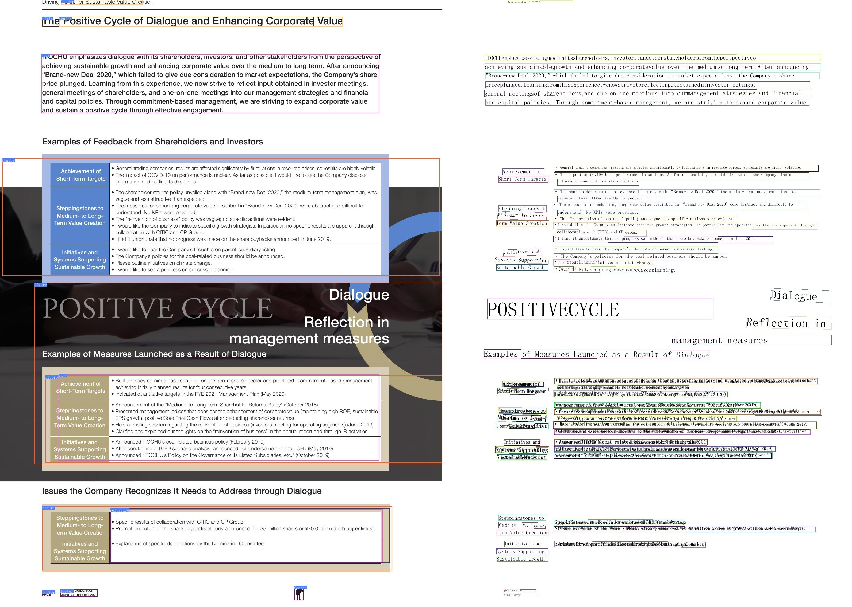

mePositive Cycle of Dialogue and Enhancing Corporate Value

OCHuemphasizesdialoguewithitsshareholders,investors,andotherstakeholdersfromtheperspective achieving sustainable growth and enhancing corporatevalue overthemedium to long term.After announcing “Brand-newDeal 2020, which failed to give due consideration to market expectations,the Company's share orice plungedLearning from this experience,wenow strive to reflct input obtained in investormeetings, general meetings of shareholders, and one-on-one meetings into ourmanagement strategies and financial and capital policies. Through commitment-based management, we are striving to expand corporate value and sustain a positive cvcle throuah efective enqaaement.