Achievement of Short-Term Targ

FYE 2021ManagementPlan

# Concept of FYE 2021 Management Plan

The business environment is undergoing tumultuous changes. We are poised to move into a new management phase in which y be prepared for economic downturn and global recession. Accomplished and completed the measures set out in our medium-term management plan, “Brand-new Deal 2020," ahead of s duringFYE2019 andFYE2020. Setting FYE 2021 as a year for consolidating our foothold, we formulated a single-year management plan. ?

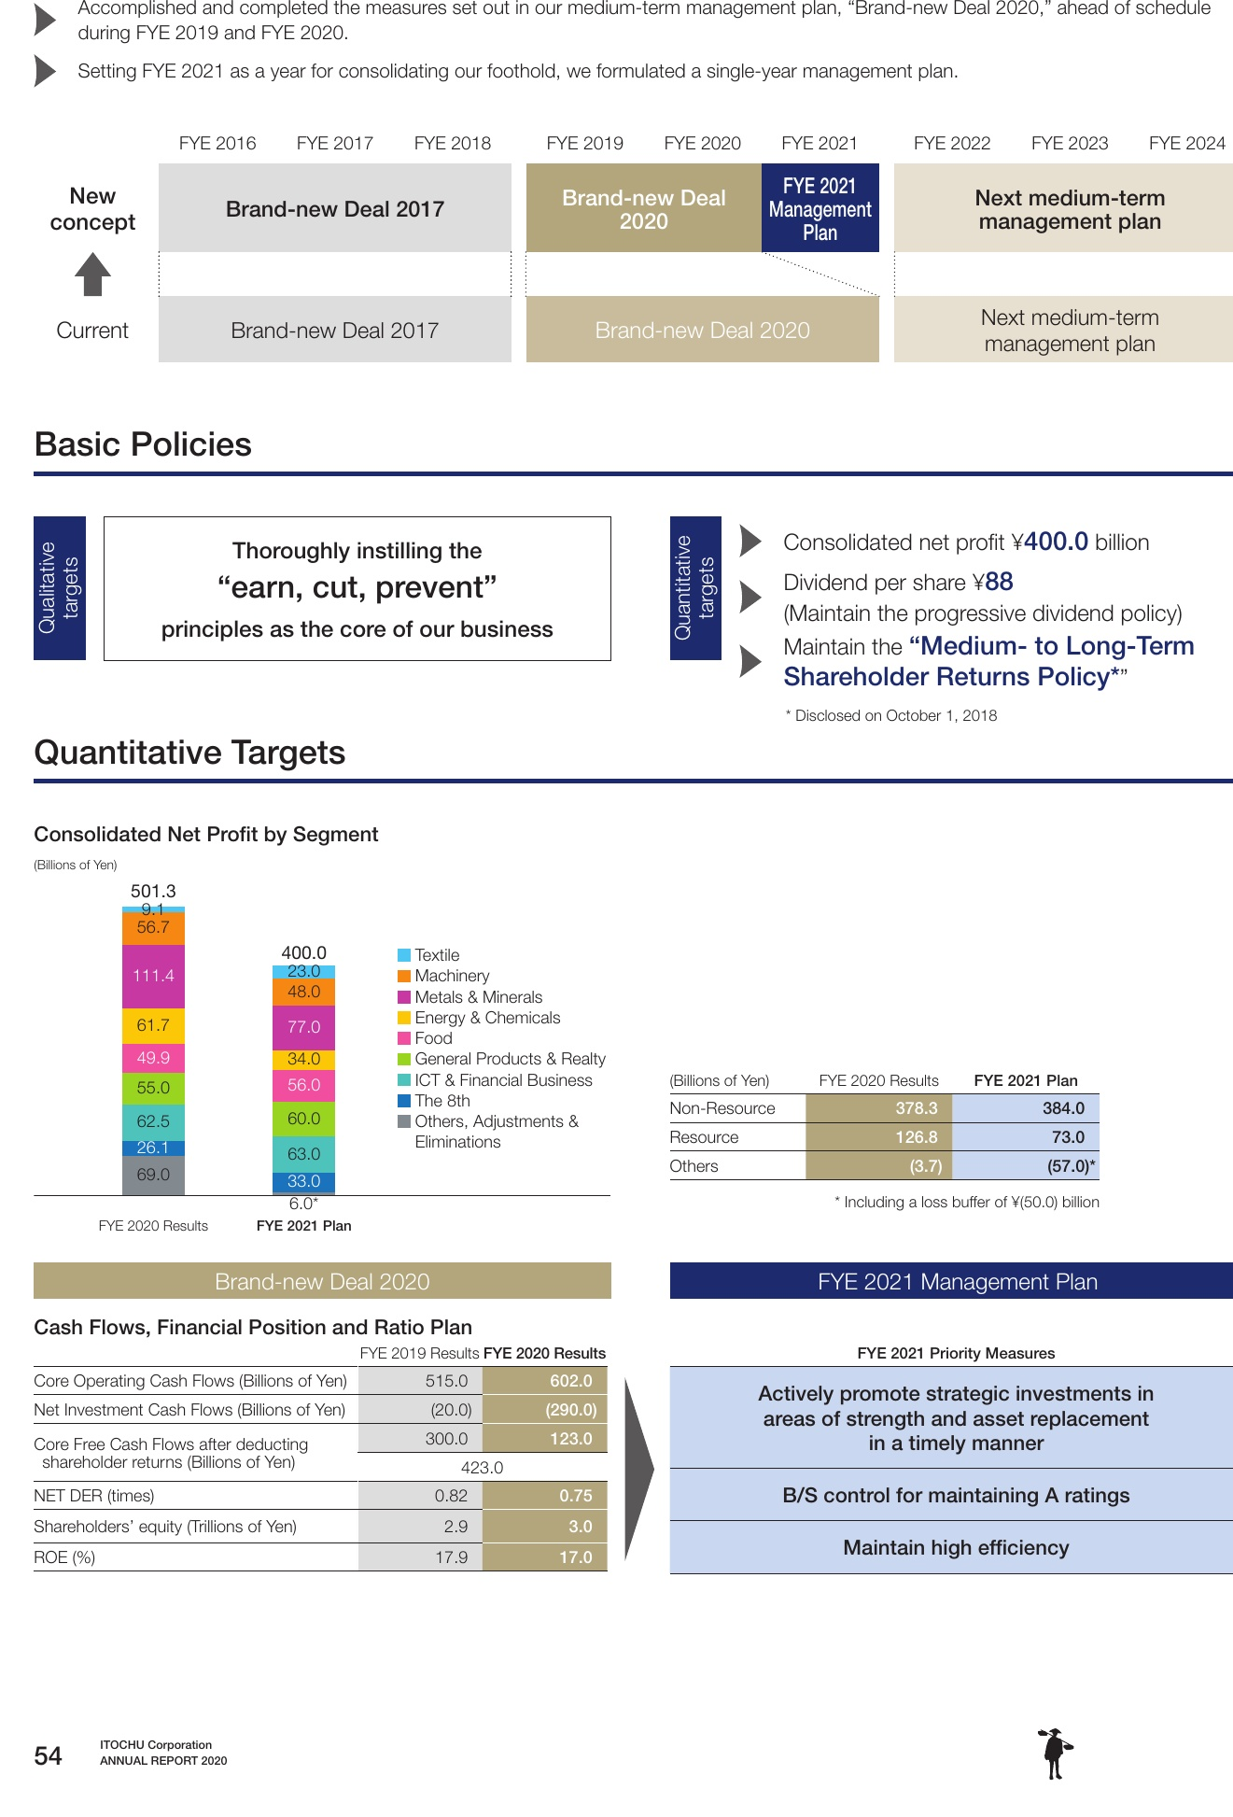

BasicPolicies

# QuantitativeTargets

54

?