UOVID-19's Impact on the Company and Status of Initiatives

# LOVID-19's Impact on the Company and Status of Initiatives

ofinitiatives

Ourinitialplanofconsolidatedbusinessperformancefo digitalizationinclientindustries,andhavesteadily FYE 2021 called for consolidated net profitof ￥400.0 promoted initatives toevolve and transform ourexisting oillion. This incorporates a direct downward impact from businessmodels.It is said that COvID-19would rapidly COVID-19 of roughly 10%, excluding such impacts as accelerate changes in purchasing methods and prefer alling resource prices. In addition,we set a higher-than ences, as well as the digital shift.That said, the basic usualoss buffe of 50.0 bilion, an increase of 20.0 businessflow-procuring and delivering what customer oillion from previous years. Our plan thus gave ample Want-remains unchanged. Going forward, we will consideration to preparedness for uncertainty in the continue to take the social needs of individual countries ousiness environment. and regions into account as we pursue our business Even before the worldwide spread of COVID-19, we from a customer viewpoint through a market-oriented have been responding to rapid structural changes and oerspective.

our initial plan of consolidated business performance fo FYE 2021 called for consolidated net profit of 400.0 oillion. This incorporates a direct downward impact from COVID-19 of roughly 10%, excluding such impacts as alling resource prices. In addition,we set a higher-thar usuallossbuffe o 50.0bilion, anincrease of 20. oillion from previous years. Our plan thus gave ample onsideration to preparedness for uncertainty in the ousiness environment. Even before the worldwide spread of COVID-19, we havebeenresponding torapid structural changes and

uigitalization in client industries, and have steadily promoted initatives toevolve and transform ourexisting business models. It is said that COvID-19would rapidll accelerate changes in purchasing methods and prefer ences, aswellas the dgital shifthat said, theac business flow—procuring and delivering what customer want-remains unchanged. Going forward, we will continue to take the social needs of individual countres and regions into account as we pursue our business from a customer viewpoint through a market-oriented spective

Lven if some business activities are suspended due ampo-yoshi," which is the philosophy we have upheld to COVID-19, rather than responding with emergency since the time of our founding. While ensuring that we actions, webelieve companis shouldmaintain responsile maintain and improve profitability,we will continue working ESG management from a medium-to long-term hard toresolve social issues by,for instance, providinga perspective. wide range of products and services and creating new In addition to environment-related measures to date, businesses. To this end, we recognize the importance of such as addressing climate change and marine plastic remaining sensitive to changing social values and continu pllution, the spread of COVID-19 provides an important ously undertaking proactive and consistent initiatives that opportunity to renew society-related initiatives, including contribute to ESG. the supply chain and human rights. In April 2020, we clared a new Group corporate mission of

|  |  |  |  |  |
| --- | --- | --- | --- | --- |
| utheIIOCHU Group'sstrength liesIn theconsumer sector,itsbusinessessupport thesocial infrastructurethat forms the foundation of everyday lives in many ways. Accordingly,we areundertaking a host of initiativesto byCOVID-19. | Fsurvices thathelpleverage corporatedata.Amid therapid shift to working from home, this company energetically COVID-19. | societyatlarqe. |  | deployed aweb-based invoicedistribution serviceboth |
| sustaincorporate activities even in an environment affected | within and outside the ITOCHU Group.This move addressed the issueof preparation and shipping of invoice |  |
| Forexample,ursubsidiary,HOKENNOMADOGUCHI GROUP INC., which is one of Japan's largest insurance agencies with walk-in stores,has promptly established anationwidesystemtoprovide insuranceconsultations online,leveraging theITOCHU Groupresources,inorder torespond tocustomerconcerns aboutconducting insur- anceconsultationsface-to-face.This systemwenton line inJuly2020.Another examplecanbefoundat an affliatecd company,WingArc1st Inc.,whichprovidessoftwareand | Throughtheseimprovementsonthefrontlinesof characteristics in business contributing to customers and |  |
| whichhadpresented abarriertoworking fromhome. Through this service,WingArc1st Inc.helps toprevent |
| infection risk atcompaniesadopting thesystem and aided the shift in workstyles in an environment affected by |
|  |  |
| businessandthesteadilyaccumulatedeffectofsmallinitia tives,theITOCHUGroupdemonstratesitshighlydistinctive |  |
|  |  |
|  |  |  |  |
|  |  |  |  |

theIIOCHUGroup'sstrength llesintheconsur survices that help leverage corporate data.Amid the sector, its usinesses support thesocialinfrastructure that shiftoworking from home, this company energetically forms the foundation of everyday lives in many ways. deployed a web-based invoice distribution service both Acordinglweareudtaingast finitatit within and outside the ITOCHU Group. This move addresedtheissueof preparation andshipping of invoice sustain corporate activities even in an environment affected oyCOVID-19. which had presented a barier to working from home. For example, our subsidiary, HOKEN NO MADOGUCHI Through this service, WingArc1st Inc. helps to prevent GROUP INC., which is one of Japan's largest insurance linfectionrisk at companies adopting the system and aided agencieswithwalk-instorehasprmptlyetablid the shit inworkstyles in an environment affected by a nationwide systemto provide insurance consultations COVID-19. online, leveraging the ITOCHU Group resources, in order Through these improvements on the front lines of 0 respond to customer concerns about conducting insur business and the steadily accumulated effect of small initia ance consultations face-to-face. This system went on line tives, theITOCHGroup demonstratesits highly distinctive in July2020. Another example can be found at an afliatecl characteristics in business contributing to customers and societyat large

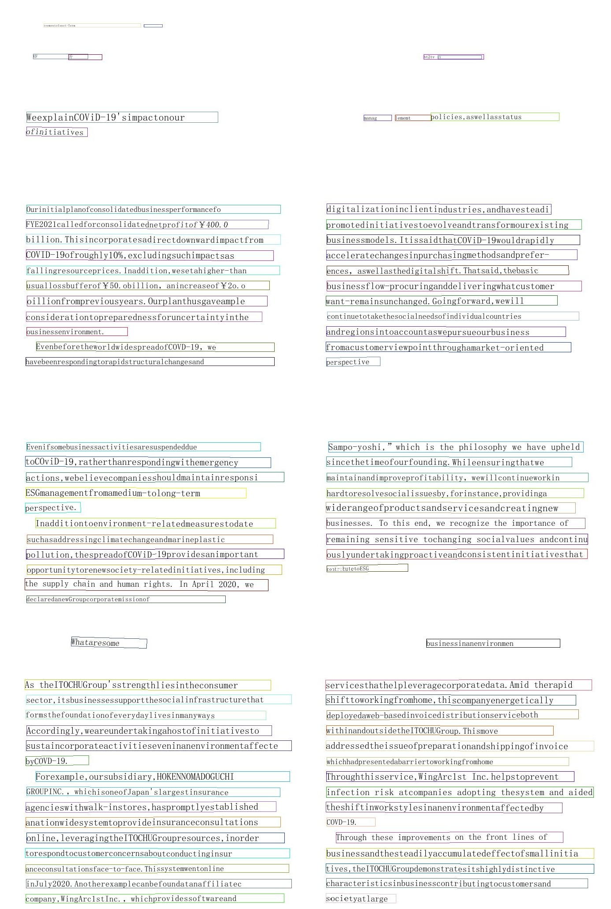

i

COtOANAL REPORT20