# Placeholder ’cause old one was too cringey

Tran Quoc Hoang

School of Biotechnology, International University - Vietnam National University HCM City

Correspondence concerning this article should be addressed to Tran Quoc Hoang, School of Biotechnology, International University - Vietnam National University HCM City, Quarter 33, Linh Xuan Ward, Ho Chi Minh City 71309, Vietnam, Email: [BTBTWE24036@student.hcmiu.edu.vn](mailto:BTBTWE24036@student.hcmiu.edu.vn)

# Abstract

*Keywords*: microplastics, immunity, neuroinflammation

# Placeholder ’cause old one was too cringey

# Introduction

This is the start of the document content…

# MP Transport and Crossing the Blood-Brain Barrier (BBB)

This is illustrated well by Figure Figure 1

## Routes of Entry

# Microglial Activation and Neuroinflammation

# Consequences and Future Directions

Figure 1

Environmental sources and human exposure of MNPs.

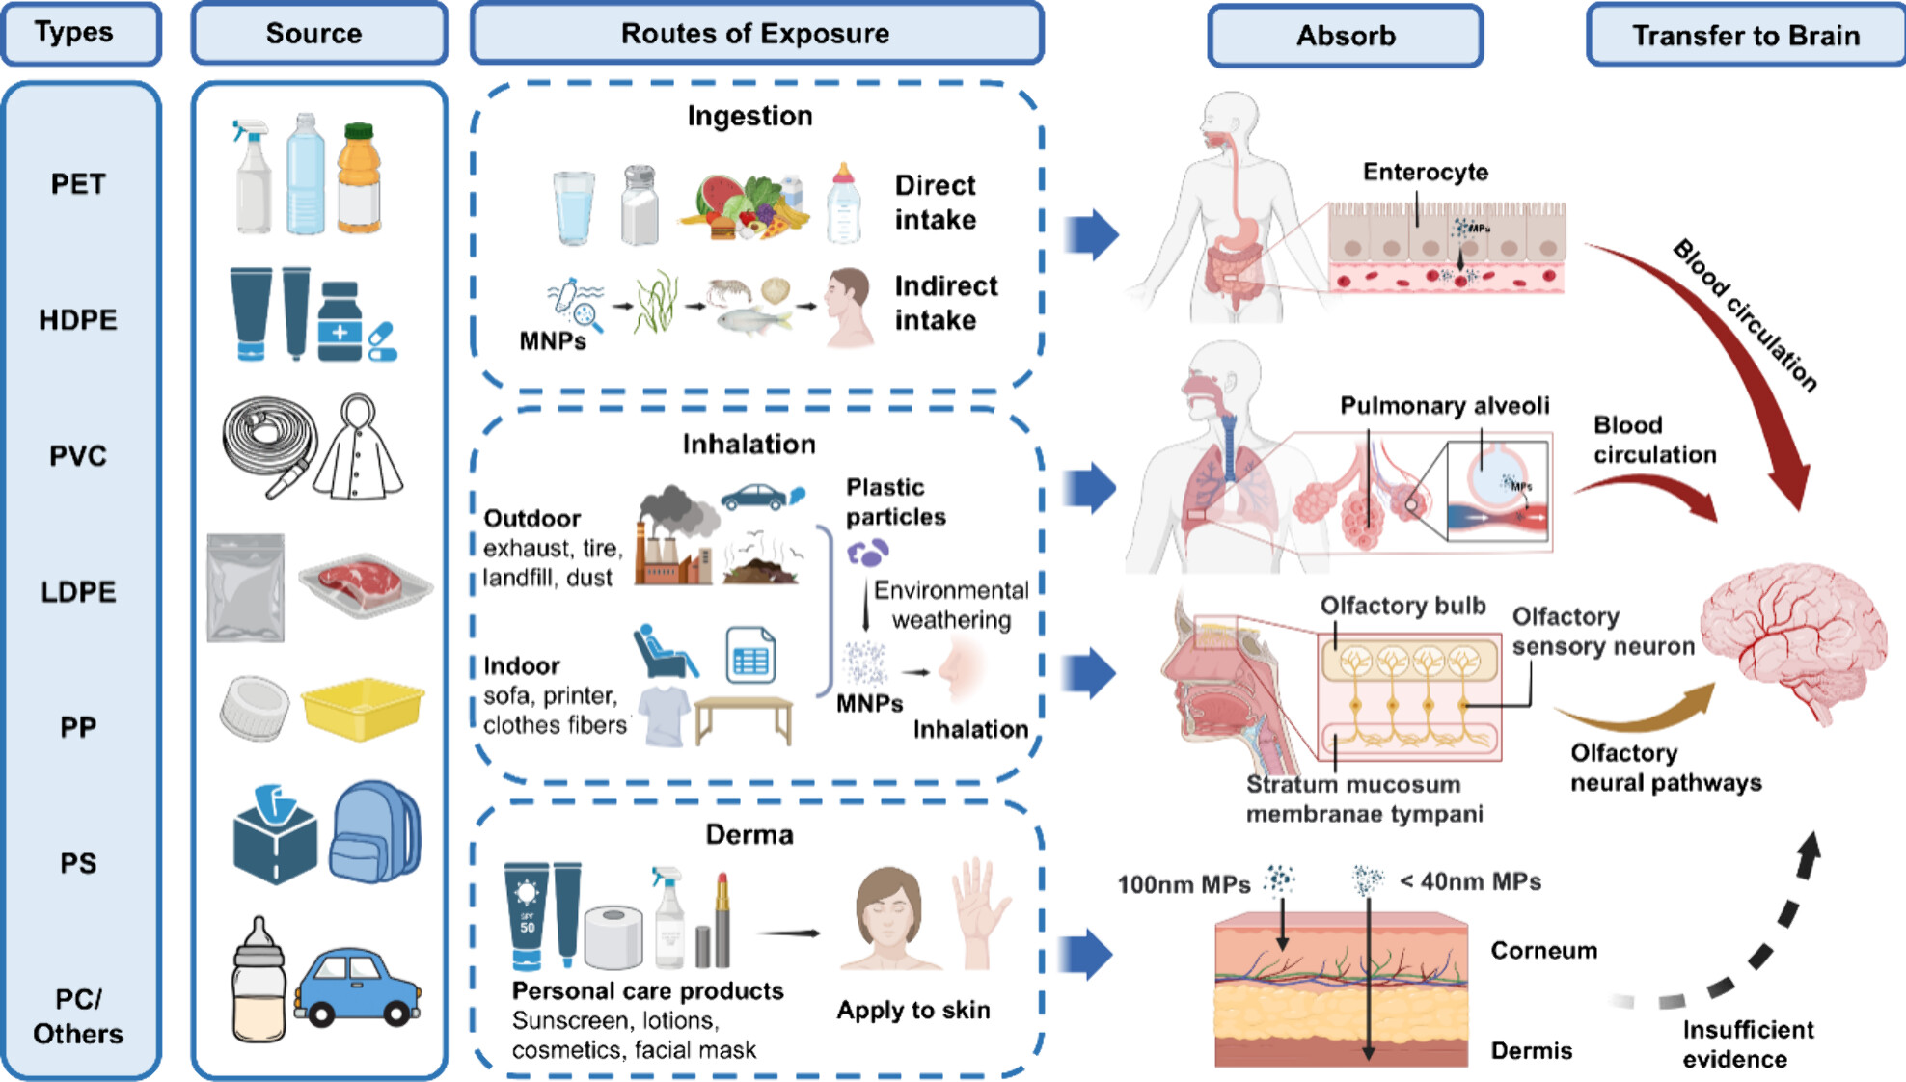

*Note*. Reprinted from Ma, Q., Lei, J., Pang, Y., Shen, Y., & Zhang, T. (2025). Neurotoxicity of Micro- and Nanoplastics: A Comprehensive Review of Central Nervous System Impacts. Environment & Health. https://doi.org/10.1021/envhealth.5c00087.