Walk through the array comparing adjacent pairs (a[j], a[j+1]). If they're out of order, swap them. After one full pass, the largest remaining element has "bubbled" to the end. Repeat on the shrinking prefix.
CODE
public class BubbleSort {
static long comparisons, swaps, arrayWrites;

public static void sort(int[] a) {
comparisons = swaps = arrayWrites = 0;
int n = a.length;
boolean swapped = true;

for (int i = 0; i < n - 1 && swapped; i++) {
swapped = false;
for (int j = 0; j < n - 1 - i; j++) {
comparisons++;
if (a[j] > a[j + 1]) { // strictly > keeps it STABLE
int tmp = a[j]; // 1 read
a[j] = a[j + 1]; // 1 read + 1 write
a[j + 1] = tmp; // 1 write
swaps++;
arrayWrites += 2; // 2 array writes per swap
swapped = true;
}
}
if (!swapped) break; // already sorted → O(n) best case
}
}
}
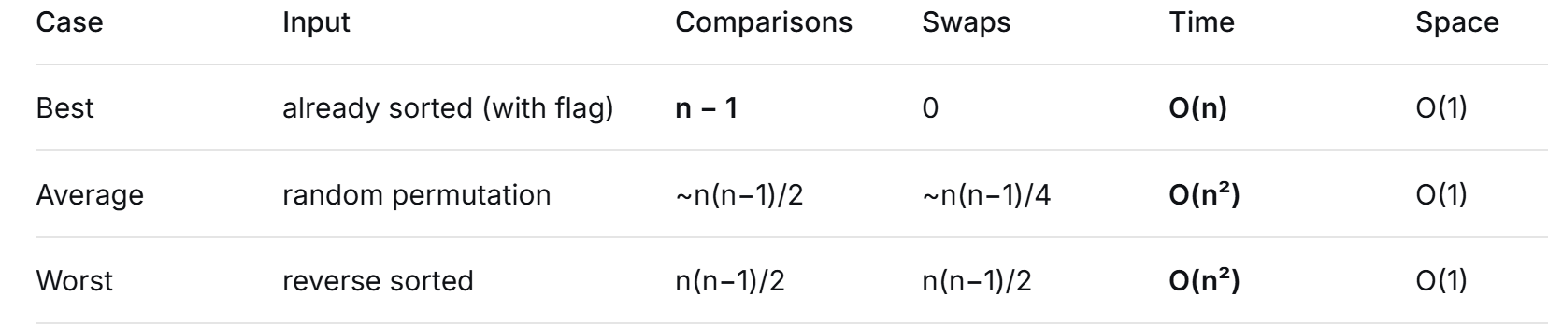
Bubble sort uses swaps, never shifts. Every time two elements are out of order, both positions are rewritten (2 array writes). Total writes, worst case: 2 × n(n−1)/2 = n² − n ≈ n² writes.
Contrast with insertion sort, which shifts: it saves the key in a register, slides the larger elements right one at a time (1 write each), then drops the key in its hole (1 write). Worst case ≈ n(n−1)/2 + n ≈ 0.5 n² writes — roughly half of bubble sort's, and with far better cache behavior on the forward-shifting loop.
Think of the array as two regions: a sorted prefix a[0..i-1] and the unsorted remainder. For each i from 1 to n−1, take a[i] as the key, slide every larger element in the prefix one slot to the right, and drop the key into the hole. The prefix grows by one each step and is always sorted.
The crucial structural difference from bubble sort: bubble sort swaps an out-of-place pair (2 array writes); insertion sort shifts (1 array write) and keeps the key in a register the whole time. That's the whole performance story.

CODE
public class InsertionSort {
static long comparisons, shifts, writes;
public static void sort(int[] a) {
comparisons = shifts = writes = 0;
int n = a.length;
for (int i = 1; i < n; i++) {
int key = a[i]; // 1 read into a register
int j = i - 1;
while (j >= 0) {
comparisons++;
if (a[j] <= key) break; // '<=' keeps it STABLE
a[j + 1] = a[j]; // shift right: 1 write, no temp
shifts++;
writes++;
j--;
}
a[j + 1] = key; // 1 write (the "insertion")
writes++;
}
}
}

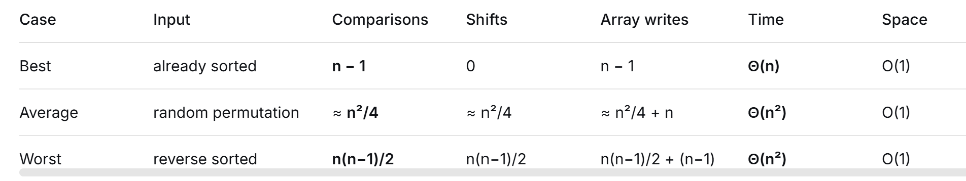
Summary: insertion sort is roughly 2× cheaper in comparisons and 2× cheaper in writes than bubble sort on average, is naturally adaptive, and is online. There is no input on which bubble sort beats it.
Repeatedly select the smallest remaining element and put it in its final place. For each i from 0 to n−2, scan a[i..n−1] for the minimum, then swap it into position i. After the swap, a[i] is permanently correct — no future pass touches it.
This gives selection sort its defining property: it does the fewest moves of any simple sort, at the cost of the most comparisons, and its comparison count is completely independent of the input.
CODE
public class SelectionSort {
static long comparisons, swaps, writes;
public static void sort(int[] a) {
comparisons = swaps = writes = 0;
int n = a.length;
for (int i = 0; i < n - 1; i++) {
int min = i;
for (int j = i + 1; j < n; j++) {
comparisons++;
if (a[j] < a[min]) min = j; // strict '<' → keeps FIRST minimum
}
if (min != i) { // guard: skip the pointless self-swap
int t = a[i];
a[i] = a[min];
a[min] = t;
swaps++;
writes += 2; // 2 array writes per swap, no shifting
}
}
}
}
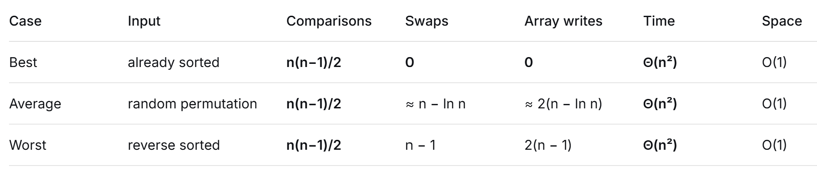
IMPLEMENT STACK USING ARRAYS
public class ArrayStack {
private int[] data;
private int top;
private static final int DEFAULT_CAP = 10;

public ArrayStack() {
data = new int[DEFAULT_CAP];
top = -1;
}

public ArrayStack(int cap) {
if (cap <= 0) throw new IllegalArgumentException("cap must be > 0");
data = new int[cap];
top = -1;
}

public boolean isEmpty() { return top == -1; }
public int size() { return top + 1; }

public boolean isFull() { return top == data.length - 1; }

public void push(int v) {
if (isFull()) throw new IllegalStateException("Stack overflow");
data[++top] = v; // tăng top trước, rồi gán
}

public int pop() {
if (isEmpty()) throw new IllegalStateException("Stack underflow");
return data[top--]; // đọc data[top], rồi giảm top
}

public int peek() {
if (isEmpty()) throw new IllegalStateException("Stack is empty");
return data[top];
}
}
IMPLEMENT STACK USING LINKLIST

public class LinkedStack {
private static class Node {
int value;
Node next;
Node(int v) { value = v; }
}

private Node head; // đỉnh stack
private int size;

public LinkedStack() {
head = null;
size = 0;
}

public boolean isEmpty() { return head == null; }
public int size() { return size; }

public void push(int v) {
Node n = new Node(v);
n.next = head;
head = n;
size++;
}

public int pop() {
if (head == null) throw new IllegalStateException("underflow");
int v = head.value;
head = head.next;
size--;
return v;
}

public int peek() {
if (head == null) throw new IllegalStateException("empty");
return head.value;
}
}

public class DynamicArrayQueue {
private int[] data;
private int front, rear, size;

public DynamicArrayQueue() {
data = new int[8];
front = rear = size = 0;
}

public boolean isEmpty() { return size == 0; }
public int size() { return size; }

private void ensureCapacity() {
if (size == data.length) {
int newCap = data.length * 2;
int[] bigger = new int[newCap];
for (int i = 0; i < size; i++) {
bigger[i] = data[(front + i) % data.length];
}
data = bigger;
front = 0;
rear = size; // size phần tử ở [0..size-1], rear là ô trống kế
}
}

public void enqueue(int v) {
ensureCapacity();
data[rear] = v;
rear = (rear + 1) % data.length;
size++;
}

public int dequeue() {
if (isEmpty()) throw new IllegalStateException("empty");
int v = data[front];
front = (front + 1) % data.length;
size--;
return v;
}

public int peek() {
if (isEmpty()) throw new IllegalStateException("empty");
return data[front];
}
}
—---------------
public class LinkedQueue {
private static class Node {
int value;
Node next;
Node(int v) { value = v; }
}
private Node head, tail;
private int size;

public LinkedQueue() {
head = tail = null;
size = 0;
}

public boolean isEmpty() { return head == null; }
public int size() { return size; }

public void enqueue(int v) {
Node n = new Node(v);
if (tail == null) {
// hàng rỗng: nút mới vừa là đầu vừa là cuối
head = tail = n;
} else {
tail.next = n;
tail = n;
}
size++;
}

public int dequeue() {
if (head == null) throw new IllegalStateException("empty");
int v = head.value;
head = head.next;
if (head == null) {
// vừa lấy nút cuối cùng: hàng trở về rỗng
tail = null;
}
size--;
return v;
}

public int peek() {
if (head == null) throw new IllegalStateException("empty");
return head.value;
}
}

Initialization
static class Node {
int value;
Node prev, next;
Node(int v) { value = v; }
}

static class DoublyList {
Node head, tail;
int size;
}
Add First
void addFirst(int v) {
Node n = new Node(v);
n.next = head;
if (head != null) head.prev = n;
else tail = n;
head = n;
size++;
}
Add Last
void addLast(int v) {
Node n = new Node(v);
n.prev = tail;
if (tail != null) tail.next = n;
else head = n;
tail = n;
size++;
}
RemoveFirst
boolean removeFirst() {
if (head == null) return false;
head = head.next;
if (head != null) head.prev = null;
else tail = null;
size--;
return true;
}

RemoveLast
boolean removeLast() {
if (tail == null) return false;
tail = tail.prev;
if (tail != null) tail.next = null;
else head = null;
size--;
return true;
}
RemoveTarget
boolean remove(int v) {
Node cur = head;
while (cur != null && cur.value != v) cur = cur.next;
if (cur == null) return false;

if (cur.prev != null) cur.prev.next = cur.next;
else head = cur.next; // cur là head

if (cur.next != null) cur.next.prev = cur.prev;
else tail = cur.prev; // cur là tail

size--;
return true;
}
Display
void printForward() {
Node p = head;
while (p != null) {
System.out.print(p.value + " ");
p = p.next;
}
System.out.println();
}
void printBackward() {
Node p = tail;
while (p != null) {
System.out.print(p.value + " ");
p = p.prev;
}
System.out.println();

