Kaplan Meier Plots

2024-03-14

# Loading R packages

setwd("C:/Users/swj88/Documents/Github/maicplus")  
devtools::load_all()  
#> ℹ Loading maicplus  
#library(maicplus)

Additional suggested packages for this vignette:

library(survminer) # this is used for ggplot version of KM plots

# Introduction

To plot Kaplan Meier curves, we need to first obtain pseudo comparator IPD by digitizing Kaplan-Meier curves from the comparator study. For more information on how to digitize Kaplan-Meier curves, refer to Guyot et al. and Liu et al. [1,2].

## Unanchored case

# Read in relevant ADaM data and rename variables of interest  
adsl <- read.csv(system.file("extdata", "adsl.csv",  
 package = "maicplus",  
 mustWork = TRUE  
))  
adtte <- read.csv(system.file("extdata", "adtte.csv",  
 package = "maicplus",  
 mustWork = TRUE  
))  
adtte$TIME <- adtte$AVAL  
adtte$EVENT <- adtte$EVNT  
  
### AgD  
# Baseline aggregate data for the comparator population  
target_pop <- read.csv(system.file("extdata", "aggregate_data_example_1.csv",  
 package = "maicplus", mustWork = TRUE  
))  
# for time-to-event endpoints, pseudo IPD from digitalized KM  
pseudo_ipd <- read.csv(system.file("extdata", "psuedo_IPD.csv",  
 package = "maicplus",  
 mustWork = TRUE  
))  
pseudo_ipd$ARM <- "B"  
  
#### prepare data  
target_pop <- process_agd(target_pop)  
adsl <- dummize_ipd(adsl, dummize_cols = c("SEX"), dummize_ref_level = c("Female"))  
use_adsl <- center_ipd(ipd = adsl, agd = target_pop)  
  
#### derive weights  
match_res <- estimate_weights(  
 data = use_adsl,  
 centered_colnames = grep("_CENTERED$", names(use_adsl)),  
 start_val = 0,  
 method = "BFGS"  
)  
#> initial value 500.000000   
#> iter 10 value 196.020742  
#> iter 20 value 173.488262  
#> final value 173.420820   
#> converged

Here is a Kaplan-Meier plot using base R graphics. Note that number at risk for weighted treatment arm is the sum of individual weights at risk.

kmplot(  
 weights_object = match_res,  
 tte_ipd = adtte,  
 trt_var_ipd = "ARM",  
 tte_pseudo_ipd = pseudo_ipd,  
 trt_var_agd = "ARM",  
 endpoint_name = "Overall Survival",  
 trt_ipd = "A",  
 trt_agd = "B",  
 trt_common = NULL,  
 km_conf_type = "log-log",  
 time_scale = "month",  
 time_grid = seq(0, 20, by = 2),  
 use_colors = NULL,  
 use_line_types = NULL,  
 use_pch_cex = 0.65,  
 use_pch_alpha = 100  
)

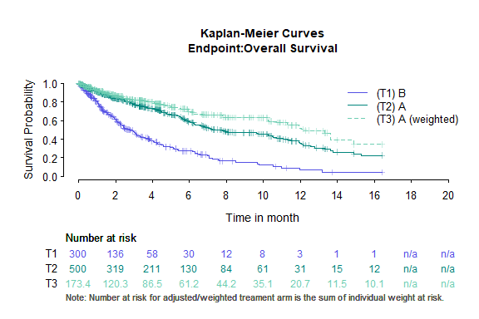

There is also a ggplot option for Kaplan-Meier curves using survminer R package.

kmplot2(  
 weights_object = match_res,  
 tte_ipd = adtte,  
 tte_pseudo_ipd = pseudo_ipd,  
 trt_ipd = "A",  
 trt_agd = "B",  
 trt_common = NULL,  
 trt_var_ipd = "ARM",  
 trt_var_agd = "ARM",  
 endpoint_name = "Overall Survival",  
 km_conf_type = "log-log",  
 time_scale = "month",  
 break_x_by = 2,  
 xlim = c(0, 20)  
)

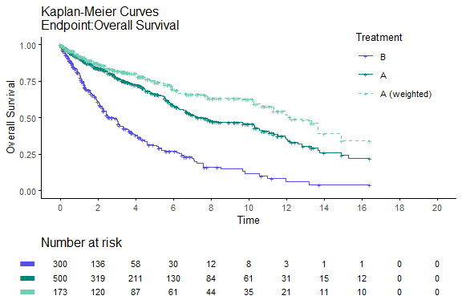

## Anchored case

# Read in relevant ADaM data and rename variables of interest  
adsl <- read.csv(system.file("extdata", "adsl.csv",  
 package = "maicplus",  
 mustWork = TRUE  
))  
adtte <- read.csv(system.file("extdata", "adtte.csv",  
 package = "maicplus",  
 mustWork = TRUE  
))  
adtte$TIME <- adtte$AVAL  
adtte$EVENT <- adtte$EVNT  
adtte2 <- adtte  
adtte2$ARM <- "C"  
adtte2$TIME <- adtte2$TIME + 7  
adtte <- rbind(adtte, adtte2)  
  
### AgD  
# Baseline aggregate data for the comparator population  
target_pop <- read.csv(system.file("extdata", "aggregate_data_example_1.csv",  
 package = "maicplus", mustWork = TRUE  
))  
# for time-to-event endpoints, pseudo IPD from digitalized KM  
pseudo_ipd <- read.csv(system.file("extdata", "psuedo_IPD.csv",  
 package = "maicplus",  
 mustWork = TRUE  
))  
pseudo_ipd$ARM <- "B"  
pseudo_ipd2 <- pseudo_ipd  
pseudo_ipd2$ARM <- "C"  
pseudo_ipd2$Time <- pseudo_ipd2$Time + 5  
pseudo_ipd <- rbind(pseudo_ipd, pseudo_ipd2)  
  
#### prepare data  
target_pop <- process_agd(target_pop)  
adsl <- dummize_ipd(adsl, dummize_cols = c("SEX"), dummize_ref_level = c("Female"))  
use_adsl <- center_ipd(ipd = adsl, agd = target_pop)  
  
#### derive weights  
match_res <- estimate_weights(  
 data = use_adsl,  
 centered_colnames = grep("_CENTERED$", names(use_adsl)),  
 start_val = 0,  
 method = "BFGS"  
)  
#> initial value 500.000000   
#> iter 10 value 196.020742  
#> iter 20 value 173.488262  
#> final value 173.420820   
#> converged  
  
# plot by trial  
kmplot(  
 weights_object = match_res,  
 tte_ipd = adtte,  
 trt_var_ipd = "ARM",  
 tte_pseudo_ipd = pseudo_ipd,  
 trt_var_agd = "ARM",  
 endpoint_name = "Overall Survival",  
 trt_ipd = "A",  
 trt_agd = "B",  
 trt_common = "C",  
 km_conf_type = "log-log",  
 km_layout = "by_trial",  
 time_scale = "month",  
 time_grid = seq(0, 20, by = 2),  
 use_colors = NULL,  
 use_line_types = NULL,  
 use_pch_cex = 0.65,  
 use_pch_alpha = 100  
)

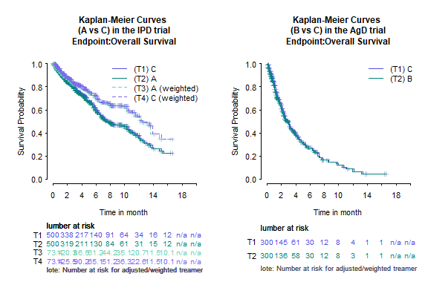

# plot by arm  
kmplot(  
 weights_object = match_res,  
 tte_ipd = adtte,  
 trt_var_ipd = "ARM",  
 tte_pseudo_ipd = pseudo_ipd,  
 trt_var_agd = "ARM",  
 endpoint_name = "Overall Survival",  
 trt_ipd = "A",  
 trt_agd = "B",  
 trt_common = "C",  
 km_conf_type = "log-log",  
 km_layout = "by_arm",  
 time_scale = "month",  
 time_grid = seq(0, 20, by = 2),  
 use_colors = NULL,  
 use_line_types = NULL,  
 use_pch_cex = 0.65,  
 use_pch_alpha = 100  
)

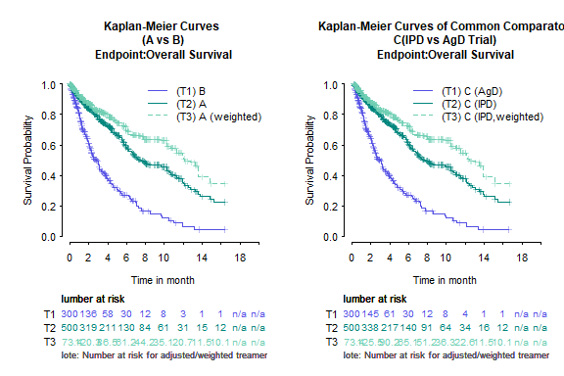

# plot all  
kmplot(  
 weights_object = match_res,  
 tte_ipd = adtte,  
 trt_var_ipd = "ARM",  
 tte_pseudo_ipd = pseudo_ipd,  
 trt_var_agd = "ARM",  
 endpoint_name = "Overall Survival",  
 trt_ipd = "A",  
 trt_agd = "B",  
 trt_common = "C",  
 km_conf_type = "log-log",  
 km_layout = "all",  
 time_scale = "month",  
 time_grid = seq(0, 20, by = 2),  
 use_colors = NULL,  
 use_line_types = NULL,  
 use_pch_cex = 0.65,  
 use_pch_alpha = 100  
)

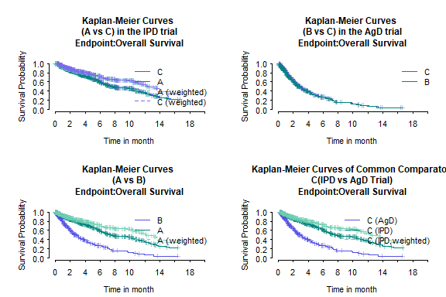

Again there is also a ggplot option

# plot by trial  
kmplot2(  
 weights_object = match_res,  
 tte_ipd = adtte,  
 tte_pseudo_ipd = pseudo_ipd,  
 trt_ipd = "A",  
 trt_agd = "B",  
 trt_common = "C",  
 trt_var_ipd = "ARM",  
 trt_var_agd = "ARM",  
 endpoint_name = "Overall Survival",  
 km_conf_type = "log-log",  
 km_layout = "by_trial",  
 time_scale = "month",  
 break_x_by = 2  
)

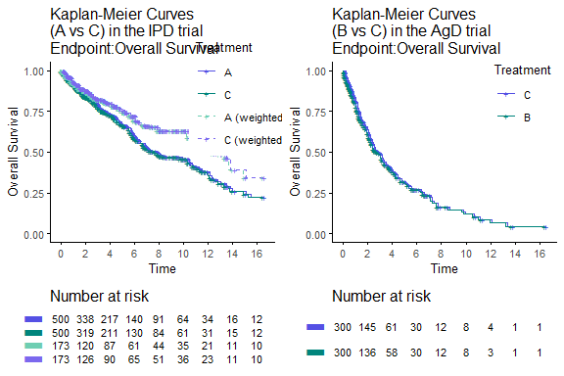

# plot by arm  
kmplot2(  
 weights_object = match_res,  
 tte_ipd = adtte,  
 tte_pseudo_ipd = pseudo_ipd,  
 trt_ipd = "A",  
 trt_agd = "B",  
 trt_common = "C",  
 trt_var_ipd = "ARM",  
 trt_var_agd = "ARM",  
 endpoint_name = "Overall Survival",  
 km_conf_type = "log-log",  
 km_layout = "by_arm",  
 time_scale = "month",  
 break_x_by = 2  
)

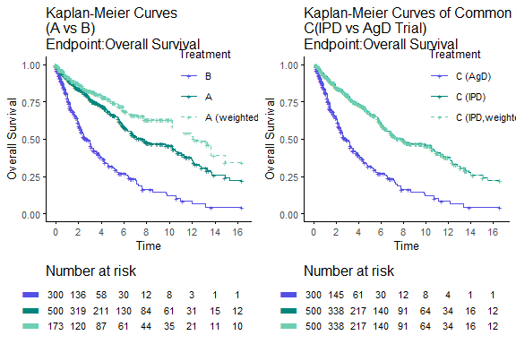

# plot all  
kmplot2(  
 weights_object = match_res,  
 tte_ipd = adtte,  
 tte_pseudo_ipd = pseudo_ipd,  
 trt_ipd = "A",  
 trt_agd = "B",  
 trt_common = "C",  
 trt_var_ipd = "ARM",  
 trt_var_agd = "ARM",  
 endpoint_name = "Overall Survival",  
 km_conf_type = "log-log",  
 km_layout = "all",  
 time_scale = "month",  
 break_x_by = 2,  
 xlim = c(0, 20)  
)

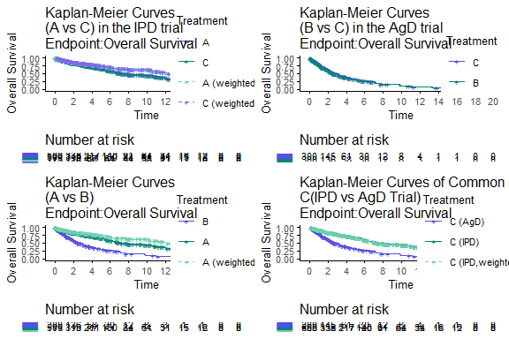

# References

[1] Guyot P, Ades A, Ouwens MJ, Welton NJ. Enhanced secondary analysis of survival data: Reconstructing the data from published kaplan-meier survival curves. BMC Medical Research Methodology 2012;12:9.

[2] Liu N, Yanhong Z, Lee JJ. IPDfromKM: Reconstruct individual patient data from published kaplan-meier survival curves. BMC Medical Research Methodology 2021;21:111.