I love casey li

Gaia

# Brainstorm

* Pokemon Go rip off except environmentally friendly instead of pokemon
* A big globe on the background that get bigger when you scroll down
* Initial donations/investments are optional and accessible through the website
* Surveys and ads are also optional for rewards
  + Extra points
* Explore page shows area photos and most popular events

## Tree

* An interactive tree that shows progress
* Tree turns into digital collage of events you donated/helped out at
* You can search for other users/view their trees

## PokeStops

|  |  |
| --- | --- |
| *Name ideas*   * Climate spots * Green stops | * Can be set up by developers or through users and user requests * Go near climate spot specified by other user(s) and participate to plant trees and raise score * Areas that need a lot of cleaning up will turn into spots when a user uploads a picture of it * Person who creates an actual spot gets 10% total points from all participants. (10% from each person) as well as 20 points. * More than 1 person can host the same spot as long as they’re in the same “group” (specified in account settings) and will split the points at the end. |

## Reward system

|  |  |
| --- | --- |
| *How to earn points*   * Visiting “PokeStops” and cleaning up garbage * Picking up garbage (indicated by taking a before and after picture)   + Amount of points are awarded based on AI * Watching ads * Doing surveys * Promoting the app/sharing photos to other social media websites | *Rules*   * If user spots little garbage and no spot is created, take a pic from the same angle before and after, indicating the garbage is gone and that you threw it out, and a few points will be awarded. * AI will automatically block upload of a spot if no/extremely minimal garbage is detected * User must upload a spot right BESIDE the garbage. If garbage is more than 5 metres away the AI blocks it. |

## Artificial intelligence

* AI analyzes and awards you a good amount of points the more before and after pics of the same angle you take for DIFFERENT PIECES OF GARBAGE, and your location is that of the spot. App AI will also analyze and detect if the same garbage type is being used (cheating). No more than 3 of the same garbage type used in a row (Tim’s cups, etc)
* AI calculates rewarded points based on the volume of garbage (analyzable) and the perceived weight. Will only award you your points once you leave the area and become more than 50m away from the spot of origin

## Social media

Should make actual social media pages/accounts

* Facebook
* Instagram
* Youtube
* Twitter

# Style

## Websites to use

*Fonts*

<https://fonts.google.com/>

<https://www.dafont.com/>

*Scaling/dimensions of objects*

<https://www.ginifab.com/feeds/cm_to_inch/scale_converter.html>

*Colour palettes*

<https://www.canva.com/colors/color-palette-generator/>

## Colour palettes

|  |  |  |  |  |  |
| --- | --- | --- | --- | --- | --- |
| 1 |  |  |  |  |  |
| 2 |  |  |  |  |  |
| 3 |  |  |  |  |  |

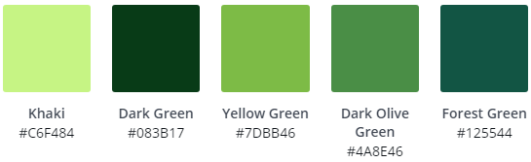

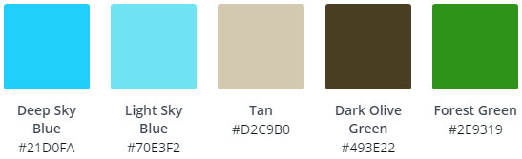

# Inspiration

|  |  |
| --- | --- |
| *Mobile app/games*  <https://www.pokemongo.com/en-ca/>  <https://supercell.com/en/games/clashofclans/>  <https://www.triviacrack.com/> | *Environmental*  <https://www.sierraclubfoundation.org/>  <https://greenpeacefund.org/>  <https://www.edf.org/>  <https://www.worldwildlife.org/> |

# Web Pages

* Home - Thuy-Vi
* About the App (description/features) - Arta
* Team (description/photos) - Cadence
* Donate (details/charities/where the money goes) - Hicham
* Climate Emergency (why now, what is the issue) - Jake