# Data

* 450 scenarios with random disruption

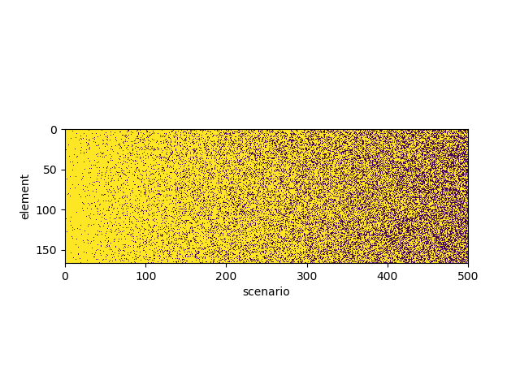

* Optimal plans for each scenario by INDP with *Rc*=4

# Model 1

## Model form

where

w_t = state of a given node at time t given that w_{t-1}=0

w_{t-1},n = sum of the state of the neighbor nodes for a given node at time t-1

w_{t-1},a = sum of the state of the connected arcs for a given node at time t-1

This model is trained for all nodes over all data point except when w_t_1_i=1 or y_t_1=1

## Estimated Parameters

|  |  |  |  |  |  |  |  |
| --- | --- | --- | --- | --- | --- | --- | --- |
|  | mean | sd | mc_error | hpd_2.5 | hpd_97.5 | n_eff | Rhat |
| Intercept | -3.2852 | 0.0237 | 0.0011 | -3.331 | -3.2358 | 497.2648 | 0.9991 |
| w_n_t_1 | 0.1898 | 0.01 | 0.0004 | 0.1708 | 0.2088 | 558.3604 | 0.9996 |
| w_a_t_1 | 0.2724 | 0.0108 | 0.0005 | 0.2526 | 0.2957 | 504.7184 | 0.999 |
| Training | data | R2: | 0.012254 |  |  |  |  |
| Test | data | R2: | 0.003821 |  |  |  |  |

## Figures

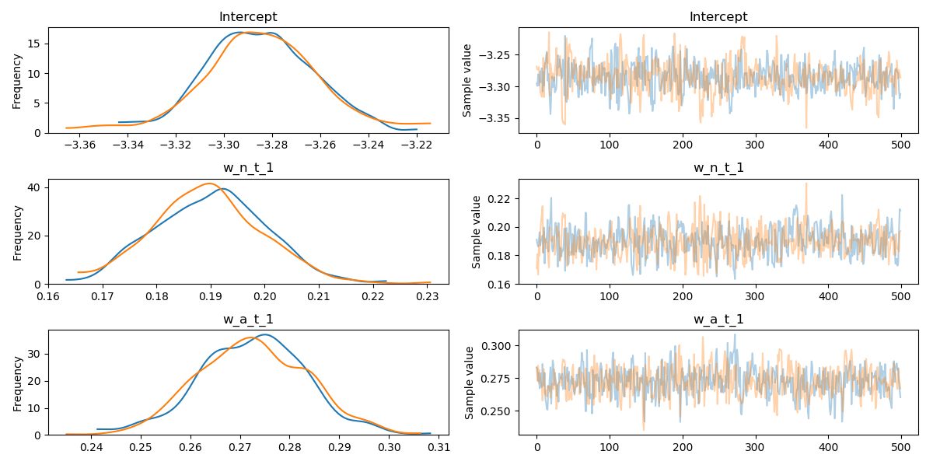

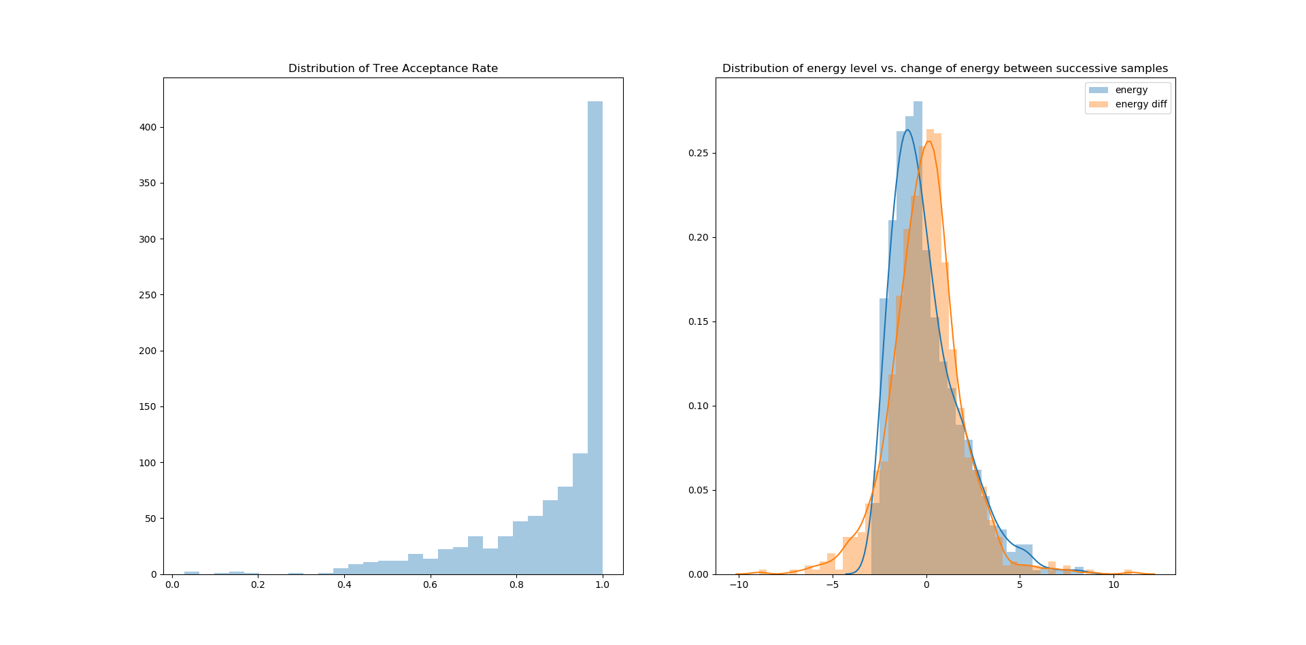

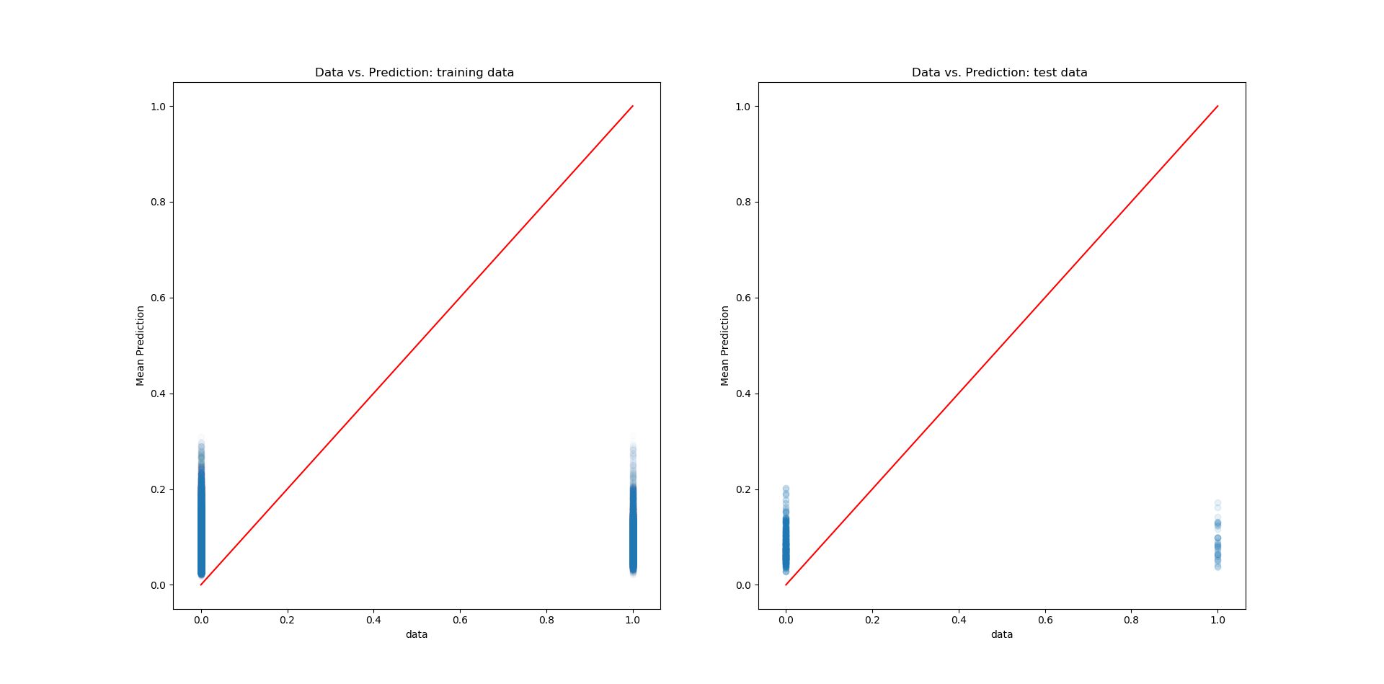

## Results

Not acceptable. Horrible prediction.

# Model 2

## Model form

where

w_t = state of a given node at time t given that w_{t-1}=0

w_{t-1},n = sum of the state of the neighbor nodes for a given node at time t-1

w_{t-1},a = sum of the state of the connected arcs for a given node at time t-1

This model is trained for all nodes over all data point except when w_t_1_i=1 or y_t_1=1

## Estimated Parameters

|  |  |  |  |  |  |  |  |
| --- | --- | --- | --- | --- | --- | --- | --- |
|  | mean | sd | mc_error | hpd_2.5 | hpd_97.5 | n_eff | Rhat |
| Intercept | -3.4047 | 0.0278 | 0.0011 | -3.4569 | -3.3523 | 542.9692 | 0.9991 |
| w_n_t_1 | 0.1837 | 0.011 | 0.0005 | 0.1616 | 0.2049 | 557.9893 | 0.9994 |
| w_a_t_1 | 0.2828 | 0.0112 | 0.0005 | 0.2581 | 0.3022 | 625.2732 | 0.999 |
| t | 0.0289 | 0.0034 | 0.0001 | 0.0222 | 0.0355 | 650.4939 | 1.0015 |
| Training | data | R2: | 0.012326012 |  |  |  |  |
| Test | data | R2: | 0.010251768 |  |  |  |  |

## Figures

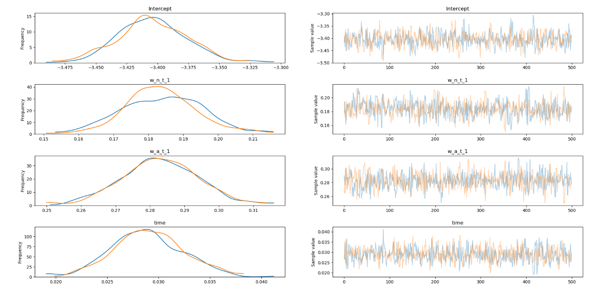

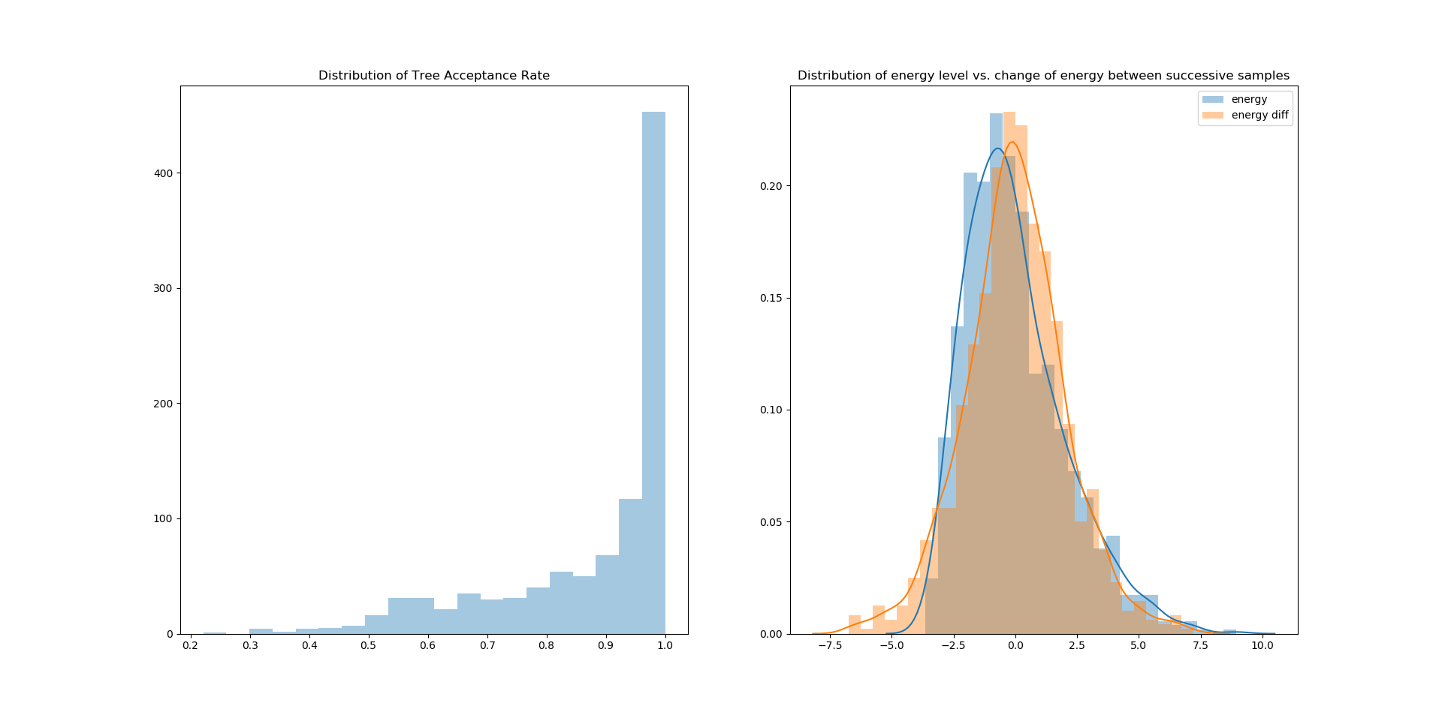

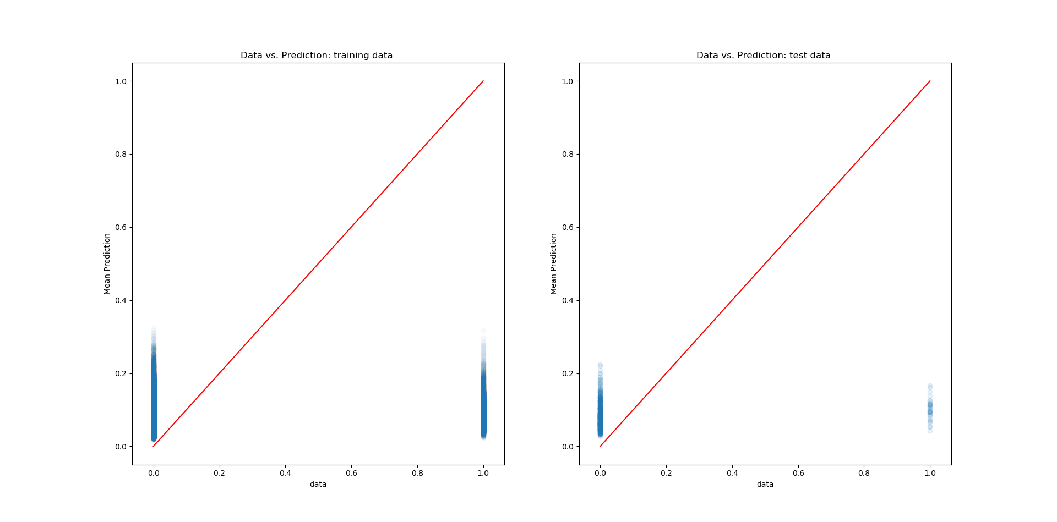

## Results

Not acceptable. Horrible prediction.

# Model 3

## Model form

where

w_t = state of a given node at time t given that w_{t-1}=0

w_{t-1},n = sum of the state of the neighbor nodes for a given node at time t-1

w_{t-1},a = sum of the state of the connected arcs for a given node at time t-1

w_{t-1},d = sum of the (1-state) of the dependee nodes for a given node at time t-1

This model is trained for all nodes over all data point except when w_t_1_i=1 or y_t_1=1

## Estimated Parameters

|  |  |  |  |  |  |  |  |
| --- | --- | --- | --- | --- | --- | --- | --- |
|  | mean | sd | mc_error | hpd_2.5 | hpd_97.5 | n_eff | Rhat |
| Intercept | -3.3934 | 0.0271 | 0.0009 | -3.444 | -3.3421 | 671.7112 | 1.0056 |
| w_n_t_1 | 0.2004 | 0.0108 | 0.0004 | 0.1812 | 0.222 | 635.4401 | 0.9998 |
| w_a_t_1 | 0.2996 | 0.0105 | 0.0005 | 0.2792 | 0.3201 | 474.2668 | 1.0011 |
| w_d_t_1 | -1.015 | 0.0473 | 0.0015 | -1.1051 | -0.9233 | 948.5553 | 0.9996 |
| time | 0.0273 | 0.0034 | 0.0001 | 0.0207 | 0.0339 | 795.0016 | 1.0035 |
| Training | data | R2: | 0.0166226 |  |  |  |  |
| Test | data | R2: | 0.0021912 |  |  |  |  |

## Figures

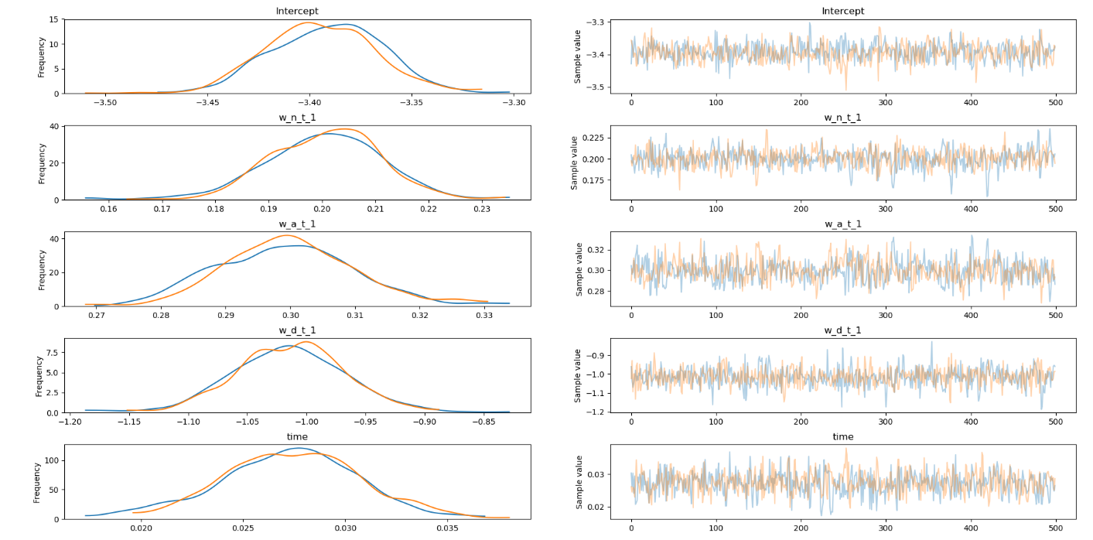

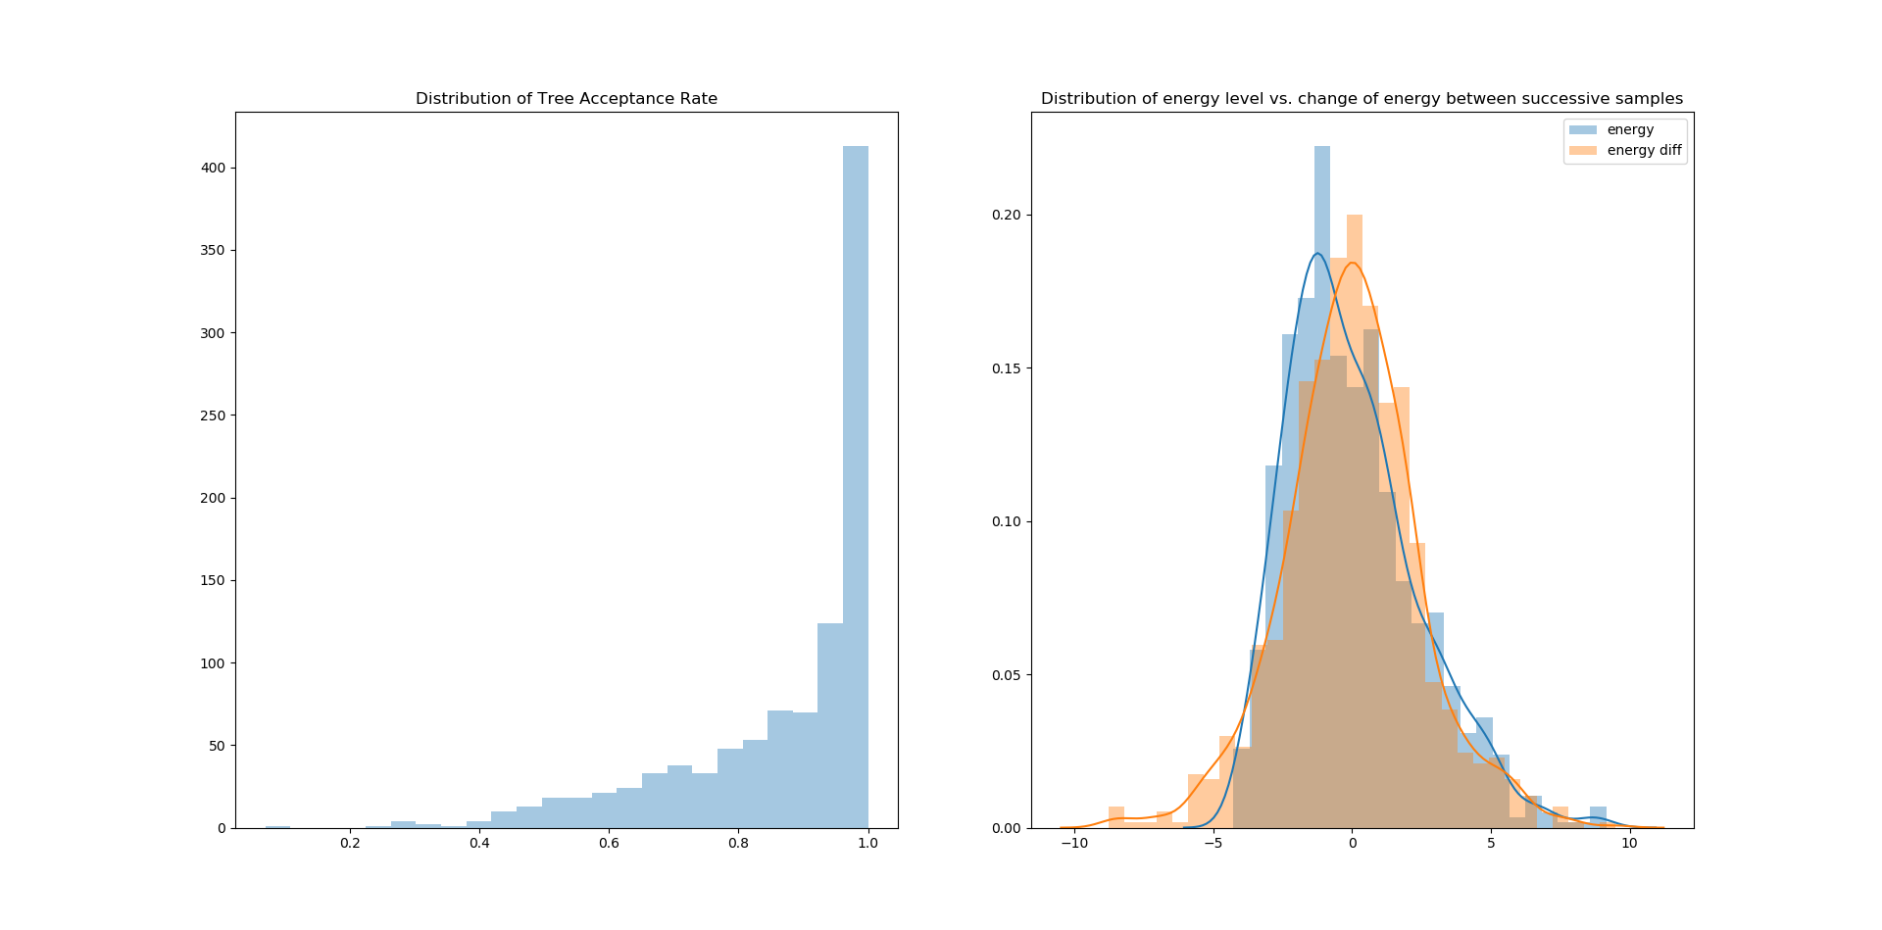

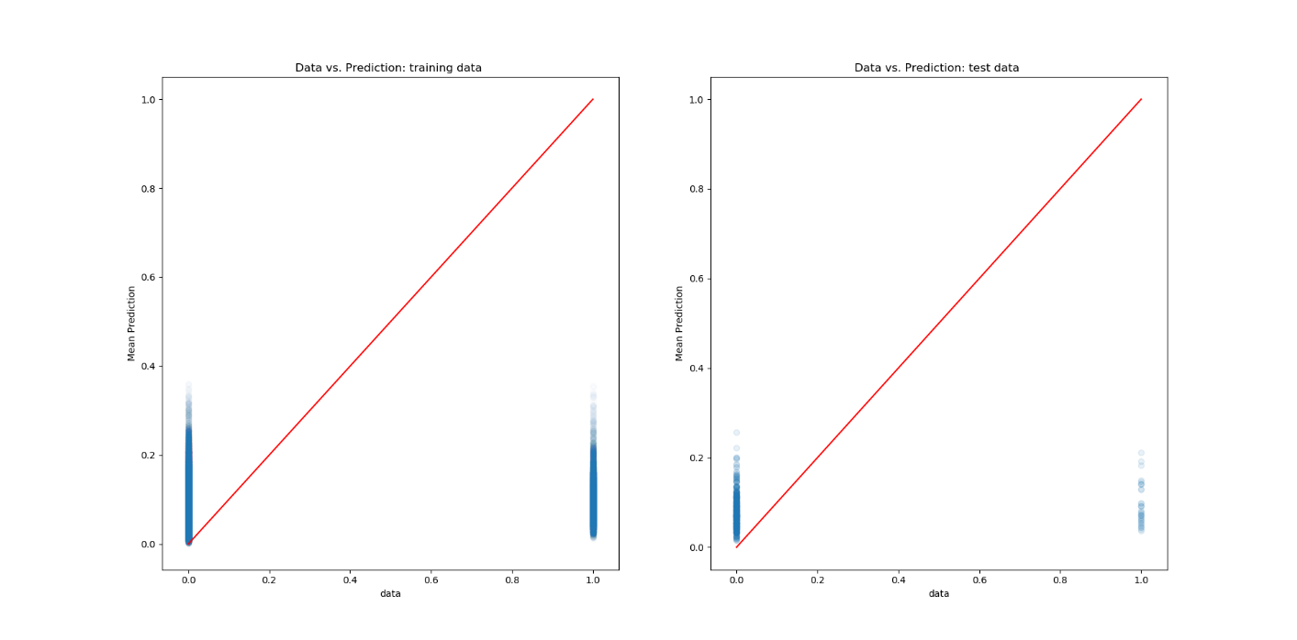

## Results

Not acceptable. Horrible prediction.

# Model 4

## Model form

where

p_i = probability of being 1 for node i

N_i = neighborhood of node i

## Estimated Parameters

## Figures

## Results

Not acceptable. Horrible prediction.

# Model 5

## Model form

where

w_t_i = state of a node i at time t given that w_{t-1}=0

w_{t-1},n = sum of the state of the neighbor nodes for a given node at time t-1

w_{t-1},a = sum of the state of the connected arcs for a given node at time t-1

w_{t-1},d = sum of the state of the dependee nodes for a given node at time t-1

This model is trained for each node over all data point except when w_t_1_i=1 or y_t_1=1

## Results

Not acceptable. Horrible prediction.

# Model 6

## Model form

where

w_t,i = state of a node i at time t

w_t_1,i = state of a node i at time t-1

w_{t-1},n = sum of the state of the neighbor nodes for a given node at time t-1

w_{t-1},a = sum of the state of the connected arcs for a given node at time t-1

w_{t-1},d = sum of the state of the dependee nodes for a given node at time t-1

y_t,i = state of an arc i at time t

y_{t-1},i = state of an arc i at time t-1

y_{t-1},n = sum of the state of the connected nodes for a given arc at time t-1

This model is trained for each node and arcs over all data point including when w_t_1_i=1 or y_t_1=1

## Results

Suspiciously good fit

# Model 7

## Model form

where

w_t,i = state of a node i at time t

w_t_1,i = state of a node i at time t-1

w_{t-1},n = sum of the state of the neighbor nodes for a given node at time t-1

w_{t-1},a = sum of the state of the connected arcs for a given node at time t-1

w_{t-1},h = sum of the state of the nodes (in the same layer) with highest absolute demand or supply at time t-1

w_{t-1},c = sum of the state of all nodes (in the same layer) at time t-1

w_{t-1},d = sum of the state of the dependee nodes for a given node at time t-1

This model is trained for each node over data points except when w_t_i=1 and w_t_1_i=1.

## Results

Not good fits

# Model 8

## Model form

where

w_t,i = state of a node i at time t

w_{<t },i = sum of the states of a node i for time<t

w_{<t },n = sum of the state of the neighbor nodes for a given node for time<t

w_{<t },a = sum of the state of the connected arcs for a given node for time<t

w_{<t },h = sum of the state of the nodes (in the same layer) with highest absolute demand or supply for time<t

w_{<t },c = sum of the state of all nodes (in the same layer) at for time<t

w_{<t },d = sum of the state of the dependee nodes for a given node for time<t

This model is trained for each node over data points except when w_t_i=1 and w_t_1_i=1.

## Estimated Parameters

## Figures

## Results

Not good fits

# Model 9

## Model form

where

w_t,i = state of a node i at time t

w_{t-1},n = state of the neighbor node n at time t-1

w_{t-1},a = state of the connected arcs a at time t-1

w_{t-1},h = state of the node h (in the same layer) with highest absolute demand or supply at time t-1

w_{t-1},d = state of the dependee node d at time t-1

This model is trained for each node over data points except when w_t_i=1 and w_t_1_i=1.

## Results

Not good fits