Expense Retest

Arbitrary File Upload

Login into Medi Zalaris
Create an expense report for a user
In the File upload a random file format
The application rejects file other than pdf , png , Jpeg

Upload a PNG file and then change the extension to an arbitrary file format
And change the content-type : to text/html

Forward the request and analyze the response :

The server accepts the request and gives 200 OK

Refer screenshot attached below for evidence

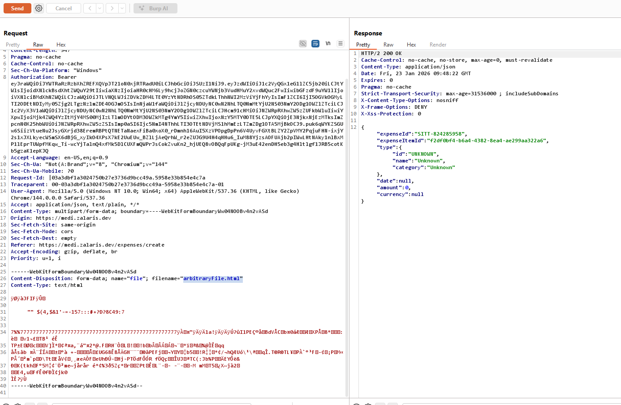

This confirms that the check is only done at the application / frontend level and not the backend level

The issue still exists

Denial Of Service via Parameter tampering

The issue exists when the user replaces the parameter limit with a negative value ‘-1’

Tested the server responds with 500 Internal Server Error

Refer Screenshot attached blow for evidence

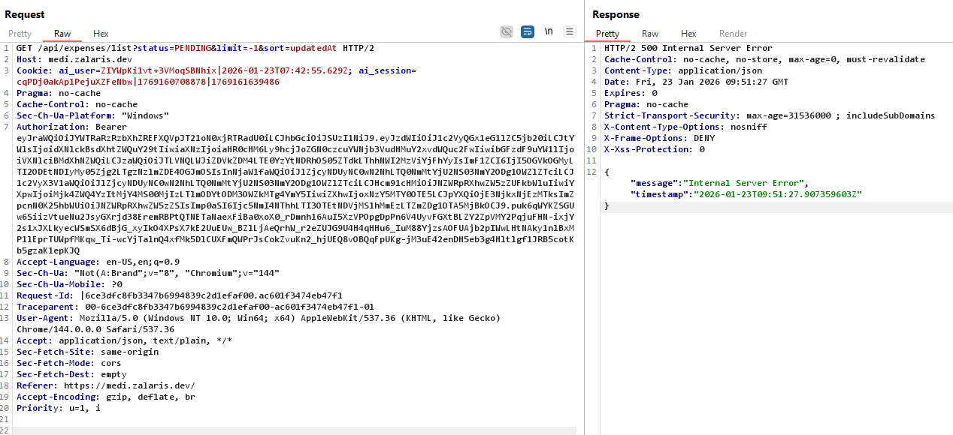

Clickjacking Due to I-Frame

The issue exists in the the old host - https://medi.zalaris.dev/

The issue is mitigated in the provided new Host : https://medi-dev.zalaris.com/

Refer screensot attached below for evidence

