25Q4 DSM Portal Manual Test

Introduction:

The purpose of this penetration testing document is to assess the security posture of the application by identifying vulnerabilities, misconfigurations, and potential attack vectors that could be exploited by malicious actors. Penetration testing is a proactive measure designed to uncover weaknesses before they can be leveraged in real-world scenarios.
This assessment was specifically carried out to evaluate the changes introduced during the recent sprint meet. By focusing on newly implemented features, modifications, and updates, the testing ensures that security risks are identified early in the development cycle and addressed before deployment.
The objectives of this assessment are to:
- Detect security flaws that may compromise confidentiality, integrity, or availability of data
- Validate that the changes made during the sprint meet do not introduce new vulnerabilities
- Provide actionable insights to strengthen the application’s resilience against cyberattacks
- Support compliance and risk management by aligning with industry best practices and regulatory requirements
By simulating adversarial techniques in a controlled environment, this document highlights areas requiring remediation and offers recommendations to mitigate risks. The ultimate goal is to safeguard sensitive information, maintain trust with stakeholders, and ensure the application operates securely in production environments.

Table of Contents
Introduction: 2
25Q4 Sprint Item 19937 Helpdesk-dev 4

25Q4 DSM Portal Manual Test

Steps

Login in to Dsm-dev.zalaris.com

Test the Avatar Upload Function
Access Contacts Section
Choose a contact and click on - edit avatar
Refer screenshot attached below for evidence
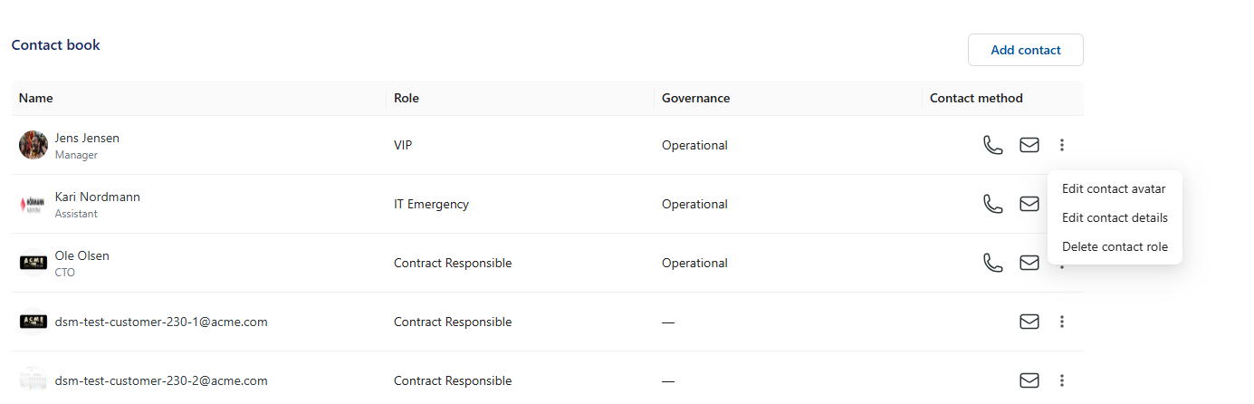

Now the upload function pops up

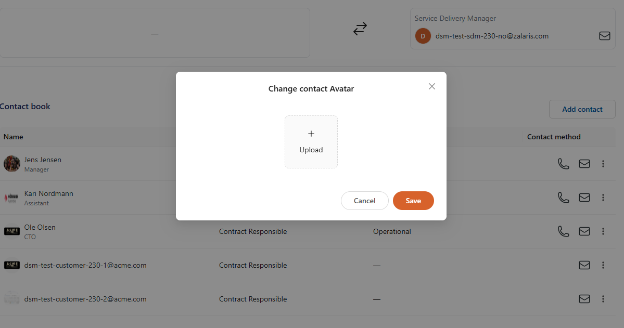

The function should accept only images , try uploading files of different format

The application accepts the different file formats and stored it as base 64 format. This must not be allowed by the server and the application

Create New report Function

In the create new Report function try uploading a file with different format say exe the front end application detects the file format and is preventing it

But when edited using a burp proxy the application accepts the file with format ‘exe’

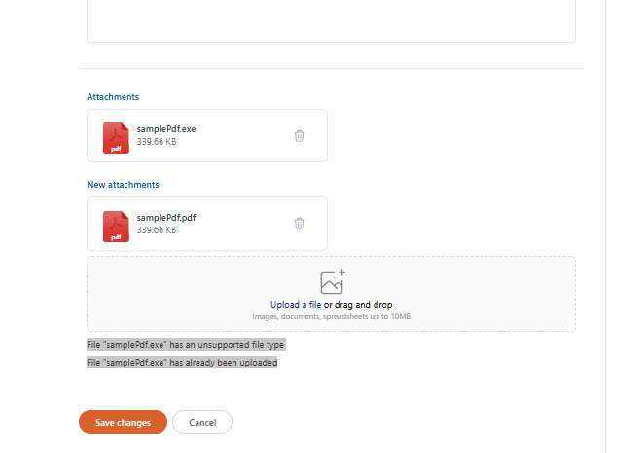

Refer screenshot attached for evidence

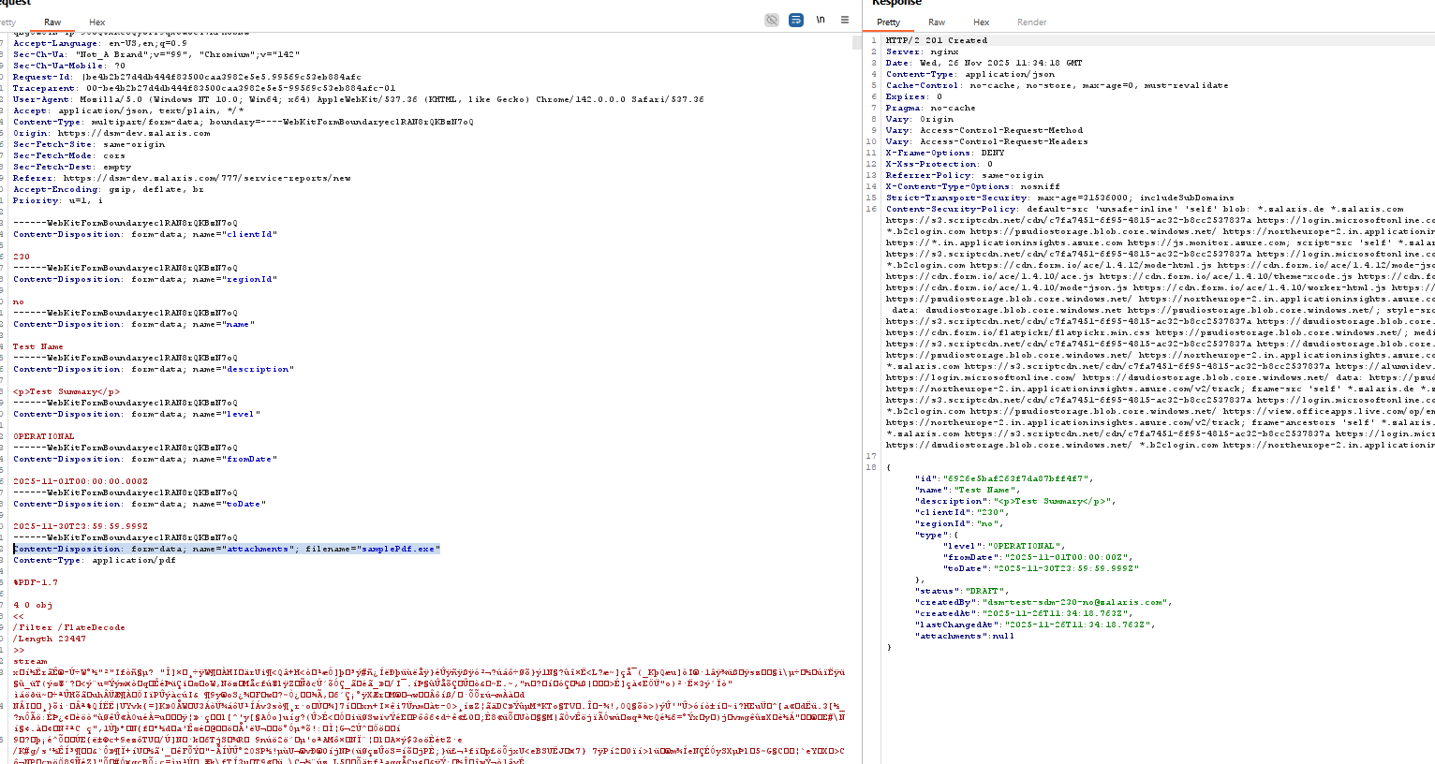

The Exe file is accepted when the file format is altered via Burp Proxy . This must be fixed else the server will process , parse or convert the data injected in the application

Test for XSS

Access the application , find out all tiles that where user input is accepted try for XSS in the input fields

Create New Report form under Service Reports

This function has form fields in it and when tested for XSS the fields are sanitized and no XSS is received

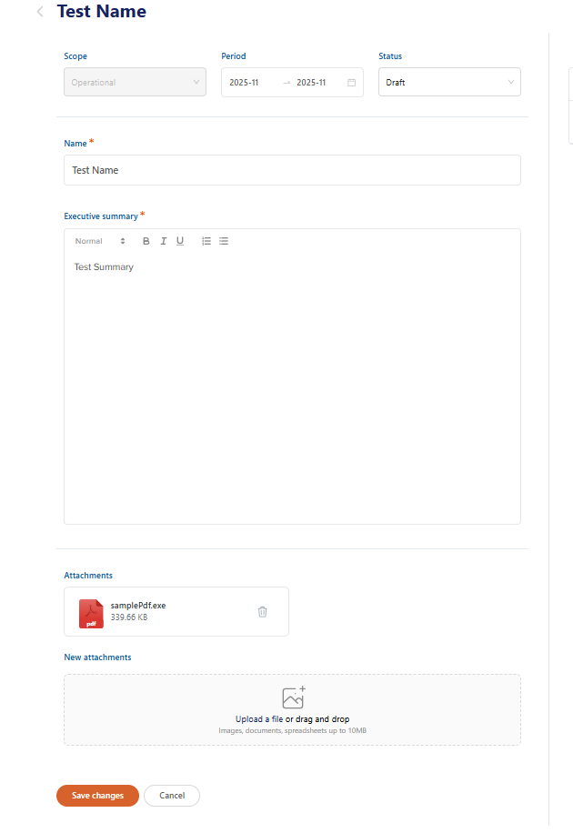

The request and response are given below
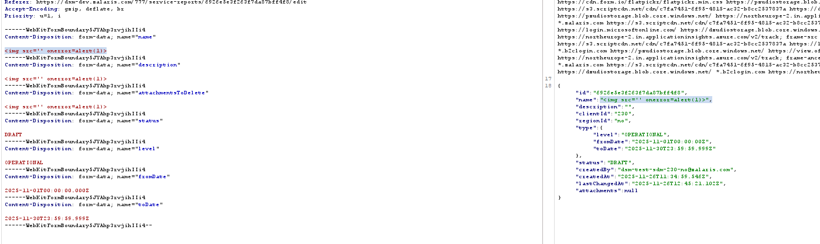

Name parameter is reflected in the response but is sanitized and executed by the application

The rest of the injected values are not reflected in the response

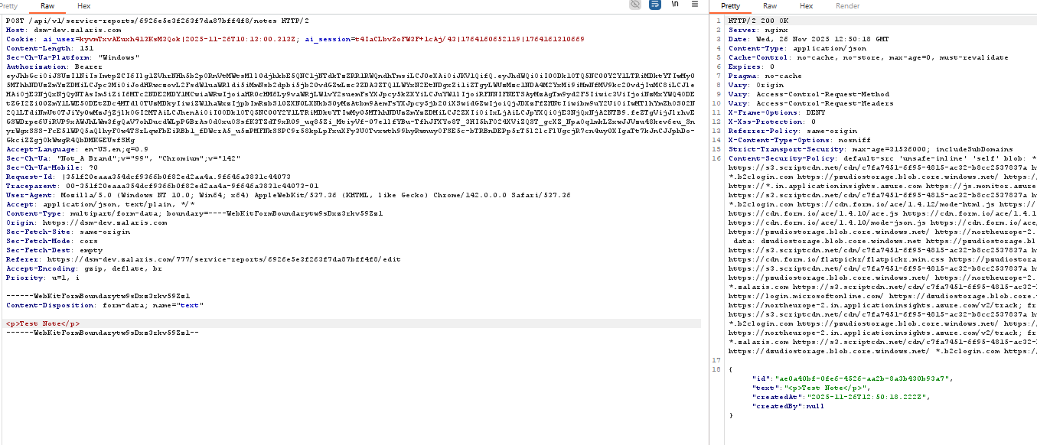

Add Note Section

The notes when injected with script are getting sanitized in the front end itself

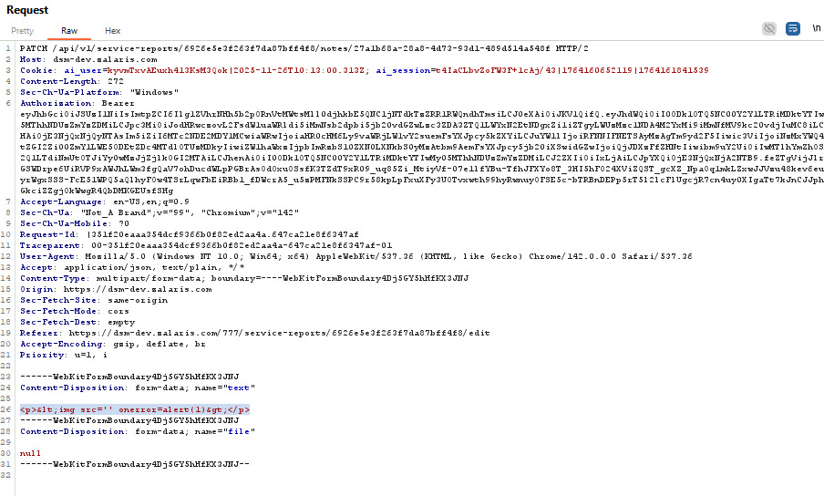

Response for the above request is attached below

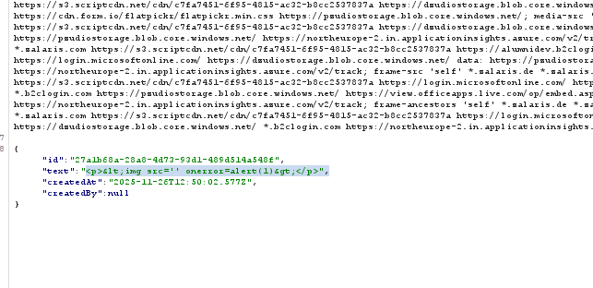

Injected with huge payload list for xss
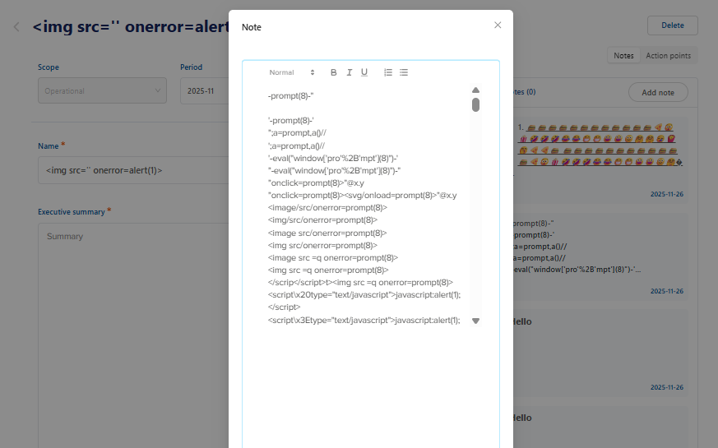

The injected scripts are sanitized and are not executed by the application

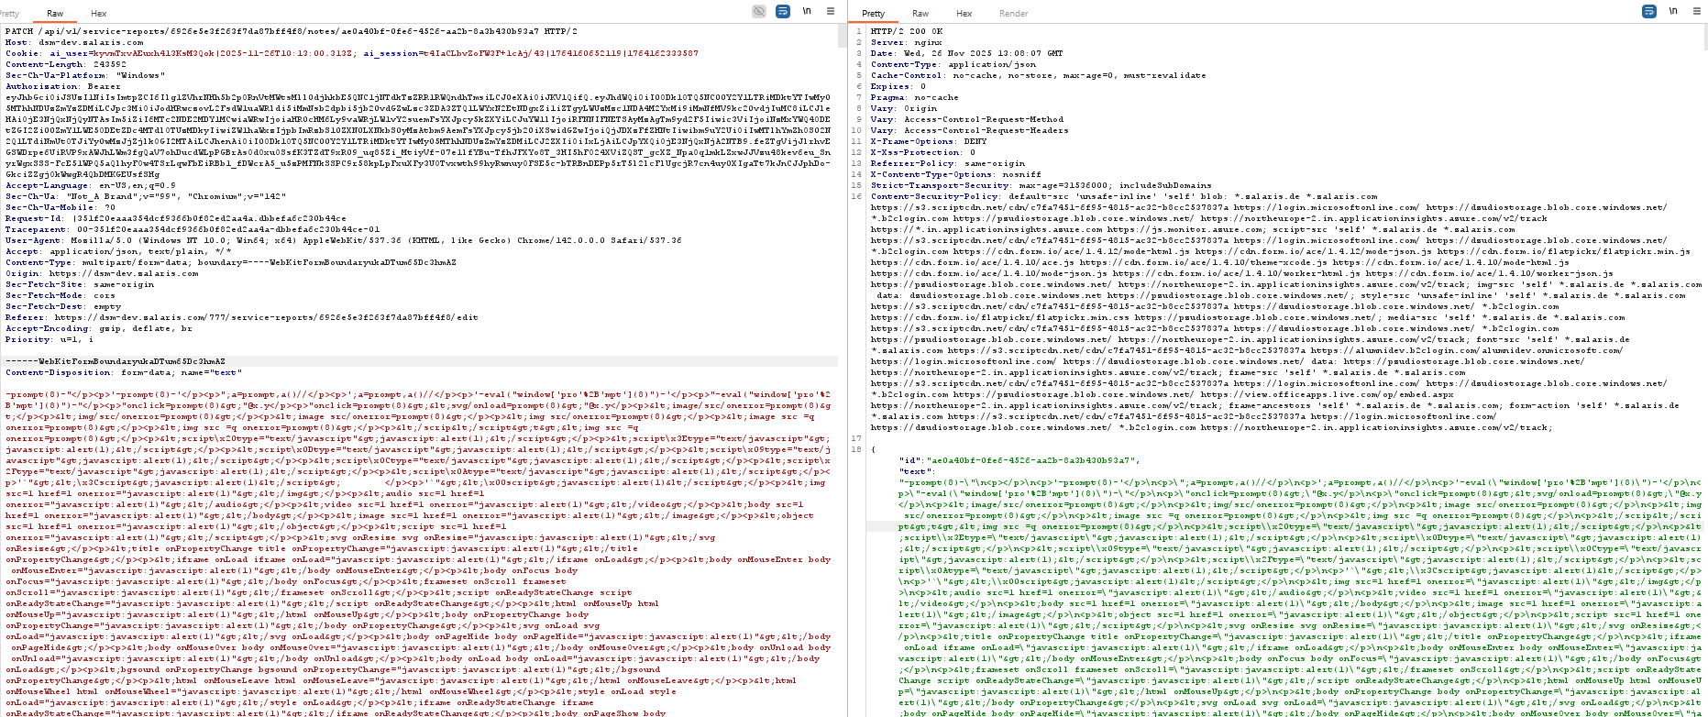

Statistics Tile

Access Statistics menu and capture the request , the request URL path is given below

https://dsm-dev.zalaris.com/api/v1/stats/active-employee-group?clientId=230&startMonthYear=20250101&endMonthYear=20251126

When the value for startMonthYear is set to * and request is forwarded , the server responds with the following message

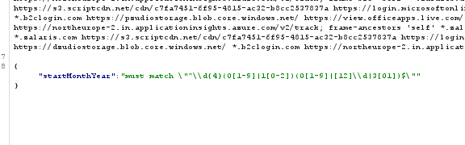

Check against the received Regex Pattern

- what does the following regex provides

This enforces:
\d{4} → a 4-digit year
(0[1-9]|1[0-2]) → valid month 01–12
(0[1-9]|[12]\d|3[01]) → valid day 01–31
So it matches a date in the format YYYYMMDD.
ReDoS (Regular Expression Denial of Service)

Test whether the regex is vulnerable to ReDoS

WORKLOG

When | What | Who | Recommended Action
26 November 2025 | Helpdesk-dev Sprint Item 19937 manual test | Mohammed Sharoz | Test in Progress parameter currentPage accepts floating point integer

