25Q4 Sprint Item - 20861 MyPaySlip Wagetype

Introduction:
This penetration test focused on evaluating the security implications of the new features, enhancements, and configuration changes introduced during the current sprint development cycle. The objective of this assessment was to ensure that recent modifications did not introduce new vulnerabilities and that existing security controls continue to operate effectively.
The evaluation included targeted testing of the updated application components, associated APIs, and any newly implemented integrations. Both manual and automated testing methodologies were utilized to identify potential threats, including authentication and authorization flaws, injection risks, misconfigurations, insecure data handling, and other issues aligned with OWASP Top 10 and industry best practices.
Identified vulnerabilities were validated to determine real-world impact and exploitability. Recommendations have been provided to mitigate risks and maintain secure application posture as development progresses.

Table of Contents
Introduction: 2
25Q4 Sprint Item 19937 Helpdesk-dev 4

25Q4 Sprint Item - 20861 MyPaySLip Wagetype

Description

Mypayslip-dev.zalaris.com application is introduced with the wage-type features. This feature is currently tested

Steps

Login in to mypaylsip-dev.zalaris.com

Click on Payslips button

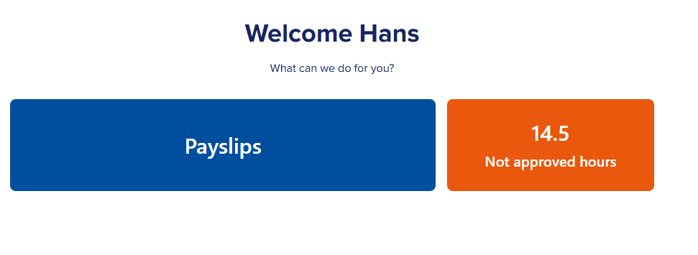
The payslip page opens with payslips categorized according to the month they have been released

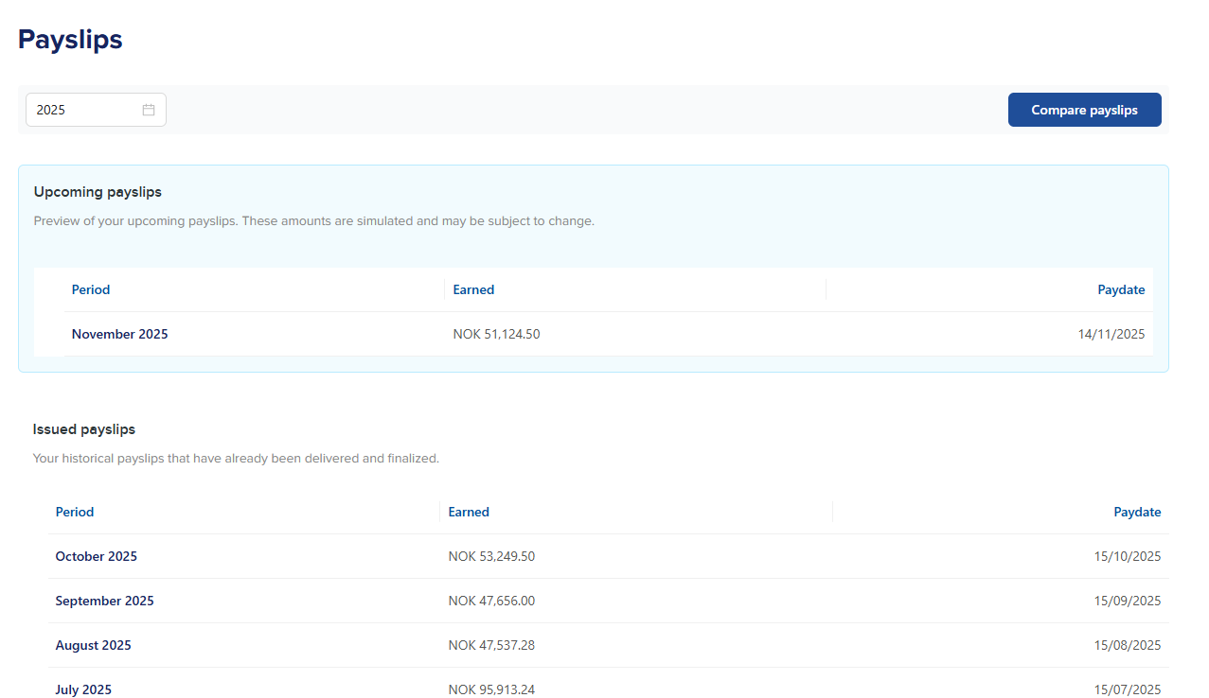

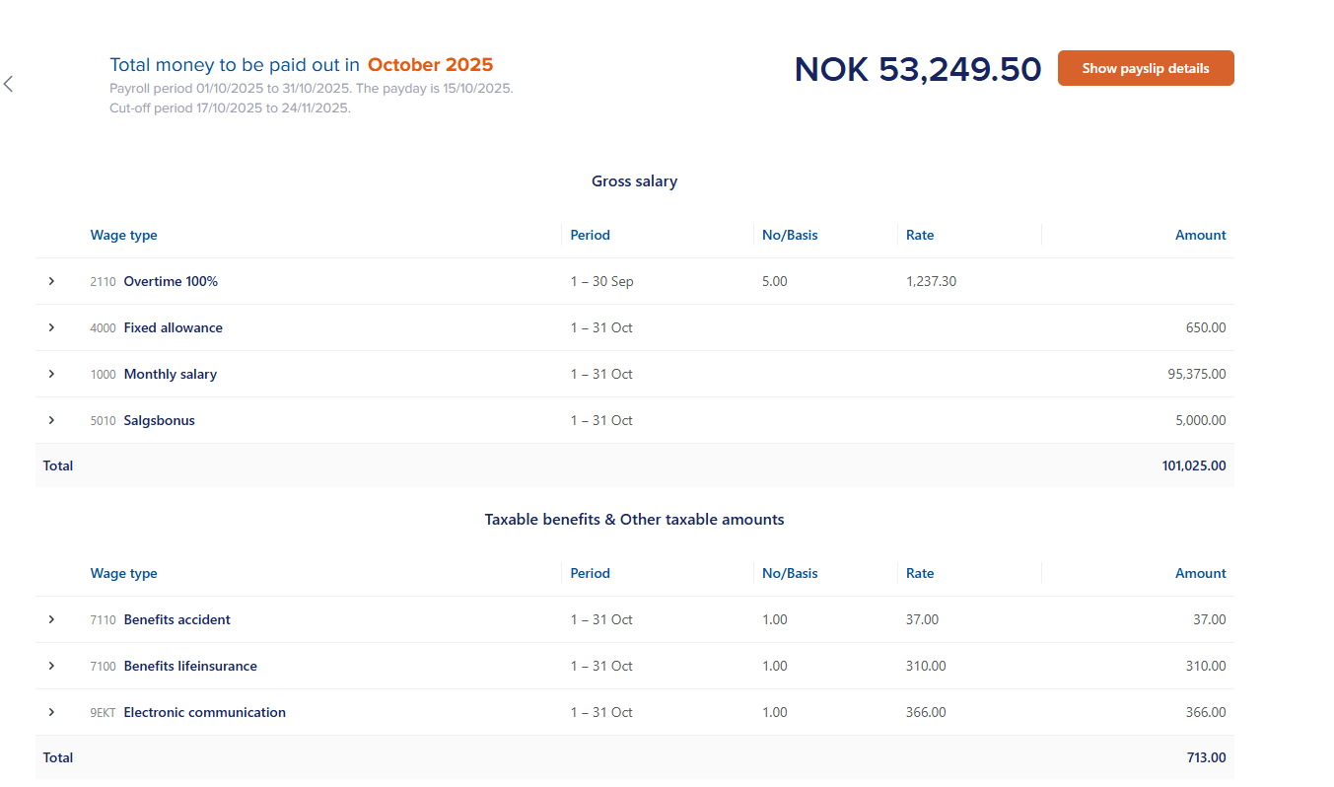

Wagetype has been categorized according the to the following class

Gross Salary
Net Detuction/Payment
Net Pay
Taxable benefits and other taxable amounts

No Input has been passed on from the request. Refer Screenshot attached for evidence

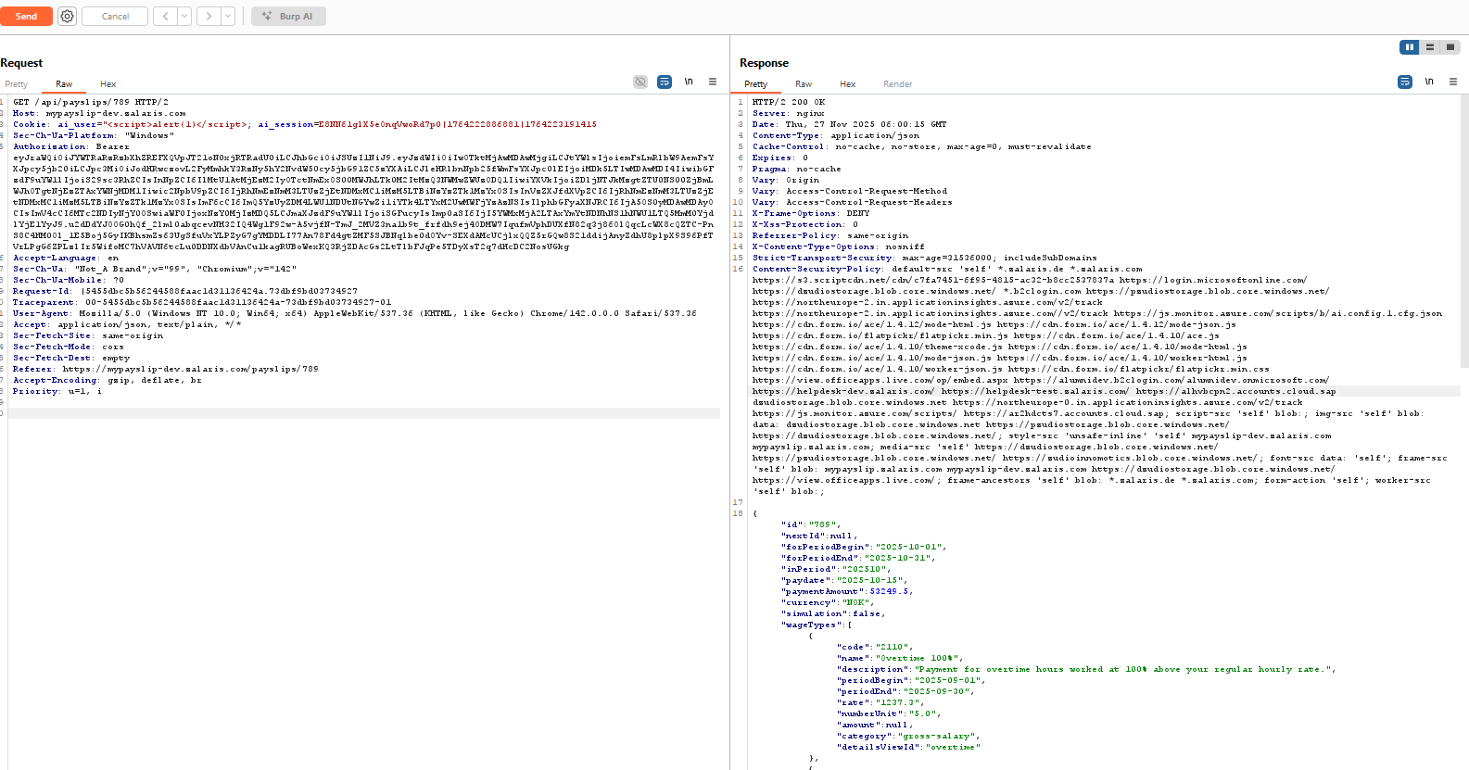

DOM Injection

DOM sinks

Analyse whether the following DOM Sinks are available in the source of the application

The list given below are high risk DOM sinks

eval()
new Function()
setTimeout(string)
setInterval(string)
document.write()
document.writeln()
window.location assignment (if string concatenation)
location.href = …
window.open(...)

setTimeout() - High Risk DOM sink found but no parameters or values have been apssed onto the function
setInterval() sink is found but no values are passed onto to the sink from the user

No instances of document.write found
No instances of document.writeLn()
No instances of window.location ()
No Instances of window.open () available

Refer Screenshot attached for evidence

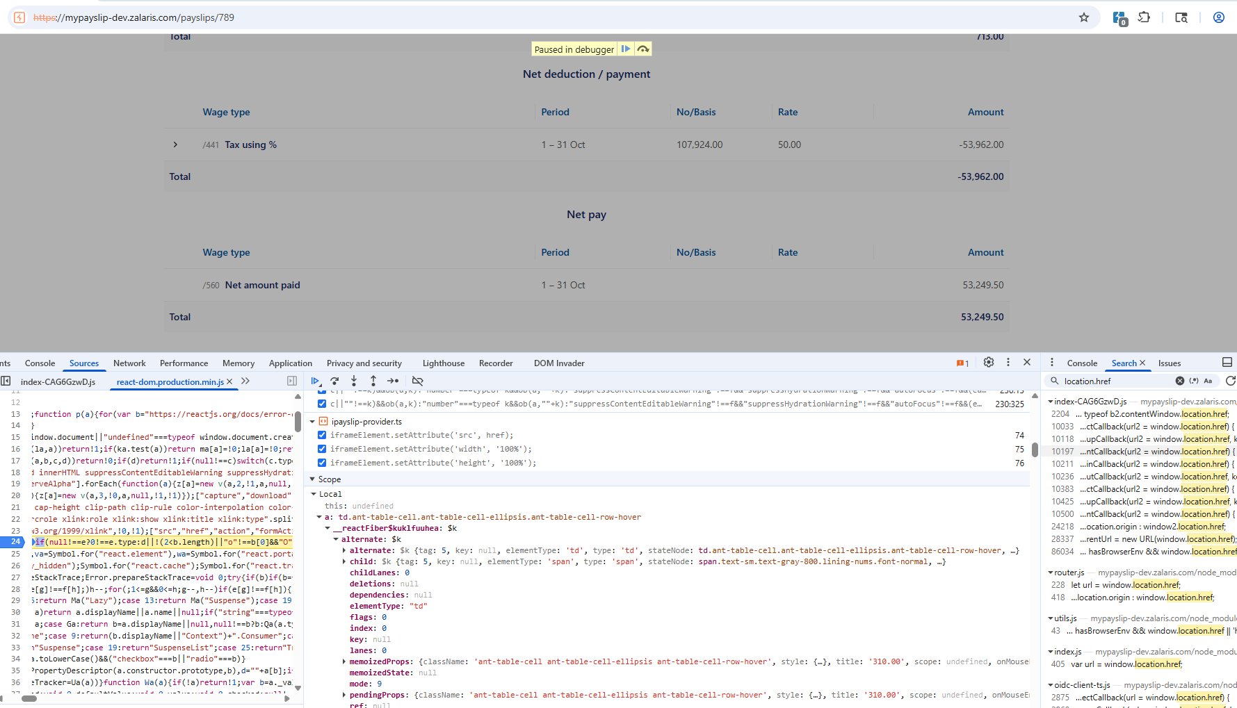

Look for HTML Injection Sinks

The following sinks must be present

innerHTML
outerHTML
insertAdjacentHTML
Document.body.innerHTML
Document.body.outerHTML

Instances of innerHTML found but no values are passed onto the sink from the user input
No instances of outerHTML found
No Instances of insertAdjacentHTML found
Document.body.innerHTML no values are passed on from the user to the sink

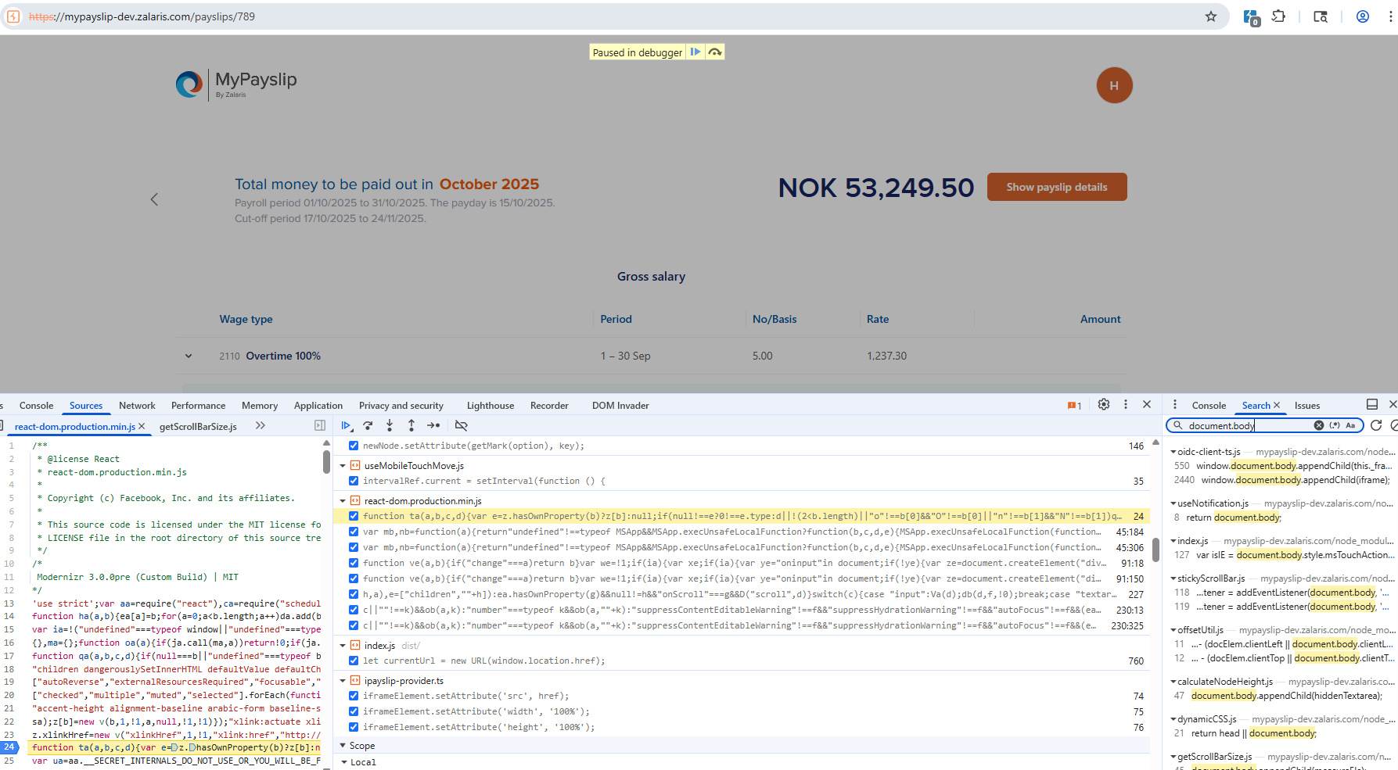

WORKLOG

When | What | Who | Recommended Action
27 November 2025 | Manually Tested | Mohammed Sharoz | Test in Progress parameter currentPage accepts floating point integer

