**Found code :**



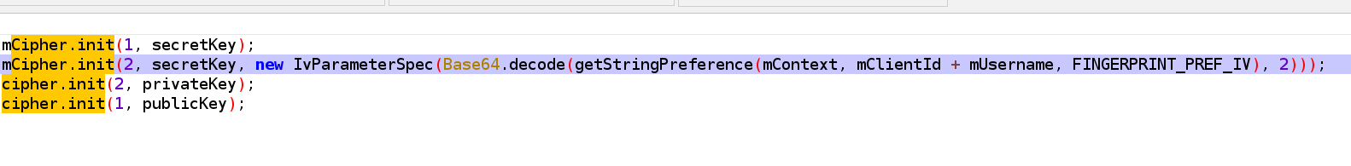

The following must be found and analyzed now

secretKey , PrivateKey , mClientIDm ,mUserName , FINGERPRINT_PREF_IV

The scenario here goes as - the IV is obtained from the Client ID + User-name + Fingerprint Pref iv

-- so if this is obtained from the above details then it is not random and the IV parameter seems to be static and stored in the local storage

- if local storage is not encrypted or can be accessed and retrieved this poses a risk

The fingerprint pref iv has the following value in the code = and find where the aes_iv value is generated and stored