**I.Data structure:**

**1.Array**

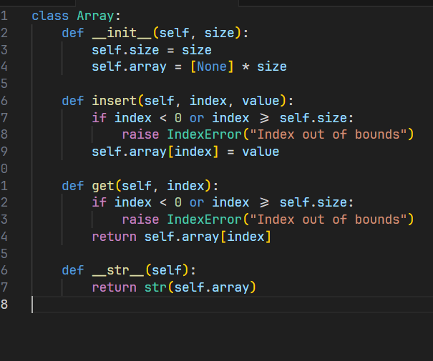

**2. Linked list :**

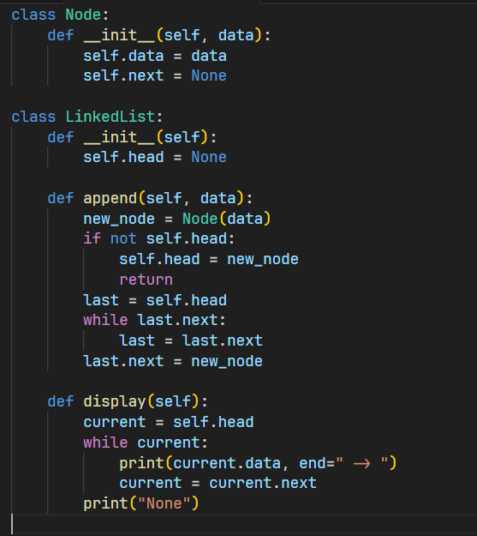

**3. Stack :**

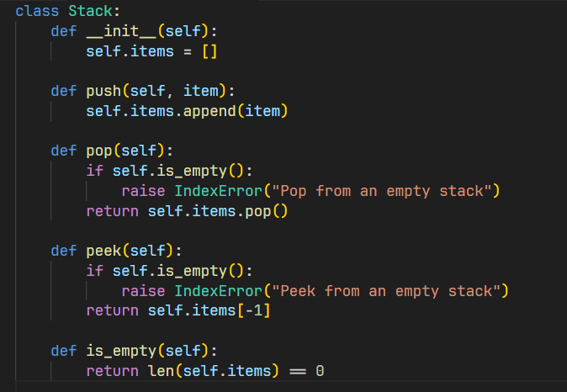

**4. Queue:**

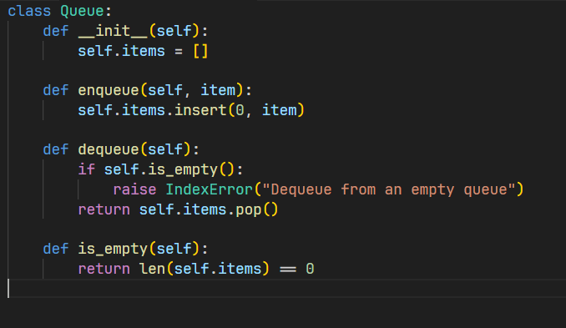

**II.** **Tree Implementations**

**1.Binary tree:**

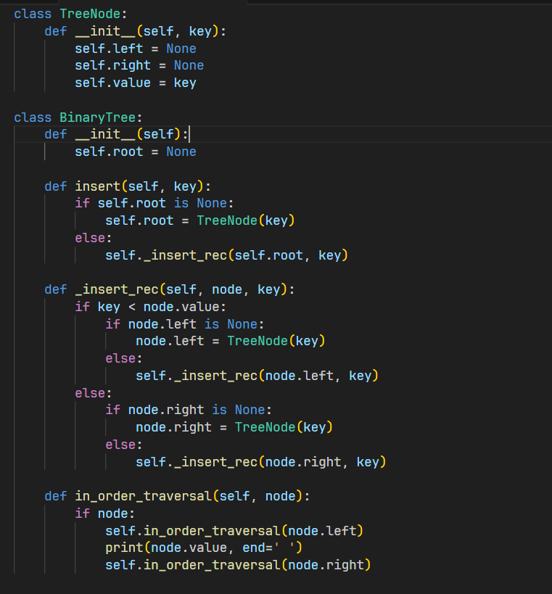

**2. Binary Search Tree :**

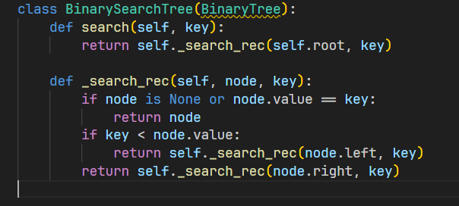

**III. Sorting Algorithms :**

1. **Bubble sort :**

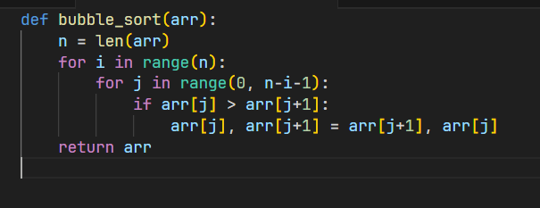

1. **Insertion sort :**

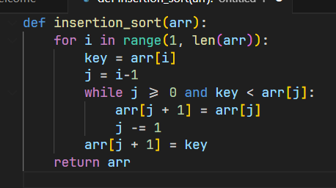

**IV. Searching Algorithms :**

1. **Linear Search :**

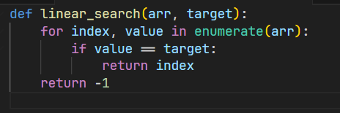

1. **Binary search :**

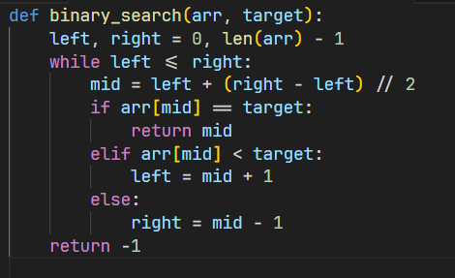

**V. Hash table implementation :**

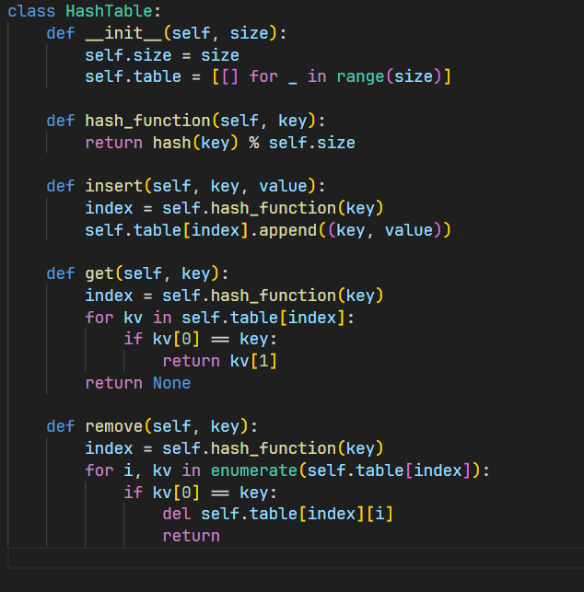

| **Data Structure / Algorithm** | **Time Complexity (Best)** | **Time Complexity (Average)** | **Time Complexity (Worst)** | **Space Complexity** |
| --- | --- | --- | --- | --- |
| **Array (Access)** | **O(1)** | **O(1)** | **O(1)** | **O(n)** |
| **Linked List (Insertion)** | **O(1)** | **O(n)** | **O(n)** | **O(n)** |
| **Stack (Push/Pop)** | **O(1)** | **O(1)** | **O(1)** | **O(n)** |
| **Queue (Enqueue/Dequeue)** | **O(1)** | **O(1)** | **O(1)** | **O(n)** |
| **Binary Tree (Insertion)** | **O(log n)** | **O(n)** | **O(n)** | **O(n)** |
| **Binary Search Tree (Search)** | **O(1)** | **O(log n)** | **O(n)** | **O(n)** |
| **Bubble Sort** | **O(n)** | **O(n^2)** | **O(n^2)** | **O(1)** |
| **Insertion Sort** | **O(n)** | **O(n^2)** | **O(n^2)** | **O(1)** |
| **Linear Search** | **O(1)** | **O(n)** | **O(n)** | **O(1)** |