House style for figures, tables and captions
High-Speed Electrical Machines and Drives — rules for every chapter
Every figure, graph and table in the book looks the same, whoever drew it. The rules are short, and most of them are enforced by two small tools, so nobody has to remember them: hsbook_style.py for Python and hsbook_style.m for MATLAB. Chapter 1 has been brought into this style and is the reference example.

1. The one rule that makes the rest work
Every figure is made at the full text width, 15.92 cm, and inserted into the manuscript at 100 %. Never scale a figure in Word and never crop it there.
Text in a figure only prints at the size it was drawn if the figure is placed at the width it was drawn at. Before this style, the same 9 pt label in Chapter 1 printed anywhere from 7 to 12 pt for exactly this reason. Only the height varies from figure to figure.
The publisher will rescale the book to its own trim size. Because every figure is built at the same width, they all scale together and stay identical to one another. When Wiley confirms the trim size, the width changes in one place in each tool and every figure is regenerated.

2. Text in figures and tables
 | Rule
Font | Times New Roman, the font of the text. Liberation Serif or Nimbus Roman are acceptable stand-ins where Times New Roman is not installed; their letter widths are identical.
Size | 11 pt, the size of the text, for every piece of text: axis labels, tick numbers, legends, labels and panel titles. Sub- and superscripts follow automatically.
Weight | Regular. In figures, nothing is bold. In tables, only the header row is bold.
Italic | Quantity symbols only (n, P, f₁, Ω), exactly as in the text. Units and descriptive subscripts are upright: v_{tip}, P_{Fe}, f_{sw}.
Case | Sentence case: "Rotational speed", not "Rotational Speed".

3. Graphs
- No title inside the figure. The caption is the title.
- Frame and ticks: full box; ticks pointing inward on all four sides; a light grey grid behind the data.
- Axis labels take the form Name symbol (unit): "Rotational speed n (r/min)", "Loss (% of rated output)". A dimensionless quantity has no parentheses.
- Numbers: decimal point; numbers of five or more digits grouped with a thin space (30 000, 100 000); four-digit numbers ungrouped (1500). Logarithmic axes carry plain numbers (0.1, 1, 10, 100 000), not powers of ten.
- Units: SI throughout. Speed in r/min, never rpm. Factors are written with ×, not x: 4×, ×16.
- Line weights: data curves 1.2 pt; axes and ticks 0.6 pt; grid 0.4 pt; reference and construction lines 0.5 pt.
- Series: up to four per graph, each a fixed pairing of colour and line style, so they stay distinguishable in greyscale print. More than four series usually means two graphs.
Series | Colour | Line
1 | blue #1f4e79 | solid
2 | rust #a6350f | dashed
3 | green #4a7c1f | dash-dot
4 | ink #1a1a1a | dotted

- Labelling the series: label curves directly, in the curve's own colour, wherever there is room. Otherwise use a legend without a frame, placed in empty space inside the axes.
- Marked points: an open circle, white fill and dark edge, joined to its label by a thin grey leader line.
- Bar charts add hatching to the colour (plain, ////, ....) for the same greyscale reason.
- Panels: (a), (b) … with a short title, centred below each panel. The caption refers to them by letter.

4. Illustrations
Figure 1.2 is the reference. Both of its panels are drawn the same way, and every illustration in the book should look as if the same hand drew it.
- Two-dimensional engineering drawings only: an elevation, a half section or a section, drawn as a drafter would draw it. No perspective, no 3-D rendering, no shading gradients, no photorealism. No AI-generated imagery (see §8).
- Flat fills, no hatching. Every part is drawn as a flat, light fill from the palette below, with an ink outline. Nothing is hatched.
- Showing the inside: draw a half section. The upper half is cut and the lower half is seen from outside, with the centre line between them. Cut housing walls take the darker section tone. Shafts, rotors and other solid parts on the axis are never cut. A laminated stack is shown by thin grey lines across it, perpendicular to the shaft.
- Machines in their setting stand on a floor: a heavy floor line with a light band below it and a baseplate above it, as in Figure 1.2. Anything below floor level, such as an oil skid, is drawn in that band.
- Line weights: part outlines 1.0 pt. Leader lines, centre lines, dimension lines, lamination lines and small details 0.5 pt.
- Centre lines: thin, grey, dash-dot.
- Labels: horizontal, sentence case, 11 pt. Main units are named above them, with the speed under the name where it matters ("compressor / 30 000 r/min"). Every other label is joined to its part by a thin grey leader line without an arrowhead. A leader that ends inside a part ends in a small dot. Arrows are kept for flow, motion and dimensions.
- Scale: where the scale carries meaning, keep it. A rotor drawn above its mode shapes shares their axial scale (Figure 1.4).
- Fills come from one material palette, light enough for labels to stay legible:
Material | Fill
Housing, casing, seen from outside | #f2f2ef
Housing wall where a section cuts it | #dcdcd6
Shaft, disc, solid steel | #cfcfcf
Rotor active part, drawn as one body | #a6a6a6
Laminated core | white, with thin grey lines across the stack
Bearings, AMB stators | white
Windings | #c9a227
Coolant, cooling jacket | #d7e4f0
Oil, lubrication | #f4e6d8
Floor, foundation | #f5f5f5

5. Colour and greyscale
Wiley has not yet said whether the book prints in colour. Until it does, every figure must read correctly when printed in greyscale. That is why each colour carries its own line style or hatching. Check by printing the figure in black and white.

6. Tables
- Caption above the table.
- Times New Roman 11 pt throughout, single line spacing, no space before or after paragraphs in cells.
- Horizontal rules only: 1 pt above and below the table, 0.5 pt under the header row. No vertical rules, no shading, no grid.
- Header row bold and repeated at the top of each page. Units go in the header in parentheses. Body rows regular. Rows are not split across pages.
- Alignment: text columns left, columns of numbers or short formulae centred.
- Full text width, sentence case, × for factors.
The Word table style HS Book Table in this document does all of this. Insert a table, choose the style, and mark the first row as a header row.

7. Captions
- Label: "Figure 4.7." or "Table 4.2.", in bold, followed by the caption in regular type. The full stop after the number is always there.
- Placement: figure captions below the figure; table captions above the table.
- Content: the first sentence names what is shown; the following sentences say what to look for. Panels are referred to by letter. Values that are illustrative rather than measured are said to be so.
- Style: the Word paragraph style Caption in this document: Times New Roman 11 pt, justified like the text.

8. Sources and rights
- No AI-generated images. The copyright in them is unsettled, so the authors may not be able to grant Wiley the licence the contract asks for. Several large publishers do not accept them at all.
- Figures taken from another source are redrawn in this style and cited in the caption: "Redrawn from [12]." When the redrawing follows the original closely, permission is still needed; ask the chapter owner.
- Data from another source is plotted in this style, and the source of the data is cited in the caption.
- Photographs are used only of real hardware, at no less than 300 dpi at printed size, and only with the owner's written permission.

9. What to deliver with a chapter
File | Purpose
fig_4_07.png | in the manuscript: 600 dpi, exactly 15.92 cm wide
fig_4_07.pdf or .svg | for production: vector, text kept as text, fonts embedded
the script or .m file that draws it | so that any figure can be regenerated when the trim size or a value changes

Name figures fig_<chapter>_<number>, with two-digit numbers: fig_4_07.

10. The tools
Python. hsbook_style.py sets matplotlib to this style. save() checks every piece of text in the figure and refuses to write a figure whose font, size or weight is off.
import hsbook_style as hs
hs.setup()
fig, ax = hs.figure(8.5) # a graph, 8.5 cm tall
ax.plot(n, P_loss)
ax.set_xlabel(hs.label('Rotational speed', 'n', 'r/min'))
ax.set_ylabel(hs.label('Loss', 'P_loss', 'kW'))
hs.save(fig, 'figures/fig_4_07') # .png, .pdf and .svg

fig, ax = hs.canvas(12.0) # an illustration, in cm
hs.laminated(ax, 2.0, 5.0, 3.1, 4.2) # a laminated stack
hs.leader(ax, 'stator', (3.5, 3.6), (3.5, 6.0), dot=True)
MATLAB. hsbook_style.m takes a finished figure and puts it into this style: width, font, size, line weights, ticks, grid, series colours and styles, no title, no legend box. It then exports it at exactly that size.
plot(n, P1, n, P2)
xlabel('Rotational speed \itn\rm (r/min)')
hsbook_style(gcf, 8.5, 'fig_4_07') % restyle, write .png, .pdf
The MATLAB function was written without access to MATLAB. Check the first figure it exports by eye, and report anything it gets wrong so that it can be fixed for everyone at once.
Word. The Caption paragraph style and the HS Book Table table style are defined in this document. Copy them into a chapter with Home → Styles → Manage Styles → Import/Export, or simply paste a table from this document.

11. Checklist before sending a chapter
- Every figure is 15.92 cm wide and inserted at 100 %, with no Word cropping.
- All text in figures and tables is Times New Roman 11 pt, with symbols in italic.
- No titles inside figures; panels lettered (a), (b) below the panels.
- Every graph reads in greyscale.
- Illustrations are 2-D drawings in flat fills from the palette, with no hatching, no AI imagery and no photorealism.
- Tables use HS Book Table, with the caption above.
- Captions use Caption, labels "Figure c.n." and "Table c.n." in bold.
- Units in SI, r/min not rpm, × not x, thin space in 30 000.
- Every borrowed figure is redrawn and cited; every borrowed dataset is cited.
- The source file of every figure is delivered with it.

Example: a graph and its caption, as in Chapter 1
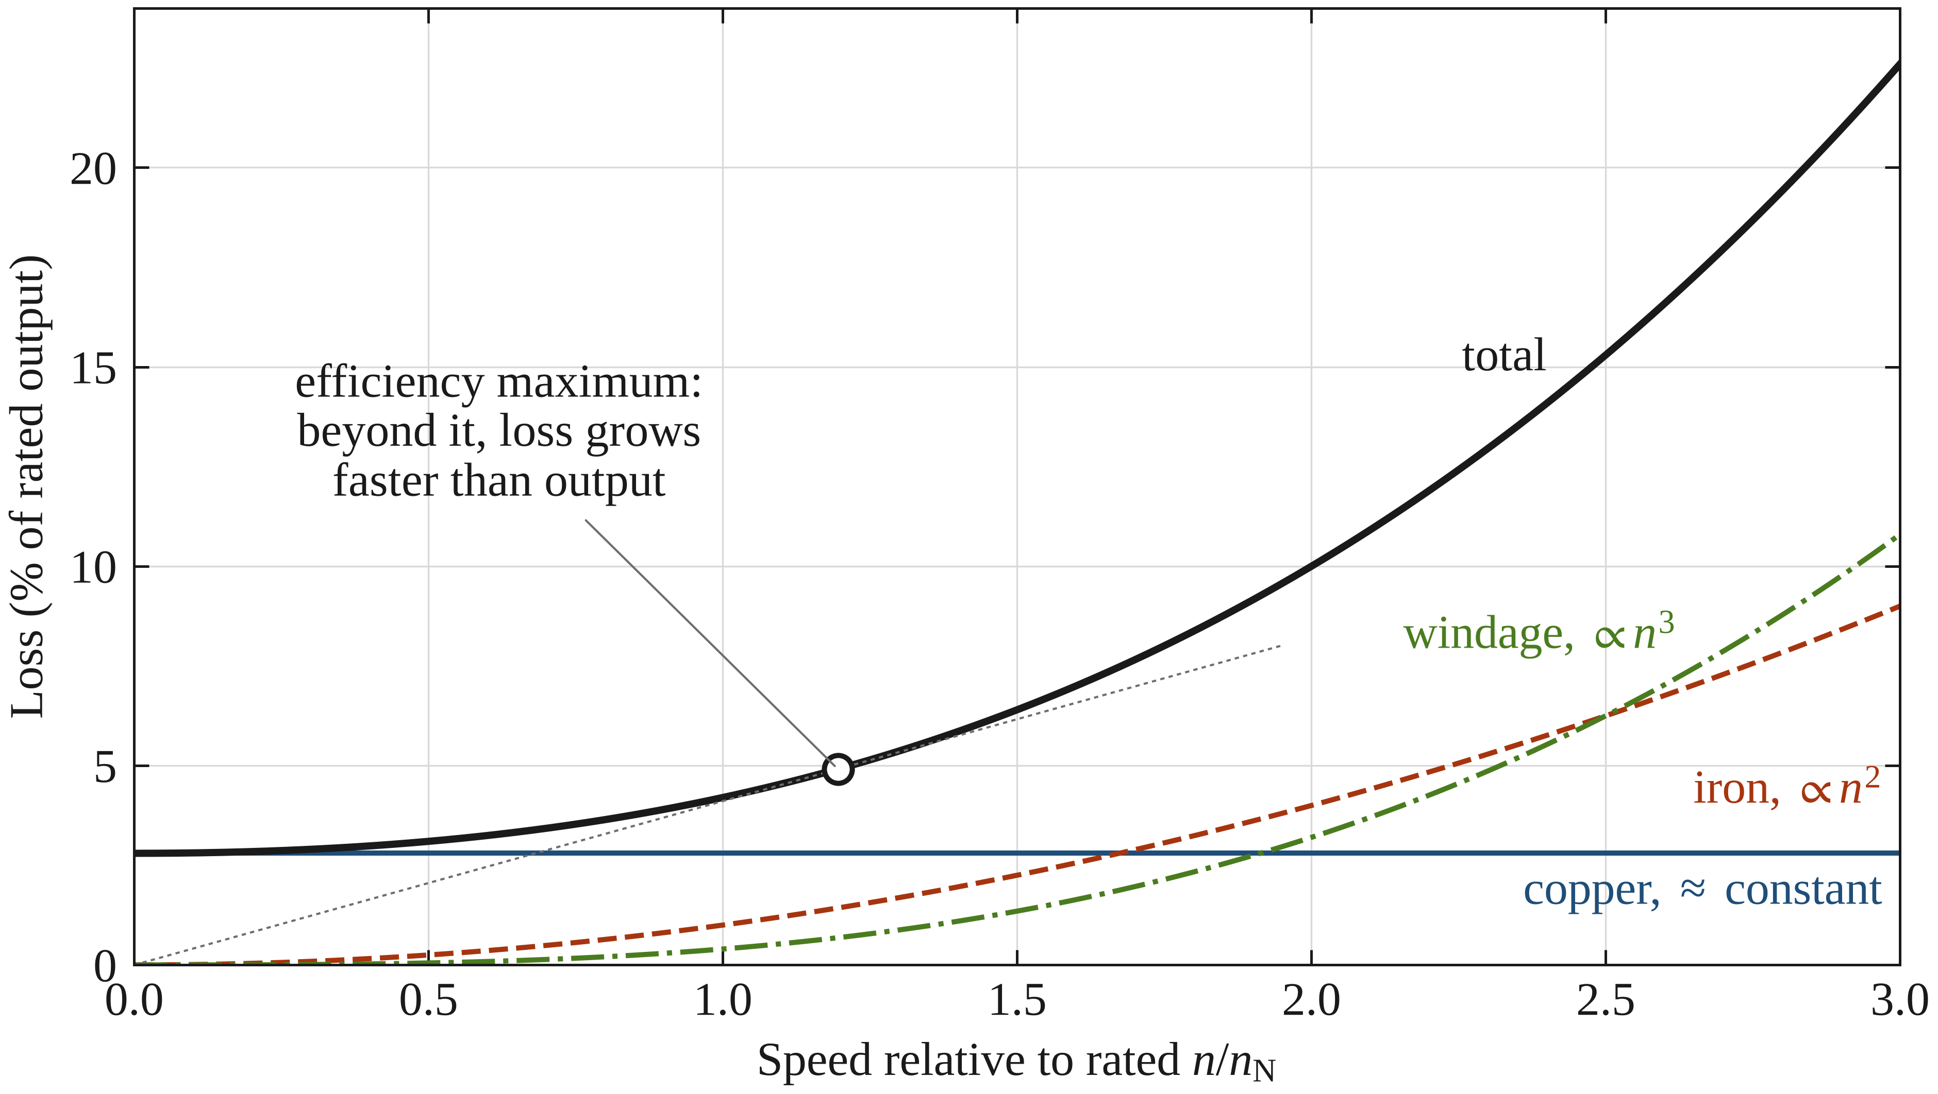
Figure 1.5. Loss components against rotational speed at fixed machine geometry: copper loss approximately constant, iron loss rising roughly with the square of speed and windage with its cube. The onset of efficiency decay marks where loss growth overtakes the linear growth of output power. Section 1.5.5 shows how this picture changes when the machine is redesigned for the higher speed rather than overspeed. The loss values are illustrative (copper 2.8 %, iron 1.0 % and windage 0.4 % of rated output at rated speed); the efficiency maximum lies where the tangent from the origin touches the total loss.

Example: an illustration and its caption, as in Chapter 1
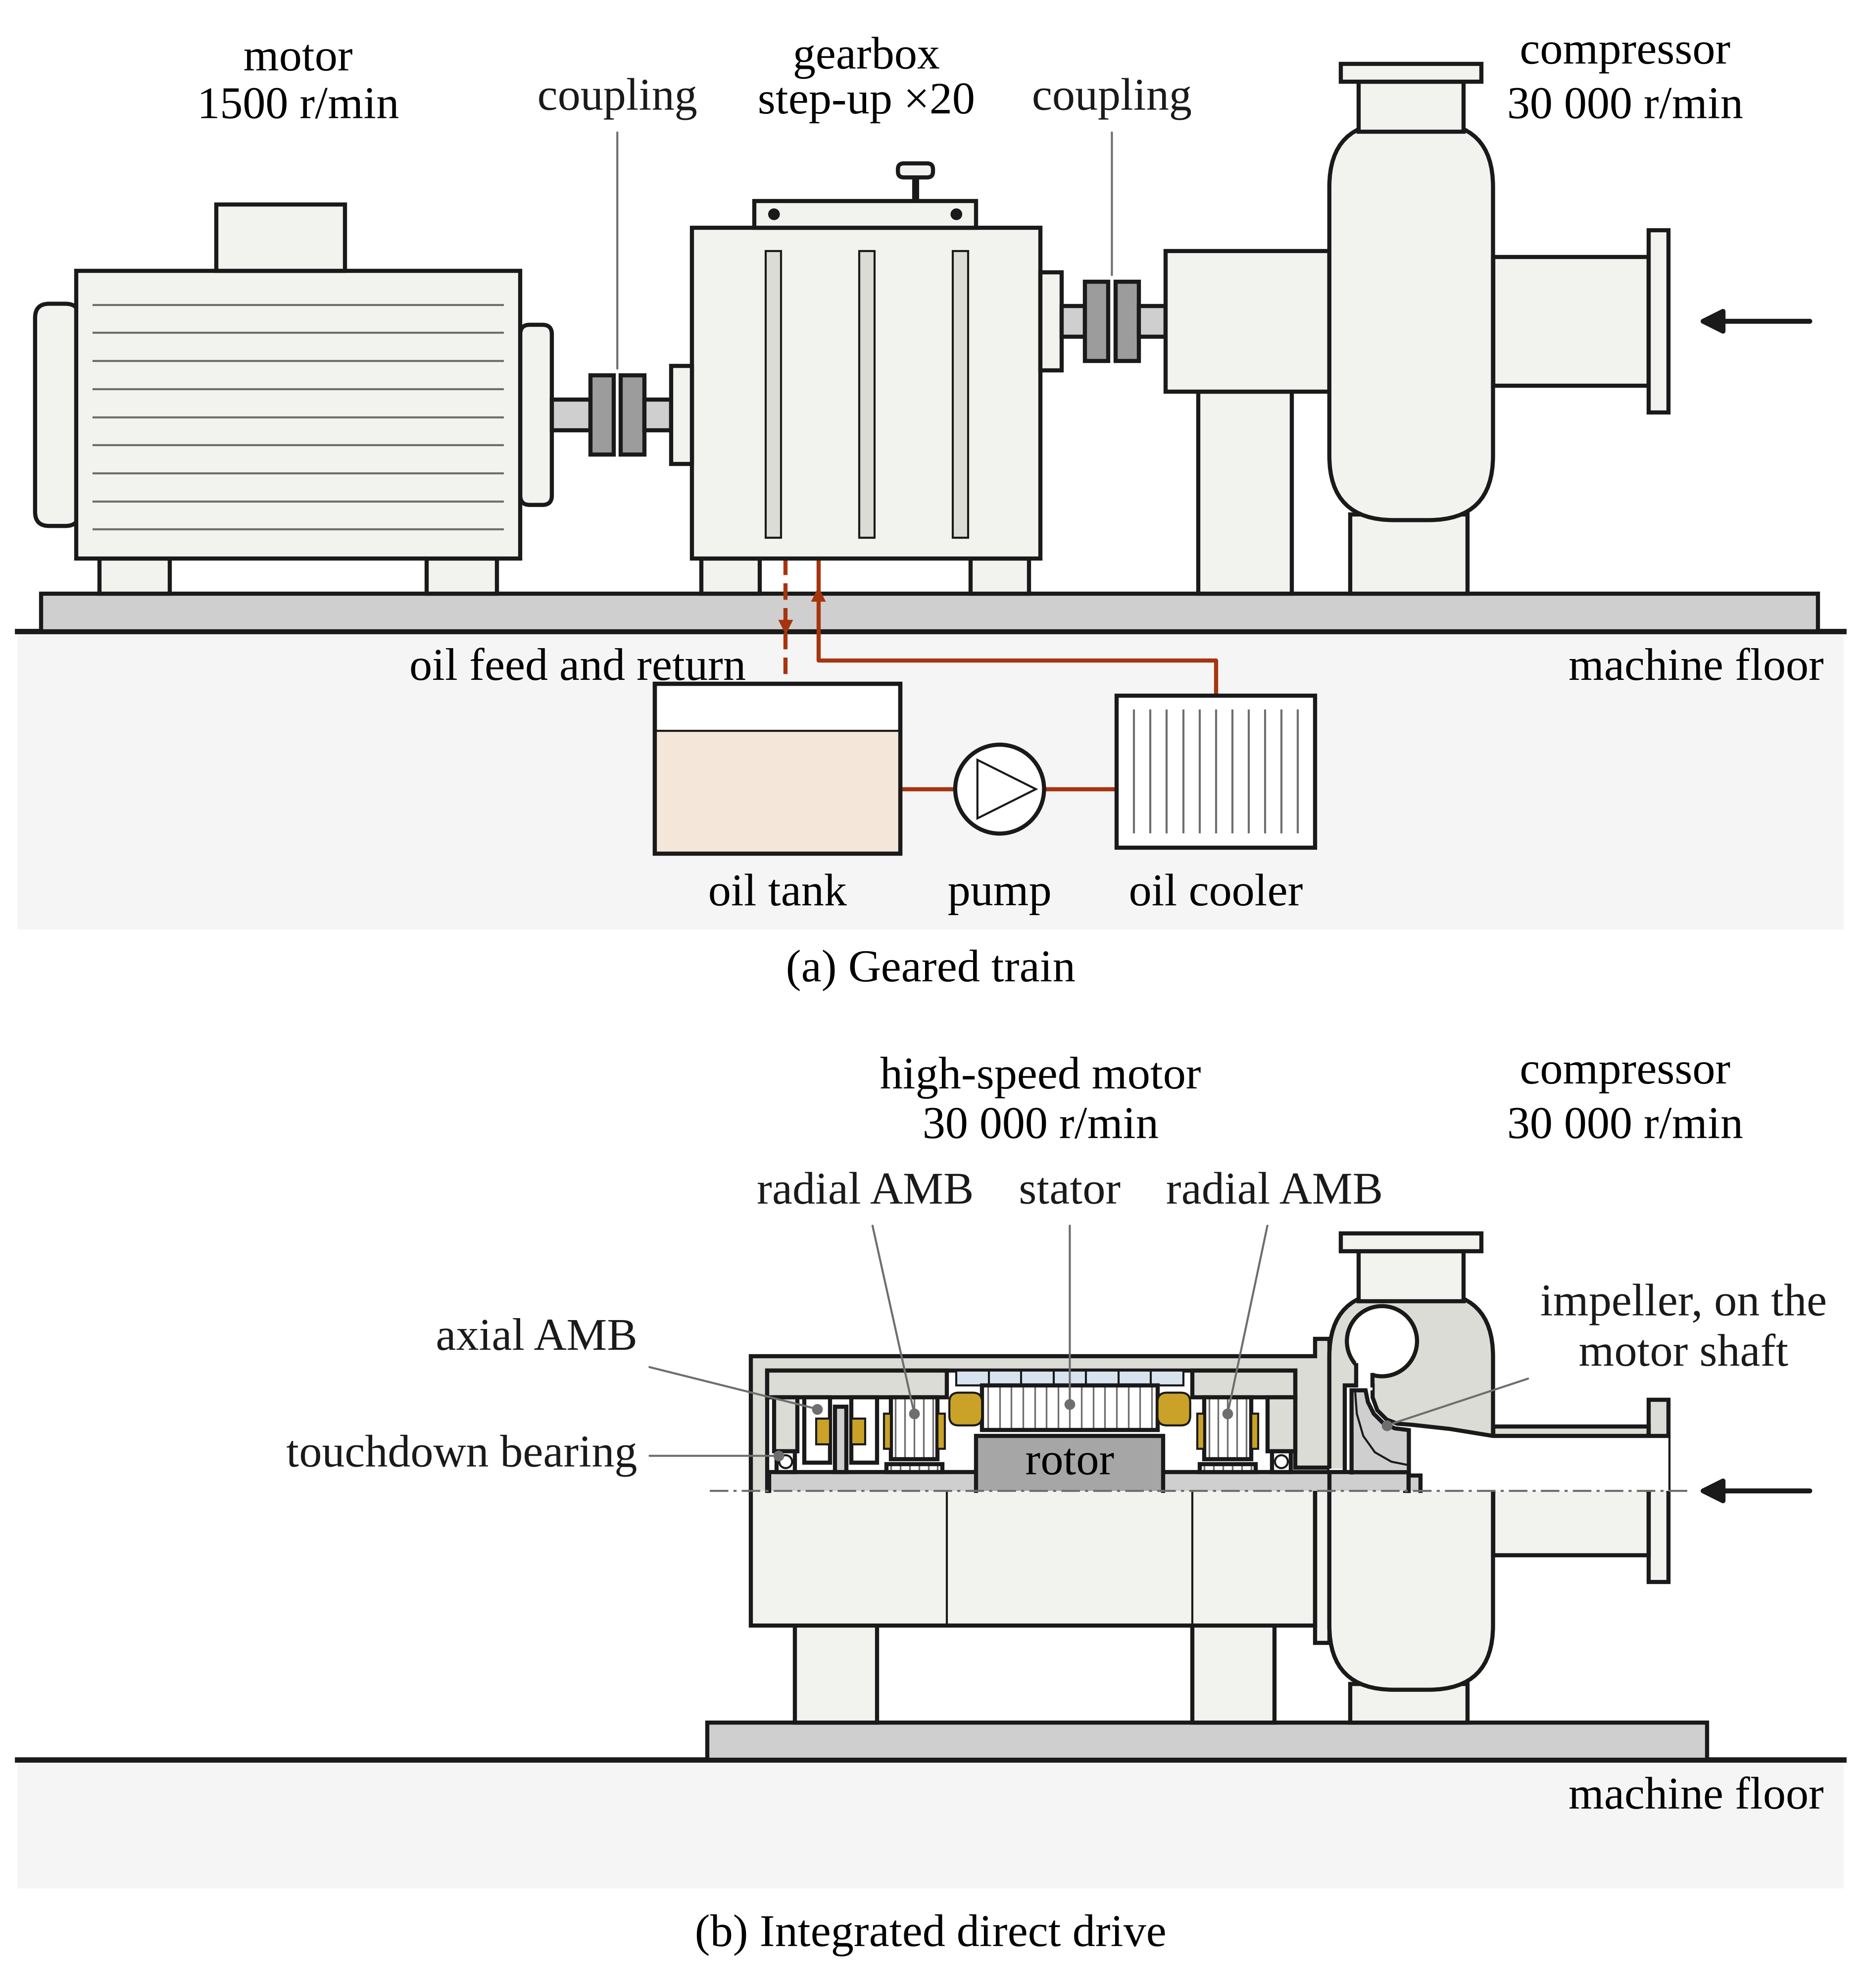
Figure 1.2. Traditional geared and integrated direct-drive architectures. (a) a mains-frequency motor drives the impeller through a step-up gearbox having a heavy lubrication system. (b) the impeller is mounted directly on the high-speed motor shaft, optionally carried on active magnetic bearings (AMBs), and the gearbox, couplings and oil system disappear. In (b) the upper half of the unit is drawn in section.

