**“Envision Prices System Documentation”**

In Partial Fulfillment of the Requirements in the Major Subject

**Modeling and Simulation**

**Submitted by:**

Escorido, Faith P.  
Fabros, Christine Sofia  
Gustilo, Hanah Trexie C.  
Domingo, Ivan Yhuri G.  
Trufil, Jascha Michael L.

Villegas, Daniel M.

**Submitted to:**

Prof. Angelica P. Payne, LPT  
**Modeling and Simulation Adviser**

February 2023

**TABLE OF CONTENTS**

COVER PAGE 1

FLOWCHART 3

INSTRUCTION MANUAL 4

**FLOWCHART**

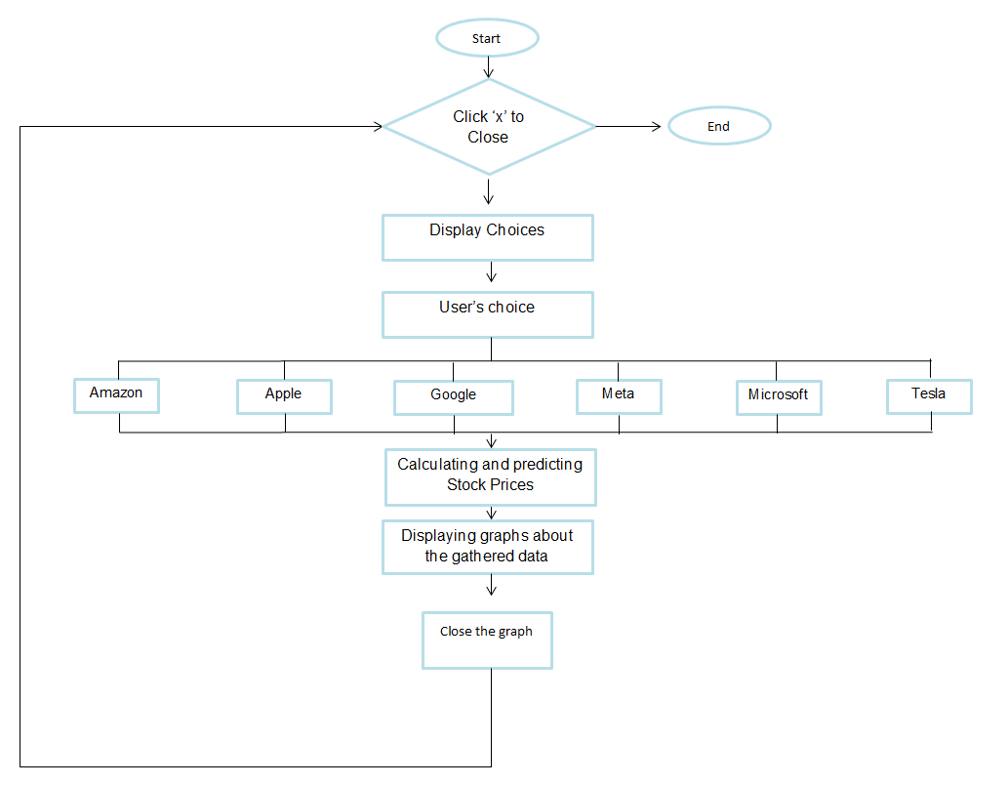

**INSTRUCTION MANUAL**

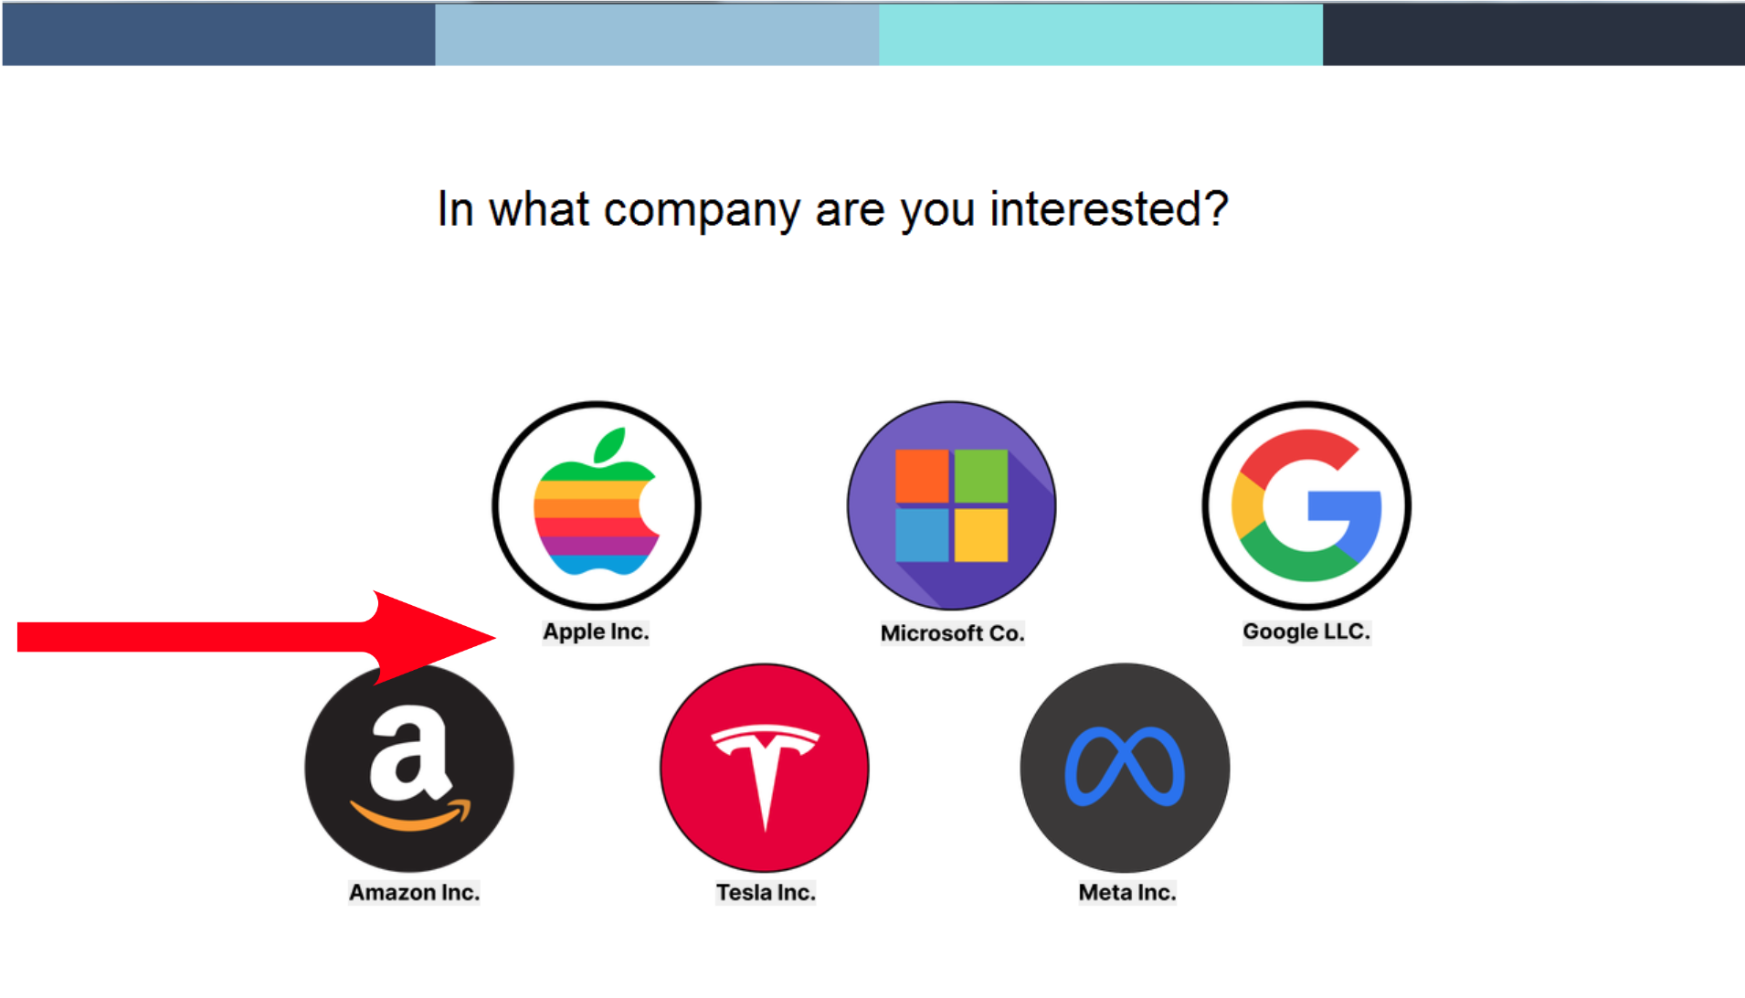

The main menu displays the companies that we can click to see their stock prices history and prediction model. To choose, click the company's name.

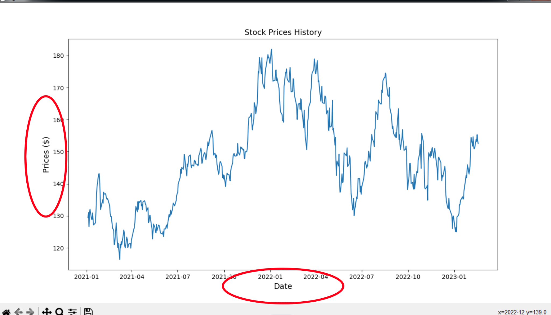

After clicking your chosen company, two figures will be displayed. The first figure shows its stock prices history with Prices and Date as labels.

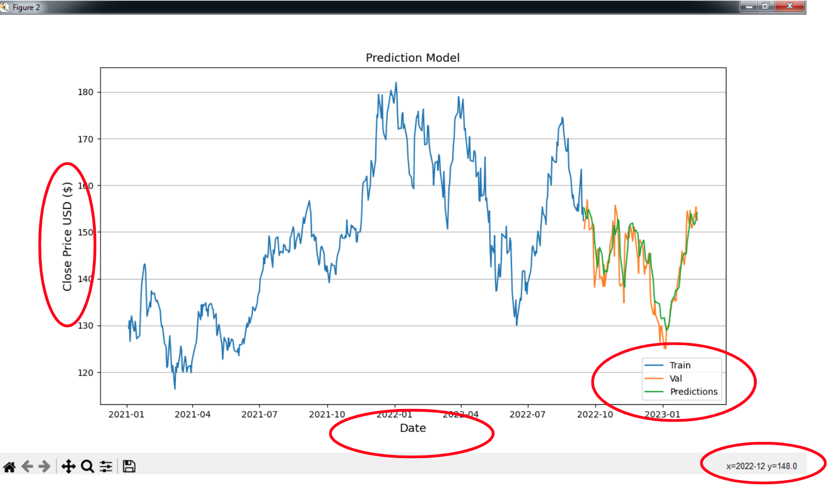

The second figure displays its prediction model with Close Price USD and Date as labels. Hovering over a part of the graph lets you see its exact x and y coordinates, which can be seen on the lower right of the screen.