Azure GAHP Interface
Azure GAHP Commands
Table of Contents

Executing GAHP 2
Linux 2
Windows 2
GAHP commands 3
Common parameters 3
COMMANDS 4
QUIT 4
RESULTS 4
VERSION 4
AZURE_PING 5
AZURE_VM_CREATE 6
AZURE_VM_DELETE 14
AZURE_VM_LIST 18
AZURE_KEYVAULT_CREATE 20
AZURE_VMSS_CREATE 23
Creation of a virtual machine scale set with GAHP job deletion functionality 30
Creation of virtual machine scale sets with GAHP key vault functionality 33
AZURE_VMSS_DELETE 36
AZURE_VMSS_START 39
AZURE_VMSS_STOP 41
AZURE_VMSS_RESTART 43
AZURE_VMSS_SCALE 44

Executing GAHP

Linux
- Open a Terminal in Linux.
- Change the present working directory to the GAHP solution directory or to the directory where the GAHP files were saved.
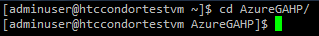
- Run AzureGAHPServer.py using Python.
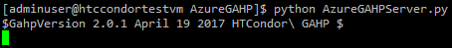

Windows
- Open a Command prompt in Windows.
- Change the present working directory to the GAHP solution directory or to the directory where GAHP files were saved.
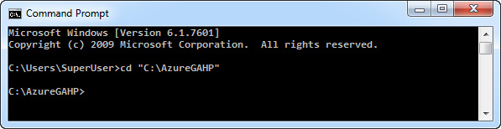
- Run AzureGAHPServer.py using Python.
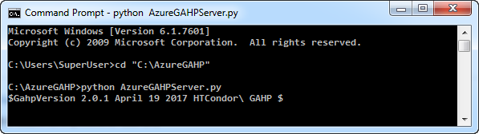

GAHP commands
GAHP provide following commands for the various actions on Azure:
- COMMANDS
- VERSION
- AZURE_PING
- QUIT
- RESULTS
- AZURE_VM_CREATE
- AZURE_VM_DELETE
- AZURE_VM_LIST
- AZURE_VMSS_CREATE
- AZURE_VMSS_DELETE
- AZURE_VMSS_START
- AZURE_VMSS_STOP
- AZURE_VMSS_RESTART
- AZURE_VMSS_SCALE

Common parameters
Below are the common parameters that need to be included with all the commands except COMMANDS, VERSION, QUIT, and RESULTS commands:
- Request Id: (yellow in below example)
  - A unique identification number given to a command so that user can differentiate between the results of multiple commands. For example: 1004
- Path of AppSettings.txt: (green in below example)
  - The path of the AppSettings.txt file that includes information about the azure subscription credentials, thread configuration and automation job configuration.
- Subscription Id: (teal in below example)
  - The Azure subscription id on which GHAP will execute commands.
Example:
AZURE_VMSS_CREATE 1004 /home/adminuser/AzureGAHP/AzureGAHP/AppSettings.txt <subscription_id> name=GahpTest location=centralindia size=Standard_D1_v2 image=linux-ubuntu-latest adminUsername=superuser key=Superuser@123 tag=IT customdata=CustomData.txt nodecount=3 --debug

COMMANDS
Lists all available commands in the GAHP.
Syntax:
COMMANDS
Example:
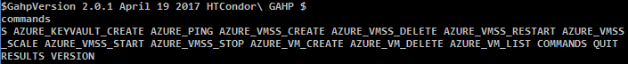

QUIT
Quits the current running instance of GAHP.
Syntax:
QUIT
Example:
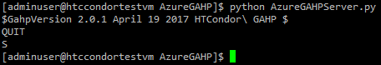

RESULTS
Shows the results from the previous command(s) executed in current session.
Syntax:
RESULTS
Example:
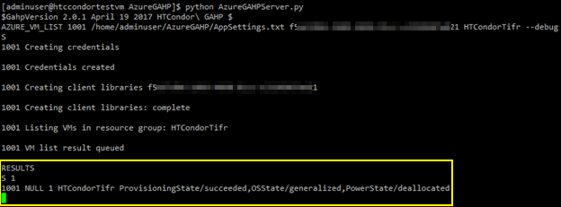

VERSION
Shows the current version of GAHP.
Syntax:
VERSION
Example:
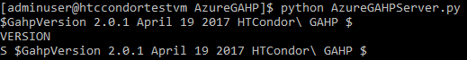

AZURE_PING
Used to validate the service principal of GAHP. It verifies whether GAHP can access the Azure subscription or not.
Syntax:
AZURE_PING
Example:
AZURE_PING 1001 /home/adminuser/AzureGAHP/AzureGAHP/AppSettings.txt <subscription_id> --debug
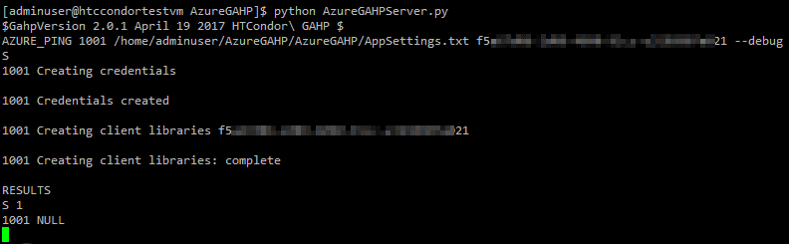

AZURE_VM_CREATE
- Creates a VM in a resource group if the resource group is not available then it first creates the resource group.
- Creates the required artifacts (example – Public IP, Virtual Network, Subnet and NIC) in an Azure subscription based on the options provided with the command.
- Creates a single VM in a single resource group.
Syntax:
AZURE_VM_CREATE <request id> <path of app_settings.txt> <subscription id> name=<resource group name> location=<location> size=<size> ostype=<windows | linux> image=<image name | vhd url> adminUsername=<username> key=<password | key> tag=<tag value> customdata=<data | file path> datadisks=<diskSize1, diskSize2…> vnetName=<VNet name> vnetRGName=<VNet resource group name> subnetName=<Subnet name> --debug
Parameter | Value | Example | Description
name | Resource group name | TestRg0 | Name of the resource group where the VM will be created with  “%RG name% + vm”.
location | Location/region | centralindia | Geographical location/region of the VM and other artifacts.
size | VM size | Standard_A1 | Size for the Azure VMs. This may differ based on the location.
ostype | Operating system | Linux OR Windows | Operating system type.
image | Image or vhd uri | linux-ubuntu-latest  OR  windows-server-latest | Linux /Windows default image or the custom vhd uri.
adminUsername | Username | testuser | Administrator username for login on VM.
key | Admin password or public key | Testuser@123 | Secure password for the admin username.  Public key is only applicable for Linux OS.
tag | Tag value | IT | “Group” is the key for the tag. So for this example tag will be, Group=IT
dataDisks | Data disks size in GB | 50 | Disk size of the VM
customData | Custom data or data file path | customdata.txt | Custom data or path of file with custom data that be used while creating VM.
vnetName | Shared Virtual Network name | TestRgvnet | Name of the Virtual Network where an existing Virtual Network will be shared. The Virtual Network should be in the same region where the VM will be created.
vnetRGName | Resource Group name of the shared virtual network | TestRg | Resource group name of the shared Virtual Network.
subnetName | Existing subnet name | TestRgsubnet | Existing subnet name in the shared Virtual Network.

Example:
- Creation of a Linux VM with TestRg0 resource group in South Central US, Basic_A0 size, a username, and secure password.
AZURE_VM_CREATE 1001 /home/adminuser/AzureGAHP/AzureGAHP/AppSettings.txt <subscription_id> name=TestRg0 location=southcentralus size=Basic_A0 image=linux-ubuntu-latest adminUsername=adminuser key=Adminuser@123 --debug
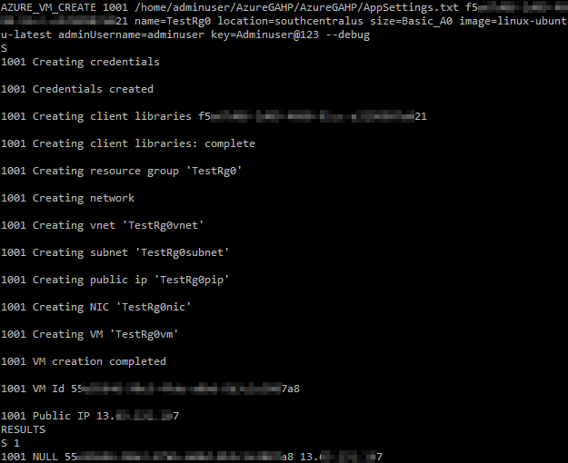
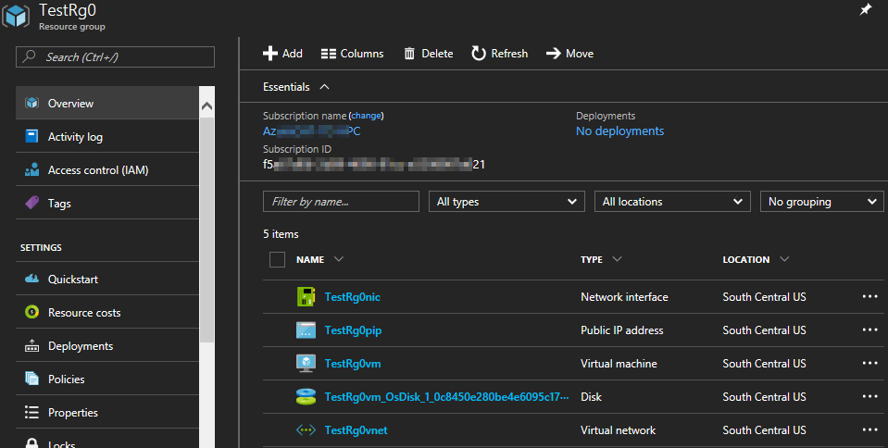
- Creation of a Linux VM with TestRg1 resource group in Central India, Standard_A1 size, a username, and id_rsa.pub public key.
AZURE_VM_CREATE 1002 /home/adminuser/AzureGAHP/AzureGAHP/AppSettings.txt <subscription_id> name=TestRg1 location=centralindia size=Standard_A1 image=linux-ubuntu-latest adminUsername=adminuser key=/home/adminuser/key/id_rsa.pub --debug
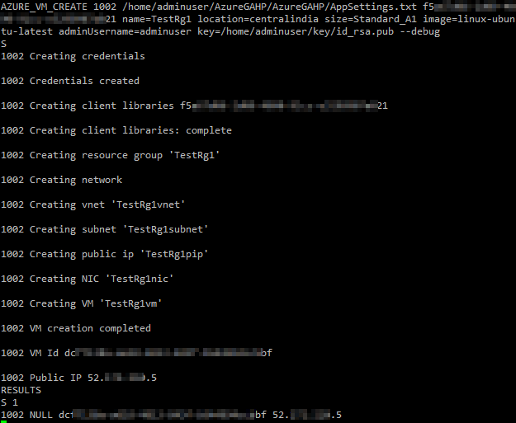
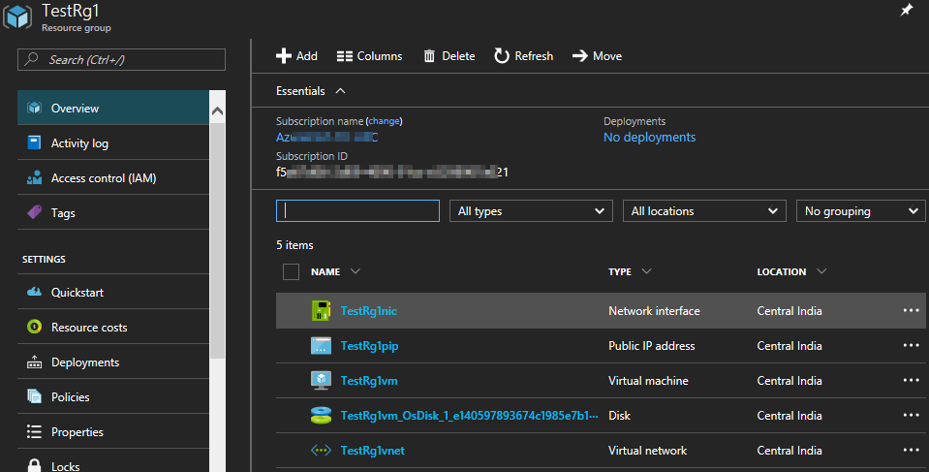
- Creation of a Windows VM with Test1 resource group in Central India, Standard_A1 size, a username, and secure password.
AZURE_VM_CREATE 1003 /home/adminuser/AzureGAHP/AzureGAHP/AppSettings.txt <subscription_id> name=Test1 location=centralindia size=Standard_A1 image=windows-server-latest adminUsername=adminuser key=Adminuser@123 --debug
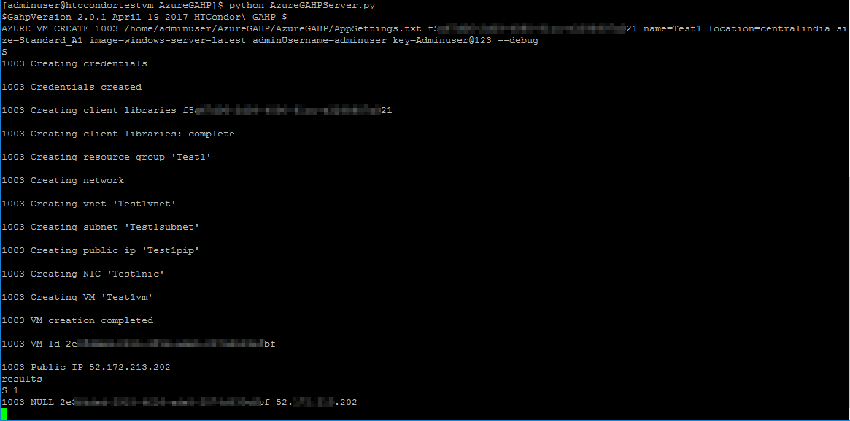
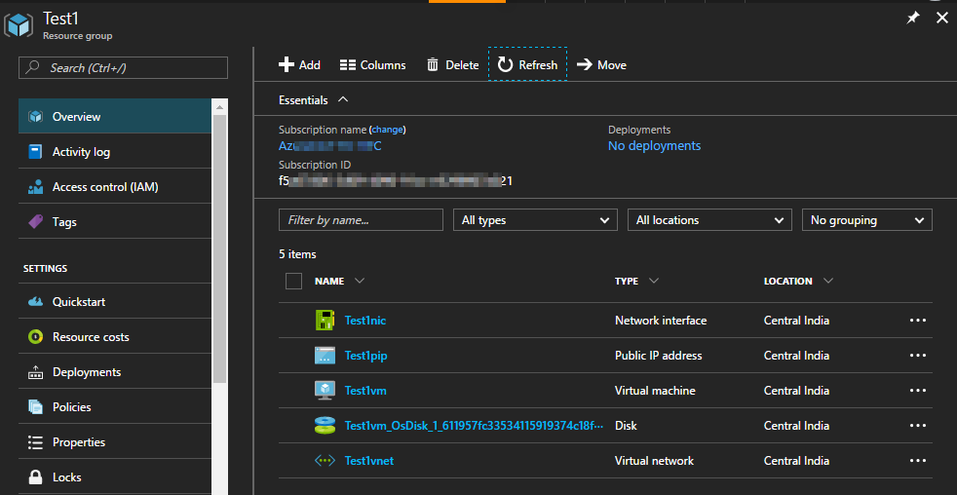

- Creation of a Linux VM with TestRg3 resource group in South Central US, Standard_A1 size, a username, and secure password where existing Virtual Network TestRgvnet of TestRg resource group will shared.
AZURE_VM_CREATE 1004 /home/adminuser/AzureGAHP/AzureGAHP/AppSettings.txt <subscription_id> name=TestRg3 location=southcentralus size=Basic_A0 image=linux-ubuntu-latest adminUsername=adminuser key=Adminuser@123 vnetName=TestRg0vnet vnetRGName=TestRg0 --debug
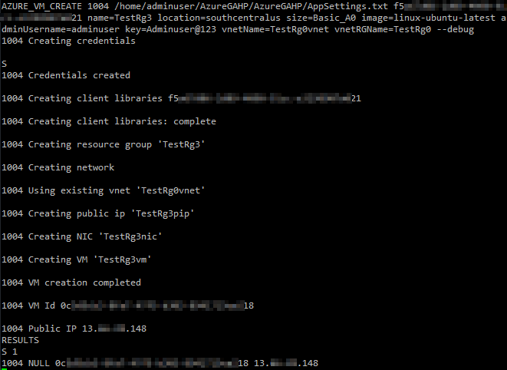
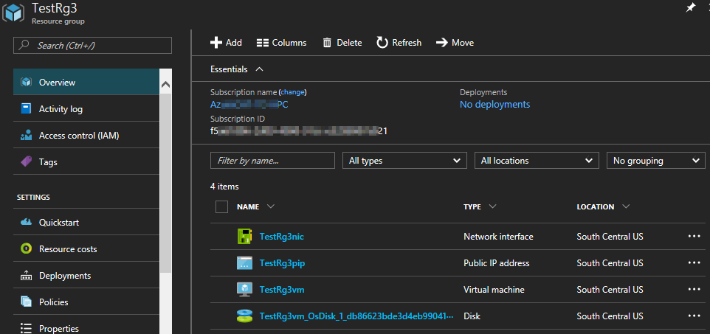
- Creation of a Linux VM with TestRg4 resource group in Central India, Standard_A1 size, a username, and secure password using a custom image.
AZURE_VM_CREATE 1005 /home/adminuser/AzureGAHP/AzureGAHP/AppSettings.txt <subscription_id> name=TestVHD location=centralindia size=Basic_A0 adminUsername=adminuser key=Adminuser@123 osType=linux image=<vhd_url> --debug
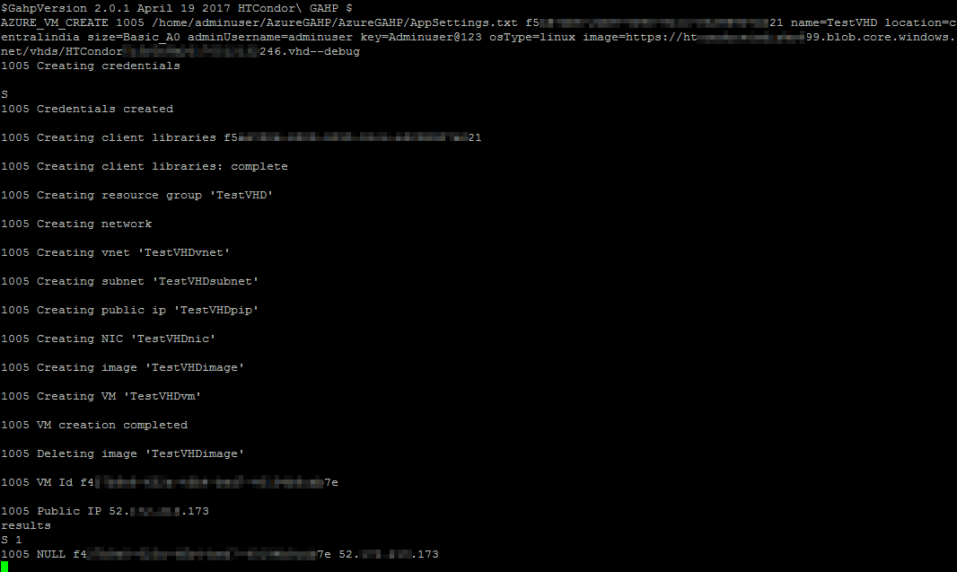
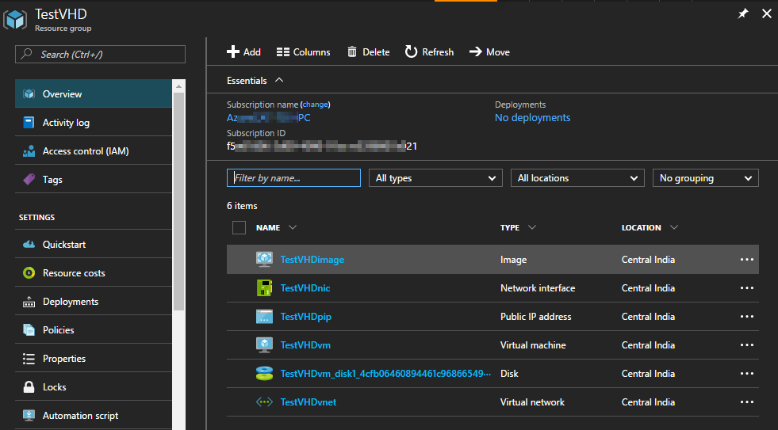
- Creation of a Linux VM with TestRg3 resource group in South Central US, Standard_A1 size, a username, and secure password where existing Virtual Network TestRgvnet and TestRgsubnet2 of TestRg resource group will be shared.
AZURE_VM_CREATE 1006 /home/adminuser/AzureGAHP/AzureGAHP/AppSettings.txt <subscription_id> name=TestRg6 location=southcentralus size=Basic_A0 image=linux-ubuntu-latest adminUsername=adminuser key=Adminuser@123 vnetRGName=TestRg0 vnetName=TestRg0vnet subnetName=TestRg0subnet2 --debug
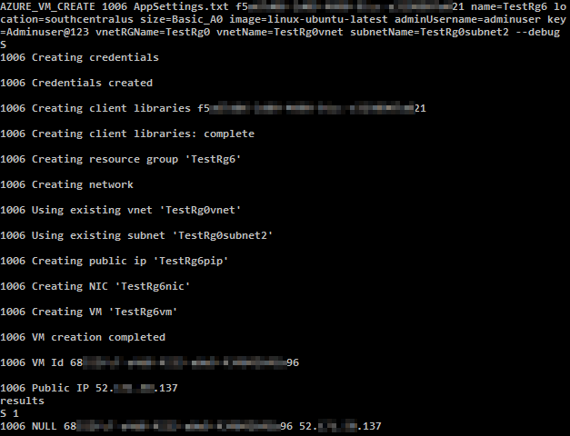

Existing subnets in the TestRg0vnet Virtual Network:
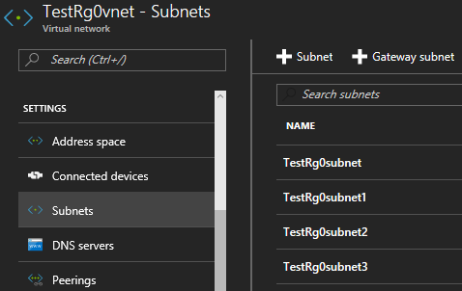
TestRg6 Resource group with all the created artifacts:
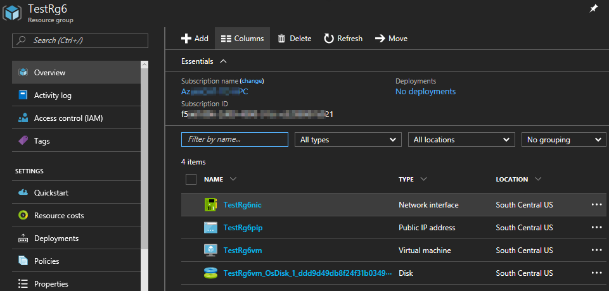

Existing TestRg0subnet2 subnet is used to share TestRg0vnet Virtual Network with TestRg6nic nic of TestRg6vm VM:
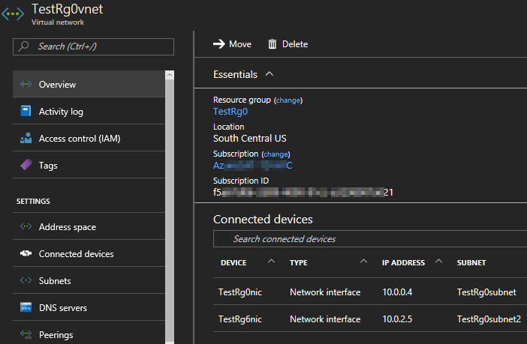

AZURE_VM_DELETE
Used to delete a resource group, VM, and associated artifacts.
Syntax:
AZURE_VM_DELETE <request id> <path of app_settings.txt> <subscription id> <resource group name> <vm name>
# | Parameter Name | Required | Description
1 | Resource group name | Yes | Resource group name
2 | VM name | No | VM name

Example:
- Delete VM and associated artifacts by deleting resource group:
AZURE_VM_DELETE 10019 /home/adminuser/AzureGAHP/AzureGAHP/AppSettings.txt <subscription_id> Test
Where “Test” is the resource group name.
Before deleting:
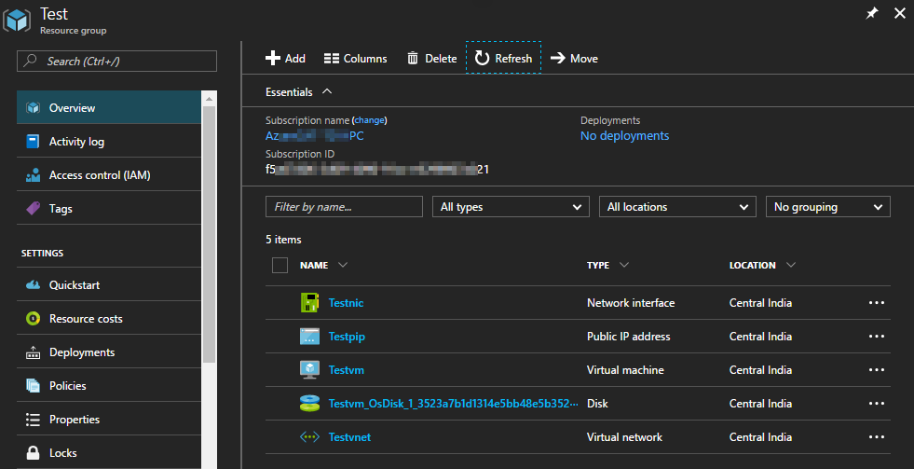

Delete command status:
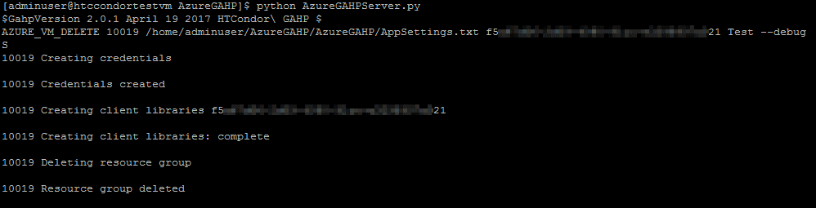
Deleting resource group:
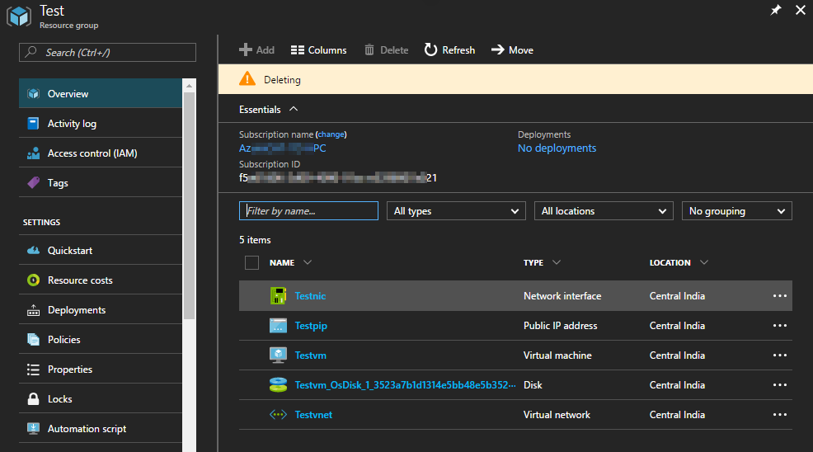

- Delete VM -
AZURE_VM_DELETE 10020 /home/adminuser/AzureGAHP/AzureGAHP/AppSettings.txt <subscription_id> Test Testvm
Where “Test” is the resource group and “Testvm” is the VM name.

Before deleting VM:
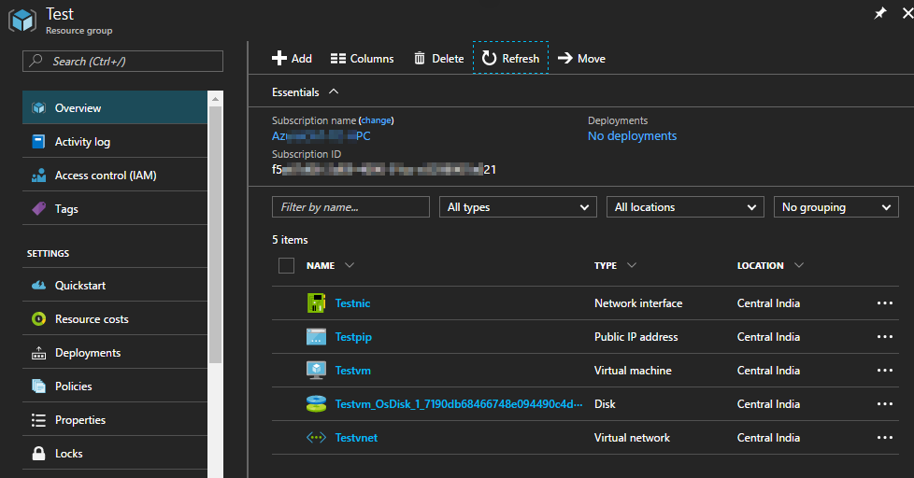

Delete command status:

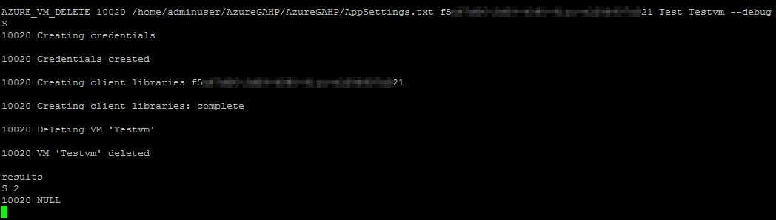

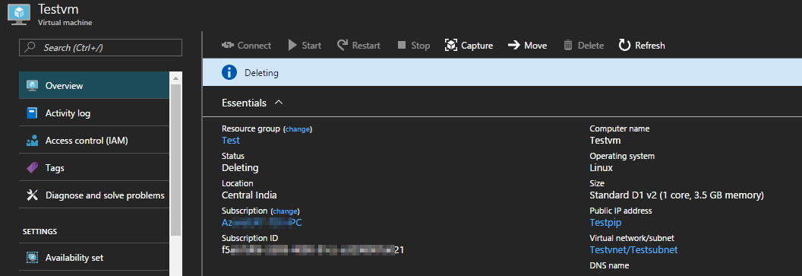
After deleting VM:

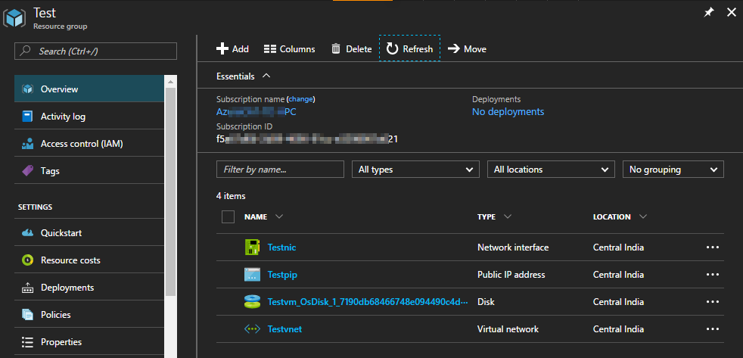

AZURE_VM_LIST
- Lists all the VMs by different search options (subscription, resource group, and tag).
- Shows the resource group name of a VM and the VM power state in single line.
Syntax:
AZURE_VM_LIST <request id> <path of app_settings.txt> <subscription id> <resource group name> <vm name> tag=[tag value]
Example:
- List all the VMs in the subscription:
AZURE_VM_LIST 1001 /home/adminuser/AzureGAHP/AzureGAHP/AppSettings.txt <subscription_id>
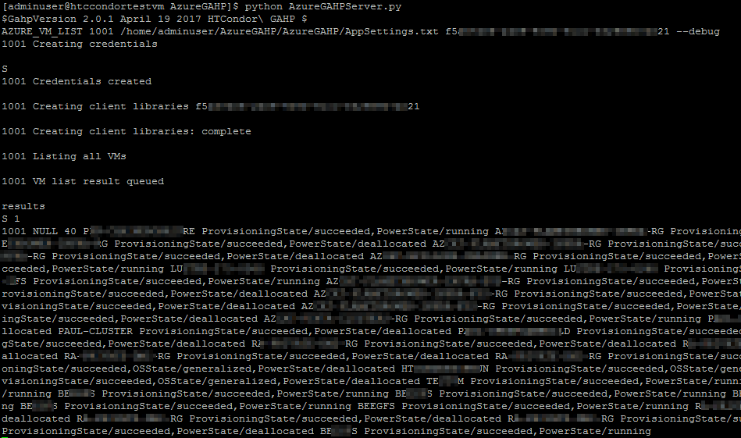
- List all the VMs in the resource group:
AZURE_VM_LIST 1002 /home/adminuser/AzureGAHP/AzureGAHP/AppSettings.txt <subscription_id> Test
Where “Test” is the resource group name.
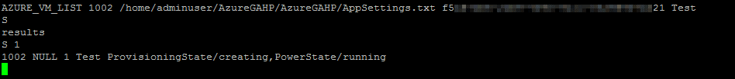
- List a specific VM:
AZURE_VM_LIST 1003 /home/adminuser/AzureGAHP/AzureGAHP/AppSettings.txt <subscription_id> Test Testvm --debug
Where “Test” is the resource group and “TestVM” is the VM name.
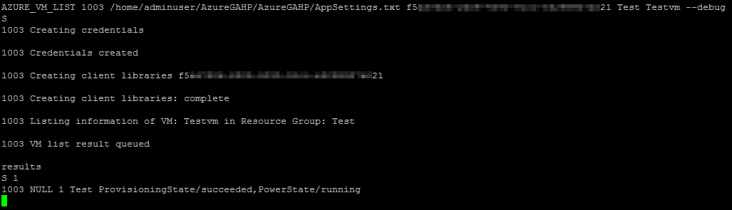
- List VMs by tag:
AZURE_VM_LIST 1004 /home/adminuser/AzureGAHP/AzureGAHP/AppSettings.txt <subscription_id> tag=IT
Where “IT” is a tag given to a group of VMs for the IT Dept.

AZURE_KEYVAULT_CREATE
The GAHP server key vault functionality downloads value of a key vault secret in the virtual machine scale set node in the post deployment phase.
Using AZURE_KEYVAULT_CREATE command, GAHP user can create or use (if already exists) the required artifacts for this functionality.
Following are pre-requisite to use key vault functionality.
- An Azure AD group.
- An Azure Key Vault.
- Shell script to download secret in virtual machine scale set nodes.
The GAHP user needs to provide user ID(s) of the user(s) who will add keys, secrets or certificates from Azure portal. To determine the user ID for a user, in the Azure portal, click the name of the directory and then click the Users tab. The User Name column lists each user ID.
The GAHP user will have to set an Azure AD group name in the AppSettings.txt file. GAHP server will create an Azure Key Vault with an Azure AD security group, add that AD group and the users (using their user IDs) in the access policies of the key vault. If the Azure AD group already exists, GAHP server will use it for the key vault functionality.
Once the key vault creation is complete, secret can be created from Azure portal by any of the user added in the access policies of the key vault.
Syntax:
AZURE_KEYVAULT_CREATE <request id> <path of app_settings.txt> <subscription id> DeletionJob name=<resource group name> location=<location> sku=<sku> users=<user_id0>,<user_id1> --debug
Parameters:
Parameter | Value | Example | Description
Name | Resource group name | TestRg | Name of the resource group where key vault will be created with  “%RG name% + kv”.
location | Location/region | Centralindia | Geographical location/region of the keyvault.
sku | Standard or Premium | Standard | Pricing tier of the key vault.
Users | Object ids of the users separated by comma and no space allowed | gh4y7d06-2yr6-5048-46gd-e3298907b654, u5a65gh06-1g39-4090-65cc-e3293407a234 | Access policies for users with id <user_id0>, <user_id1> will be added so that they can add keys, secrets or certificates from Azure portal.
Example:
- Creation of a Gahpkv key vault with Gahp resource group in Central India, Standard sku and access policies for user_id0, user_id1.
AZURE_KEYVAULT_CREATE 1001 AppSettings.txt <subscription_id> name=Gahp location=centralindia sku=standard users=<user_id0>, <user_id1> --debug
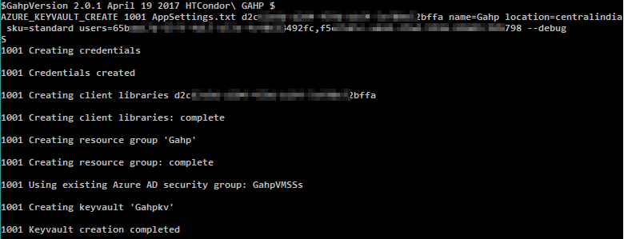
Creation of Gahpkv key vault.
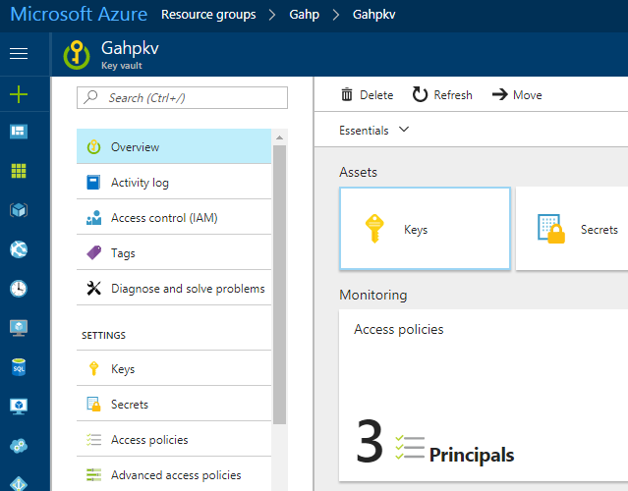

Creation of access policies for users and AD group.
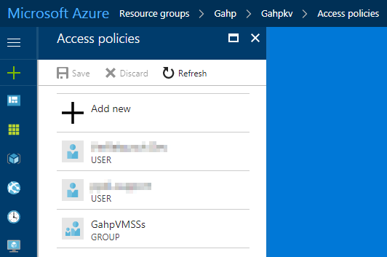
Creation of GahpVMSSs group.
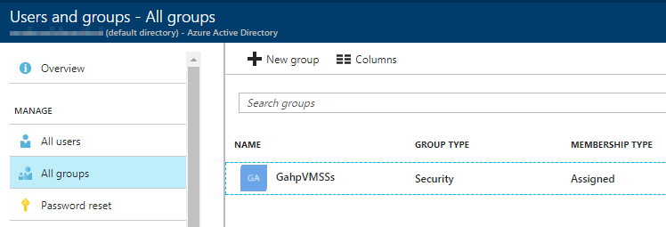

AZURE_VMSS_CREATE
Create a virtual machine scale set after creating a resource group in an Azure subscription based on the options provided with the command.
The DeletionJob parameter, if used, can schedule a job in Azure that will delete the resource group at the scheduled time. It will create a scheduler job collection that will have a scheduled job that will execute the PowerShell script to delete the created virtual machine scale set at a schedule time. DeletionJob parameter requires Azure Automation account to automate the process.
Syntax:
AZURE_VMSS_CREATE <request id> <path of app_settings.txt> <subscription id> DeletionJob name=<resource group name> location=<location> size=<size> ostype=<windows | linux> image=<image name | vhd url> adminUsername=<username> key=<password | key> tag=<tag value> customdata=<data | file path> datadisks=<diskSize1, diskSize2…> nodecount=<number of VMs> vnetName=<VNet name> vnetRGName=<VNet resource group name> schedule=<scheduled date and time> keyvaultname=<Azure key vault name> vaultname=<Secret name> --debug
Parameters:
Parameter | Value | Example | Description
name | Resource group name | TestRg | Name of the resource group where VM will be created with  “%RG name% + vmss”.
location | Location/region | Centralindia | Geographical location/region of the VM and other artifacts.
size | VM size in the virtual machine scale set | Standard_A1 | Size for the Azure virtual machines in a virtual machine scale set. This may differ based on the location.
ostype | Operating system | Linux OR windows | Operating system type for VMs in virtual machine scale set.
image | Image or vhd uri | linux-ubuntu-latest  OR  windows-server-latest | Linux / windows default image or the custom vhd uri.
adminUsername | Username | Testuser | Administrator username for login.
key | Admin password or public key | Testuser@123 | Secure Password for the username for login.  Public key is only applicable for Linux OS.
tag | Tag value | IT | “Group” is key of the tag. So, for this example tag will be, Group=IT.
dataDisks | Data disks size in GB | 50 | Disk size of the VMs in virtual machine scale set.
customData | Custom data or data file path | customdata.txt | Custom data or path of file with custom data which be used while creating virtual machine scale set.
nodecount | Number of VMs | 25 | Number of VMs to be created in a virtual machine scale set.
vnetName | Shared Virtual Network name | ContosoVnet | Name of the Virtual Network where an existing Virtual Network will be shared. The Virtual Network should be in the same region where the virtual machine scale set will be created.
vnetRGName | Resource Group name of the shared Virtual Network | Contoso | Resource group name of the shared Virtual Network.
DeletionJob |  |  | Indicator to register delete job to delete virtual machine scale set with a schedule.
schedule | Job schedule date and time in given format: YYYYMMDDHHmm | 201706140435 | The date and time at which the scheduled job will start deletion of virtual machine scale set. The date and time should in UTC and in the given format, YYYYMMDDHHmm.
keyvaultrg | Resource group name of the Azure Key Vault | ContosoKeyVaultRg | Name of the resource group of the Azure Key Vault.
keyvaultname | Azure Key Vault name | ContosoKeyVault | Name of the Azure Key Vault where the secret is available.
vaultkey | Secret name | ContosoSecret | Name of the Secret that is available in the provided Azure Key Vault.

Example:
- Creation of a Linux virtual machine scale set with Test1 resource group in South Central US with Standard_D1_v2 size, a username, and secure password.
AZURE_VMSS_CREATE 1001 /home/adminuser/AzureGAHP/AzureGAHP/AppSettings.txt <subscription_id> name=Test1 location=southcentralus size=Standard_D1_v2 image=linux-ubuntu-latest adminUsername=adminuser key=Adminuser@123 nodecount=3 --debug
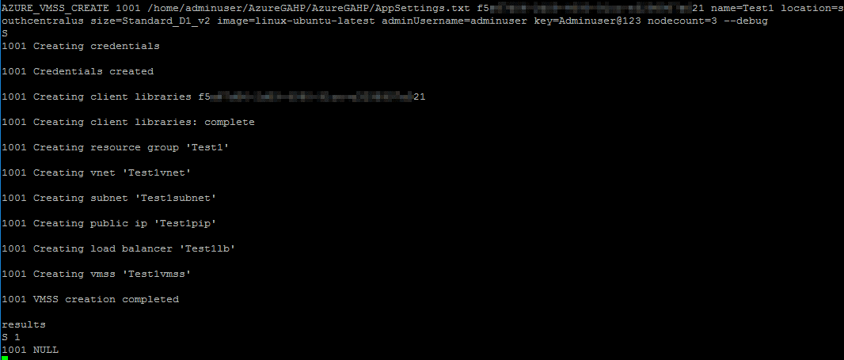
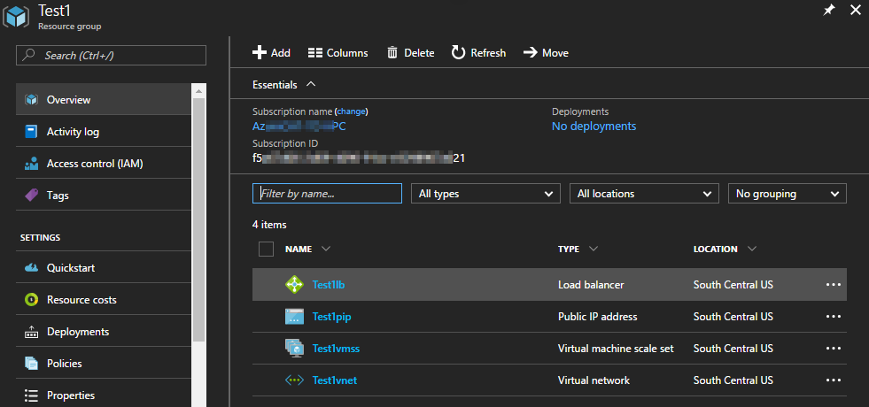
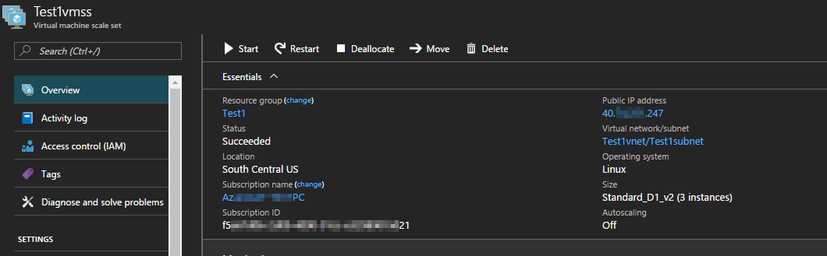
- Creation of a Linux virtual machine scale set with Test2 resource group in Central India with Standard_A1 size, a username, and id_rsa.pub public key.
AZURE_VMSS_CREATE 1002 /home/adminuser/AzureGAHP/AzureGAHP/AppSettings.txt <subscription_id> name=Test2 location=centralindia size=Standard_A1 image=linux-ubuntu-latest adminUsername=adminuser key=/home/adminuser/.ssh/id_rsa.pub –debug
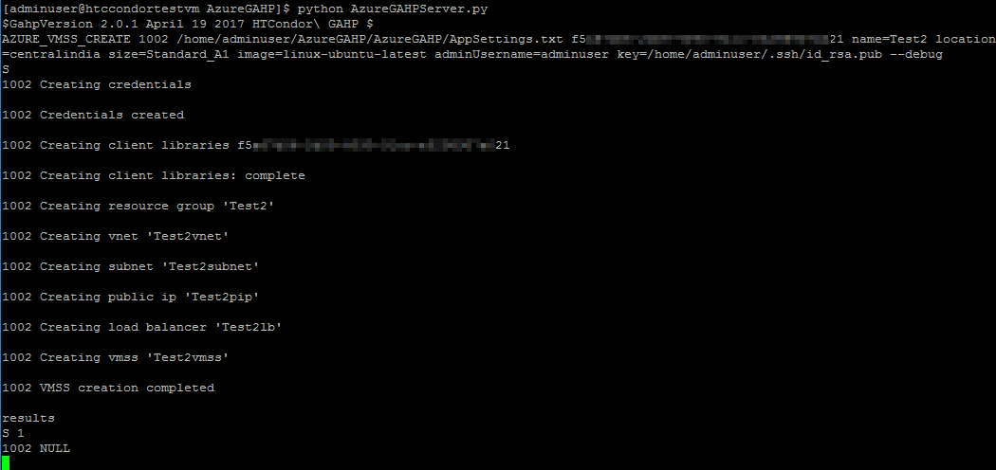
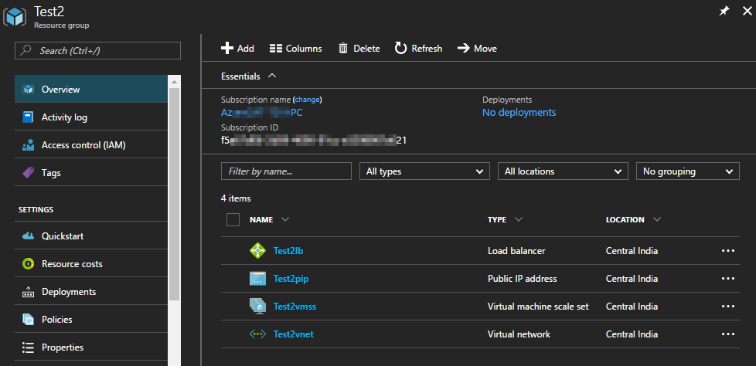
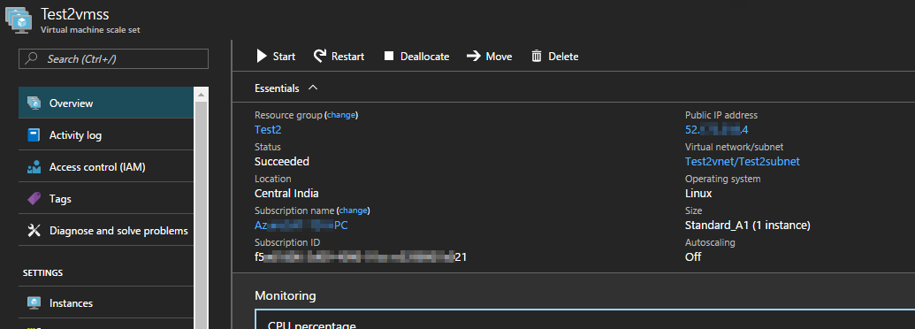
- Creation of a Windows virtual machine scale set with Test3 resource group in Central India with Standard_D1_v2 size, a username, and secure password.
AZURE_VMSS_CREATE 1003 /home/adminuser/AzureGAHP/AzureGAHP/AppSettings.txt <subscription_id> name=Test3 location=centralindia size=Standard_D1_v2 image=windows-server-latest adminUsername=adminuser key=Adminuser@123 nodecount=2 –debug
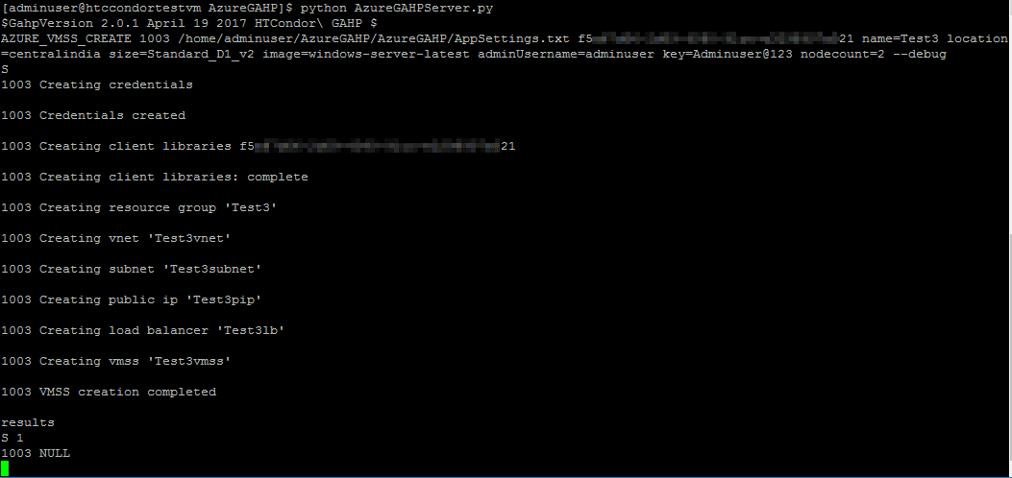
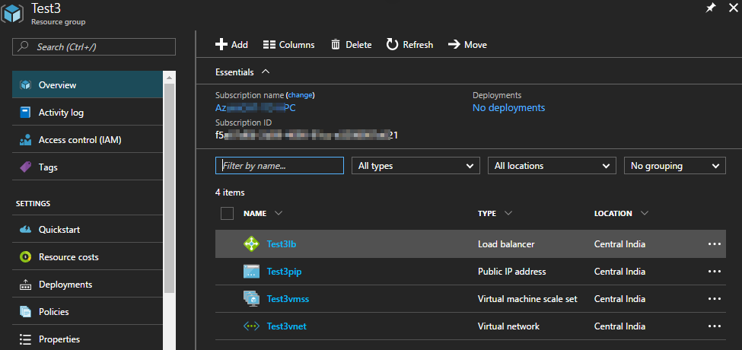
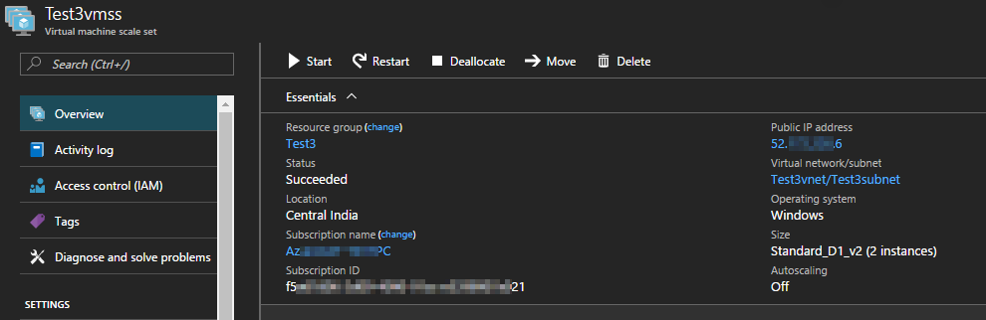
- Creation of a Windows virtual machine scale set with Test4 resource group in Central India, Standard_A1 size, a username, and secure password where existing Virtual Network TestVnet of TestRg resource group will be used.
AZURE_VMSS_CREATE 1004 /home/adminuser/AzureGAHP/AzureGAHP/AppSettings.txt <subscription_id> name=Test4 location=centralindia size=Standard_A1 image=windows-server-latest adminUsername=adminuser key=Adminuser@123 vnetName=TestVnet vnetRGName=TestRg --debug
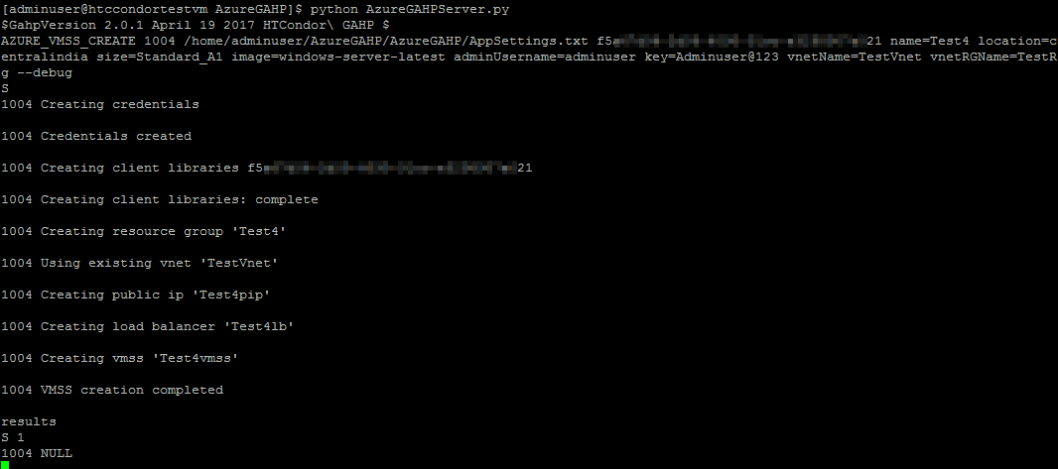
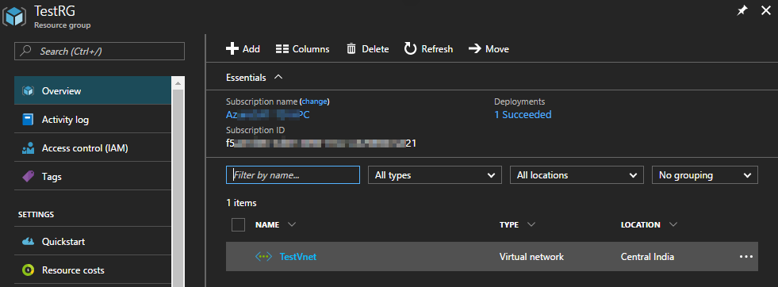
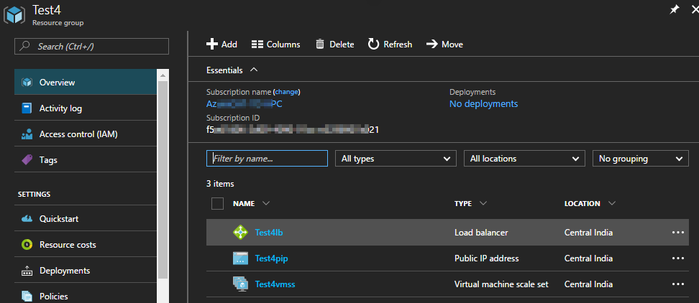
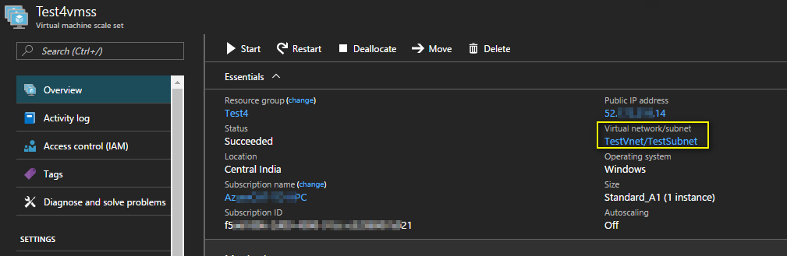

Creation of a virtual machine scale set with GAHP job deletion functionality
- Creation of a Linux virtual machine scale set in GahpTestRg1 resource group with 2 instances in Central India, Standard_A1 size, a username, and secure password. The DeletionJob parameter will allow user to schedule a time at which the created virtual machine scale set will get deleted automatically. The scheduled time must be in UTC and in YYYYMMDDHHmm format.
AZURE_VMSS_CREATE 10013 AppSettings.txt <subscription_id> DeletionJob name=GahpTestRg1 location=centralindia size=Standard_D1_v2 image=linux-ubuntu-latest adminUsername=adminuser key=Adminuser@123 tag=IT nodecount=2 schedule=201706221300 --debug
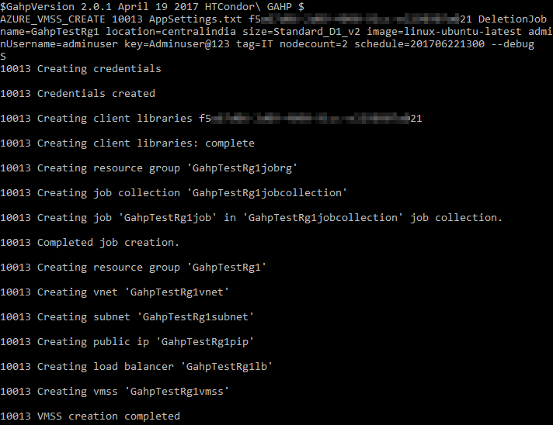

The virtual machine scale set and scheduled job got created successfully.
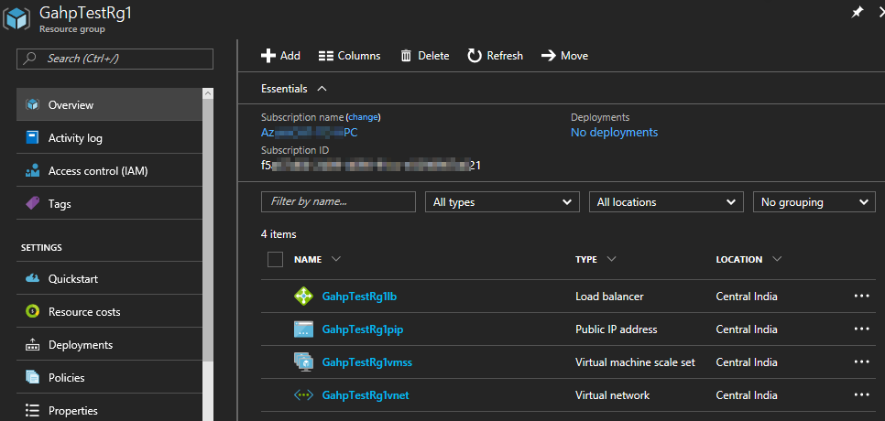
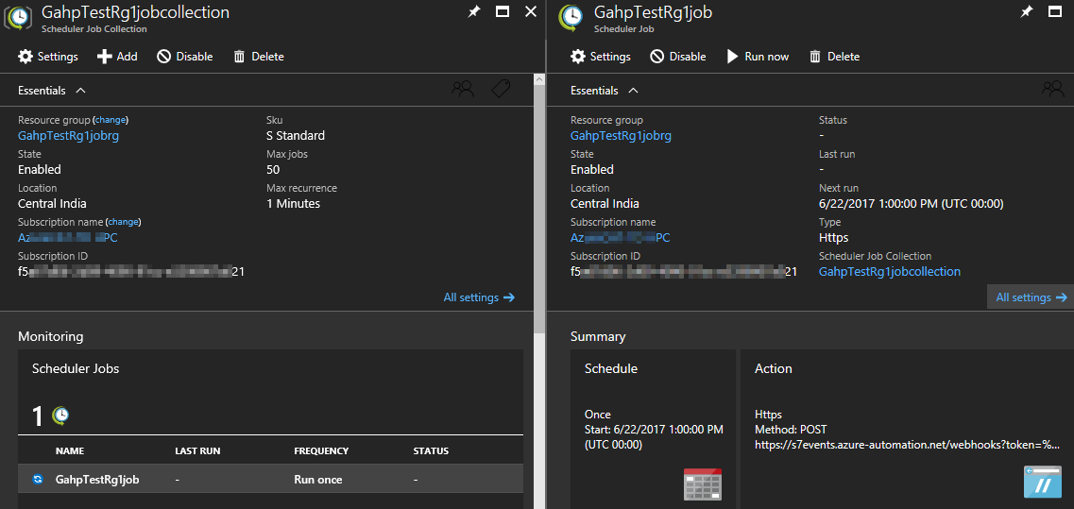

The scheduled job ran successfully.
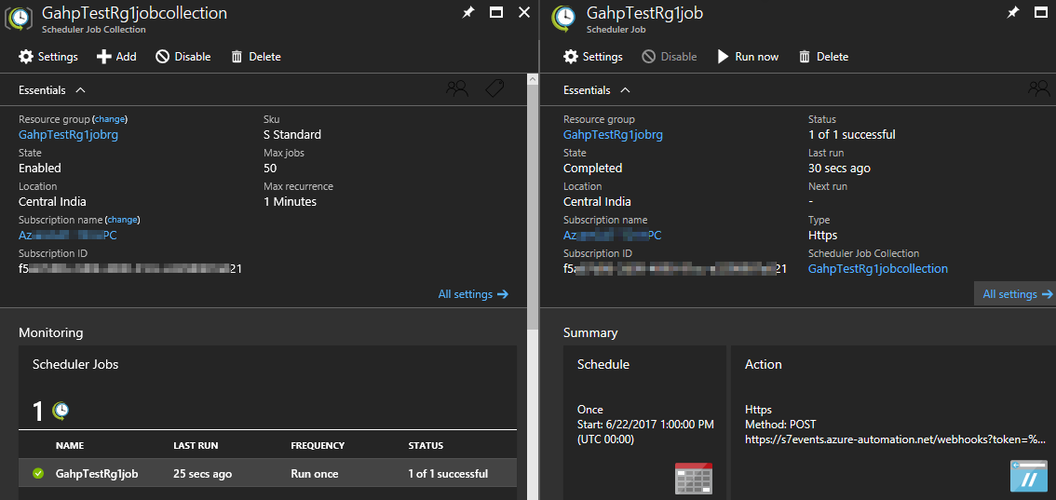
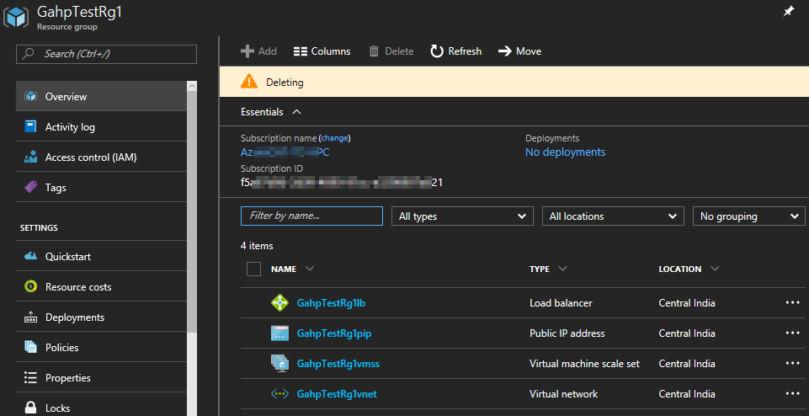
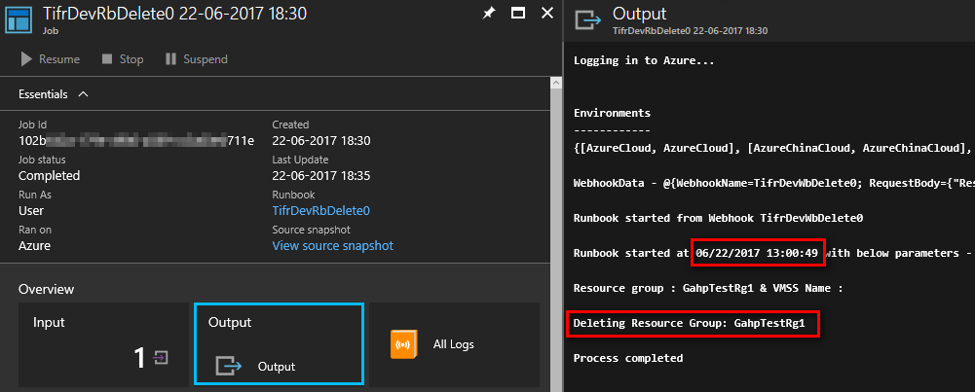

Creation of virtual machine scale sets with GAHP key vault functionality
GAHP key vault functionality allows a user to download the latest value of secret from an Azure Key Vault in the virtual machine scale set nodes created using AZURE_VMSS_CREATE command.

Note
The user needs to perform the following to use the key vault functionality of GAHP.
1. Create a key vault using the AZURE_KEYVAULT_CREATE command.
2. Manually create a secret in the created key vault.
3. Provide Azure Key Vault name and secret name with the AZURE_VMSS_CREATE command.
In the post deployment phase, virtual machine scale set instances will download the latest secret value in a file using Linux MSI extension and a custom shell script in a folder in root directory. The name of the file and the folder will be same as the secret name and Azure Key Vault name, respectively.
The instructions to setup GAHP for this functionality are provided in “Pre-Requisites and installation of GAHP interface” document.
For example: if GahpKv is the Azure Key Vault name and GahpSecret is secret name then the secret value will be downloaded in /root/GahpKv/GahpSecret file.
- Creation of a Linux virtual machine scale set in Gahp resource group with 3 instances in Central India, Standard_A1 size, a username, and secure password. The value of gahpsecret secret from the gahpkv Azure Key Vault will be download in the /root/gahpkv/gahpsecret file.
AZURE_VMSS_CREATE 10013 AppSettings.txt <subscription_id> name=Gahp location=centralindia size=Standard_A1 image=linux-ubuntu-latest adminUsername=adminuser key=Adminuser@123 tag=IT nodecount=3 keyvaultrg=Gahp keyvaultname=gahpkv vaultkey=gahpsecret --debug
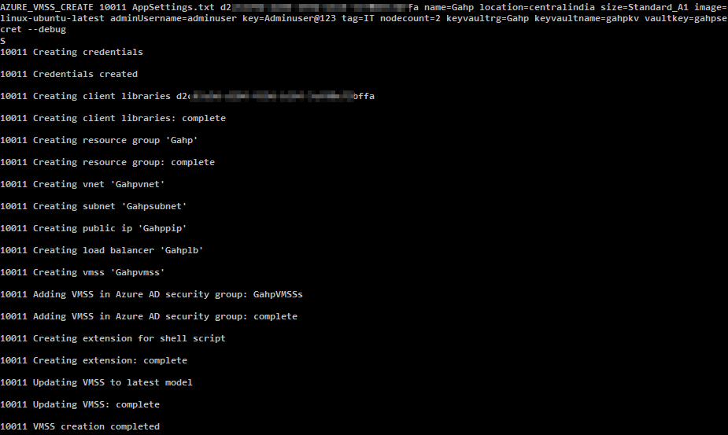
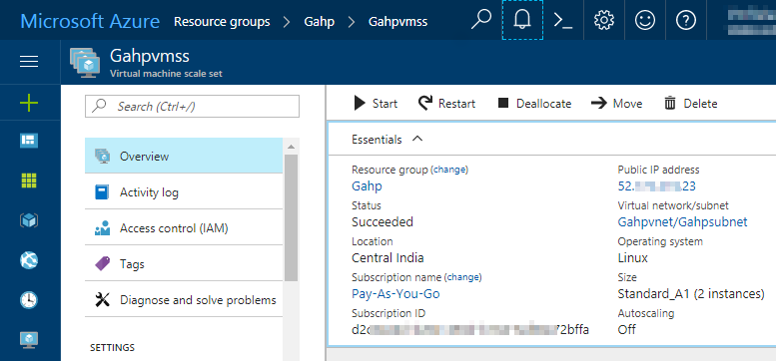
Azure Key Vault and secret that will be downloaded on VM. Highlighted is the secret value.
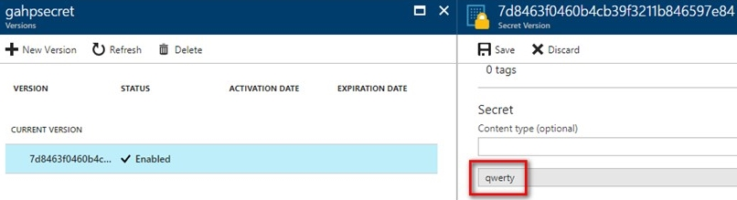
Verify the downloaded secret from Azure Key Vault.
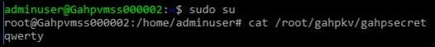

AZURE_VMSS_DELETE
- Used to delete a virtual machine scale set.
- Used to delete the resource group and virtual machine scale set.
Syntax:
AZURE_VMSS_DELETE <request id> <path of app_settings.txt> <subscription id> <resource group name> <vmss name>
# | Parameter Name | Required | Description
1 | Resource group name | Yes | Resource group name
2 | VM name | No | Virtual machine scale set name

Example:
- Delete a resource group to delete virtual machine scale set and associated artifacts.
AZURE_VMSS_DELETE 1001 /home/adminuser/AzureGAHP/AzureGAHP/AppSettings.txt <subscription_id> Test
Where “Test” is the resource group name.
Before deleting virtual machine scale set:
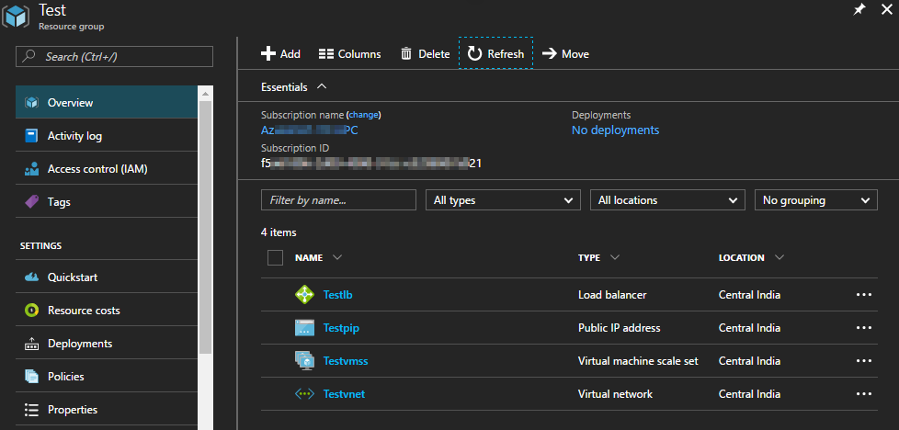

Delete resource group command status:
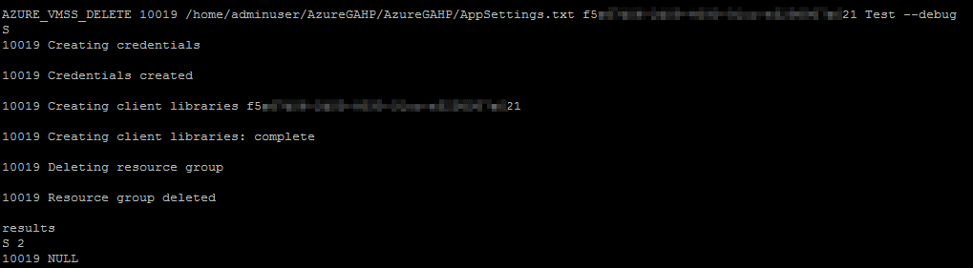
- Delete virtual machine scale set:
AZURE_VMSS_DELETE 1002 /home/adminuser/AzureGAHP/AzureGAHP/AppSettings.txt <subscription_id> Test Testvmss
Where “Test” is the resource group name and “Testvmss” is the virtual machine scale set name.
Before deleting virtual machine scale set:
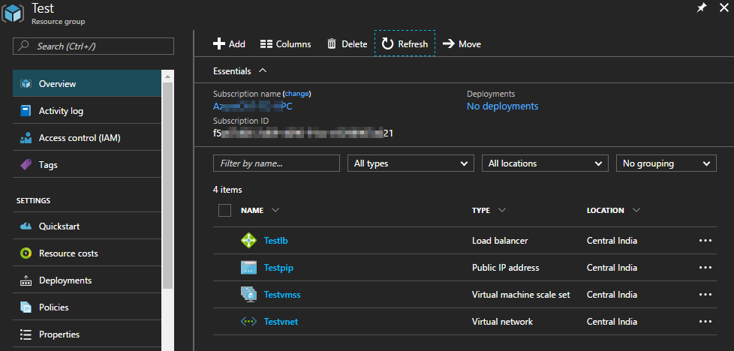

Delete virtual machine scale set command status:
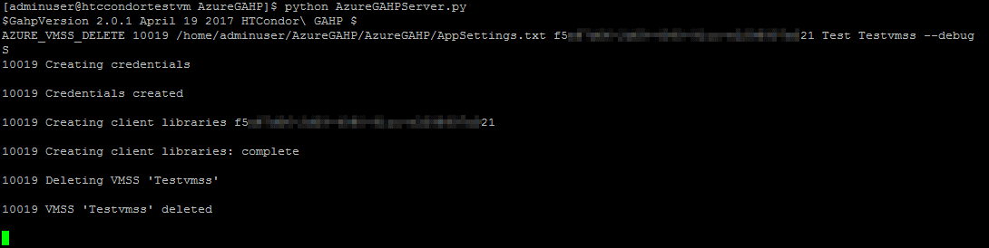
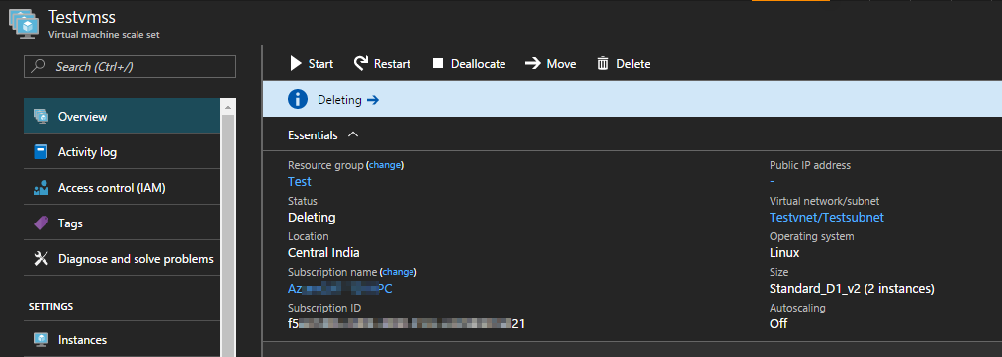
After deleting virtual machine scale set:
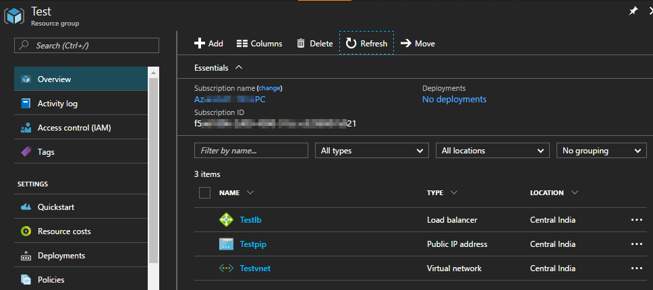

AZURE_VMSS_START
Used to start all the VMs in a virtual machine scale set.
Syntax:
AZURE_VMSS_START <request id> <path of app_settings.txt> <subscription id> <resource group name> <vmss name>
Example:
AZURE_VMSS_START 1001 /home/adminuser/AzureGAHP/AzureGAHP/AppSettings.txt <subscription_id> Test Testvmss
Where “Test” is the resource group and “Testvmss” is the virtual machine scale set.
Before starting:
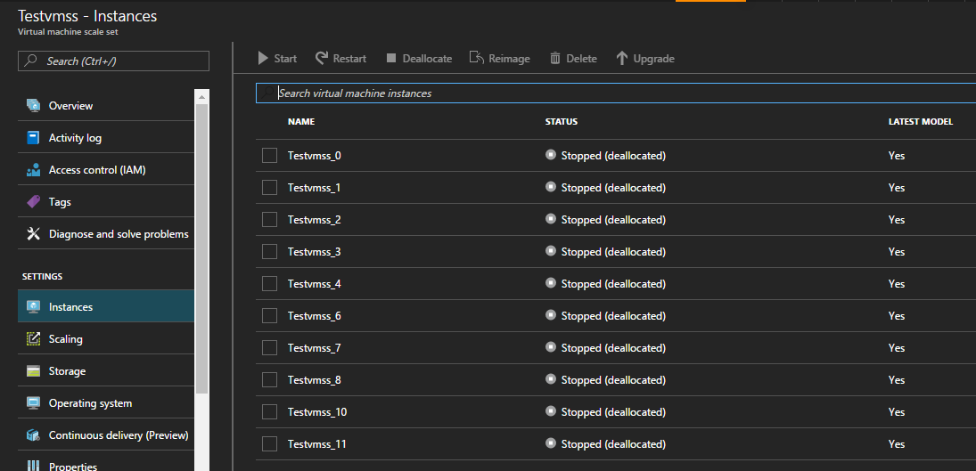
Virtual machine scale set start command status:
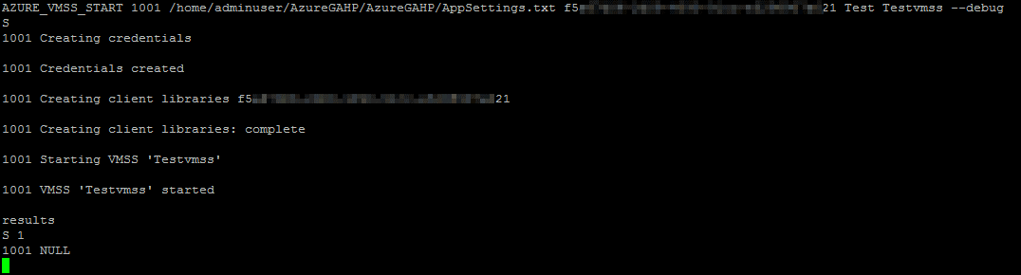
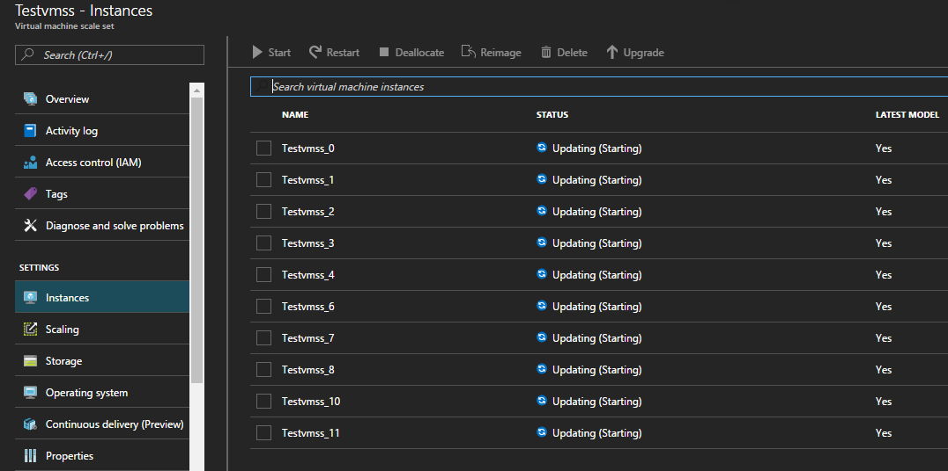
After starting virtual machine scale set:
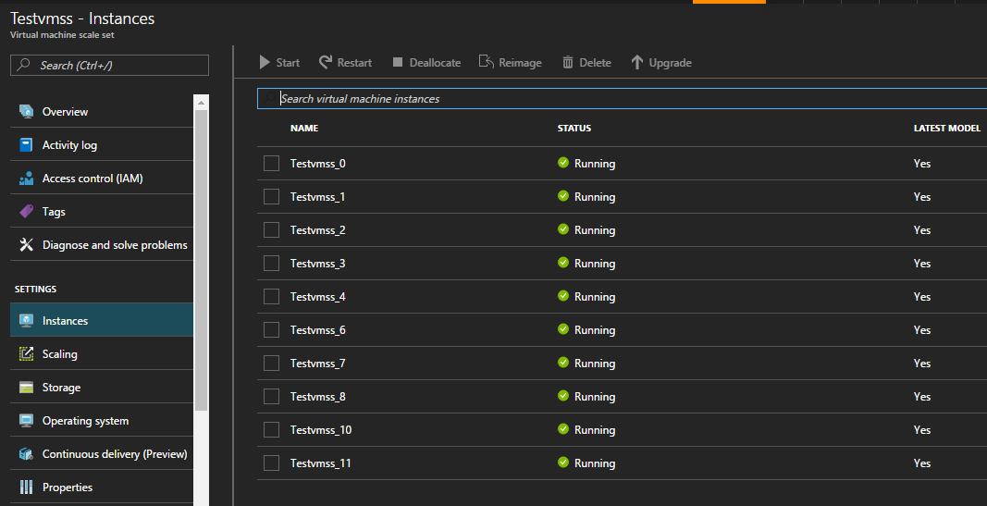

AZURE_VMSS_STOP
Used to stop all the virtual machine(s) in a virtual machine scale set.
Syntax:
AZURE_VMSS_STOP <request id> <path of app_settings.txt> <subscription id> <resource group name> <vmss name>
Example:
AZURE_VMSS_STOP 1001 /home/adminuser/AzureGAHP/AzureGAHP/AppSettings.txt <subscription_id> Test Testvmss
Where “Test” is the resource group and “Testvmss” is the virtual machine scale set.
Before stopping:

Virtual machine scale set stop command status:
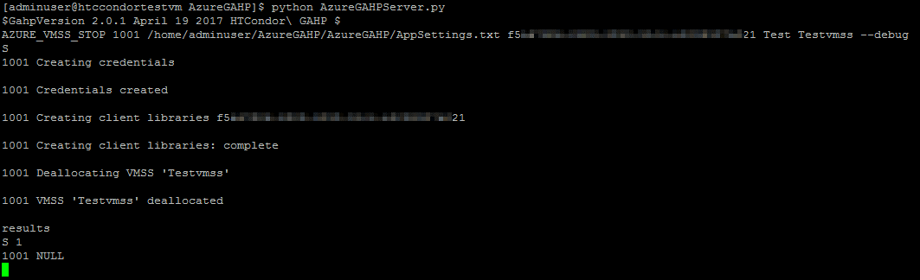
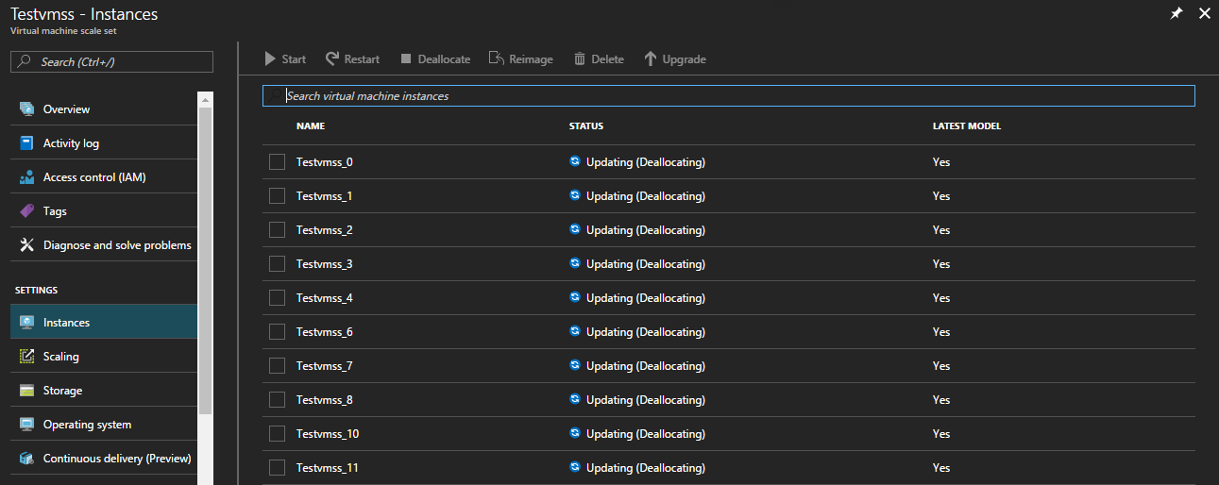
After stopping virtual machine scale set:


AZURE_VMSS_RESTART
Used to restart all the VMs in a virtual machine scale set.
Syntax:
AZURE_VMSS_STOP <request id> <path of app_settings.txt> <subscription id> <resource group name> <vmss name>
Example:
AZURE_VMSS_RESTART 1001 /home/adminuser/AzureGAHP/AzureGAHP/AppSettings.txt <subscription_id> Test Testvmss --debug
Where “Test” is the resource group and “Testvmss” is the virtual machine scale set.
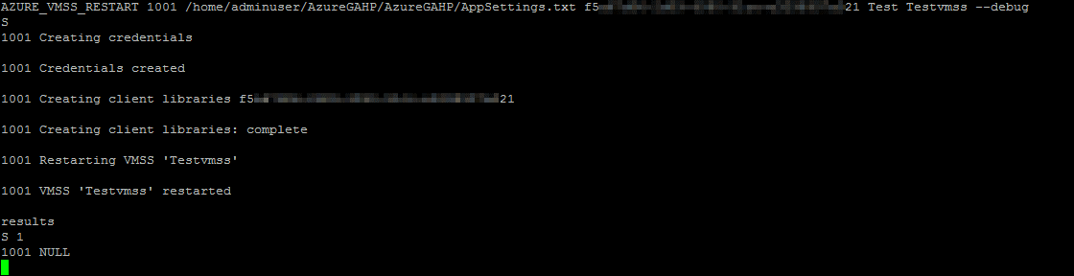
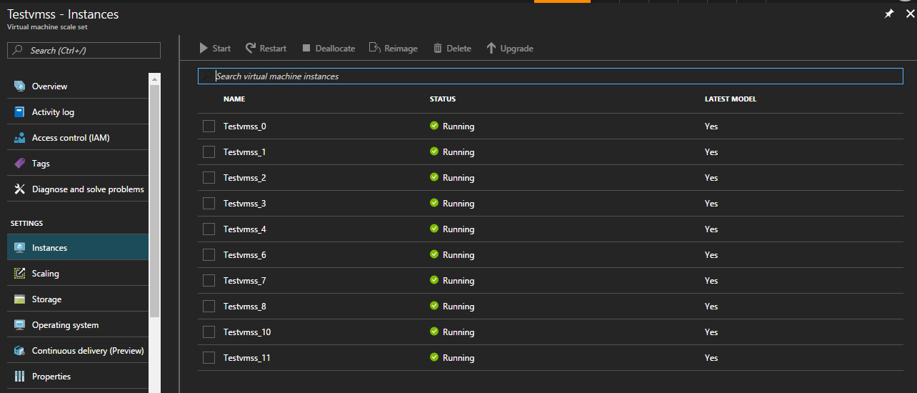

AZURE_VMSS_SCALE
Used to scale up/down the virtual machine scale set instances.
Syntax:
AZURE_VMSS_SCALE <request id> <path of app_settings.txt> <subscription id> <resource group name> <vmss name> <instance count>
Example:
AZURE_VMSS_SCALE 1001 /home/adminuser/AzureGAHP/AzureGAHP/AppSettings.txt <subscription_id> Test1 Test1vmss 7 --debug
Where “Test1” is the resource group, “Test1vmss” is the virtual machine scale set, and 7 is the instance count which will be updated.
Existing virtual machine scale set with 3 instances:
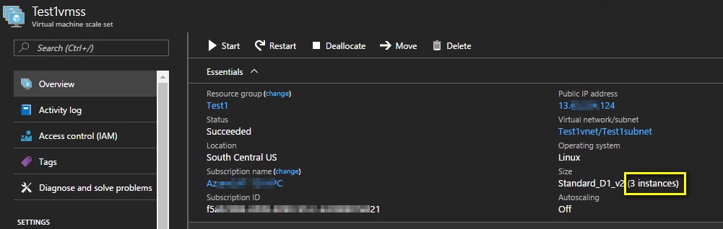

Command started scaling the instances:
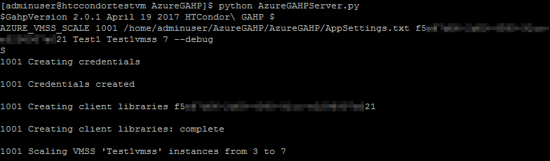

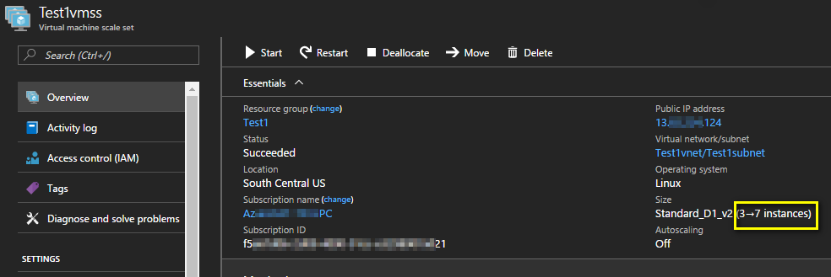
Command completed:
