Overview
Amazon EC2 offers two pricing schemes for its virtual machines. The first, which Condor (via the EC2 GAHP) presently supports, are for “dedicated instances”, generally intended to provide infrastructure (“as-a-service”). These virtual machines, once active, remain so for as long as you can pay for them. The second pricing scheme, for “spot instances,” allows customers to bid (in cents per hour) for whatever resources happen to be available at the moment. Unlike dedicated instances, submitting a spot request – a bid – does not ensure that an instance starts; neither, once started, is a spot instance guaranteed to remain active. It may be terminated by Amazon at any time. However, the hourly cost under the second scheme tends to be much lower, therefore making it worthwhile for users whose applications can deal with unreliable computational resources. The parallels to Condor’s opportunistic computing model need not be further elaborated.
The spot instance API allows users to specify their bid, how many instances they’re willing to start at that price, and the “launch group;” each request in a launch group will only start an instance if every request does. Normally, once those instances have all started, the request will not start additional instances. A spot instance request (SIR) may instead be “persistent”, which means that it can spawn an instance whenever it doesn’t currently have one, regardless of how many instances it may have spawned before. This gives users a simple way of saying that they want to be running a spot instance whenever their bid is high enough.

Our goal for this design was to change as little as possible while still producing something useful. In particular, we wanted to reuse as much of the existing EC2 GAHP and grid manager logic as possible; ideally, we could implement spot instances as a small modification to the existing dedicated instances. However, spot instances are not one-for-one replacements for dedicated instances:

- Some may be part of a launch group.
- Some may be persistent.
- Amazon may terminate them at any time.
- Canceling a spot request does not terminate the corresponding instance.
- There is no built-in support for idempotent requests.

We didn’t seriously consider supporting #1 in Condor; even if Amazon guaranteed that the group terminated atomically, it’s not clear how we would represent gang scheduling in the queue. Furthermore, we want to abuse the EC2 attribute used by this mechanism to address #5. Therefore, we don’t provide a mechanism for requesting group starts.
Likewise, for #2, we decline to provide a mechanism for “persistent” spot requests at the EC2 API level. If our users request a similar mechanism, we should be able to implement it in Condor (e.g., using OnExitRemove = FALSE). Otherwise, because of #4, we would have to add a job to the queue for each instance spawned by the spot request. (There would otherwise be no way to distinguish between “cancel the request” and “terminate the instance.”) This could potentially be implemented by abusing the flocking mechanism, but we’d rather avoid opening this can of worms.
As for #3, further research has revealed that should be possible to extend the EC2 GAHP to recognize, on instance termination, the “state reason type”, which includes spot instance shutdowns. We could report this as a job failure. (The EC2 GAHP doesn’t presently distinguish between “VM shut itself down” and “terminated by user,” and reports all terminations as successful.)
As for #4, by declining to support launch groups and persistent requests, we have restricted ourselves to supporting SIRs which start at most one instance. This means we can make operations on the job unambiguous, despite it tracking two distinct resources in EC2: before the SIR starts an instance, removing it (or putting it on hold) cancels the SIR; afterwards, removing the job (or putting it on hold) terminates the instance. When the grid manager detects than an SIR has started a job, it cancels the SIR and proceeds as normal for a dedicated instance, using the instance ID provided by the SIR.

As mentioned above, we address issue #5 by using the LaunchGroup attribute. Because we only ever launch one-shot instance
s, we don’t need this attribute for its intended purpose. (Note, however, that the launch group is not passed along to the instance.) The EC2 GAHP fills the LaunchGroup attribute with the client token generated by the grid manager for idempotent dedicated instance commands. This uniquely marks the job so we can determine, during recovery, if the corresponding SIR exists.

Architecture

We added four commands to the EC2 GAHP to support spot instances: start, stop, status, and status-all, which cover the EC2 API functions.
To minimize changes, we implemented spot requests as a subgraph of the grid manager’s EC2 state machine. See the diagram below. As usual for grid universe jobs, important changes to job state are recorded in the job ad.
The crash-recovery logic for spot requests is based on what information we have recorded in the job ad. Because the state machine saves the client token back to the schedd before doing anything else, the grid manger only does recovery for jobs which have a client token. If the job also has a spot price declared, we enter spot request recovery. Two more pieces of information may be available: a request ID and an instance ID. If neither are available, we check to see if any SIR the job’s credentials let us see have the job’s client token, using the recovery state GM_SPOT_CHECK. (We need to use a new state because we need to call an EC2 GAHP function not called anywhere else.) One which does obviously gives us the request ID; it may also reveal an instance ID. At this point, we’re in the same case as we would be if the job had an instance ID when recovery started: if there’s no corresponding instance, we enter the state machine at GM_SPOT_SUBMITTED (that is, we have submitted the request); if there is, we enter the state machine at GM_SAVE_INSTANCE_ID (that is, the request has started an instance). Strictly speaking, this is an optimization: GM_SPOT_SUBMITTED would transition to GM_SPOT_QUERY and notice the instance ID there. Otherwise, when we find no SIR with the job’s client token, we assume that the grid manger crashed before submitting the request, and try to resubmit. (Suppose, instead, that we crashed after submitting the request. An SIR can be purged only after expiring, cancellation, or closing. We never submit SIRs that expire. If the user cancels an SIR, then we don’t need to tell them about it. If the request closed, then the instance has terminated (because our SIRs don’t expire), and we no longer care.)

Diagram
The four new states are in blue, with the two modified states in red. The state GM_SPOT_CHECK is not present on the diagram, as it is fully described in the paragraph about recovery logic, above. GM_SPOT_START submits the SIR; GM_SPOT_SUBMITTED handles the timer for polling with GM_SPOT_QUERY, which contains all the logic for handling SIR state changes. GM_SPOT_CANCEL cancels the request, which concludes our responsibility for it, and then enters the dedicated-instance state machine at GM_SUBMITTED. The exit to GM_DONE_SAVE happens when the SIR becomes inactive without spawning an instance (and should generally not happen). Note that this transition is superseded by the detection of a new instance, despite the labeling.

Development Plan
[Jaime] Code review.
[ToddM] Test suite.
[ToddM] Fix GM_SPOT_CHECK.
[ToddM] Add StateReasonType parsing to EC2 GAHP to recognize when an instance is not user- or self- terminated.
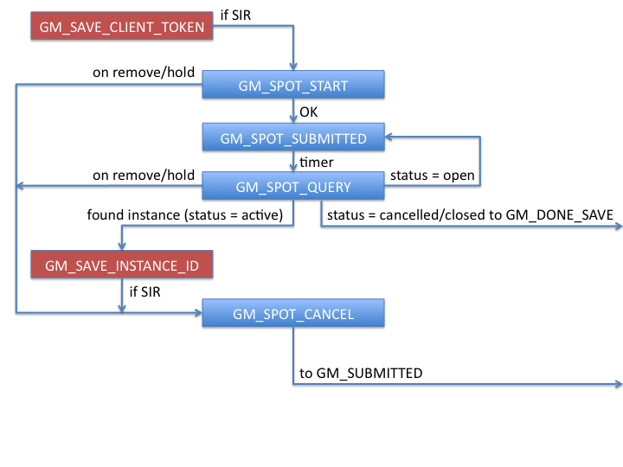

Amazon EC2 does not support hibernation or suspension. Amazon distinguishes between “clean” and “immediate” terminations (preferring the former for spot instances); presumably, the former injects an ACPI power-button event (allowing the guest to run its shutdowns script) and the latter just “pulls the plug.”

