COSC2543 Mobile Application programming

# TUTORIAL WEEK 2: SIMPLE MIDLET WITH UI

**Aim:** Getting familiar with High Level UI API and Event Handling.

**Timing estimate**: 90 minutes

## 1. Main Screen for a Game

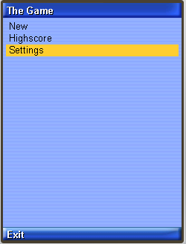In modules 3 to 10 you will be creating a game with collision detecting, highscore, sounds, network connection and more. In this exercise you will be creating the main screen for you game application.

1. Start a new Java ME project. Create new MIDlet "MainScreen"
2. When the MIDlet launches, display a implicit List with three choices: "New Game", "Highscore" and "Settings"
3. When user selects one of given options, an Alert is displayed showing the text user selected
4. Implement also an exit command. When selected, the MIDlet exists

## 2. Settings Screen for the Game

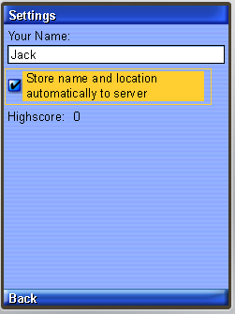Now implement a settings screen for the game. In the settings, user is able to give his/her name and enable automatic connection to server. Also user can view his/her personal high score.

1. Create new class "SettingsScreen" which inherites Form. Display the SettingsScreen when user selects Settings from the main screen.
2. Add to the Form a new TextField, where user is able to write his/her name
3. Add to the Form a checkbox (ChoiceGroup) where user can enable automatic connection to server and location. When user achieves a new personal highscore, the score will be sent to server with user's location automatically. This functionality will be implemented later.
4. Add StringItem to the form. StringItem displays the personal highscore, at this time 0.
5. Implement also "Back" command which brings the user to the main screen.

## 3. Answer the questions

# True or False: Use the high-level API whenever possible because it is portable

# True or False: If you need special screen layouts (e.g. games) then use the low-level API

# What are tickers used for?

# What are abstract commands?

# How to you capture user events?

# How does the look-and-feel of the High Level API vary over platforms?

# How can you create custom widgets?

# What is a Screen?

# What are the different types of Screens?

# How many screens can be attached to a display at the same time?

# How do you override the drawing and customize a Screen or Form Item?