COSC2082 Mobile Application programming

# TUTORIAL WEEK 3

Write an application that simply allow user to enter their personal information and store them in to the device’s RMS. User also can retrieve their information after form RMS.

The application consists of 3 main screens.

1. Welcome screen (1):
   * Contain a welcome message
   * Commands are as in the figure below:

Exit: exit MIDlet

Enter Data: Navigate to screen (2)

List Records: Navigate to screen (3)

Delete Records:

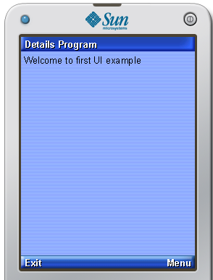 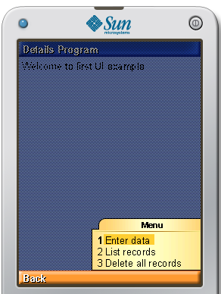

**Screen 1**

1. Enter Data Screen:
   * A form with *TextFields* to allow users to enter their information
   * Commands

Next : Move to Alert (1)

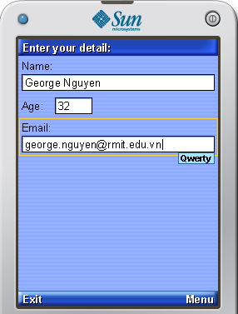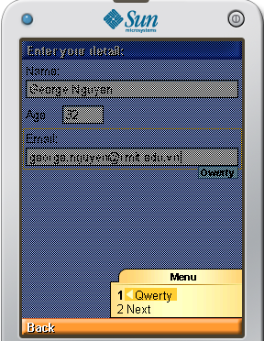

**Screen 2**

* + When clicking to the next will lead to confirmation Alert 1

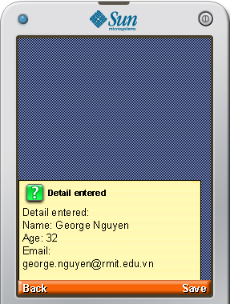 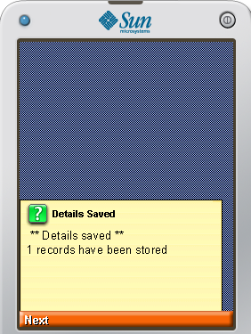

**Alert 1**

1. List Records Screen:
   * Command

Exit: Back to Screen (1)

