COSC2543 Mobile Application programming

# TUTORIAL WEEK 4: HTTP COMMUNICATION

**TASK 1**

Develop a simple HTTP Application to connect to a website and retrieve 2 information about that website, namely: responseCode and content-type

The syntax for getting these information from a site:

HttpConnection hc = (HttpConnection) Connector.open(url);

int responseCode = hc.getResponseCode();

String type = hc.getHeaderField("content-type");

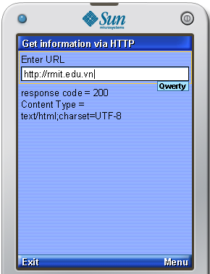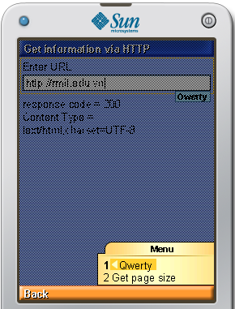

**TASK 2**

**Aim:** Getting familiar with http connection. Using http as a interface.

This exercise requires web server with php capabilities. You can either upload the given server side scripts to some server or you can use the server provided you by the instructor.

**Timing estimate**: 180 minutes

## 1. Server

The idea is to implement a simple common highscore for all the players. All the scores are stored in web-server. Ask the specific URL from the instructor.

The script is used with following interface http://www.webserver.com/save.php?name=*yourname*&score=*yourscore*&longitude=*logitudevalue*&latitude=*latitudevalue*

Example usage:

http://www.webserver.com/save.php?name=Jack&score=50&longitude=2.0&latitude=2.0

The longitude and latitude parameters are optional:

http://www.webserver.com/save.php?name=Jack&score=50

The showall.php scripts displays all the scores in a simple text file.

http://www.webserver.com/showall.php

Upload the scripts into a web server and test that you can store a score using the http interface. The given values are stored in xml-file:

http://www.webserver.com/highscore.xml

## 2. Client: Storing Name and Score

Now implement functionality when a new highscore is achieved, save the user name (from settings) and score to the web server using the given http interface. The connection is made in a different thread. The name and score is saved automatically if user chose this option from the settings.

* Implement class HttpConnection that inherites Thread
* run() - methods makes a connection to given url
* The url can be passed to the class in it's constructor
* When the connection is over the class can make a callback to it's host informing what was the result.

## 3. Client: Retrieving Highscores

Implement function where the user can retrieve all the highscores in a form. In the main screen, when user selects "High Scores", a form is set as current and the form contains all the highscores located in the server. The form contains a item for each score. Create your own custom item for the scores.