COSC2543 Mobile Application programming

# TUTORIAL WEEK 6: WIRELESS MESSAGING

As most of the students finished question 1 & 2 in class, you will need to focus on question 3. For whom, that are not fully understand SMS, you can start practicing question 1 & 2 again.

1. Create a simple SMS application, which allows sending SMS to the WMA Console. In order to open WMA Console you will need to go to your Java Platform 🡪 WTK (Wireless Toolkit) 🡪 Open Utilities 🡪 WMA Console.

Remember in looking at the WMA Console for the number.

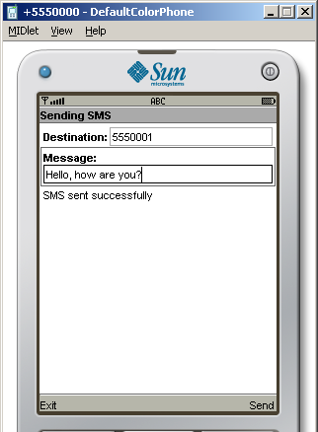 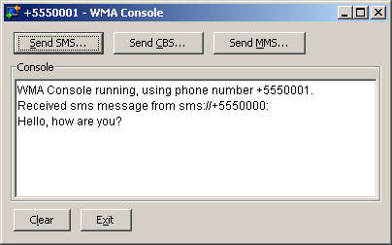

Running the application

* To start the MIDlets, just open the project normally in NetBeans and run normally
* To start the WMA Console in NetBeans do the following:
  1. Go to the *Tools* option on the menu and select *Java Platform Manager*
  2. Select the *Sun Java Wireless Toolkit* platform
  3. Click on the *Tools & Extensions* tab
  4. Click on the *Open Utilities* button
  5. Select *WMA Console* and click *Launch*
  6. Select *Tools -> Java Platforms*

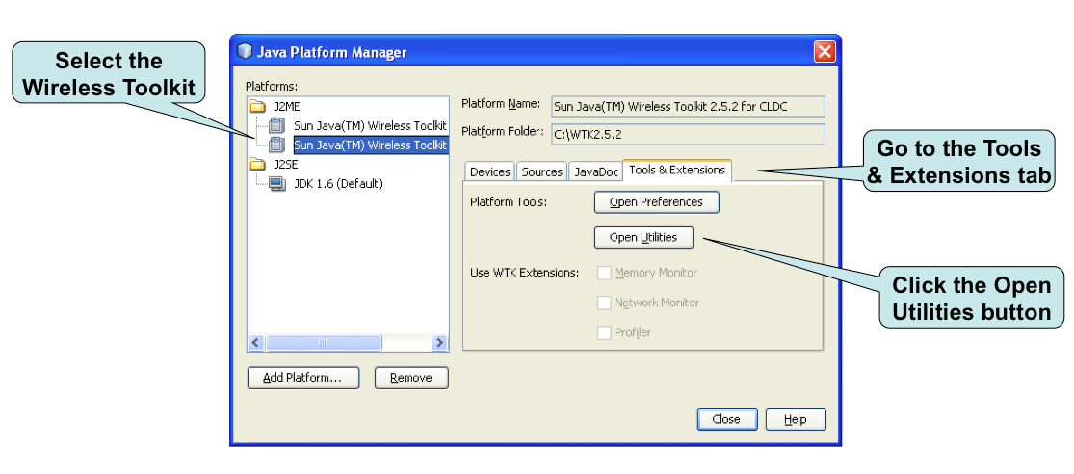

Start the Console

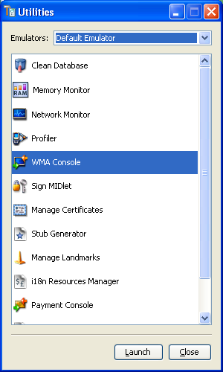 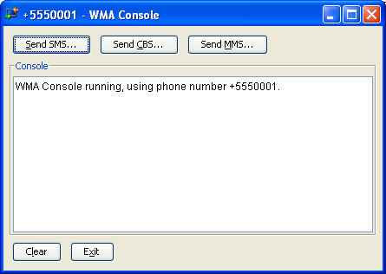

1. Complete the application by create a MIDlet to receive SMS from WMA Console.

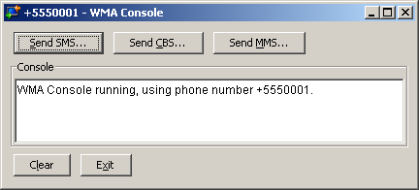

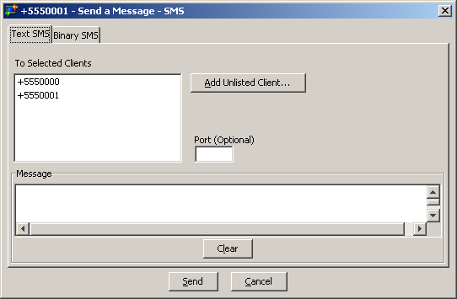

1. Look at the 2nd part of lecture slide about BinaryMessage & MMS and try to create similar MIDlet to send and receive BinaryMessage & MMS. The sample codes of BinaryMessage & MMS are on BB under Extras section.

***Please only refer to those after you have attempted!***