# POC Document — Employee Data Processing with AWS Lambda & S3

Prepared by: Harikrishna T

POC Date: 27th October 2025, 3:00 PM IST

Environment: AWS Console (No local setup)

## 1. Objective

To demonstrate a fully serverless data ingestion and transformation pipeline using AWS services. The POC reads employee data from a MongoDB collection, converts it into a Parquet format, and uploads it to Amazon S3. An AWS Lambda function automatically triggers upon upload to validate, log, or further process the file.

## 2. Scope

Included:

• Reading employee data from MongoDB Atlas via AWS Lambda  
• Generating a Parquet file dynamically  
• Uploading the file to Amazon S3  
• Triggering a Lambda function automatically on file upload  
• Logging process details in CloudWatch

Excluded:

• On-premise or local development setups  
• Any UI or client-side component (handled separately in later phase)

## 3. Technology Stack

|  |  |
| --- | --- |
| Component | Technology / Service Used |
| Database | MongoDB Atlas |
| File Format | Apache Parquet |
| Cloud Storage | Amazon S3 |
| Compute | AWS Lambda (Python 3.9 runtime) |
| Logging | Amazon CloudWatch |
| IAM | For Lambda execution and S3 permissions |
| AWS Console | Used for all configurations and testing |

## 4. Architecture Overview

Flow Diagram (Conceptual):

MongoDB Atlas → AWS Lambda (Python) → Parquet Conversion → Amazon S3 (Upload) → Lambda Trigger → CloudWatch Logs

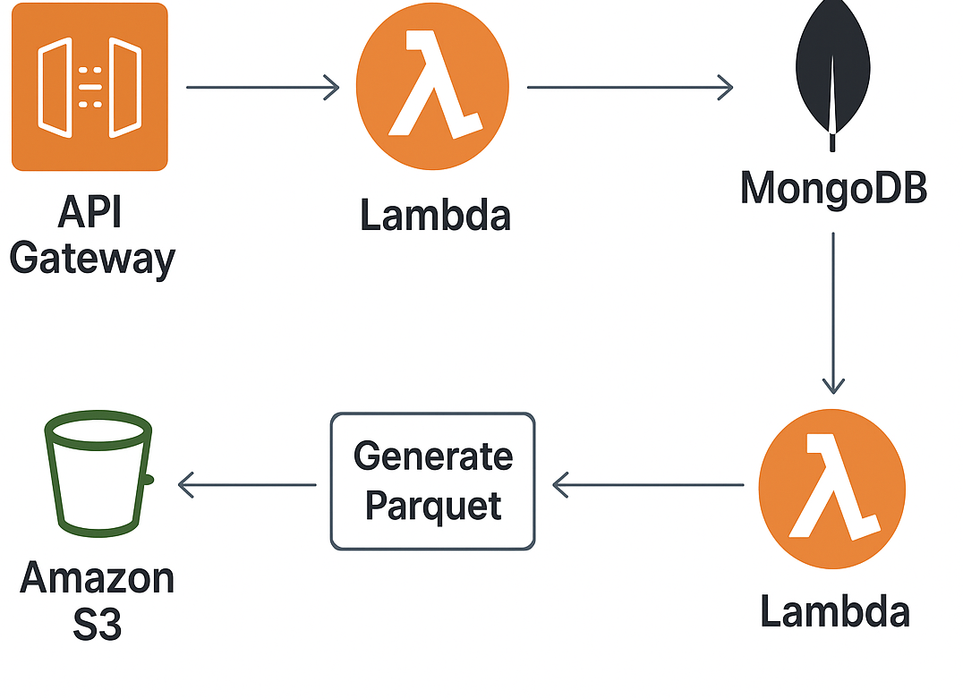

## Step-by-Step Flow:

1. Lambda connects to MongoDB Atlas via connection string.  
2. Fetches employee records (empId, name, dept, salary).  
3. Converts data into Parquet file using pandas/pyarrow.  
4. Uploads generated Parquet file to S3 bucket.  
5. S3 event notification triggers another Lambda function.  
6. Triggered Lambda validates file and logs details to CloudWatch.

## 5. Success Scenarios

• MongoDB connection established successfully.  
• Data fetched and Parquet file created correctly.  
• File successfully uploaded to S3.  
• Trigger Lambda executes automatically and logs event details.  
• No manual intervention required at any step.

## Expected Output in CloudWatch:

INFO: Received file upload event for employee_data_2025_10_27.parquet  
INFO: File size: 245 KB  
INFO: Processing completed successfully.

## 6. Failure & Edge Cases

|  |  |  |  |
| --- | --- | --- | --- |
| Failure Scenario | Root Cause | Detection | Mitigation / Handling |
| MongoDB connection failure | Wrong credentials / Network issue | Lambda logs error 'Connection timeout' | Validate connection string, add retry logic |
| No data fetched | Empty collection / wrong query | Lambda logs 'No records found' | Add conditional check and skip upload |
| Parquet conversion failure | Missing library / schema mismatch | Lambda exception in conversion step | Verify pyarrow/pandas import and data types |
| S3 upload failure | IAM permission denied / bucket not found | Error 'Access Denied' in CloudWatch | Check IAM role policies for S3 PutObject |
| Trigger not firing | Misconfigured S3 event | File upload but no logs in CloudWatch | Verify S3 event notification configuration |
| Lambda timeout | Large dataset | Timeout error | Optimize query, use pagination or increase timeout |

## 7. Assumptions & Dependencies

• MongoDB Atlas instance is publicly accessible via connection string.  
• AWS services (Lambda, S3, CloudWatch) are in the same region.  
• Required Python libraries added as Lambda layers or inline.

## 8. Validation Plan

|  |  |  |
| --- | --- | --- |
| Test Case | Expected Behavior | Validation Method |
| Successful file upload | Trigger Lambda logs event in CloudWatch | Check CloudWatch logs |
| Empty dataset | No file uploaded | Verify no new object in S3 |
| Invalid MongoDB credentials | Error logged in Lambda | Check CloudWatch error logs |
| IAM permission issue | Upload fails | Observe AccessDenied error |
| Large dataset | Lambda runs within timeout | Confirm execution time in logs |

## 9. Risks & Mitigations

• Lambda dependency size limit exceeded → Use external layer.  
• Data sensitivity → Use encrypted S3 bucket and secure credentials.  
• Event trigger misconfiguration → Test end-to-end before demo.

## 10. Next Steps

• Integrate React UI for manual upload and visualization.  
• Automate pipeline using AWS Step Functions.  
• Add DynamoDB for metadata storage.  
• Extend to multiple file formats (CSV, JSON).

## 11. Appendix

AWS Region: ap-south-1 (Mumbai)  
S3 Bucket Example: employee-data-bucket-demo  
Lambda Names: lambda-fetch-employee, lambda-on-upload-trigger