/home/iiap/anaconda3/envs/pytorch/bin/python /home/iiap/桌面/作业/hw2/BayesNetworkTestScript.py  
Question1 -------------------------------------------  
size of the network is: 44310855680  
Question2 -------------------------------------------  
The probability of diabetes if I have bad habits is:   
 probs diabetes exercise long_sit stay_up smoke  
0 0.179597 1 2 1 1 1  
1 0.008754 2 2 1 1 1  
2 0.791160 3 2 1 1 1  
3 0.020489 4 2 1 1 1   
  
The probability of stroke if I have bad habits is:   
 probs stroke exercise long_sit stay_up smoke  
0 0.053214 1 2 1 1 1  
1 0.946786 2 2 1 1 1   
  
The probability of attack if I have bad habits is:   
 probs attack exercise long_sit stay_up smoke  
0 0.085704 1 2 1 1 1  
1 0.914296 2 2 1 1 1   
  
The probability of angina if I have bad habits is:   
 probs angina exercise long_sit stay_up smoke  
0 0.09542 1 2 1 1 1  
1 0.90458 2 2 1 1 1   
  
The probability of diabetes if I have good habits is:   
 probs diabetes exercise long_sit stay_up smoke  
0 0.075195 1 1 2 2 2  
1 0.009409 2 1 2 2 2  
2 0.903426 3 1 2 2 2  
3 0.011970 4 1 2 2 2   
  
The probability of stroke if I have good habits is:   
 probs stroke exercise long_sit stay_up smoke  
0 0.029202 1 1 2 2 2  
1 0.970798 2 1 2 2 2   
  
The probability of attack if I have good habits is:   
 probs attack exercise long_sit stay_up smoke  
0 0.036655 1 1 2 2 2  
1 0.963345 2 1 2 2 2   
  
The probability of angina if I have good habits is:   
 probs angina exercise long_sit stay_up smoke  
0 0.03551 1 1 2 2 2  
1 0.96449 2 1 2 2 2   
  
The probability of diabetes if I have poor health is:   
 bmi diabetes cholesterol bp probs  
0 3 1 1 1 0.115423  
1 3 2 1 1 0.007662  
2 3 3 1 1 0.860873  
3 3 4 1 1 0.016043   
  
The probability of stroke if I have poor health is:   
 cholesterol bp bmi stroke probs  
0 1 1 3 1 0.082686  
1 1 1 3 2 0.917314   
  
The probability of attack if I have poor health is:   
 cholesterol bp bmi attack probs  
0 1 1 3 1 0.140784  
1 1 1 3 2 0.859216   
  
The probability of angina if I have poor health is:   
 cholesterol bp bmi angina probs  
0 1 1 3 1 0.161608  
1 1 1 3 2 0.838392   
  
The probability of diabetes if I have good health is:   
 bmi diabetes cholesterol bp probs  
0 2 1 2 3 0.057710  
1 2 2 2 3 0.009543  
2 2 3 2 3 0.922194  
3 2 4 2 3 0.010553   
  
The probability of stroke if I have good health is:   
 cholesterol bp bmi stroke probs  
0 2 3 2 1 0.01446  
1 2 3 2 2 0.98554   
  
The probability of attack if I have good health is:   
 cholesterol bp bmi attack probs  
0 2 3 2 1 0.016161  
1 2 3 2 2 0.983839   
  
The probability of angina if I have good health is:   
 cholesterol bp bmi angina probs  
0 2 3 2 1 0.013326  
1 2 3 2 2 0.986674   
  
Question3 -------------------------------------------  
probability of diabetes given income status is saved.   
probability of stroke given income status is saved.   
probability of attack given income status is saved.   
probability of angina given income status is saved.

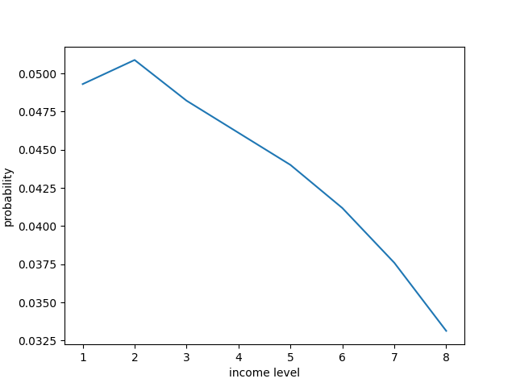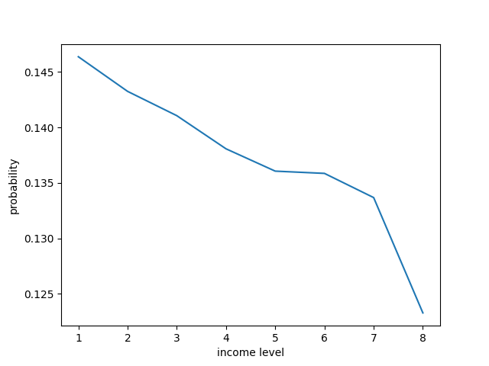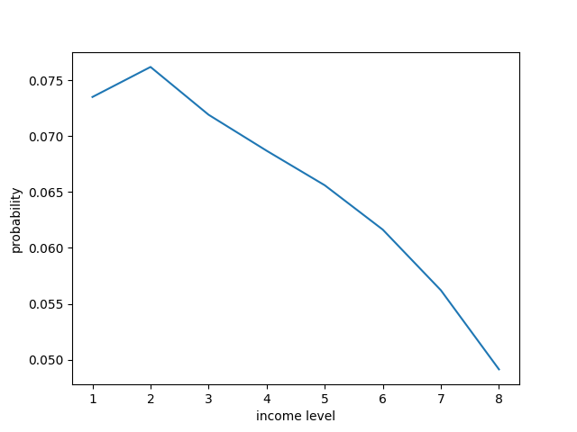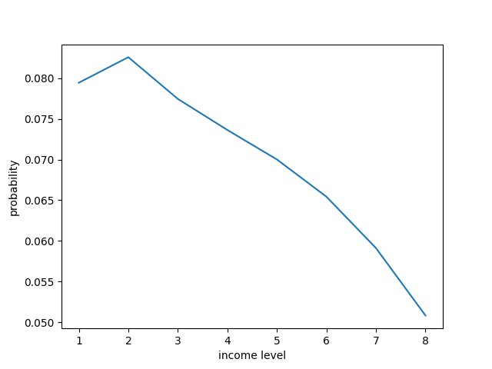

可以得出结论：收入和疾病之间是有关系的，往往收入越高得病概率均会减小  
Question4 -------------------------------------------  
The probability of diabetes if I have bad habits is:   
 probs exercise smoke diabetes long_sit stay_up  
0 0.245992 2 1 1 1 1  
1 0.006928 2 1 2 1 1  
2 0.723721 2 1 3 1 1  
3 0.023359 2 1 4 1 1   
  
The probability of stroke if I have bad habits is:   
 probs exercise smoke stroke long_sit stay_up  
0 0.080488 2 1 1 1 1  
1 0.919512 2 1 2 1 1   
  
The probability of attack if I have bad habits is:   
 probs exercise smoke attack long_sit stay_up  
0 0.135301 2 1 1 1 1  
1 0.864699 2 1 2 1 1   
  
The probability of angina if I have bad habits is:   
 probs exercise smoke angina long_sit stay_up  
0 0.138072 2 1 1 1 1  
1 0.861928 2 1 2 1 1   
  
The probability of diabetes if I have good habits is:   
 probs exercise smoke diabetes long_sit stay_up  
0 0.056227 1 2 1 2 2  
1 0.010160 1 2 2 2 2  
2 0.923710 1 2 3 2 2  
3 0.009903 1 2 4 2 2   
  
The probability of stroke if I have good habits is:   
 probs exercise smoke stroke long_sit stay_up  
0 0.019464 1 2 1 2 2  
1 0.980536 1 2 2 2 2   
  
The probability of attack if I have good habits is:   
 probs exercise smoke attack long_sit stay_up  
0 0.021213 1 2 1 2 2  
1 0.978787 1 2 2 2 2   
  
The probability of angina if I have good habits is:   
 probs exercise smoke angina long_sit stay_up  
0 0.023948 1 2 1 2 2  
1 0.976052 1 2 2 2 2   
  
The probability of diabetes if I have poor health is:   
 probs bmi diabetes cholesterol bp  
0 0.121241 3 1 1 1  
1 0.007492 3 2 1 1  
2 0.854769 3 3 1 1  
3 0.016498 3 4 1 1   
  
The probability of stroke if I have poor health is:   
 probs cholesterol bp bmi stroke  
0 0.082697 1 1 3 1  
1 0.917303 1 1 3 2   
  
The probability of attack if I have poor health is:   
 probs cholesterol bp bmi attack  
0 0.140083 1 1 3 1  
1 0.859917 1 1 3 2   
  
The probability of angina if I have poor health is:   
 probs cholesterol bp bmi angina  
0 0.161096 1 1 3 1  
1 0.838904 1 1 3 2   
  
The probability of diabetes if I have good health is:   
 probs bmi diabetes cholesterol bp  
0 0.055937 2 1 2 3  
1 0.009697 2 2 2 3  
2 0.924042 2 3 2 3  
3 0.010323 2 4 2 3   
  
The probability of stroke if I have good health is:   
 probs cholesterol bp bmi stroke  
0 0.014544 2 3 2 1  
1 0.985456 2 3 2 2   
  
The probability of attack if I have good health is:   
 probs cholesterol bp bmi attack  
0 0.016183 2 3 2 1  
1 0.983817 2 3 2 2   
  
The probability of angina if I have good health is:   
 probs cholesterol bp bmi angina  
0 0.013328 2 3 2 1  
1 0.986672 2 3 2 2   
我认为这两个变量之间是相互独立的，因为导致的影响比较小。  
Question5 -------------------------------------------  
second network:   
probability of stroke level 1 given diabetes level 1 is 0.044417  
probability of stroke level 1 given diabetes level 3 is 0.039955  
third network: Adding an edge from diabetes to stroke  
probability of stroke level 1 given diabetes level 1 is 0.076542  
probability of stroke level 1 given diabetes level 3 is 0.034456  
我认为是有效的，概率提升了接近一倍，说明影响很大  
Process finished with exit code 0