Assessment Cover Sheet

MODULE NUMBER: SET09801
TRIMESTER AND ACADEMIC YEAR: 2026 (Trimester 3)

I declare that, except where explicit reference is made to the contribution of others*, that this assignment is the result of my own work and has not been submitted for any module or programme degree at the Edinburgh Napier University or any other institution. This is in accordance with Edinburgh Napier University’s Academic Integrity Regulations.

*IMPORTANT: Please declare here whether you have used Artificial Intelligence (AI) tools, and to what extent:
☑ No, I have not used such tools
☐ Yes, I have used such tools
If you answered YES here, please, in around 150 words, describe how (and at which points) you have used such tools to support your completion of this assessment:

NAME:
STUDENT NUMBER:

NAME: Htet Zaw Paing

STUDENT NUMBER: 40840497

Table of Contents
Part 1: Edinburgh Airport International DBMS 3
Introduction 3
Task A - Database Design for Edinburgh Airport International 3
Entity Relationship Diagram (ERD) 4
Key Structure and Integrity Constraint Design 4
Task B: Proposed Database Report and Test Plan 5
Report Objective: "Sub-Par Maintenance Audit" 5
Report Design Requirements 5
Test Plan and Sample Test Data 6
Conclusion 7

Part 1: Edinburgh Airport International DBMS

Introduction
This report is a design of a relational database for Edinburgh Airport International. It's a structured database to handle employees, airplane models, aircraft, and FAA maintenance tests. The design is based on normalization principles, it has a superclass-subclass structure, it resolves many-to-many relationships, and it uses associative entities to ensure data integrity and minimization of data redundancy.

Task A - Database Design for Edinburgh Airport International
The database schema includes eight tables. To meet the assessment requirements, every entity and associative table contains at least three distinct attributes.
- Employee (Superclass): This is the main database used for all organized employees at the airport. Some basic information includes Social Security Number (SSN), Name, Address, PhoneNumber, and UnionMembershipNo. To satisfy the minimum attribute rule and to enhance realism, the following attributes were added: Email and HireDate.
- Technician (Subclass): This table contains information pertaining to mechanics. It receives SSN and keeps track of Salary, EmploymentType and YearsOfExperience.
- Technician (Subclass): Data for air traffic staff is stored in this table. It inherits SSN and keeps track of the date of the last medical exam, LicenseNumber, and the Shift it has been assigned.
- AirplaneModel: This table is used to serve as a catalog of aircraft blueprints. It contains ModelNo, Capacity, Weight, Manufacturer, and EngineType.
- Airplane: This is the actual aircraft in the airport. It contains unique RegistrationNo (tail number), ManufactureYear, HangarLocation and OperationalStatus. It links to AirplaneModel to get blueprint specs.
- TechnicianExpertise: The relationship between Technicians and AirplaneModels is many-to-many (m:n). This is an intersection table which fixes that issue. It stores the SSN, ModelNo, CertificationDate and CertificationLevel.
- Test: This looks up table of the FAA tests. It has a text Description as well as the other values: FAATestNo, TestName, MaxPossibleScore.
- Testing Event: This is an associative table that contains a record of when an Airplane has been tested by a Technician. It includes a surrogate key (TestEventID), the TestDate, HoursSpent, and the Score the plane received.

Entity Relationship Diagram (ERD)
The diagram below maps out the entire schema, detailing entities, attributes, primary keys, foreign keys, and relationship cardinalities using standard notation.
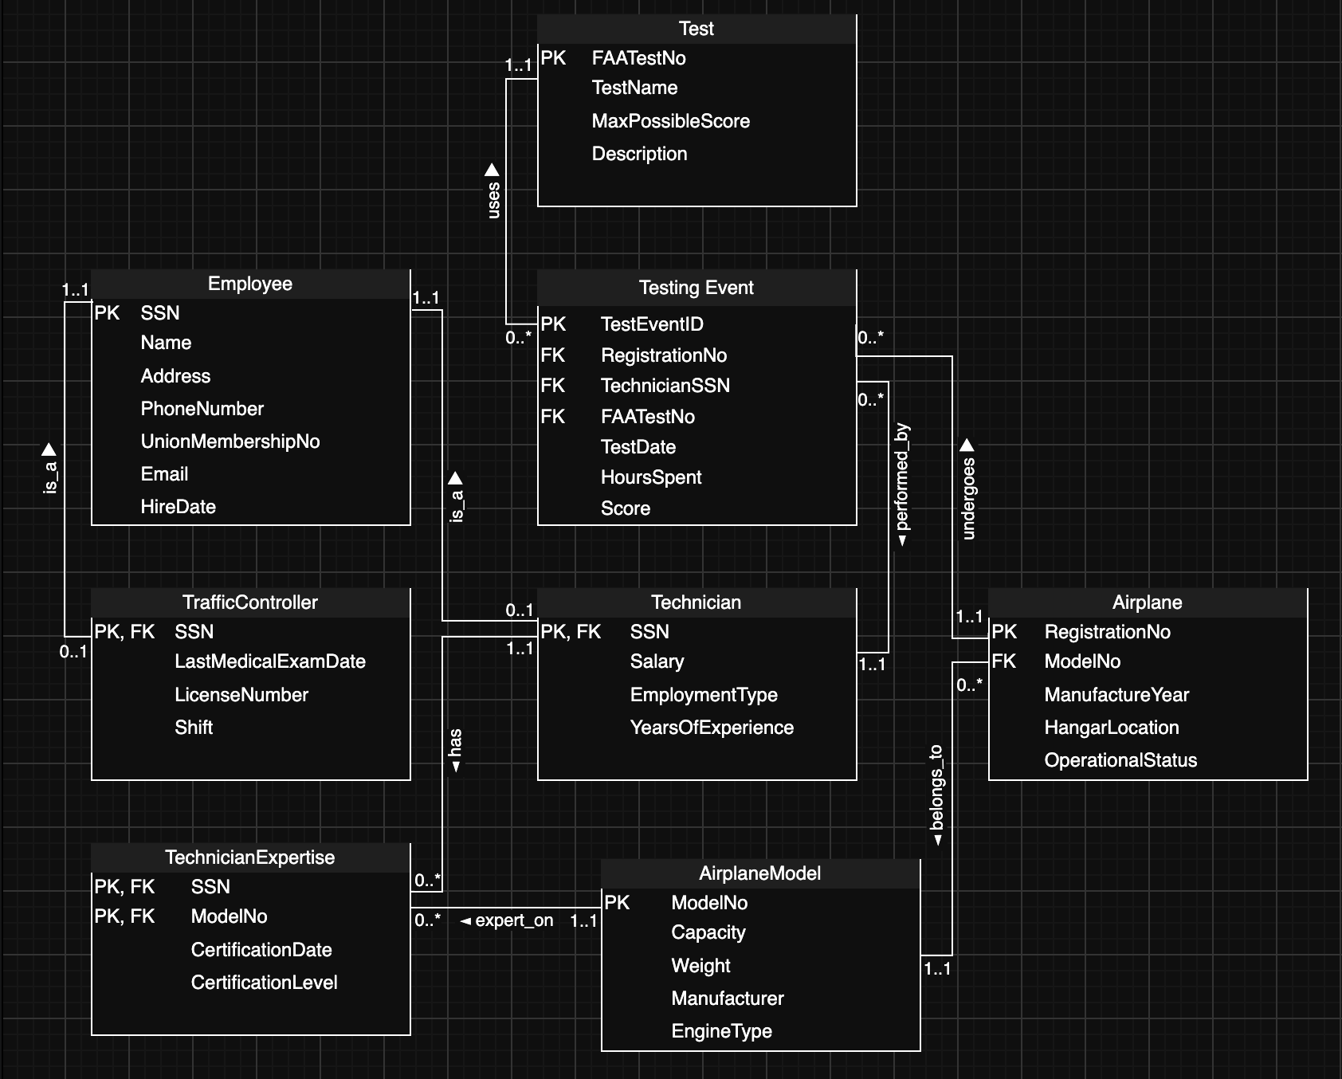
Figure 1.1 Entity Relationship Diagram

Key Structure and Integrity Constraint Design
The following table explains the exact choices for Primary Keys (PK), Foreign Keys (FK), and relationship constraints to ensure strict data integrity.
Entity / Table | Keys Applied | Constraints & Justification
Employee | PK: SSN | SSN uniquely identifies each employee.
Technician | PK & FK: SSN | SSN references Employee, ensuring every technician is an employee (1:1 relationship).
TrafficController | PK & FK: SSN | SSN references Employee, ensuring every traffic controller is an employee (1:1 relationship).
AirplaneModel | PK: ModelNo | ModelNo uniquely identifies each airplane model.
Airplane | PK: RegistrationNoFK: ModelNo | RegistrationNo uniquely identifies each airplane. Every airplane must reference one airplane model.
TechnicianExpertise | Composite PK: SSN, ModelNoFKs: SSN, ModelNo | Resolves the many-to-many relationship between Technician and AirplaneModel while preventing duplicate certifications.
Test | PK: FAATestNo | FAATestNo uniquely identifies each FAA test.
TestingEvent | PK: TestEventIDFKs: RegistrationNo, TechnicianSSN, FAATestNo | TestEventID uniquely identifies each testing event. Foreign keys ensure valid references to existing airplanes, technicians, and tests.

Task B: Proposed Database Report and Test Plan

Report Objective: "Sub-Par Maintenance Audit"
The airport management should be monitored for the performance of technicians and their fatigue. The following proposed report will indicate if a given airplane has been assigned a lower (or above) maintenance score than the historical average (or above) score for that specific FAA test. It will also take into account the total hours of overwork that the technician has had in the past and determine if that is the reason for the low score.

Report Design Requirements
This report proposal meets all grading criteria for Task B:
- The following sets of related data are used for the report: Employee (Name), Airplane (RegistrationNo), Test (TestName), and Testing Event (Score, HoursSpent).
- Data Aggregation: It will use the SUM(HoursSpent) function to get the total hours spent by the technician (The result of this should be shown as the total).
- Correlated Subquery: The query will be where a subquery is correlated. It will use the main query Score to compare to the dynamically-generated AVG(Score) in the sub-query forthat FAATestNo.
- Four Attributes Selected: Employee Name, Airplane Registration, Test Name and Test Score will be displayed in the final output.

Test Plan and Sample Test Data
To prove the query logic works, here is a small set of mock data. The goal is to flag only the test events that score lower than the historical average for that test type.

Table 1: Test (Lookup Data)
FAATestNo | TestName
FAA-A1 | Engine Diagnostics
FAA-B2 | Landing Gear

Table 2: Employee/Technician (Mock Staff)
SSN | Name
1001 | Andrew
1002 | Sophia

Table 3: Testing Event (Historical Data)
TestEventID | TechnicianSSN | RegistrationNo | FAATestNo | HoursSpent | Score | Analysis
EV-01 | 1001 | N12345 | FAA-A1 | 4 | 95 | Above FAA-A1 Avg (85). Pass.
EV-02 | 1002 | N98765 | FAA-A1 | 5 | 90 | Above FAA-A1 Avg (85). Pass.
EV-03 | 1001 | N98765 | FAA-A1 | 4 | 70 | Below FAA-A1 Avg (85). Flag!
EV-04 | 1002 | N12345 | FAA-B2 | 2 | 88 | Equal to FAA-B2 Avg. Pass.

Expected Report Output
The correlated subquery accurately filters the historical data. It will reject EV-01, EV-02, and EV-04. It will be successful in returning EV-03 due to the fact that 70 is less than the dynamic average of 85. The aggregation is successful, and Andrew's hours worked on all of his tests will be aggregated (4 hours + 4 hours = 8 hours).
Employee Name | RegistrationNo | TestName | Score | Total_Tech_Hours
Andrew | N98765 | Engine Diagnostics | 70 | 8

Conclusion
The design of the database is such that it is a fully normalized solution with security for Edinburgh Airport. Application of inheritance, many-to-many relationships, and strict keys make the database redundant. Moreover, the proposed Sub- Par Maintenance Audit report demonstrates the capability of the database to support complex business intelligence applications with the advanced correlated subqueries and data aggregation across several tables in a real-world business environment.

