CHAPTER 1

INTRODUCTION

1.1 Introduction
The Student Attendance System is a Windows desktop application developed in C# with Windows Forms and Microsoft SQL Server. It replaces manual attendance sheets with a centralized system for managing lecturers, university classes, courses, lecturer assignments, students, timetables, class sessions, attendance records, and monthly reports. Role-based access gives administrators full academic-data management while lecturers work only with their assigned classes and sessions. The system reduces repetitive work, improves record accuracy, prevents timetable conflicts, and makes attendance information easier to retrieve and review.

1.2 Objectives of the System

- To provide secure login and role-based access for administrators and lecturers.
- To manage lecturers, university classes, courses, students, and academic-year information accurately.
- To assign lecturers to the correct class and course and prevent timetable conflicts.
- To allow lecturers to record attendance only for their assigned timetable sessions.
- To allow home-room lecturers to manage their students while other assigned lecturers have read-only access to student lists.
- To provide attendance history and monthly attendance reports for authorized users.

CHAPTER 2
IMPLEMENTATION OF THE SYSTEM
PART A - ADMINISTRATOR MODULE
2.1 Admin Login Page
The Login Page provides secure access to the Student Attendance System for both administrators and lecturers. A user enters a username and password and selects Sign in. The system validates the password hash, account status, and role. A valid administrator is directed to the Admin Dashboard, while a valid lecturer is directed to the Lecturer Dashboard. Invalid or inactive accounts are denied access. The Login Page is shown in Figure 2.1.
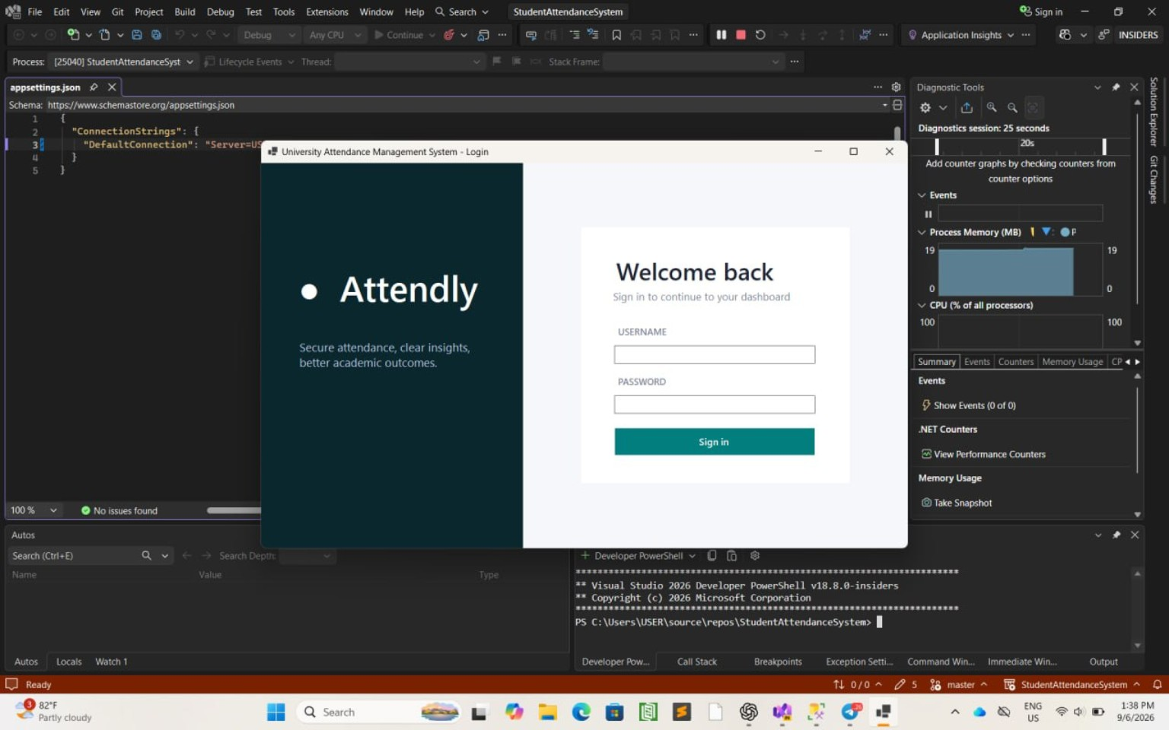
Figure 2.1 Admin Login Page
2.2 Admin Dashboard Overview
After signing in, the administrator can view the system overview. The dashboard displays summary information such as active students, accessible classes, active courses, and attendance records for the current month. The navigation menu also provides access to lecturers, university classes, courses, lecturer assignments, timetable, students, and attendance reports. The picture of the Admin Dashboard Overview is as shown in figure 2.2.
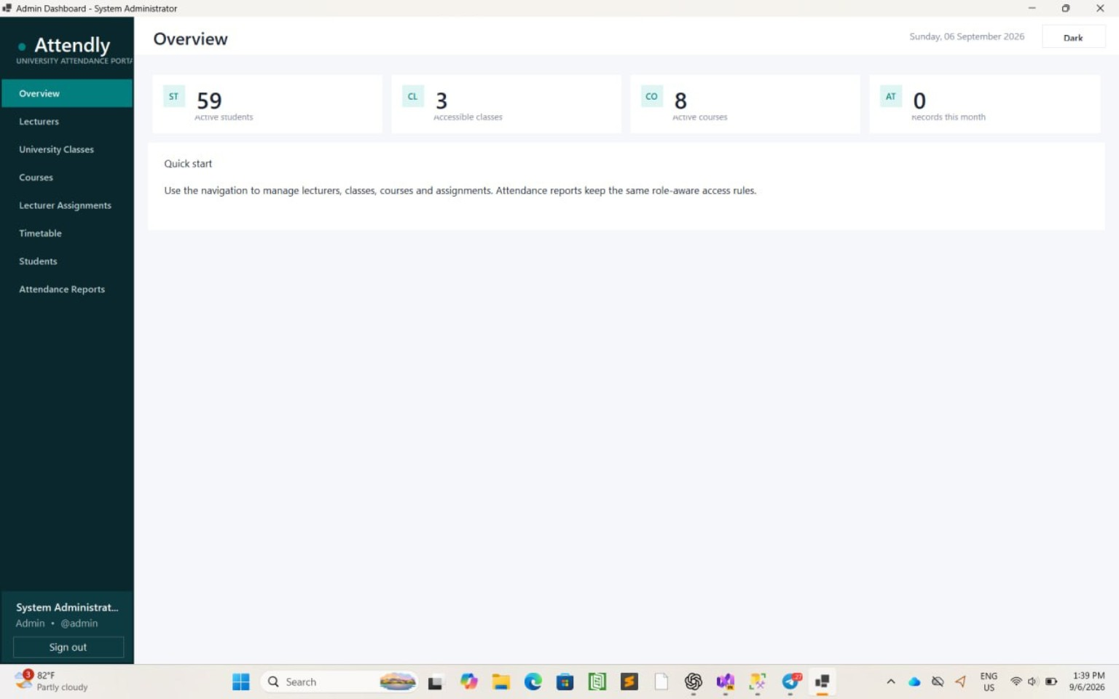
Figure 2.2 Admin Dashboard Overview
2.3 Lecturers
The Lecturers Page allows the administrator to manage lecturer accounts and profiles. The administrator can search records, add a lecturer with a temporary password, edit the selected lecturer's code, name, and phone number, activate or deactivate the lecturer account, and refresh the list. The table displays lecturer code, name, phone number, username, and active status. The Lecturers Page is shown in Figure 2.3.
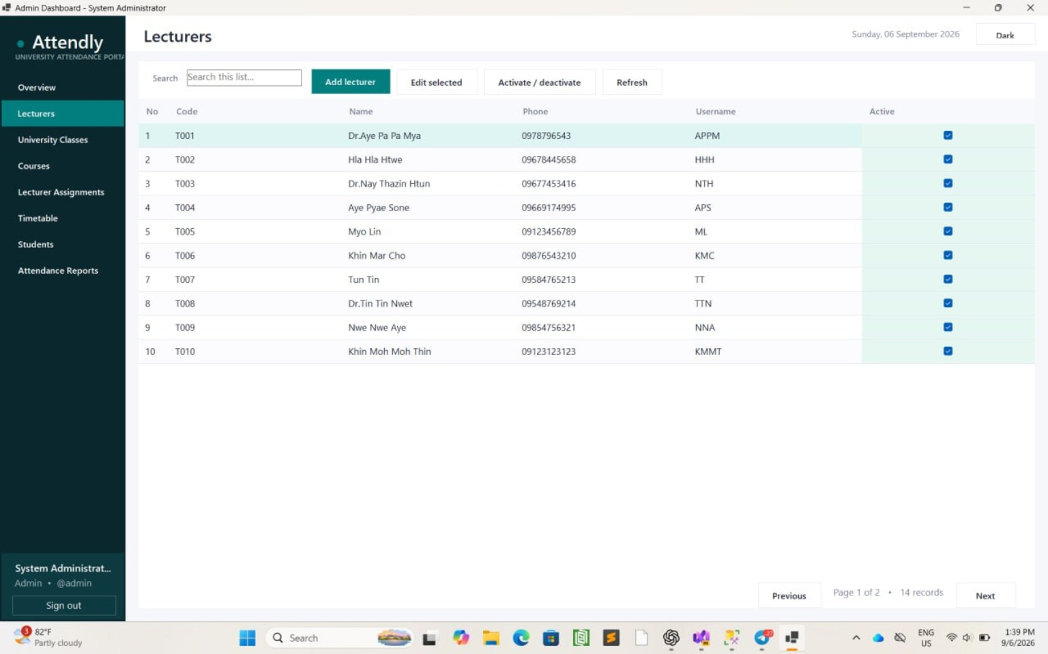
Figure 2.3 Lecturers Page
2.4 University Classes
The University Classes Page allows the administrator to manage the classes used in the attendance system. It displays class section, department, program, study level, semester, academic year, home teacher, and active status. The administrator can add a class, edit the selected class, activate or deactivate a class, search records, and refresh the list. The picture of the University Classes Page is as shown in figure 2.4.
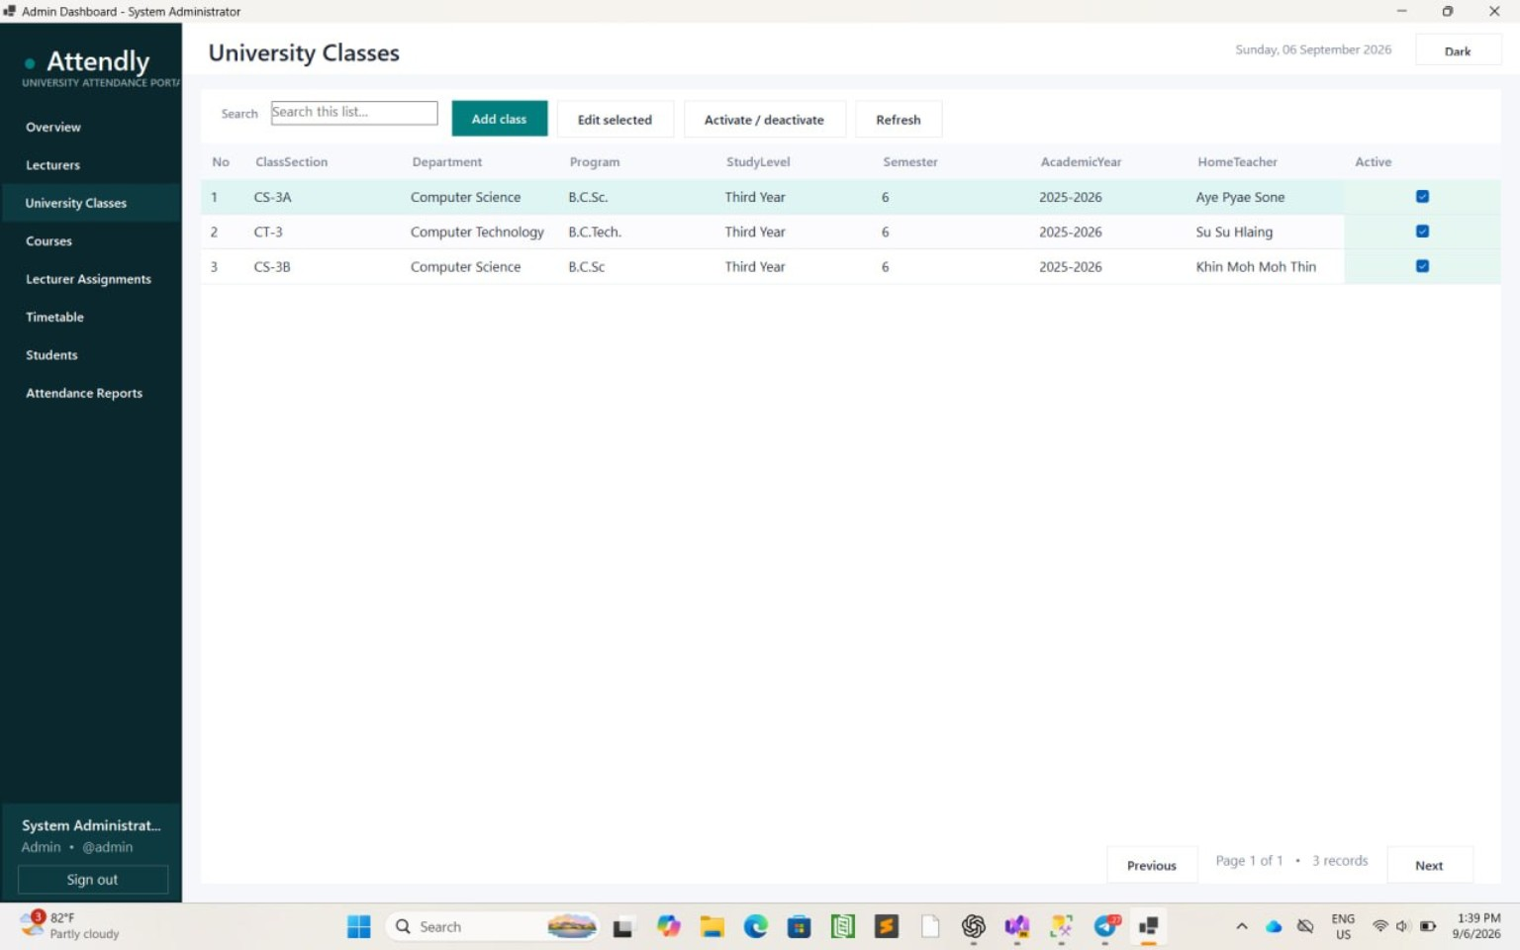
Figure 2.4 University Classes Page
2.5 Courses
The Courses Page allows the administrator to manage the subjects offered by the university. Course code, course name, and active status are displayed in the table. The administrator can search courses, add a new course, edit the selected course, activate or deactivate a course, and refresh the course list. The picture of the Courses Page is as shown in figure 2.5.
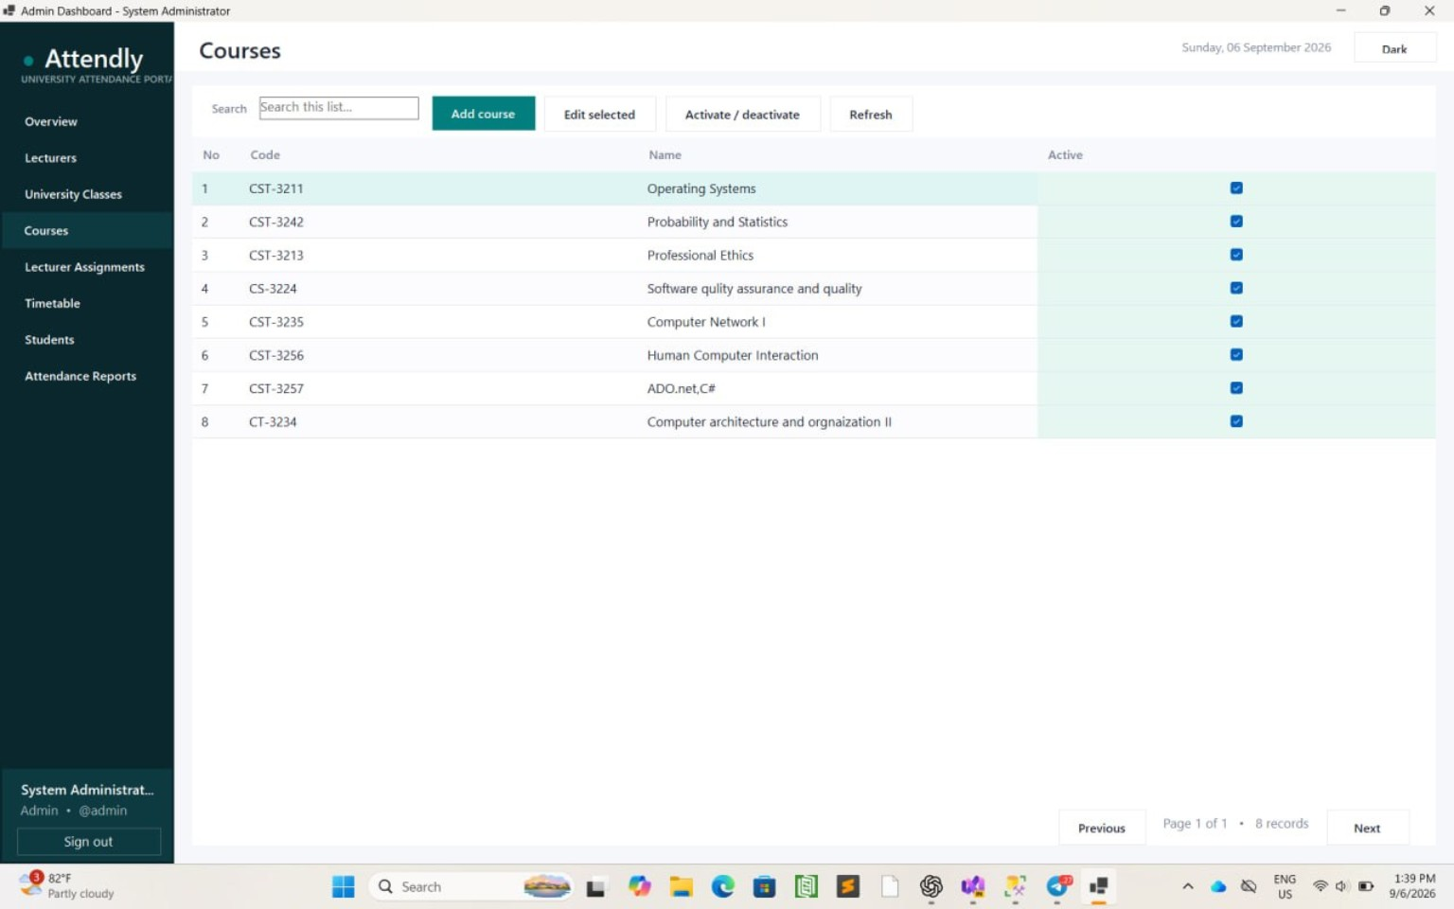
Figure 2.5 Courses Page
2.6 Lecturer Assignments
The Lecturer Assignments Page links an active lecturer to a university class and course for the class's academic year. These assignments determine which courses a lecturer may teach, which student lists may be viewed, and which timetable sessions and attendance records the lecturer may access. The administrator can add, edit, activate, or deactivate an assignment. The Lecturer Assignments Page is shown in Figure 2.6.
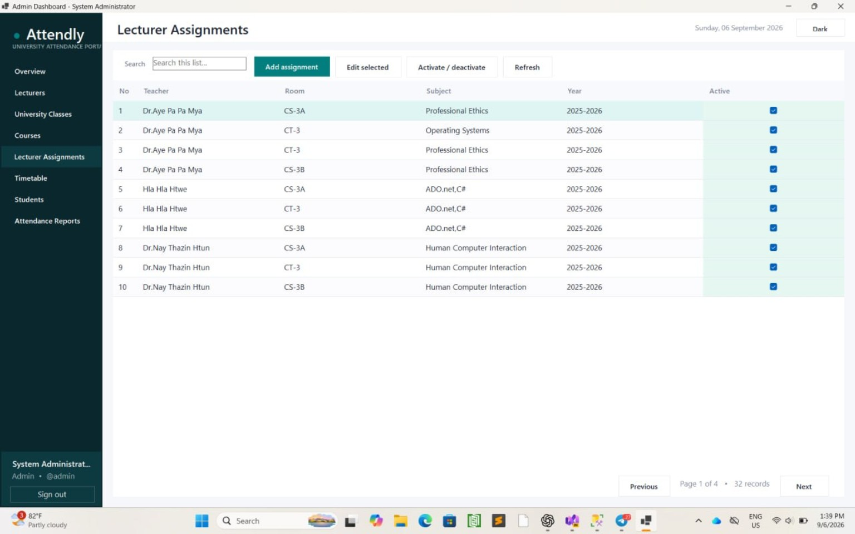
Figure 2.6 Lecturer Assignments Page
2.7 Timetable
The Timetable Page manages scheduled teaching periods. The administrator can filter sessions by class and can search, add, edit, activate, or deactivate timetable records. When a class and course are selected, the lecturer list contains only active lecturers with a matching assignment. The system rejects overlapping active sessions when either the class or lecturer is already occupied during the same effective date range. Each record stores the class, course, lecturer, weekday, start and end times, effective dates, and active status. The Timetable Page is shown in Figure 2.7.
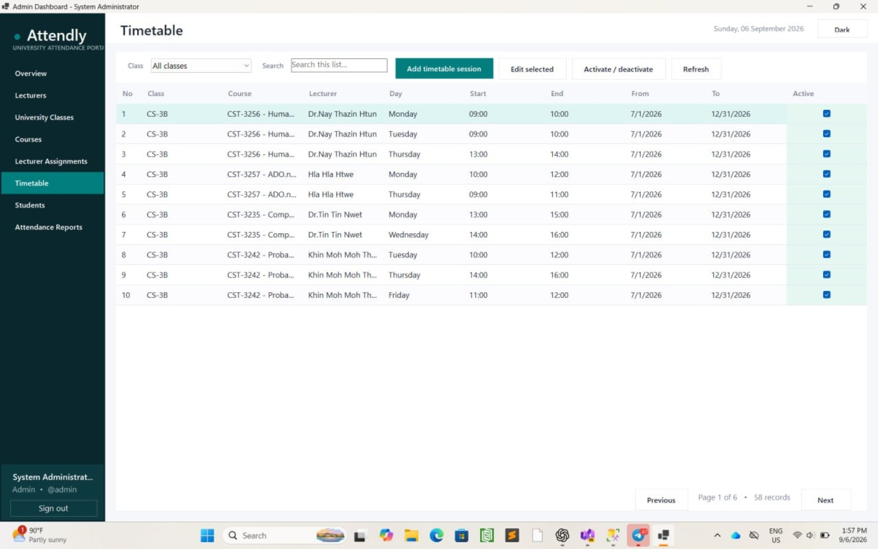
Figure 2.7 Timetable Page
2.8 Students
The Students Page allows the administrator to manage student records by class. The page displays registration number, student name, gender, class, and status. The administrator can select a class, search students, add a student, edit the selected student, activate or deactivate a student, and refresh the list. The picture of the Students Page is as shown in figure 2.8.
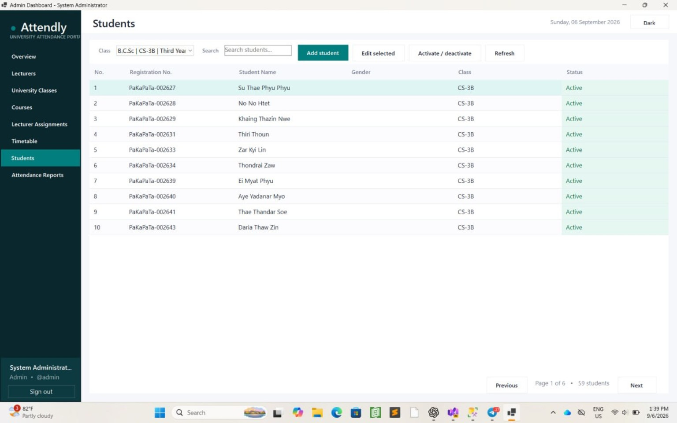
Figure 2.8 Students Page
2.9 Attendance Reports
The Attendance Reports Page allows the administrator to generate monthly attendance reports for a selected class and year. The report shows each student’s total sessions, present, absent, late and excused records, attendance percentage, and remark. The administrator selects the class, reporting month, and year, and then clicks the “Generate report” button to display the attendance information. The picture of the Attendance Reports Page is as shown in figure 2.9.
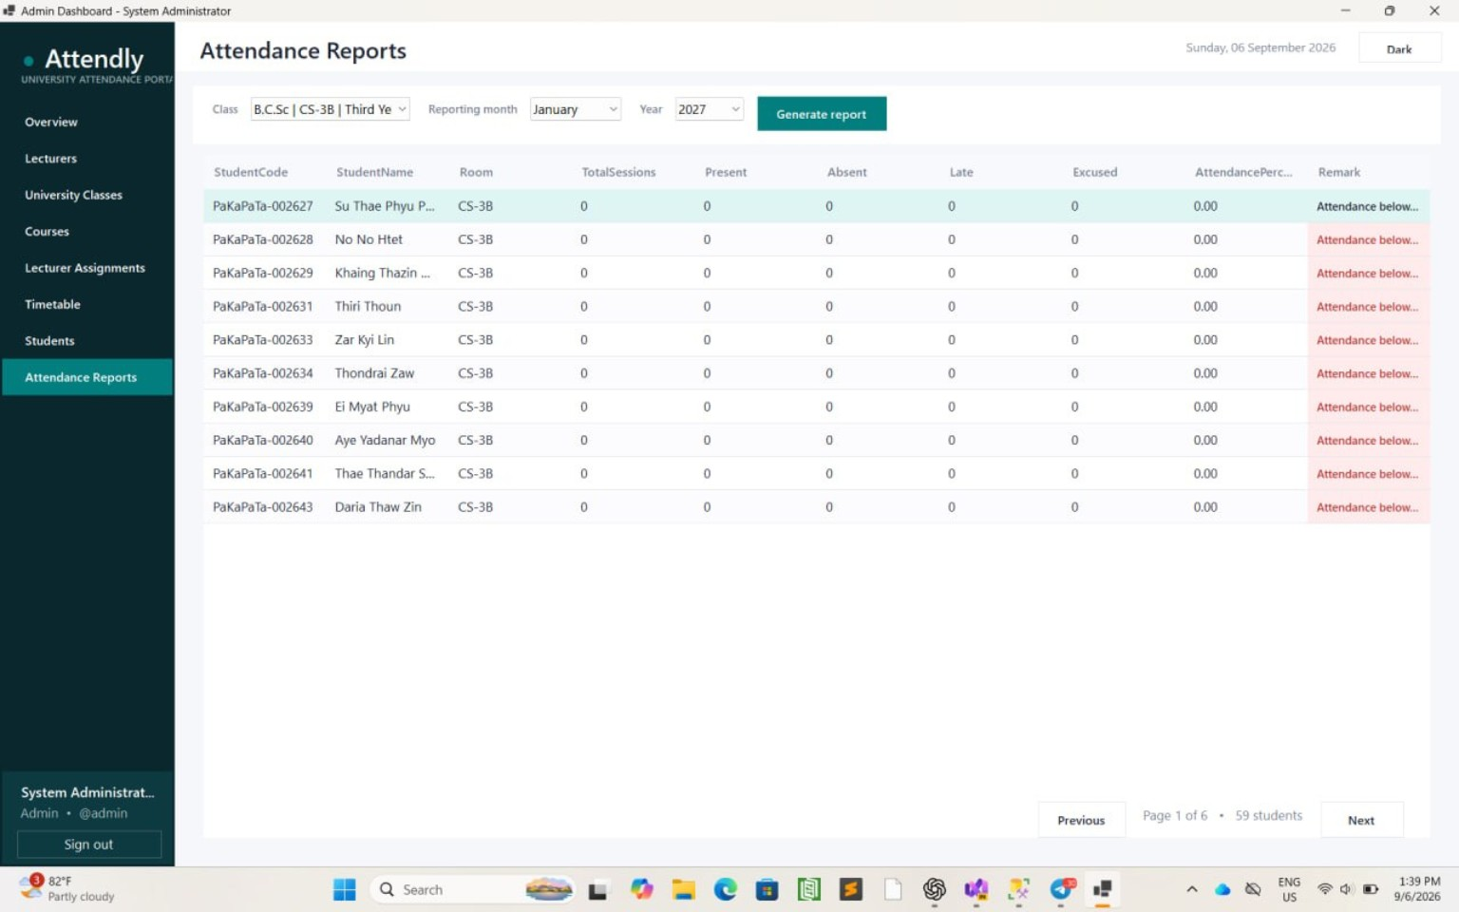
Figure 2.9 Attendance Reports Page

PART B - LECTURER / TEACHER MODULE
The Lecturer Module provides functions according to teaching assignments and home-room responsibility. A lecturer can view student lists for assigned classes, take attendance for scheduled sessions, review attendance history, and generate monthly reports. Student lists are read-only for ordinary assigned classes. Add, edit, activate, and deactivate student functions are available only for the lecturer's active home-room class.
2.10 Lecturer Dashboard Overview
After signing in, the lecturer sees summary information for accessible classes, students, courses, and current-month attendance. The navigation menu provides Students, Take Attendance, Attendance History, and Monthly Reports. Home Room Overall is added only when the lecturer is assigned as the home-room teacher of an active class. The Lecturer Dashboard Overview is shown in Figure 2.10.
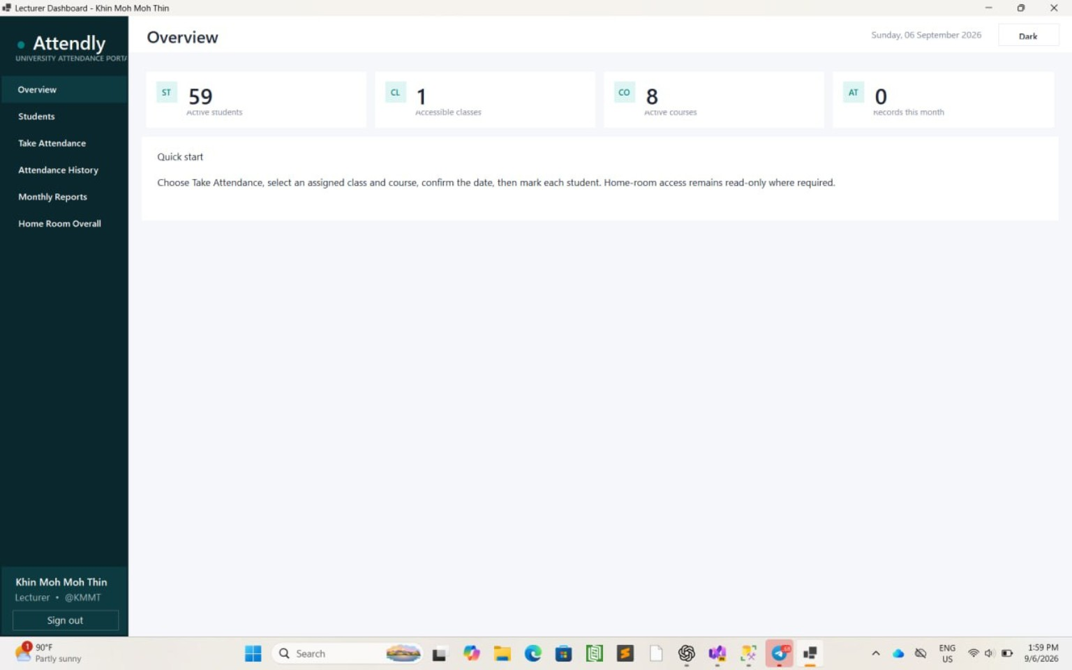
Figure 2.10 Lecturer Dashboard Overview
2.11 Lecturer Students Page
The Lecturer Students Page displays students in every class the lecturer actively teaches. The lecturer can select a class and search by registration number, name, or gender. For an ordinary teaching assignment, the list is read-only. When the selected class is the lecturer's home room, Add student, Edit selected, and Activate/deactivate are enabled. These restrictions are also enforced by the service layer. The Lecturer Students Page is shown in Figure 2.11.
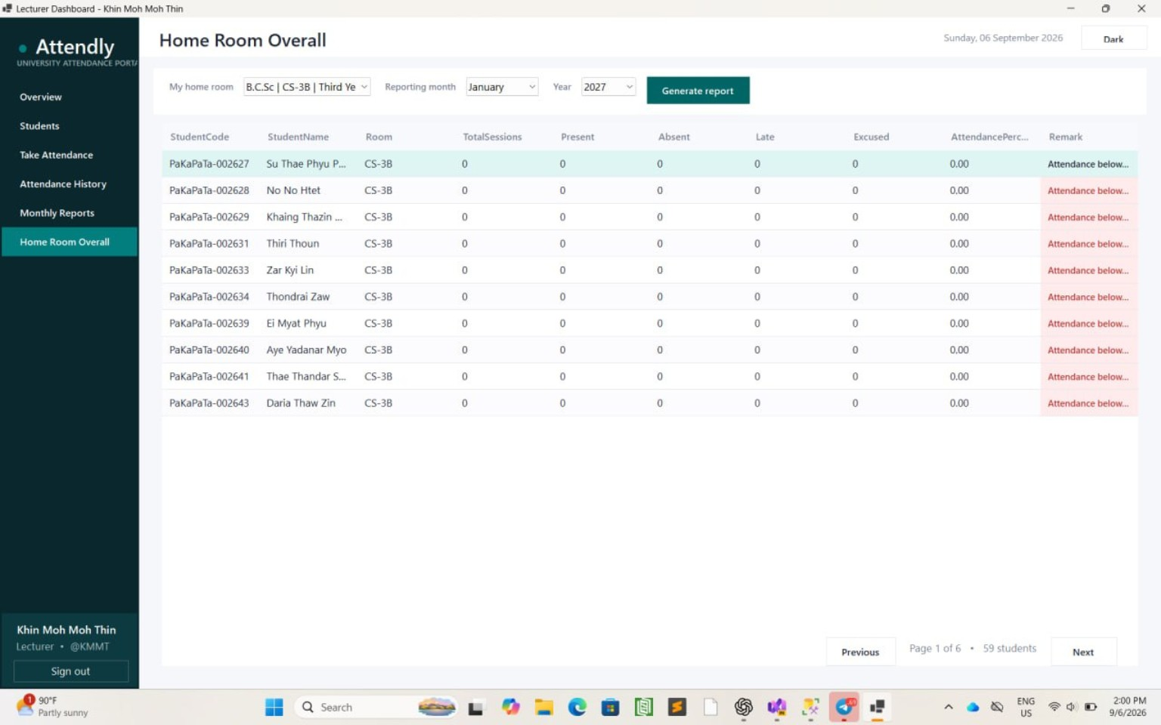
Figure 2.11 Lecturer Students Page
2.12 Take Attendance
The Take Attendance Page displays the lecturer's active timetable sessions for the selected date. After choosing a session, the active students in that class are loaded. The lecturer can mark all students present or absent, change individual statuses, enter remarks, and save attendance. Saving creates or updates records linked to the class session and changes the session status to Held. A session may be cancelled only before attendance has been recorded. The Take Attendance Page is shown in Figure 2.12.
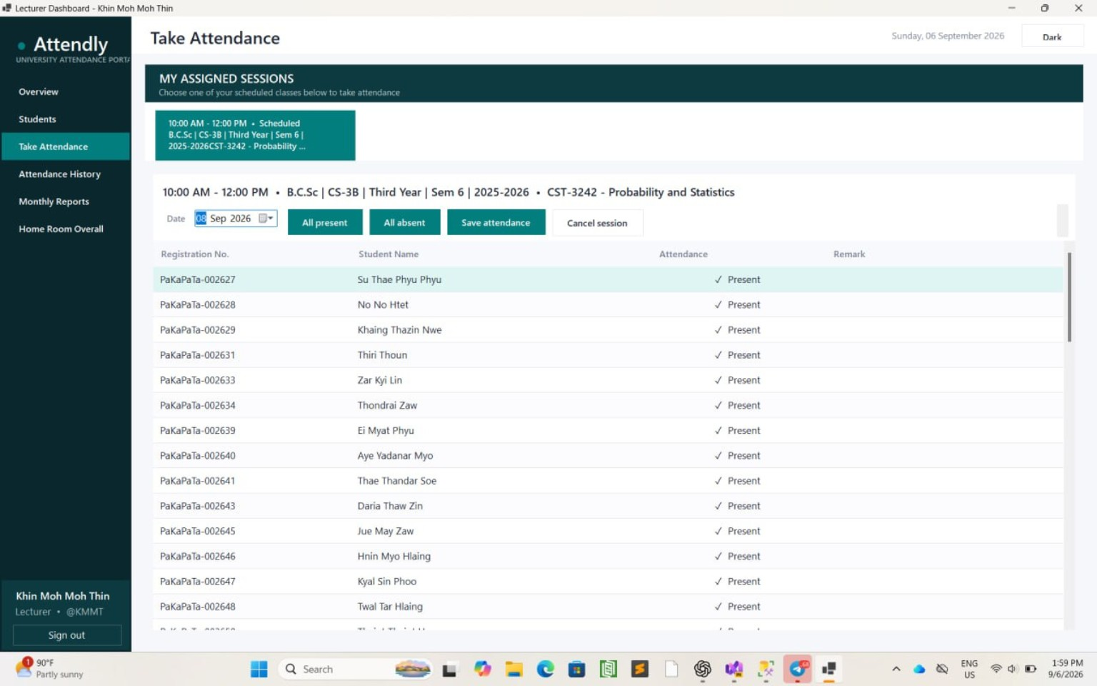
Figure 2.12 Take Attendance Page
2.13 Attendance History
The Attendance History Page displays previously saved attendance for an authorized class and course. Results load automatically and can be filtered by class, course, From date, and To date. The table shows attendance date, student code, student name, status, remark, and recording lecturer, with the newest records first. The Attendance History Page is shown in Figure 2.13.
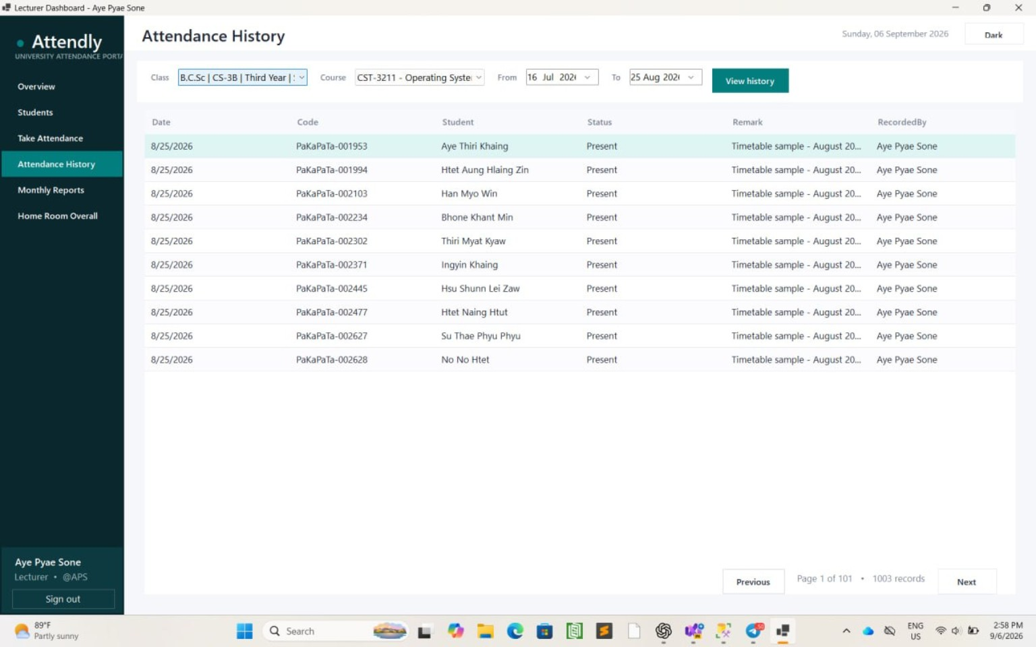
Figure 2.13 Attendance History Page
2.14 Monthly Reports
The Monthly Reports Page allows a lecturer to generate a report for any class the lecturer actively teaches. After selecting a class, month, and year, the system calculates each student's total sessions, present, absent, late, and excused counts, attendance percentage, and remark. This reporting permission does not grant permission to modify the class's students. The Monthly Reports Page is shown in Figure 2.14.
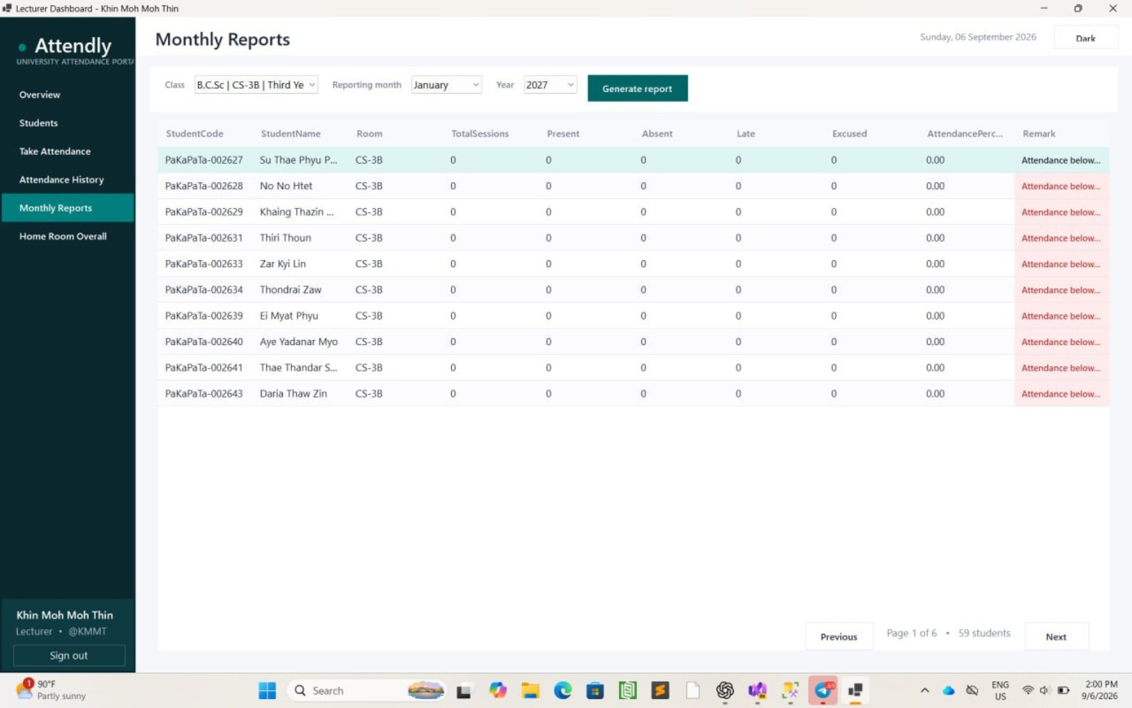
Figure 2.14 Monthly Reports Page
2.15 Home Room Overall
The Home Room Overall Page is available only to a lecturer who is the home-room teacher of an active class. It provides the complete monthly attendance summary for that home-room class. The lecturer selects a reporting month and year and generates the report showing session totals, attendance counts, percentage, and remarks for each student. The Home Room Overall Page is shown in Figure 2.15.
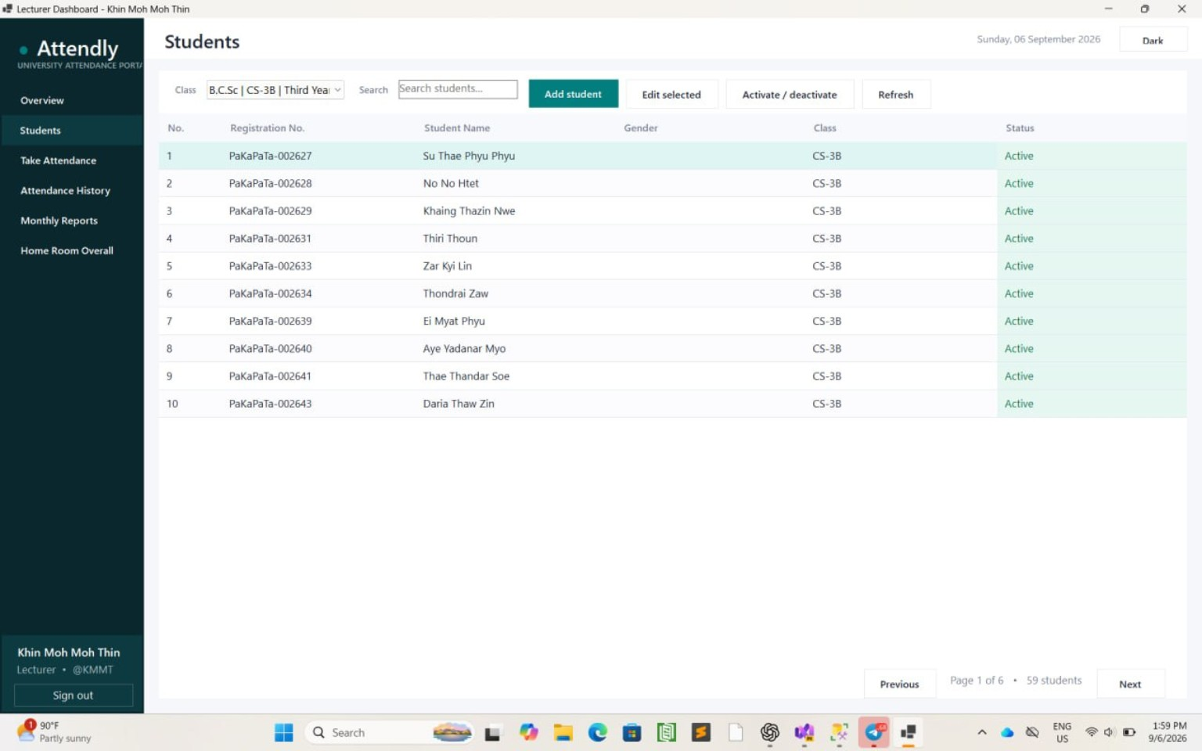
Figure 2.15 Home Room Overall Page
CHAPTER 3

3.1 Functional Requirement

3.1.1 Authentication and Authorization - The system shall authenticate administrators and lecturers using a username and password, reject inactive accounts, and display functions according to the user's role.
3.1.2 Academic Data Management - An administrator shall add, edit, search, activate, and deactivate lecturers, university classes, and courses.
3.1.3 Assignment and Timetable Management - An administrator shall assign lecturers to classes and courses, create timetable sessions only for assigned lecturers, and prevent class or lecturer time conflicts.
3.1.4 Student Management - An administrator shall manage students in all classes. A lecturer shall view students in assigned classes but shall modify students only in the lecturer's home-room class.
3.1.5 Attendance Management - A lecturer shall record attendance for assigned scheduled sessions, add remarks, save Present or Absent status, and cancel a session before attendance is recorded.
3.1.6 Reporting - Authorized users shall view attendance history and generate monthly reports. Home Room Overall shall be restricted to the responsible home-room lecturer.

3.2 Non- Functional Requirement

3.2.1 Performance - The application should load filtered lists and reports promptly and use database indexes for common attendance, timetable, student, and assignment queries.
3.2.2 Security - Passwords must be stored as salted PBKDF2 hashes. Role, assignment, account status, and home-room permissions must be validated in the service layer before protected operations.
3.2.3 Usability - The Windows Forms interface should provide consistent navigation, searchable tables, pagination, clear validation messages, and confirmation for status changes.
3.2.4 Data Integrity - SQL Server foreign keys, unique constraints, checks, transactions, and timetable-overlap validation should preserve consistent academic and attendance records.
3.2.5 Maintainability - The system should separate forms, services, models, helpers, and database scripts so that changes can be tested and maintained with limited impact.
3.2.6 Compatibility - The application requires a Windows computer with the .NET 8 Desktop Runtime and access to Microsoft SQL Server. It is a desktop application rather than a browser or mobile application.
3.2.7 Reliability - Attendance updates and administrative changes should use parameterized SQL and transactions where multiple related records must succeed or fail together.

3.3 Installation Manual
1. Install Microsoft SQL Server and SQL Server Management Studio, and install the .NET 8 Desktop Runtime on the Windows computer.
2. Open Database/Setup.sql in SQL Server Management Studio and execute it to create the StudentAttendanceSystem database and its tables, constraints, indexes, and reporting procedure.
3. Run Database/MigrateTimetable.sql and any later migration scripts required by the current project version.
4. Update appsettings.json with the SQL Server connection string for the StudentAttendanceSystem database.
5. Create the first administrator by running Database/BootstrapAdmin.ps1 from PowerShell with a username, full name, and secure password.
6. Open StudentAttendanceSystem.csproj in Visual Studio 2022, restore NuGet packages, and build the solution.
7. Start the application, sign in as the administrator, and create lecturers, classes, courses, assignments, and timetable sessions before lecturers record attendance.
8. Optional sample and timetable SQL scripts in the Database folder may be executed for demonstration data after their prerequisite classes, courses, lecturers, and assignments exist.
CHAPTER 4

CONCLUSION

The Student Attendance System provides a centralized Windows desktop solution for managing university attendance. Administrators maintain lecturers, classes, courses, assignments, timetables, and students, while lecturers record attendance through their assigned class sessions. SQL Server constraints, parameterized commands, role checks, home-room permissions, and timetable-overlap validation improve the accuracy and consistency of the stored information.
The completed system includes secure user login, role-based dashboards, student management, timetable scheduling, attendance history, and monthly report generation. Future improvements could include configurable Present, Absent, Late, and Excused entry controls, report export, automated notifications, database backup tools, and an optional web or mobile client connected to the same secured service layer.

  - Advantages of the System
- Time Saving - Lecturers can load scheduled sessions and record attendance without preparing manual attendance sheets.
- Accurate Records - Validation, foreign keys, unique constraints, and session-linked attendance reduce inconsistent and duplicate data.
- Role-Based Access - Administrators, assigned lecturers, and home-room lecturers receive functions appropriate to their responsibilities.
- Conflict Prevention - The timetable prevents overlapping active sessions for the same class or lecturer.
- Easy Retrieval - Search, filters, pagination, attendance history, and monthly summaries make records easier to find and review.
- Centralized Management - Lecturer, class, course, assignment, timetable, student, and attendance information is maintained in one database.
- Reduced Paper Use - Digital attendance records reduce reliance on printed registers and manual monthly calculations.

REFERENCES

- Microsoft. (2026). Windows Forms documentation. https://learn.microsoft.com/dotnet/desktop/winforms/

- Microsoft. (2026). Microsoft.Data.SqlClient documentation. https://learn.microsoft.com/sql/connect/ado-net/microsoft-ado-net-sql-server

- Microsoft. (2026). SQL Server documentation. https://learn.microsoft.com/sql/sql-server/

- Microsoft. (2026). .NET configuration documentation. https://learn.microsoft.com/dotnet/core/extensions/configuration

- Microsoft. (2026). Password hashing guidance for .NET. https://learn.microsoft.com/aspnet/core/security/data-protection/consumer-apis/password-hashing

