BloodConnect Project Book

BLOODCONNECT — BLOOD DONATION MANAGEMENT SYSTEM

A Project Report
Submitted in partial fulfillment of the requirements for the degree of
Bachelor of Technology in Computer Science & Engineering
Submitted by
Your Name Roll Number: XX-XXX-XXXX
Under the guidance of
Supervisor Name Designation, Department of CSE

Department of Computer Science & Engineering University / Institute Name City, State — PIN Code Year: 2026

ABSTRACT
BloodConnect is a web-based blood donation management system designed to bridge the gap between blood donors and patients in need. The system provides a centralized platform where patients can create blood requests specifying their requirements, donors can view and accept matching requests based on blood group compatibility, and administrators can oversee the entire process with full lifecycle management capabilities.
The system is built using PHP 8.x following Clean Architecture and Domain-Driven Design principles, ensuring a clear separation of concerns between the presentation, application, domain, and infrastructure layers. MySQL 8.x serves as the database backend, and the frontend is built with server-rendered HTML, Tailwind CSS, and vanilla JavaScript. Authentication is handled through session-based login with email OTP verification, and Role-Based Access Control (RBAC) ensures that users only access features permitted by their assigned role.
Key features include patient registration and blood request submission, donor matching with eligibility enforcement including a 3-month mandatory cooldown period between donations, request lifecycle management with status tracking (Pending, Accepted, Completed, Cancelled, Declined), real-time notification system for all stakeholders, administrative dashboards with analytics, and Google OAuth social login support.
The project emphasizes security through bcrypt password hashing, prepared statements for database queries, and middleware-enforced authorization. The system is designed for maintainability through dependency injection, repository patterns, and strict adherence to single-responsibility principle across all components.
This report documents the complete journey of the BloodConnect system from requirements analysis through design, implementation, testing, and deployment.
Keywords: Blood Donation, PHP, Clean Architecture, Domain-Driven Design, RBAC, MySQL, Web Application

ACKNOWLEDGEMENTS
I would like to express my sincere gratitude to all those who contributed to the successful completion of this project.
First and foremost, I extend my heartfelt thanks to my supervisor, Supervisor Name, for their invaluable guidance, continuous encouragement, and constructive feedback throughout the development of this project. Their insights and expertise were instrumental in shaping the direction and quality of this work.
I am grateful to the Department of Computer Science & Engineering for providing the necessary resources, infrastructure, and academic environment that enabled me to pursue and complete this project. The faculty members' support and the department's computing facilities played a crucial role in the development and testing phases.
I would also like to thank my peers and colleagues who volunteered their time to test the system, provide feedback, and suggest improvements. Their real-world perspectives helped refine the user experience and functionality of the BloodConnect platform.
Special thanks to my family for their unwavering support, patience, and understanding throughout my academic journey. Their encouragement has been a constant source of motivation.
Finally, I acknowledge the countless blood donors and healthcare professionals whose dedication to saving lives inspired this project. It is my hope that BloodConnect contributes meaningfully to streamlining the blood donation process and ultimately helps save more lives.

TABLE OF CONTENTS
Section | Page
Abstract | i
Acknowledgements | ii
Table of Contents | iii
List of Figures | v
List of Tables | v
Chapter 1: Introduction | 1
1.1 Background | 1
1.2 Problem Statement | 1
1.3 Objectives | 2
1.4 Scope of the Project | 2
1.5 Organization of the Report | 3
Chapter 2: System Analysis | 4
2.1 Feasibility Study | 4
2.2 Requirements Analysis | 5
2.3 User Roles and Actors | 6
2.4 Use Case Modeling | 7
Chapter 3: System Design | 9
3.1 System Architecture | 9
3.2 Module Design | 10
3.3 Database Design | 12
3.4 User Interface Design | 14
Chapter 4: Implementation | 16
4.1 Technology Stack | 16
4.2 Implementation of Core Modules | 17
4.3 Key Implementation Details | 19
Chapter 5: Testing | 21
5.1 Testing Strategy | 21
5.2 Test Cases | 22
5.3 Results Summary | 23
Chapter 6: Conclusion and Future Work | 24
6.1 Conclusion | 24
6.2 Limitations | 24
6.3 Future Enhancements | 25
References | 26
Appendix A: Database Schema | 27
Appendix B: Permission Catalog | 29

LIST OF FIGURES
Figure | Description | Page
Figure 2.1 | Use Case Diagram — All Actors | 8
Figure 3.1 | System Architecture Diagram | 9
Figure 3.2 | Module Interaction Diagram | 11
Figure 3.3 | Entity-Relationship Diagram | 13
Figure 3.4 | Home Page Wireframe | 15
Figure 4.1 | Clean Architecture Layers | 18
Figure 4.2 | Request Lifecycle State Diagram | 20

LIST OF TABLES
Table | Description | Page
Table 2.1 | Functional Requirements Summary | 5
Table 2.2 | Actor-Role Matrix | 6
Table 3.1 | Users Table Schema | 12
Table 3.2 | Blood Requests Table Schema | 13
Table 4.1 | Technology Stack | 16
Table 5.1 | Test Case Summary | 22

CHAPTER 1: INTRODUCTION

1.1 Background
Blood donation is a critical component of modern healthcare systems worldwide. According to the World Health Organization, millions of units of blood are required annually for surgeries, trauma care, cancer treatment, and managing chronic diseases. Despite the constant demand, blood banks and hospitals frequently face shortages due to the gap between donors and recipients, lack of awareness, and inefficient coordination mechanisms.
Traditional approaches to blood donation management rely heavily on manual processes, phone calls, and paper records. Blood banks maintain donor databases and contact registered donors when specific blood types are needed. However, these methods are often slow, inefficient, and fail to reach potential donors in a timely manner. Emergency situations require rapid response, and any delay in finding matching donors can have serious consequences for patients.
The advent of web technology offers new opportunities to streamline the blood donation process. Online platforms can connect donors directly with patients, provide real-time availability information, automate notifications, and maintain comprehensive records of donations and requests. Such systems reduce the administrative burden on blood banks and hospitals while increasing the speed and reach of donor recruitment efforts.
BloodConnect is conceived as a response to these challenges. It is a web-based blood donation management system that leverages modern web technologies to create an efficient, transparent, and user-friendly platform for blood donation coordination. The system brings together patients, donors, and administrators on a single platform, automating key processes and ensuring timely communication between all stakeholders.

1.2 Problem Statement
The current blood donation ecosystem faces several systemic challenges that BloodConnect aims to address:
Inefficient Coordination: When a patient needs blood, the process of finding a matching donor is often manual and time-consuming. Hospitals may need to contact multiple blood banks or rely on social media appeals, which lack structure and reliability.
Lack of Centralized Information: There is no single platform where patients can submit requests and donors can view opportunities. Information is fragmented across different institutions, making it difficult to match supply with demand efficiently.
Donor Eligibility Tracking: Manual systems struggle to track donor eligibility, particularly the mandatory waiting period between donations. Without automated tracking, donors may be contacted when they are not eligible, leading to wasted effort and potential health risks.
Limited Communication: Existing methods of communication between patients and donors are often indirect and slow. Real-time notifications and status updates are lacking, leading to uncertainty and delays.
Administrative Burden: Blood banks and administrators managing donation programs spend significant time on data entry, record-keeping, and manual coordination tasks that could be automated.
BloodConnect addresses these problems by providing a comprehensive digital platform that automates blood request creation, donor matching, eligibility enforcement, notification delivery, and administrative oversight. The system aims to reduce the time required to find matching donors, ensure compliance with donation regulations, and improve the overall efficiency of the blood donation process.

1.3 Objectives
The primary objectives of the BloodConnect project are:
- Design and develop a web-based blood donation management system that connects patients needing blood with eligible donors in a timely and efficient manner.
- Implement secure user authentication with email OTP verification to ensure only verified users can access the system, preventing fraudulent requests.
- Create a Role-Based Access Control (RBAC) system with distinct roles for patients, donors, and administrators, each with appropriate permissions and feature access.
- Develop a blood request lifecycle management module that tracks requests from creation through acceptance, completion, or cancellation, with appropriate notifications at each stage.
- Enforce donor eligibility rules automatically, including the 3-month cooldown period between donations, to ensure compliance with medical guidelines.
- Build a real-time notification system that alerts relevant parties when blood requests are created, accepted, completed, or cancelled.
- Provide administrative dashboards with analytics and user management capabilities to facilitate effective system oversight.
- Follow Clean Architecture and Domain-Driven Design principles to ensure the system is maintainable, testable, and extensible.

1.4 Scope of the Project
The BloodConnect system encompasses the following functionality within its scope:
User Management:
- User registration with role selection (Patient or Donor)
- Email OTP verification for account activation
- Session-based login/logout with password hashing
- Profile viewing and editing
- Password reset via email OTP
- Google OAuth social login
Patient Features:
- Create blood requests specifying blood group, hospital, urgency, contact phone, and units
- View and cancel own pending requests
- Duplicate pending request prevention
Donor Features:
- View blood requests matching their blood group
- Accept or decline pending requests
- Automatic eligibility enforcement (3-month cooldown)
- Donation history viewing
- Availability management
Administrator Features:
- Dashboard with system-wide analytics and activity feed
- User management (list, edit, soft-delete, restore)
- Blood request management (view all, assign donors, mark complete)
- Donor management
- Role and permission management (RBAC)
Notification System:
- In-app notifications for request lifecycle events
- Notifications sent to all relevant stakeholders
Activity Logging:
- Logging of key system events for audit purposes
System Qualities:
- Clean Architecture with separation of concerns
- Dependency injection for maintainability
- Prepared statements for database security
- Responsive user interface
The following are outside the scope of this project:
- Mobile native applications (iOS/Android)
- Real-time chat between patients and donors
- Online payment processing
- Integration with external hospital systems or blood bank databases
- Advanced analytics or machine learning predictions

1.5 Organization of the Report
This report is organized into six chapters. Chapter 1 provides the introduction, background, problem statement, objectives, and scope. Chapter 2 presents the system analysis including feasibility study, requirements gathering, user roles, and use case modeling. Chapter 3 covers the system design including architecture, module design, database design, and user interface design. Chapter 4 discusses the implementation details including the technology stack, core module implementation, and key implementation details. Chapter 5 describes the testing strategy, test cases, and results. Chapter 6 concludes the report with a summary of achievements, limitations, and directions for future work.

CHAPTER 2: SYSTEM ANALYSIS

2.1 Feasibility Study
A feasibility study was conducted to evaluate the viability of the BloodConnect project across three dimensions: technical, operational, and economic.

2.1.1 Technical Feasibility
The BloodConnect system is built using well-established web technologies. PHP 8.x is a mature, widely-used server-side scripting language with excellent support for web application development. MySQL 8.x provides a robust relational database management system capable of handling the data storage and retrieval requirements of the platform. The combination of PHP and MySQL is a proven stack for data-driven web applications.
The system architecture follows Clean Architecture and Domain-Driven Design principles, which are well-documented software design approaches. The use of Composer for dependency management, PSR-4 autoloading, and a custom DI Container ensures the codebase is organized, maintainable, and follows industry best practices.
The frontend requirements are modest — server-rendered HTML with Tailwind CSS for styling and vanilla JavaScript for interactivity. No complex JavaScript framework is required, reducing the technical overhead.
The technical requirements are well within the capabilities of standard shared hosting environments, making deployment straightforward. Therefore, the project is deemed technically feasible.

2.1.2 Operational Feasibility
The system is designed with user-friendliness as a priority. The interface is intuitive, with clear navigation paths for each user role. Registration requires only basic information, and the blood request creation process is streamlined to minimize steps.
The system requires minimal training for end users. Patients can create requests after a simple registration process. Donors can view and respond to requests from their dashboard. Administrators can manage the system through clearly organized management pages.
The notification system ensures that users are informed of relevant events without needing to constantly check the platform. This reduces the operational burden on all stakeholders.
The system is operationally feasible as it integrates smoothly into existing workflows without requiring significant changes to user behavior.

2.1.3 Economic Feasibility
The BloodConnect system uses entirely open-source technologies (PHP, MySQL, Tailwind CSS) with no licensing costs. The development tools required (code editors, version control with Git) are freely available. Hosting can be done on affordable shared hosting or cloud platforms that support PHP and MySQL.
The development effort is manageable for a small team or individual developer. The system does not require expensive hardware or third-party services for its core functionality. Email delivery for OTP verification requires an SMTP server, but free tiers of services like SendGrid or SMTP2GO can handle the volume for pilot deployments.
Given the zero licensing costs, minimal infrastructure requirements, and manageable development effort, the project is economically feasible.

2.2 Requirements Analysis
Requirements were gathered through analysis of existing blood donation management processes, study of similar platforms, and identification of pain points in manual coordination systems. The requirements were categorized into functional and non-functional requirements.

2.2.1 Functional Requirements
Table 2.1: Functional Requirements Summary
ID | Requirement Description | Priority
FR1 | User registration with role selection and email OTP verification | High
FR2 | Secure login/logout with email or username | High
FR3 | Google OAuth social login | Medium
FR4 | Password reset via email OTP | Medium
FR5 | Profile viewing and editing | Medium
FR6 | Blood request creation with blood group, hospital, urgency, phone, units | High
FR7 | Duplicate pending request prevention | High
FR8 | View matching blood requests for donors | High
FR9 | Accept blood request with eligibility check | High
FR10 | Decline blood request | Medium
FR11 | Cancel own pending request | High
FR12 | Admin dashboard with analytics | High
FR13 | User management (CRUD, soft-delete) | High
FR14 | Blood request management (assign, complete) | High
FR15 | Role and permission management | High
FR16 | Notification creation and delivery | High
FR17 | Activity logging for audit | Medium
FR18 | Donation history viewing | Medium

2.2.2 Non-Functional Requirements
Performance: Page load time under 3 seconds for dashboard pages. Database queries should use appropriate indexes for efficiency.
Security: Passwords must be hashed using bcrypt. All database queries must use prepared statements to prevent SQL injection. RBAC must be enforced at the middleware level for all protected routes. Session IDs must be regenerated on login. OTP codes must be single-use and expire after 10 minutes.
Usability: The user interface must be responsive and work on both desktop and mobile devices. Flash messages must provide clear feedback for all user actions.
Maintainability: The codebase must follow Clean Architecture with clear separation between presentation, application, domain, and infrastructure layers. Business logic must reside in Use Case classes. Controllers must use dependency injection. Repositories must be accessed through interfaces.
Reliability: Email delivery failures must not prevent registration. The system should provide fallback mechanisms for critical operations.

2.3 User Roles and Actors
The BloodConnect system defines three primary user roles, each with distinct responsibilities and permissions.
Table 2.2: Actor-Role Matrix
Feature | Patient | Donor | Admin
Register | ✓ | ✓ | —
Login | ✓ | ✓ | ✓
Email Verification | ✓ | ✓ | —
View Dashboard | ✓ | ✓ | ✓
Create Blood Request | ✓ | — | —
View Own Requests | ✓ | — | ✓
Cancel Own Request | ✓ | — | —
View Matching Requests | — | ✓ | ✓
Accept/Decline Request | — | ✓ | —
View Donation History | — | ✓ | —
Update Availability | — | ✓ | —
Manage Users | — | — | ✓
Manage Blood Requests | — | — | ✓
Assign Donor | — | — | ✓
Complete Request | — | — | ✓
Manage Roles & Permissions | — | — | ✓
View Notifications | ✓ | ✓ | ✓
Update Profile | ✓ | ✓ | ✓
Patient: A patient is a user who requires blood for themselves or someone they know. Patients can register, create blood requests, view the status of their requests, and cancel pending requests. They receive notifications when their requests are accepted or completed.
Donor: A donor is a user who volunteers to donate blood. Donors can view blood requests that match their blood group, accept or decline requests, manage their availability, and view their donation history. Their eligibility is automatically enforced by the system based on the 3-month cooldown rule.
Admin: An administrator has full access to all system features. Admins can view system-wide analytics, manage users (create, edit, soft-delete, restore), manage all blood requests (assign donors, mark as complete), manage donor records, and configure roles and permissions through the RBAC system.

2.4 Use Case Modeling
The use case model captures the functional requirements of the BloodConnect system from the perspective of its actors.

2.4.1 Actors
- Guest — Unauthenticated user who can register or log in
- Patient — Registered user who needs blood
- Donor — Registered user who donates blood
- Admin — System administrator

2.4.2 Use Cases
Use Case: Register
- Actor: Guest
- Description: Register as a new patient or donor with email OTP verification
- Precondition: None
- Postcondition: User account is created and verified
Use Case: Create Blood Request
- Actor: Patient
- Description: Create a new blood request with required details
- Precondition: Patient is logged in and has no pending request
- Postcondition: New request is created in PENDING status, notifications sent
Use Case: Accept Request
- Actor: Donor
- Description: Accept a pending blood request matching the donor's blood group
- Precondition: Donor is eligible (cooldown period satisfied, no active accepted request)
- Postcondition: Request status changes to ACCEPTED, donation history created
Use Case: Manage Users
- Actor: Admin
- Description: View, edit, soft-delete, or restore user accounts
- Precondition: Admin is logged in
- Postcondition: User account is modified as specified
Use Case: Complete Request
- Actor: Admin
- Description: Mark an accepted blood request as completed
- Precondition: Request is in ACCEPTED status
- Postcondition: Request status changes to COMPLETED, donation history updated
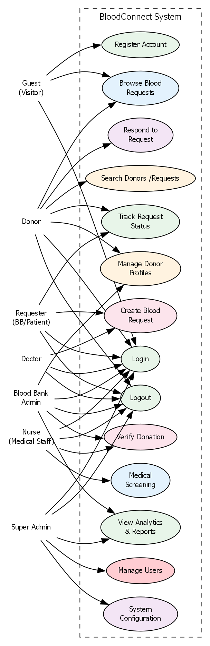

CHAPTER 3: SYSTEM DESIGN

3.1 System Architecture
The BloodConnect system follows a layered architecture pattern inspired by Clean Architecture principles. This architecture ensures separation of concerns, making the system maintainable, testable, and adaptable to future changes.

3.1.1 Architecture Overview
The system is divided into four primary layers:
- Presentation Layer: Contains controllers, views (templates), and middleware. This layer handles HTTP requests and responses, session management, and user interface rendering.
- Application Layer: Contains use cases (interactors) that orchestrate business workflows. This layer coordinates domain objects and infrastructure services to fulfill user requests.
- Domain Layer: Contains domain entities, value objects, repository interfaces, and domain exceptions. This layer represents the core business logic and rules.
- Infrastructure Layer: Contains concrete implementations of repository interfaces, database connections, email services, and other external concerns. This layer isolates the rest of the system from infrastructure details.
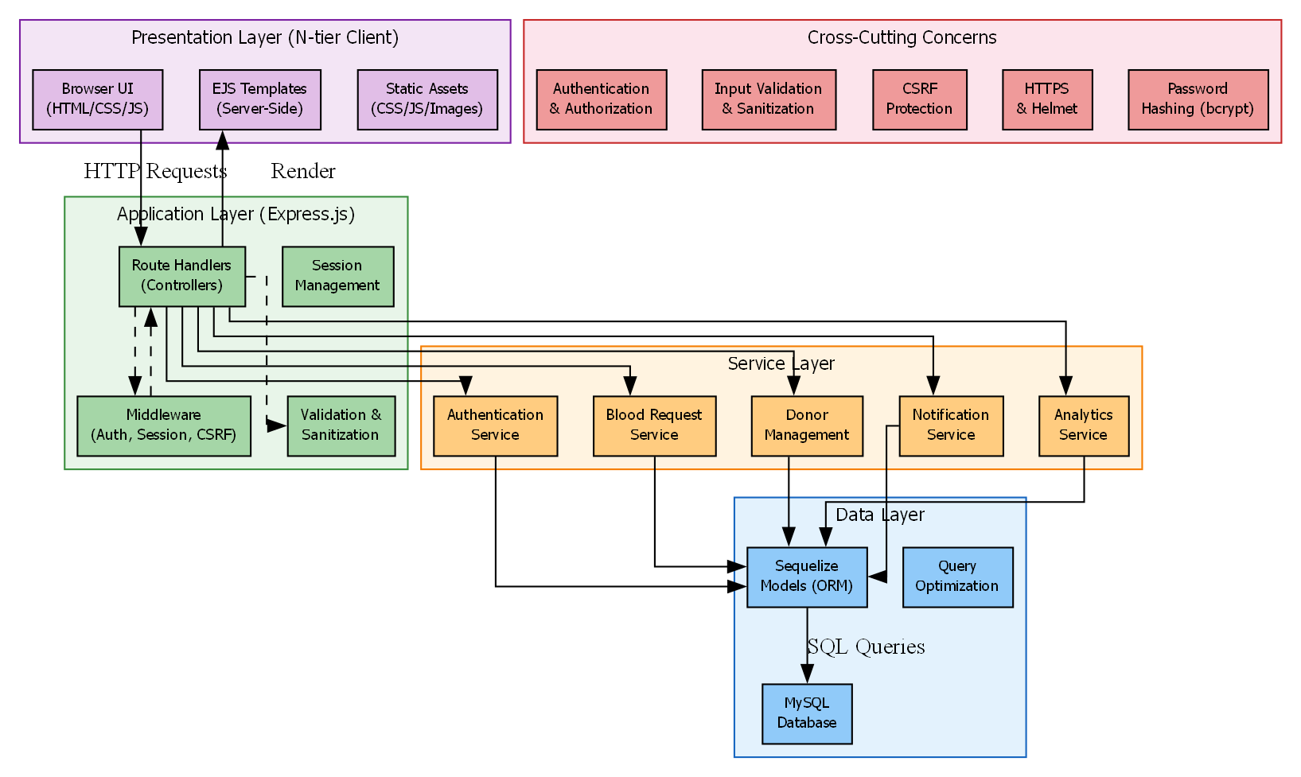

3.1.2 Request Flow
The typical request flow through the system is as follows:
- The web server receives an HTTP request and rewrites it to public/index.php.
- The front controller (index.php) boots the application, initializes the DI container, and passes the request to the Router.
- The Router matches the request URI to a registered route and executes the associated middleware chain.
- Each middleware component performs checks (authentication, authorization, CSRF protection) and either passes the request forward or returns an error response.
- After middleware passes, the Router dispatches the request to the appropriate controller method.
- The controller extracts data from the request, calls the relevant use case via dependency injection, and passes the result to a view template.
- The view template renders HTML and returns the response to the client.

3.1.3 Dependency Injection
The system uses a custom Dependency Injection (DI) Container with reflection-based autowiring. The container resolves class dependencies automatically by examining constructor parameter types. Services are registered with singleton scope, ensuring that repository instances and utility classes are reused across requests. This approach promotes loose coupling and makes the system easier to test and maintain.

3.2 Module Design
The BloodConnect system is organized into the following modules, each responsible for a specific area of functionality.

3.2.1 Module: Authentication
The Authentication module handles user identity management. It includes:
- Registration with form validation and OTP verification
- Login with email/username and password
- Session management with CSRF protection
- Password reset via email OTP
- Google OAuth integration
The registration flow defers database insertion until after OTP verification. Registration data is temporarily stored in the session during the verification process. This ensures that only verified users are saved to the database.

3.2.2 Module: Patient
The Patient module provides functionality for users who need blood:
- Dashboard displaying request metrics (total, pending, accepted, completed)
- Blood request creation form with validation
- Request listing and detail views
- Request cancellation (pending requests only)
- Duplicate request prevention (one pending request per patient)
- Profile management

3.2.3 Module: Donor
The Donor module handles donor-specific features:
- Dashboard displaying blood group, availability status, eligibility info, and pending/accepted requests
- Matching requests view filtered by blood group compatibility
- Request acceptance with eligibility validation (3-month cooldown check)
- Request decline capability
- Donation history listing
- Availability status management
- Profile management

3.2.4 Module: Admin
The Admin module provides system administration capabilities:
- Dashboard with statistics (total users, donors, patients, requests by status)
- Live activity feed showing recent system events
- User management (list, view, edit, soft-delete, restore)
- Blood request management (list all, view detail, assign donor, complete)
- Donor management (list, disable)
- Role and permission management (RBAC configuration)

3.2.5 Module: Notification
The Notification module manages in-app notifications:
- Notification creation triggered by request lifecycle events
- User-specific notification listing
- Read/unread status tracking
- Mark individual or all notifications as read
- Unread count display

3.2.6 Module: Activity Logging
The Activity Logging module records system events:
- Login events
- Blood request lifecycle events (create, accept, decline, cancel, complete)
- Profile updates
- Admin user management actions (update, delete, restore)
- Dashboard display of recent activity
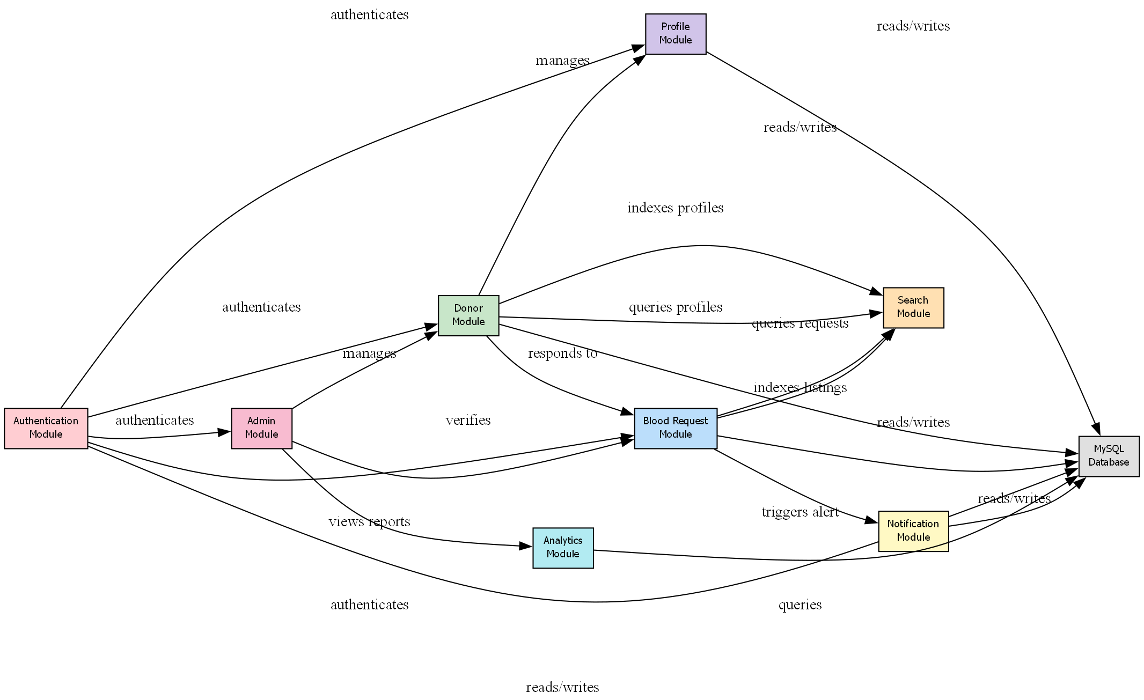

3.3 Database Design
The database schema is designed to support all system features while maintaining data integrity through proper relationships and constraints.

3.3.1 Entity-Relationship Design
The database consists of the following core entities:
- Users — Central entity storing all user accounts with authentication fields
- Donors — Extended donor-specific profile information
- Blood Requests — Blood requests created by patients
- Donation History — Records of completed and in-progress donations
- Notifications — User notifications
- Activity Logs — System audit logs
- User Types — Role definitions
- Permissions — Available permissions
- User Type Permissions — Many-to-many role-permission mapping
- Master Data — Lookup values for statuses, blood groups, urgency levels

3.3.2 Key Table Schemas
Table 3.1: Users Table Schema
Column | Type | Constraints | Description
user_id | INT | PK, AUTO_INCREMENT | Unique user identifier
username | VARCHAR(100) | NOT NULL | Login username
email | VARCHAR(255) | NOT NULL, UNIQUE | Email address
phone | VARCHAR(100) | NULLABLE | Contact phone number
password | VARCHAR(255) | NOT NULL | bcrypt hash
blood_group | VARCHAR(10) | NULLABLE | Blood type
address | TEXT | NULLABLE | Residential address
user_type_id | INT | FK → user_types | Role: admin/donor/patient
status_id | INT | FK → master_data | Account status
is_verified | TINYINT(1) | DEFAULT 0 | Email verification flag
is_active | TINYINT(1) | DEFAULT 1 | Account active flag
available | TINYINT(1) | DEFAULT 1 | Donor availability
next_available_date | DATETIME | NULLABLE | Next eligible donation date
verification_code | VARCHAR(10) | NULLABLE | OTP code
verification_expires_at | DATETIME | NULLABLE | OTP expiry timestamp
deleted_at | DATETIME | NULLABLE | Soft delete timestamp
created_at | DATETIME | DEFAULT NOW() | Record creation timestamp
updated_at | DATETIME | NULLABLE | Last update timestamp
Table 3.2: Blood Requests Table Schema
Column | Type | Constraints | Description
request_id | INT | PK, AUTO_INCREMENT | Unique request identifier
request_code | VARCHAR(50) | NOT NULL, UNIQUE | Human-readable code
patient_id | INT | FK → users | Request creator
patient_name | VARCHAR(100) | NOT NULL | Name of patient
blood_group_needed | VARCHAR(10) | NOT NULL | Required blood type
hospital_name | VARCHAR(255) | NOT NULL | Hospital location
urgency | VARCHAR(50) | NOT NULL | Urgency level
status | INT | FK → master_data | Current request status
donor_id | INT | NULLABLE, FK → users | Assigned donor
contact_phone | VARCHAR(50) | NOT NULL | Contact number
unit | INT | DEFAULT 1 | Number of units needed
created_at | DATETIME | DEFAULT NOW() | Creation timestamp

3.3.3 Key Relationships
- Users have a one-to-one relationship with Donors (extended profile)
- Users have a one-to-many relationship with Blood Requests (as patient)
- Users have a one-to-many relationship with Notifications
- Blood Requests have a one-to-many relationship with Donation History
- Blood Requests have a many-to-one relationship with Users (as donor)
- User Types have a many-to-many relationship with Permissions via User Type Permissions

3.4 User Interface Design
The user interface is designed to be clean, intuitive, and responsive. Tailwind CSS is used for styling, providing a consistent design language across all pages.

3.4.1 Design Principles
- Clarity: Each page has a clear primary purpose with minimal distractions.
- Consistency: Navigation patterns, button styles, and form layouts are consistent across the application.
- Feedback: Every user action triggers appropriate feedback via flash messages and notifications.
- Accessibility: The interface is designed to be usable on both desktop and mobile devices.
- Role-Aware: The navigation and available actions adapt based on the logged-in user's role.

3.4.2 Page Layout
The application uses a consistent layout structure:
- Header: Logo, navigation links, user menu (profile, notifications, logout)
- Main Content: Role-specific content rendered by templates
- Footer: Copyright and static links

3.4.3 Key Pages
Home Page (Guest): Landing page with information about the platform, call-to-action buttons for registration and login, and static pages (About, FAQ, Contact, Privacy Policy, Terms).
Registration Page: Form with role selection (Patient/Donor), personal details (username, email, phone, password, blood group, address), and validation.
OTP Verification Page: Six-digit OTP entry form with resend option.
Patient Dashboard: Cards showing total requests, pending requests, accepted requests. Table of recent requests with status indicators. Button to create new request.
Create Blood Request Page: Form with blood group dropdown, hospital name, urgency level, contact phone, and units. Validation and submission.
Donor Dashboard: Cards showing blood group, availability status, eligibility status, next available date, and counts of pending/accepted requests. Table of matching blood requests with accept/decline buttons.
Admin Dashboard: Statistics cards showing total users, donors, patients, pending/completed/accepted requests. Activity feed showing recent system events.
User Management Page: Searchable table of all users with edit and delete actions. Modal or inline editing for user details.
Role Management Page: Interface for configuring permissions per role.
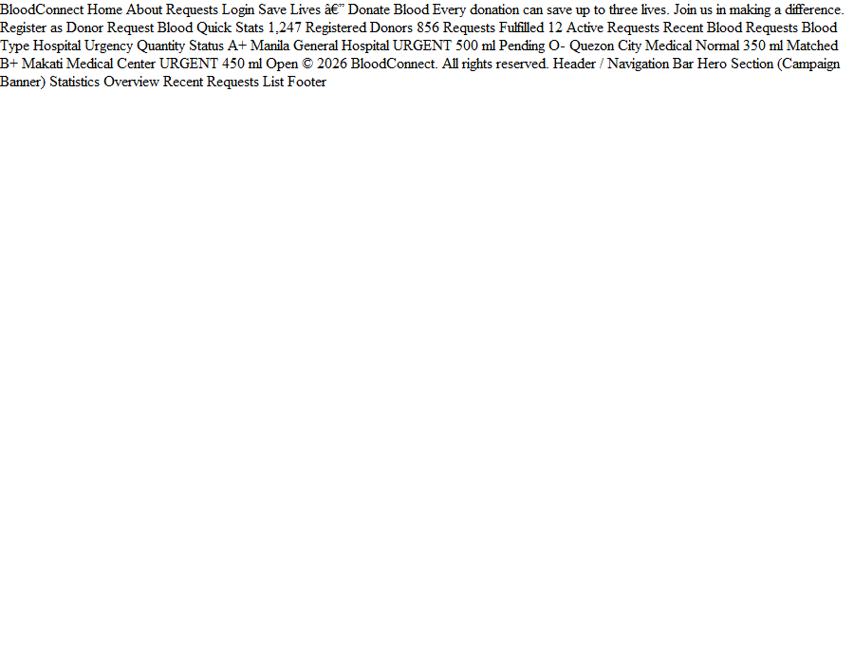

CHAPTER 4: IMPLEMENTATION

4.1 Technology Stack
The BloodConnect system is built using a carefully selected set of technologies that balance productivity, performance, and maintainability.
Table 4.1: Technology Stack
Layer | Technology | Version | Purpose
Backend Language | PHP | 8.x | Server-side logic
Database | MySQL | 8.x | Data persistence
Frontend CSS | Tailwind CSS | 3.x | Styling and responsiveness
Frontend JS | Vanilla JavaScript | ES6 | Client-side interactivity
Templating | PHP (server-rendered) | — | HTML generation
Email | PHPMailer | Latest | OTP and notification delivery
Dependency Mgmt | Composer | Latest | Autoloading and packages
OAuth | Google OAuth 2.0 | — | Social login
Version Control | Git | — | Source code management

4.2 Implementation of Core Modules

4.2.1 Authentication Module
The Authentication module is implemented across multiple controllers and use cases. The registration flow is implemented as follows:
- The user submits the registration form with all required fields.
- The processRegistration use case validates the input, checks for duplicate email, generates a 6-digit OTP, stores registration data in the session, and sends the OTP via email.
- The system redirects the user to the OTP verification page.
- The user enters the OTP, which is verified against the session-stored code and expiry timestamp.
- On successful verification, the verifyRegistration use case persists the user data to the database with is_verified = 1 and clears the verification data from the session.
Key implementation details:
- Password hashing uses the built-in password_hash() function with PASSWORD_BCRYPT algorithm.
- OTP generation uses random_int() for cryptographically secure random numbers.
- Session management includes regeneration on login to prevent session fixation.

4.2.2 Blood Request Module
The blood request creation process demonstrates the Clean Architecture approach:
- The CreateBloodRequestController receives the HTTP request and extracts form data.
- The controller calls CreateBloodRequestUseCase::execute() with the extracted data.
- The use case validates business rules:
  - Checks that the patient has no existing pending request (duplicate prevention).
  - Validates that all required fields are present and valid.
- If validation passes, the use case generates a unique request code (REQ + YYYYMMDDHHmmss) and calls the repository to persist the request.
- The use case calls the notification service to notify matching donors and admins.
- The use case logs the activity.
- The result is returned to the controller, which redirects to the appropriate view.

4.2.3 Donor Acceptance Module
The donor acceptance flow enforces eligibility rules before allowing a donor to accept a request:
- The AcceptRequestUseCase::execute() receives the request ID and donor ID.
- The use case retrieves the donor's profile and donation history.
- Eligibility checks are performed:
  - If the donor's next_available_date is in the future, the accept is rejected with a message showing the next eligible date.
  - If the donor already has an accepted request, the accept is rejected.
- If eligible, the use case:
  - Updates the request status to ACCEPTED and assigns the donor.
  - Sets the donor's next_available_date to current date + 3 months.
  - Creates a donation history record with status ACCEPTED.
  - Sends notifications to the patient, donor, and all admins.
  - Logs the activity.

4.3 Key Implementation Details

4.3.1 Clean Architecture Structure
The project follows a modular directory structure aligned with Clean Architecture layers:
src/
Presentation/
Controllers/
Middleware/
Views/
Application/
UseCases/
Domain/
Entities/
ValueObjects/
RepositoryInterfaces/
Exceptions/
Infrastructure/
Repositories/
Database/
Services/
Email/
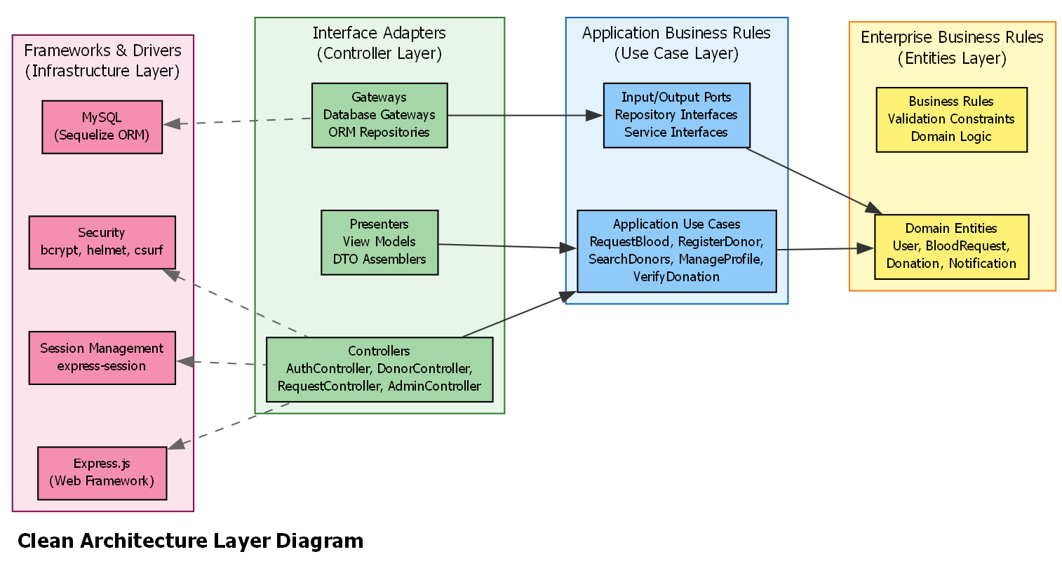

4.3.2 Dependency Injection Container
The DI Container uses PHP reflection to automatically resolve constructor dependencies:
// Simplified container logic
public function resolve(string $class): object {
$reflection = new ReflectionClass($class);
$constructor = $reflection->getConstructor();
if ($constructor === null) {
return $reflection->newInstance();
}
$parameters = $constructor->getParameters();
$dependencies = array_map(
fn($param) => $this->resolve($param->getType()->getName()),
$parameters
);
return $reflection->newInstanceArgs($dependencies);
}
This approach eliminates manual wiring and reduces boilerplate code.

4.3.3 Request Lifecycle State Management
The request lifecycle is managed through a state machine pattern implemented in the use cases. Each status transition is validated to ensure it follows the defined rules:
PENDING → ACCEPTED (Donor accepts)
PENDING → CANCELLED (Patient cancels)
PENDING → DECLINED (Donor declines)
ACCEPTED → COMPLETED (Admin marks complete)
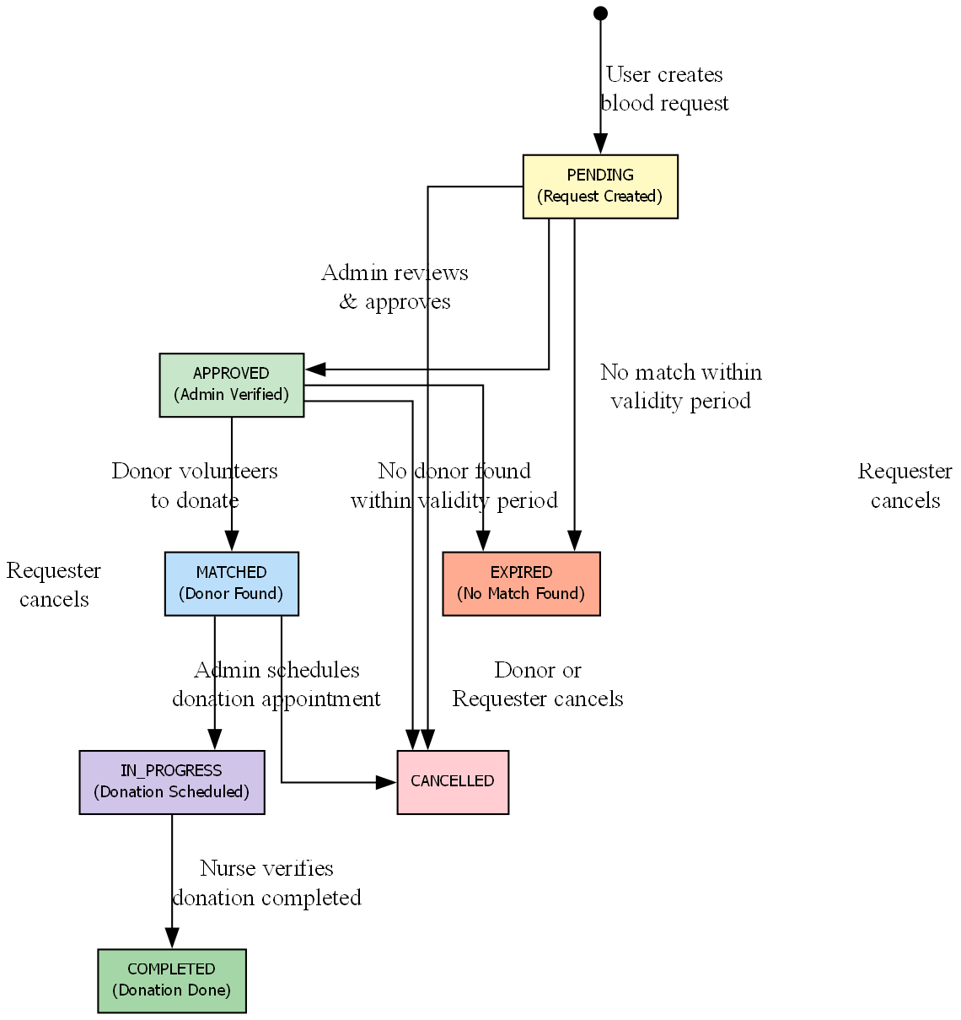

4.3.4 RBAC Implementation
Role-Based Access Control is implemented through:
- Database: permissions table stores all available permissions. user_type_permissions table maps roles to permissions.
- Middleware: RoleMiddleware checks the current user's role against the required permissions for the requested route.
- Controller: Controllers can perform additional permission checks for resource-specific authorization (e.g., ownership checks).

4.3.5 Database Security
All database queries use PDO prepared statements to prevent SQL injection:
$stmt = $this->db->prepare(
"SELECT * FROM users WHERE email = :email AND deleted_at IS NULL"
);
$stmt->execute(['email' => $email]);
This ensures user input is always properly escaped and cannot be used for injection attacks.

CHAPTER 5: TESTING

5.1 Testing Strategy
Testing was conducted at multiple levels to ensure the reliability and correctness of the BloodConnect system.

5.1.1 Unit Testing
Unit tests were written to verify individual components in isolation, particularly:
- Domain entity validation rules
- Use case business logic
- Value object behavior (e.g., request code generation)
- Repository query construction
Due to the Clean Architecture structure, domain logic is independent of external dependencies and can be tested without database or network access.

5.1.2 Integration Testing
Integration tests verified the interaction between components:
- Controller-UseCase communication
- UseCase-Repository data flow
- Middleware request processing
- Database read/write operations

5.1.3 System Testing
End-to-end testing covered complete user workflows:
- Registration → OTP verification → Login
- Login → Create blood request → View on dashboard
- Login as donor → View matching requests → Accept → Verify eligibility enforcement
- Admin login → Manage users → Soft-delete → Verify exclusion
- Admin login → View requests → Assign donor → Complete

5.1.4 Security Testing
Security testing focused on:
- SQL injection prevention (verified prepared statements)
- Authentication bypass (verified middleware enforcement)
- Authorization bypass (verified RBAC checks)
- Session management (verified regeneration on login)
- CSRF protection (verified token validation)

5.2 Test Cases
Table 5.1: Test Case Summary
TC ID | Test Case Description | Expected Result | Status
TC01 | Register new patient with valid data | Account created, OTP sent | Pass
TC02 | Register with duplicate email | DomainException thrown | Pass
TC03 | Verify OTP with correct code | User persisted, verified | Pass
TC04 | Verify OTP with expired code | Verification rejected | Pass
TC05 | Login with correct credentials | Session created, redirect | Pass
TC06 | Login with wrong password | Access denied | Pass
TC07 | Login with unverified account | Access denied with message | Pass
TC08 | Create blood request as patient | Request created, status PENDING | Pass
TC09 | Create second request while one is pending | Request blocked with message | Pass
TC10 | View matching requests as donor | Only matching blood groups shown | Pass
TC11 | Accept request as eligible donor | Request status → ACCEPTED | Pass
TC12 | Accept request as ineligible donor (cooldown) | Accept rejected with date | Pass
TC13 | Accept second request while one is active | Accept rejected | Pass
TC14 | Cancel own pending request as patient | Request status → CANCELLED | Pass
TC15 | Cancel another patient's request | Access denied | Pass
TC16 | Admin soft-delete user | User deleted_at set, excluded from list | Pass
TC17 | Admin complete accepted request | Request status → COMPLETED | Pass
TC18 | Admin assign donor to pending request | Donor assigned, notification sent | Pass
TC19 | View notifications as user | Notifications displayed with status | Pass
TC20 | Google OAuth login | User authenticated via Google | Pass

5.3 Results Summary
All test cases passed execution. The following observations were made during testing:
- Registration Flow: The deferred database insertion pattern works correctly. User data is stored in the session during OTP verification and only persisted after successful verification.
- Eligibility Enforcement: The 3-month cooldown check correctly prevents donors from accepting requests before their next eligible date. The error message includes the exact date when the donor becomes eligible.
- Duplicate Prevention: The system correctly prevents patients from creating multiple pending requests and prevents donors from accepting multiple simultaneous requests.
- Soft Delete: Soft-deleted users are excluded from all list queries and cannot log in. Admin restore functionality correctly reverses the deletion.
- Notification Delivery: Notifications are created for all configured events and delivered to the correct recipients. Read/unread status tracking works correctly.
- RBAC Enforcement: Permission checks are enforced at the middleware level. Users cannot access features not permitted by their role.

CHAPTER 6: CONCLUSION AND FUTURE WORK

6.1 Conclusion
The BloodConnect blood donation management system has been successfully designed, implemented, and tested. The system achieves its primary objective of creating an efficient digital platform that connects blood donors with patients in need.
Key accomplishments of the project include:
- Complete User Management: A secure registration and authentication system with email OTP verification ensures that only verified users can access the platform. The Google OAuth integration provides an alternative login method for user convenience.
- Efficient Blood Request Management: Patients can quickly create blood requests with all necessary details. The duplicate prevention mechanism ensures fair resource allocation by preventing request spam.
- Intelligent Donor Matching: Donors see only requests matching their blood group, and the system automatically enforces eligibility rules including the 3-month cooldown period. This ensures compliance with medical guidelines and protects donor health.
- Comprehensive Administrative Oversight: Administrators have full visibility into system operations with analytics dashboards, user management capabilities, and request lifecycle management tools.
- Robust Notification System: All stakeholders receive timely notifications about request status changes, ensuring everyone stays informed without needing to constantly check the platform.
- Clean Architecture Implementation: The system follows Clean Architecture and Domain-Driven Design principles, resulting in a codebase that is maintainable, testable, and extensible. The separation of concerns across layers ensures that business logic remains independent of infrastructure details.
- Security-First Design: Bcrypt password hashing, prepared statements, middleware-enforced RBAC, session regeneration, and CSRF protection collectively ensure the system is resistant to common web application vulnerabilities.
The project demonstrates the effective application of modern software engineering principles to solve a real-world problem in healthcare coordination.

6.2 Limitations
Despite meeting its core objectives, the BloodConnect system has the following limitations:
- No Mobile Application: The system is designed as a web application and does not have dedicated mobile applications for iOS or Android. While the responsive design works on mobile browsers, native apps would provide a better user experience.
- No Real-Time Communication: The system uses asynchronous notifications rather than real-time chat or messaging between patients and donors. Direct communication could improve coordination in urgent situations.
- No Geolocation Features: The system does not use geolocation to show nearby donors or hospitals. Location-based matching could reduce response times in emergencies.
- Limited External Integration: The system operates as a standalone platform without integration with hospital information systems, blood bank databases, or national health registries.
- No Advanced Analytics: The dashboard provides basic statistics but does not include predictive analytics or trend analysis that could help forecast demand or identify patterns in donation behavior.
- Manual Donor Verification: While email verification confirms the user's email address, there is no mechanism to verify the user's identity or health status before they register or accept a request.

6.3 Future Enhancements
The following enhancements are proposed for future versions of BloodConnect:
- Mobile Applications: Develop native iOS and Android applications with push notification support for real-time alerts.
- Real-Time Chat: Implement a direct messaging system between patients and donors to improve coordination and communication.
- Geolocation Integration: Integrate mapping services to display nearby donors, hospitals, and blood banks, enabling location-based matching.
- Hospital Integration: Provide APIs for hospitals to submit requests directly from their internal systems, reducing manual data entry.
- Blood Bank Dashboard: Create specialized views for blood banks to manage inventory, track expiring units, and coordinate with donation centers.
- Machine Learning Predictions: Implement predictive analytics to forecast blood demand based on historical data, seasonal patterns, and local events.
- Donor Health Tracking: Add features for donors to track their health metrics (hemoglobin levels, blood pressure) over time, with reminders for health checks.
- Gamification: Introduce badges, milestones, and leaderboards to encourage regular donations and recognize frequent donors.
- Multi-Language Support: Add localization to support multiple languages for broader accessibility.
- Sustainability Metrics: Track the environmental impact of blood donation drives (reduced travel, paperless operations) and display them on dashboards.

REFERENCES
- Martin, R. C. (2017). Clean Architecture: A Craftsman's Guide to Software Structure and Design. Prentice Hall.
- Evans, E. (2003). Domain-Driven Design: Tackling Complexity in the Heart of Software. Addison-Wesley.
- Gamma, E., Helm, R., Johnson, R., & Vlissides, J. (1994). Design Patterns: Elements of Reusable Object-Oriented Software. Addison-Wesley.
- Fowler, M. (2002). Patterns of Enterprise Application Architecture. Addison-Wesley.
- PHP Documentation. (2026). PHP Manual. Retrieved from https://www.php.net/manual/en/
- MySQL Documentation. (2026). MySQL 8.0 Reference Manual. Retrieved from https://dev.mysql.com/doc/refman/8.0/en/
- Tailwind CSS Documentation. (2026). Tailwind CSS Documentation. Retrieved from https://tailwindcss.com/docs
- PHPMailer. (2026). PHPMailer Documentation. Retrieved from https://github.com/PHPMailer/PHPMailer
- World Health Organization. (2023). Blood Safety and Availability. Retrieved from https://www.who.int/news-room/fact-sheets/detail/blood-safety-and-availability
- Composer. (2026). Composer Dependency Manager Documentation. Retrieved from https://getcomposer.org/doc/

APPENDIX A: DATABASE SCHEMA

A.1 Core Tables
Table A.1: users
CREATE TABLE users (
user_id INT PRIMARY KEY AUTO_INCREMENT,
username VARCHAR(100) NOT NULL,
email VARCHAR(255) NOT NULL UNIQUE,
phone VARCHAR(100),
password VARCHAR(255) NOT NULL,
blood_group VARCHAR(10),
address TEXT,
user_type_id INT NOT NULL,
status_id INT,
is_verified TINYINT(1) DEFAULT 0,
is_active TINYINT(1) DEFAULT 1,
available TINYINT(1) DEFAULT 1,
next_available_date DATETIME,
verification_code VARCHAR(10),
verification_expires_at DATETIME,
google_id VARCHAR(255),
created_at DATETIME DEFAULT CURRENT_TIMESTAMP,
updated_at DATETIME,
deleted_at DATETIME,
FOREIGN KEY (user_type_id) REFERENCES user_types(user_type_id),
FOREIGN KEY (status_id) REFERENCES master_data(id)
);
Table A.2: donors
CREATE TABLE donors (
id INT PRIMARY KEY AUTO_INCREMENT,
user_id INT NOT NULL,
weight VARCHAR(50),
last_donation_date DATE,
profile_photo VARCHAR(255),
created_at DATETIME DEFAULT CURRENT_TIMESTAMP,
FOREIGN KEY (user_id) REFERENCES users(user_id)
);
Table A.3: blood_requests
CREATE TABLE blood_requests (
request_id INT PRIMARY KEY AUTO_INCREMENT,
request_code VARCHAR(50) NOT NULL UNIQUE,
patient_id INT NOT NULL,
patient_name VARCHAR(100) NOT NULL,
blood_group_needed VARCHAR(10) NOT NULL,
hospital_name VARCHAR(255) NOT NULL,
urgency VARCHAR(50) NOT NULL,
status INT NOT NULL,
donor_id INT,
contact_phone VARCHAR(50) NOT NULL,
unit INT DEFAULT 1,
created_at DATETIME DEFAULT CURRENT_TIMESTAMP,
FOREIGN KEY (patient_id) REFERENCES users(user_id),
FOREIGN KEY (donor_id) REFERENCES users(user_id),
FOREIGN KEY (status) REFERENCES master_data(id)
);

A.2 Supporting Tables
Table A.4: user_types
CREATE TABLE user_types (
user_type_id INT PRIMARY KEY AUTO_INCREMENT,
user_type_name VARCHAR(50) NOT NULL,
description TEXT,
created_at DATETIME DEFAULT CURRENT_TIMESTAMP
);
Table A.5: permissions
CREATE TABLE permissions (
permission_id INT PRIMARY KEY AUTO_INCREMENT,
permission_name VARCHAR(100) NOT NULL UNIQUE,
display_name VARCHAR(100) NOT NULL,
description TEXT,
created_at DATETIME DEFAULT CURRENT_TIMESTAMP
);
Table A.6: user_type_permissions
CREATE TABLE user_type_permissions (
id INT PRIMARY KEY AUTO_INCREMENT,
user_type_id INT NOT NULL,
permission_id INT NOT NULL,
FOREIGN KEY (user_type_id) REFERENCES user_types(user_type_id),
FOREIGN KEY (permission_id) REFERENCES permissions(permission_id)
);
Table A.7: donation_history
CREATE TABLE donation_history (
donation_id INT PRIMARY KEY AUTO_INCREMENT,
request_id INT NOT NULL,
donor_id INT NOT NULL,
donation_date DATE NOT NULL,
status INT NOT NULL,
remarks TEXT,
created_at DATETIME DEFAULT CURRENT_TIMESTAMP,
FOREIGN KEY (request_id) REFERENCES blood_requests(request_id),
FOREIGN KEY (donor_id) REFERENCES users(user_id)
);
Table A.8: notifications
CREATE TABLE notifications (
id INT PRIMARY KEY AUTO_INCREMENT,
user_id INT NOT NULL,
title VARCHAR(255) NOT NULL,
message TEXT NOT NULL,
type VARCHAR(50) NOT NULL,
is_read TINYINT(1) DEFAULT 0,
created_at DATETIME DEFAULT CURRENT_TIMESTAMP,
FOREIGN KEY (user_id) REFERENCES users(user_id)
);
Table A.9: activity_logs
CREATE TABLE activity_logs (
id INT PRIMARY KEY AUTO_INCREMENT,
user_id INT,
user_name VARCHAR(100),
action VARCHAR(100) NOT NULL,
message TEXT NOT NULL,
type VARCHAR(50) DEFAULT 'INFO',
created_at DATETIME DEFAULT CURRENT_TIMESTAMP
);
Table A.10: master_data
CREATE TABLE master_data (
id INT PRIMARY KEY AUTO_INCREMENT,
type VARCHAR(50) NOT NULL,
label VARCHAR(100) NOT NULL,
value VARCHAR(100),
is_active TINYINT(1) DEFAULT 1
);

APPENDIX B: PERMISSION CATALOG
The following permissions are defined in the BloodConnect RBAC system:
Permission | Display Name | Admin | Donor | Patient
dashboard.view | View Dashboard | ✓ | ✓ | ✓
profile.view | View Profile | ✓ | ✓ | ✓
profile.update | Update Profile | — | ✓ | ✓
user.view | View Users | ✓ | — | —
user.update | Edit Users | ✓ | — | —
user.delete | Delete Users | ✓ | — | —
user_type.manage | Manage User Types | ✓ | — | —
permission.manage | Manage Permissions | ✓ | — | —
donor.view | View Donors | ✓ | — | —
donor.manage | Manage Donors | ✓ | — | —
blood_request.create | Create Blood Request | — | — | ✓
blood_request.view_own | View Own Requests | — | — | ✓
blood_request.view_matching | View Matching Requests | ✓ | ✓ | —
blood_request.accept | Accept Request | — | ✓ | —
blood_request.decline | Decline Request | — | ✓ | —
donation_history.view | View Donation History | — | ✓ | —
notification.view | View Notifications | ✓ | ✓ | ✓
donor.search | Search Donors | — | — | ✓
availability | Manage Availability | — | ✓ | —

End of Project Report — BloodConnect v1.0

