Energy Drinks UMMG 2026
Dr. Htet Phyo Aung
2026-09-06

Age distribution of the students
mean
percentiles
sd
present with mean(sd) min max median (IQR)
[1] 20.51754
[1] 19 20 21 21 24
[1] 0.7783856
age distribution histogram
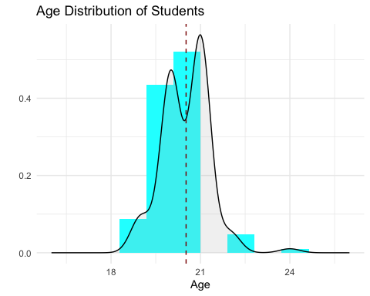
##frequency table for catagorized variables
One-way Tabulation
+ -------- --------------------- + ----- ------- ----- +
| Variable Category | Freq. Percent Cum. |
+ -------- --------------------- + ----- ------- ----- +
| sex Male | 55 48.2 48.2 |
| Female | 59 51.8 100.0 |
| --------------------- | ----- ------- ----- |
| Total | 114 100 100 |
| -------- --------------------- | ----- ------- ----- |
| marital Single | 109 95.6 95.6 |
| Married | 0 0.0 95.6 |
| Other | 5 4.4 100.0 |
| --------------------- | ----- ------- ----- |
| Total | 114 100 100 |
| -------- --------------------- | ----- ------- ----- |
| religion Buddhist | 113 99.1 99.1 |
| Christan | 1 0.9 100.0 |
| Islam | 0 0.0 100.0 |
| Hindu | 0 0.0 100.0 |
| Other | 0 0.0 100.0 |
| --------------------- | ----- ------- ----- |
| Total | 114 100 100 |
| -------- --------------------- | ----- ------- ----- |
| living School Dormitory | 95 83.3 83.3 |
| Private Hostel | 4 3.5 86.8 |
| With Family/Relatives | 15 13.2 100.0 |
| Other | 0 0.0 100.0 |
| --------------------- | ----- ------- ----- |
| Total | 114 100 100 |
+ -------- --------------------- + ----- ------- ----- +

Sex
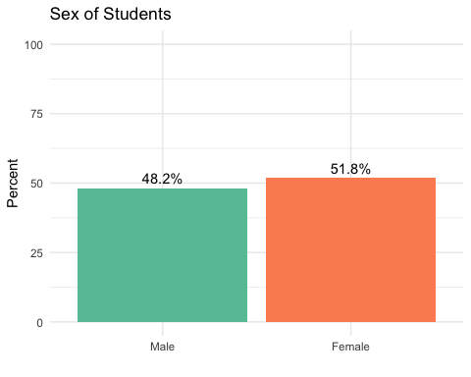

Marital status
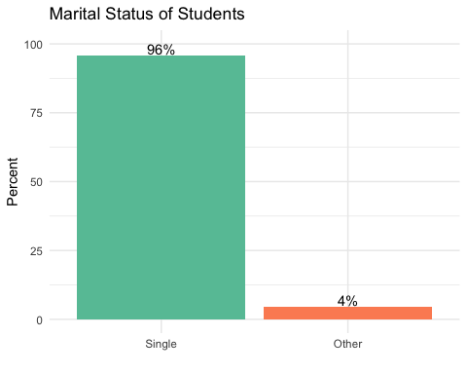

Religion
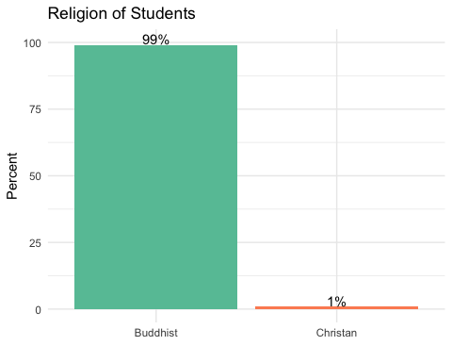

expenditure
[1] 427456.1
[1] 50000 400000 475000 500000 850000
[1] 138575.6
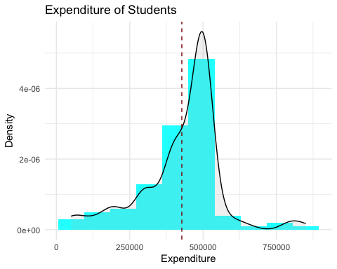

Current living condition
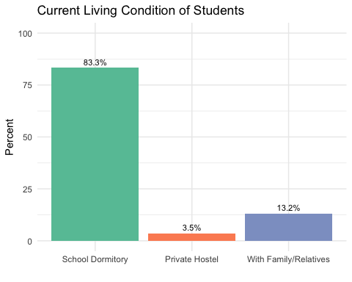

friends drinking edrink
One-way Tabulation
+ -------- -------- + ----- ------- ----- +
| Variable Category | Freq. Percent Cum. |
+ -------- -------- + ----- ------- ----- +
| friends Yes | 112 98.2 98.2 |
| No | 2 1.8 100.0 |
| -------- | ----- ------- ----- |
| Total | 114 100 100 |
+ -------- -------- + ----- ------- ----- +
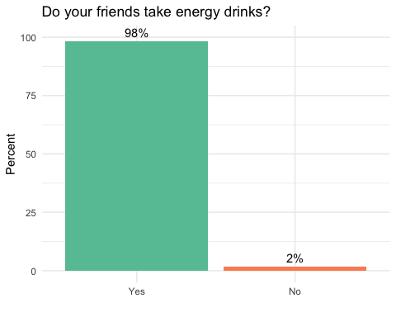

family take edrink
One-way Tabulation
+ -------- -------- + ----- ------- ----- +
| Variable Category | Freq. Percent Cum. |
+ -------- -------- + ----- ------- ----- +
| family Yes | 74 64.9 64.9 |
| No | 40 35.1 100.0 |
| -------- | ----- ------- ----- |
| Total | 114 100 100 |
+ -------- -------- + ----- ------- ----- +
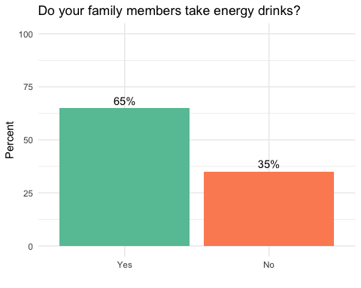

Awareness Questions
#B1, Do you know what an energy drink is?
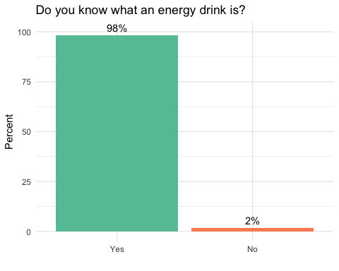
##B2.Choose the kinds of energy drink you know. (multiple response)
Option Percentage of (114) cases
1 Total 575.438596
2 Shark 92.105263
3 Carabao 85.964912
4 Speed 85.087719
5 Red Bull 74.561404
6 LIPOVITAN-D 67.543860
7 M-150 57.894737
8 Burn 57.017544
9 Rocker 50.877193
10 Other 4.385965
##B3. Which of these substances do you think are contained in energy drinks?(Multiple response)
Option Percentage of (114) cases
1 Total 422.807018
2 Sugars 99.122807
3 Vitamins 85.964912
4 Flavouring Agents 85.964912
5 Caffeine 80.701754
6 Preservatives 69.298246
7 Others 1.754386
##B4. What effects do you think energy drinks have? (Multiple Response)
Option Percentage of (114) cases
1 Total 180.701754
2 provide alertness 87.719298
3 Increase study concentration 57.017544
4 Increase physical resistance 25.438596
5 Don't Know 8.771930
6 B4e 1.754386
##B5. Caffeine in energy drinks causes the following symptoms.(Multiple Response)
Option Percentage of (114) cases
1 Total 264.035088
2 Insomnia 71.052632
3 Palpitation 66.666667
4 Tremor 51.754386
5 Anxiety 32.456140
6 Nervousness 28.070175
7 Headache 8.771930
8 B5g 5.263158
##B6. Frequent consumption of Energy drinks is
One-way Tabulation
+ -------- --------------- + ----- ------- ----- +
| Variable Category | Freq. Percent Cum. |
+ -------- --------------- + ----- ------- ----- +
| B6 Good for Health | 0 0.0 0.0 |
| Bad for Health | 112 98.2 98.2 |
| Don't Know | 2 1.8 100.0 |
| --------------- | ----- ------- ----- |
| Total | 114 100 100 |
+ -------- --------------- + ----- ------- ----- +
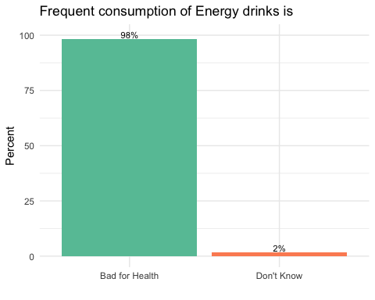
##B7. Consumption of High-level sugar-sweetened drinks is
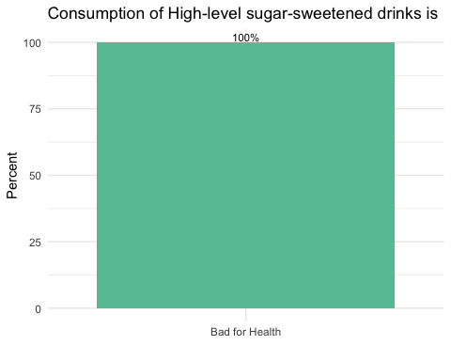
##B8. Health effects/risks due to consumption of energy drinks are(Multiple response)
Option Percentage of (114) cases
1 Total 392.105263
2 Sleep Disturbance 95.614035
3 Type 2 Diabetes 95.614035
4 Overweight/Obse 84.210526
5 Hyperlipidaemia 62.280702
6 Hypertension 34.210526
7 Hyperacidity 15.789474
8 Tuberculosis 3.508772
9 Anaemia 0.877193

Attitude towards E drinks
##C1. Energy drink consumption is not harmful for health
One-way Tabulation
+ -------- -------- + ----- ------- ----- +
| Variable Category | Freq. Percent Cum. |
+ -------- -------- + ----- ------- ----- +
| C1 Disagree | 92 80.7 80.7 |
| Neutral | 12 10.5 91.2 |
| Agree | 10 8.8 100.0 |
| -------- | ----- ------- ----- |
| Total | 114 100 100 |
+ -------- -------- + ----- ------- ----- +
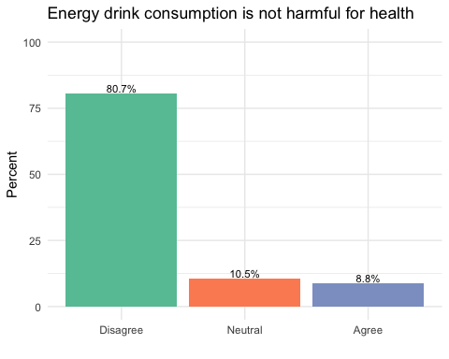
##C2. Energy drinks should be consumed because for the nutrients in it
One-way Tabulation
+ -------- -------- + ----- ------- ----- +
| Variable Category | Freq. Percent Cum. |
+ -------- -------- + ----- ------- ----- +
| C2 Disagree | 75 65.8 65.8 |
| Neutral | 34 29.8 95.6 |
| Agree | 5 4.4 100.0 |
| -------- | ----- ------- ----- |
| Total | 114 100 100 |
+ -------- -------- + ----- ------- ----- +
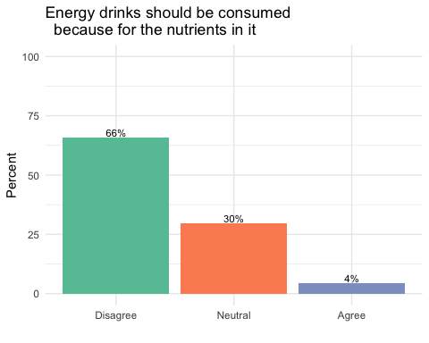
##C3. Energy drinks are consumed because they are easily available
One-way Tabulation
+ -------- -------- + ----- ------- ----- +
| Variable Category | Freq. Percent Cum. |
+ -------- -------- + ----- ------- ----- +
| C3 Disagree | 6 5.3 5.3 |
| Neutral | 23 20.2 25.5 |
| Agree | 85 74.6 100.1 |
| -------- | ----- ------- ----- |
| Total | 114 100 100 |
+ -------- -------- + ----- ------- ----- +
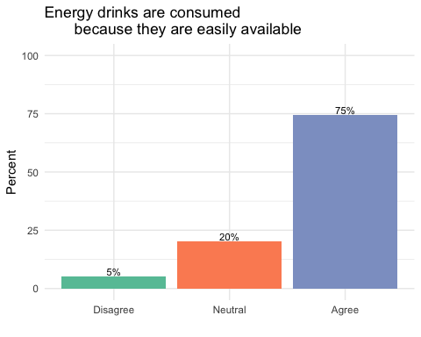
##C4. Advertisements for energy drinks should be banned
One-way Tabulation
+ -------- -------- + ----- ------- ----- +
| Variable Category | Freq. Percent Cum. |
+ -------- -------- + ----- ------- ----- +
| C4 Disagree | 41 36.0 36.0 |
| Neutral | 65 57.0 93.0 |
| Agree | 8 7.0 100.0 |
| -------- | ----- ------- ----- |
| Total | 114 100 100 |
+ -------- -------- + ----- ------- ----- +
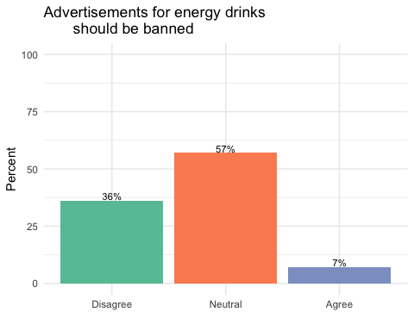
##C5. Energy drinks should be sold with cheap price
One-way Tabulation
+ -------- -------- + ----- ------- ----- +
| Variable Category | Freq. Percent Cum. |
+ -------- -------- + ----- ------- ----- +
| C5 Disagree | 25 21.9 21.9 |
| Neutral | 63 55.3 77.2 |
| Agree | 26 22.8 100.0 |
| -------- | ----- ------- ----- |
| Total | 114 100 100 |
+ -------- -------- + ----- ------- ----- +
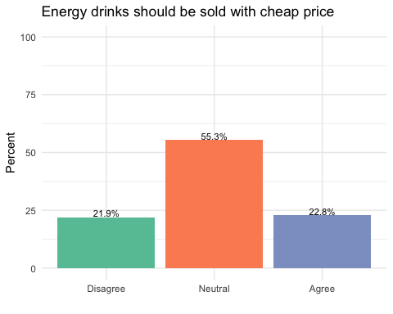
##C6. Water or fresh fruit juice should be drunk instead of energy drinks
One-way Tabulation
+ -------- -------- + ----- ------- ----- +
| Variable Category | Freq. Percent Cum. |
+ -------- -------- + ----- ------- ----- +
| C6 Disagree | 1 0.9 0.9 |
| Neutral | 3 2.6 3.5 |
| Agree | 110 96.5 100.0 |
| -------- | ----- ------- ----- |
| Total | 114 100 100 |
+ -------- -------- + ----- ------- ----- +
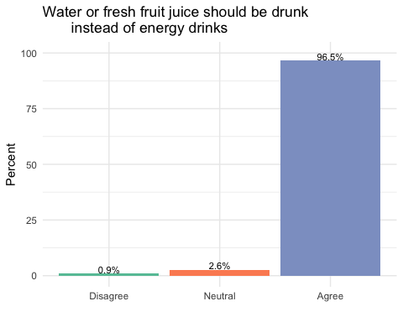
##C7. Ingredients in energy drinks should be known
One-way Tabulation
+ -------- -------- + ----- ------- ----- +
| Variable Category | Freq. Percent Cum. |
+ -------- -------- + ----- ------- ----- +
| C7 Disagree | 1 0.9 0.9 |
| Neutral | 5 4.4 5.3 |
| Agree | 108 94.7 100.0 |
| -------- | ----- ------- ----- |
| Total | 114 100 100 |
+ -------- -------- + ----- ------- ----- +
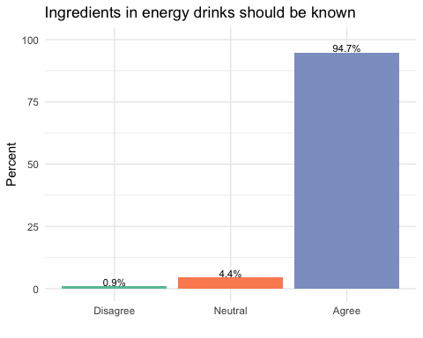
##C8. Energy drinks consumption can cause Diabetes
One-way Tabulation
+ -------- -------- + ----- ------- ----- +
| Variable Category | Freq. Percent Cum. |
+ -------- -------- + ----- ------- ----- +
| C8 Disagree | 1 0.9 0.9 |
| Neutral | 2 1.8 2.7 |
| Agree | 111 97.4 100.1 |
| -------- | ----- ------- ----- |
| Total | 114 100 100 |
+ -------- -------- + ----- ------- ----- +
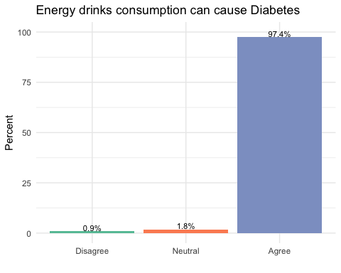
##C9. Energy drinks are not appropriate for children
One-way Tabulation
+ -------- -------- + ----- ------- ----- +
| Variable Category | Freq. Percent Cum. |
+ -------- -------- + ----- ------- ----- +
| C9 Disagree | 1 0.9 0.9 |
| Neutral | 11 9.6 10.5 |
| Agree | 102 89.5 100.0 |
| -------- | ----- ------- ----- |
| Total | 114 100 100 |
+ -------- -------- + ----- ------- ----- +
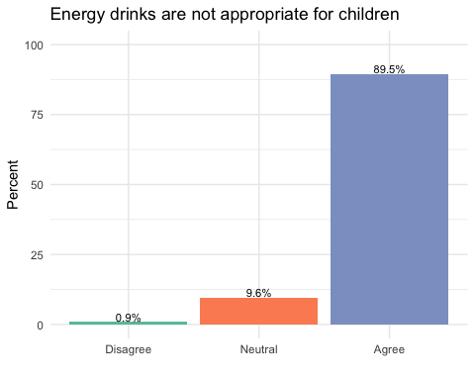
##C10. Frequent consumption of energy drinks can become dependent
One-way Tabulation
+ -------- -------- + ----- ------- ----- +
| Variable Category | Freq. Percent Cum. |
+ -------- -------- + ----- ------- ----- +
| C10 Disagree | 4 3.5 3.5 |
| Neutral | 16 14.0 17.5 |
| Agree | 94 82.5 100.0 |
| -------- | ----- ------- ----- |
| Total | 114 100 100 |
+ -------- -------- + ----- ------- ----- +
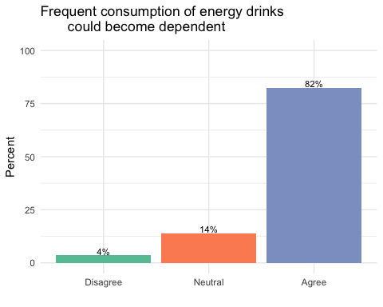
###Practice
##D1. Do you recently consumed energy drinks? (within one month)
One-way Tabulation
+ -------- -------- + ----- ------- ----- +
| Variable Category | Freq. Percent Cum. |
+ -------- -------- + ----- ------- ----- +
| D1 Yes | 75 65.8 65.8 |
| No | 39 34.2 100.0 |
| -------- | ----- ------- ----- |
| Total | 114 100 100 |
+ -------- -------- + ----- ------- ----- +
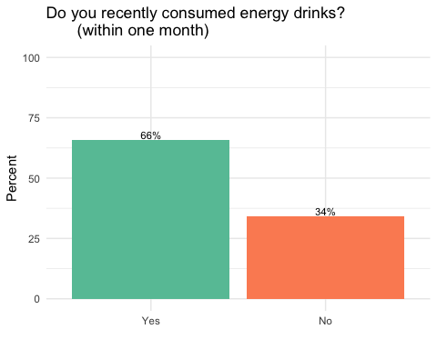
##D2. What age did you start consume energy drink?
[1] 11.10526
[1] 3.0 9.0 10.5 13.0 19.0
[1] 3.332246
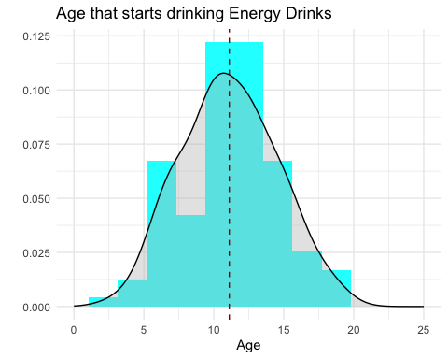
##D3. How many times did you consume energy drink during the last week?
One-way Tabulation
+ -------- ------------- + ----- ------- ----- +
| Variable Category | Freq. Percent Cum. |
+ -------- ------------- + ----- ------- ----- +
| D3 Everyday | 3 2.6 2.6 |
| five to six | 4 3.5 6.1 |
| Three to four | 15 13.2 19.3 |
| Two or less | 92 80.7 100.0 |
| ------------- | ----- ------- ----- |
| Total | 114 100 100 |
+ -------- ------------- + ----- ------- ----- +
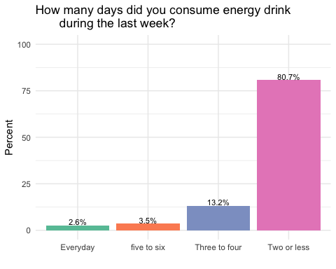
#D4. How were you first introduced to Energy drinks?
One-way Tabulation
+ -------- ----------------------- + ----- ------- ----- +
| Variable Category | Freq. Percent Cum. |
+ -------- ----------------------- + ----- ------- ----- +
| D4 Advertisements | 51 44.7 44.7 |
| Sellers' Recommend | 2 1.8 46.5 |
| Family/Friend recommend | 55 48.2 94.7 |
| Others | 6 5.3 100.0 |
| ----------------------- | ----- ------- ----- |
| Total | 114 100 100 |
+ -------- ----------------------- + ----- ------- ----- +
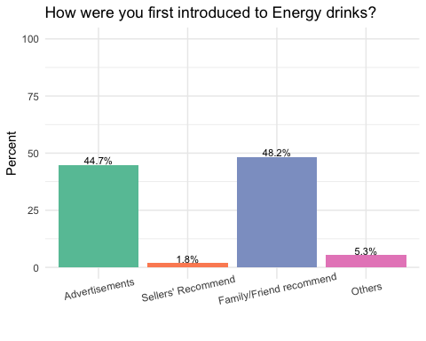
##D5. Reasons for consuming energy drinks (multiple response)
Option Percentage of (114) cases
1 Total 221.052632
2 To stay awake 69.298246
3 Energy Boost 69.298246
4 To study 50.000000
5 Sports 17.543860
6 Mental Enhancer 14.035088
7 Weight control 0.877193
#D6 How many energy drinks do you consume in an average week?
[1] 1.77193
[1] 0 1 2 2 7
[1] 1.401864
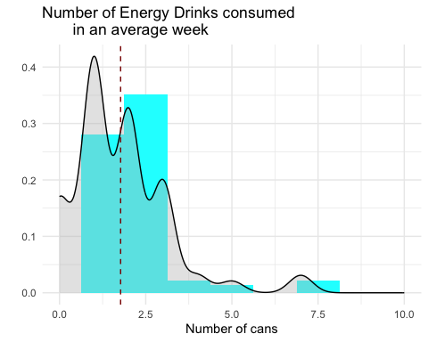
##D7. Do you usually read the food label before buying energy drink?
One-way Tabulation
+ -------- -------- + ----- ------- ----- +
| Variable Category | Freq. Percent Cum. |
+ -------- -------- + ----- ------- ----- +
| D7 Yes | 64 56.1 56.1 |
| No | 50 43.9 100.0 |
| -------- | ----- ------- ----- |
| Total | 114 100 100 |
+ -------- -------- + ----- ------- ----- +
