**CURRICULUM VITAE**

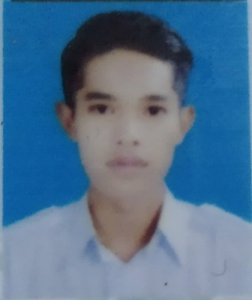

**PERSONAL INFORMATION**

Name : Htet Wai Yan Aung

Date of Birth : 2.1.1999

N.R.C No. : 5/SaKaNa(N)251780

Religion : Buddhist

Race : Burmese

Nationality : Myanmar

Marital Status : Single

Gender : Male

Language : Burmese, English

**CONTACT ME**

Email : [htetwaiyanaung.sgg@gmail.com](mailto:htetwaiyanaung.sgg@gmail.com)

Contact Address : Ywa Htaung Quarter, Sagaing Township.

Phone : +959790611402

+959957231588

**EDUCATION**

Education : Fifth year of Electronics Communication ( TU-Sagaing )

From 2015 to 2019

Applied Post : Junior Web Developer

**WORK EXPERIENCE**

Working Experience : No

**CERTIFICATE**

