# Admin manual

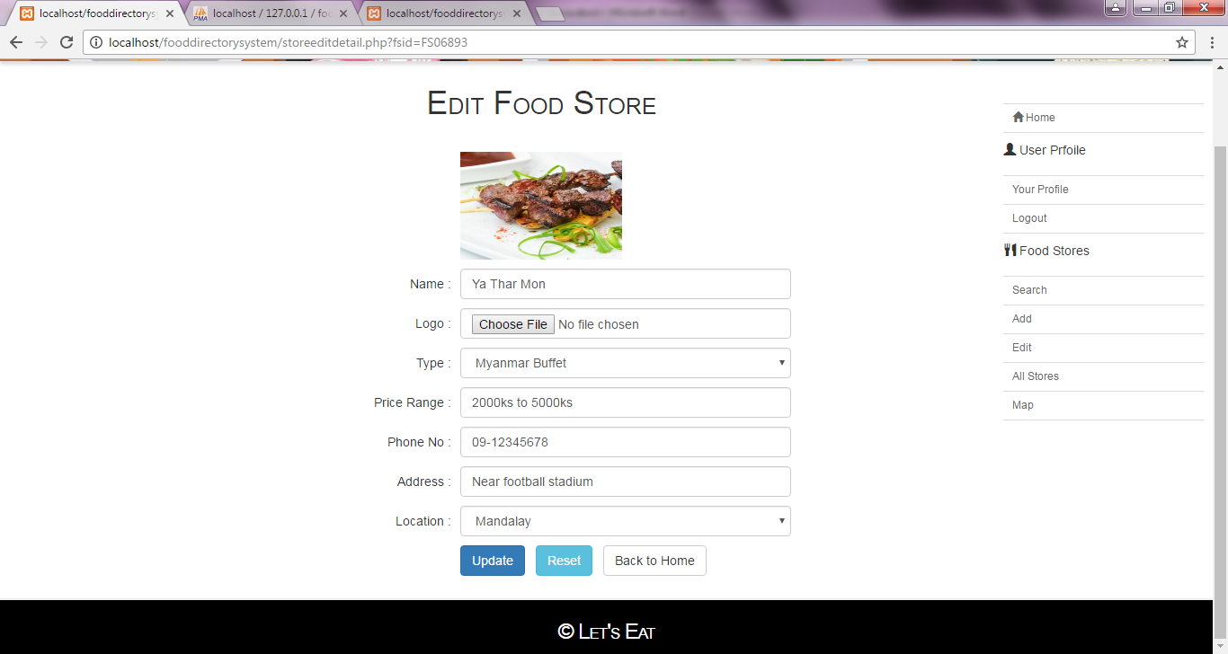

This is the edit store page of admin. The admin can edit all of the food stored which are added by the ad min team.

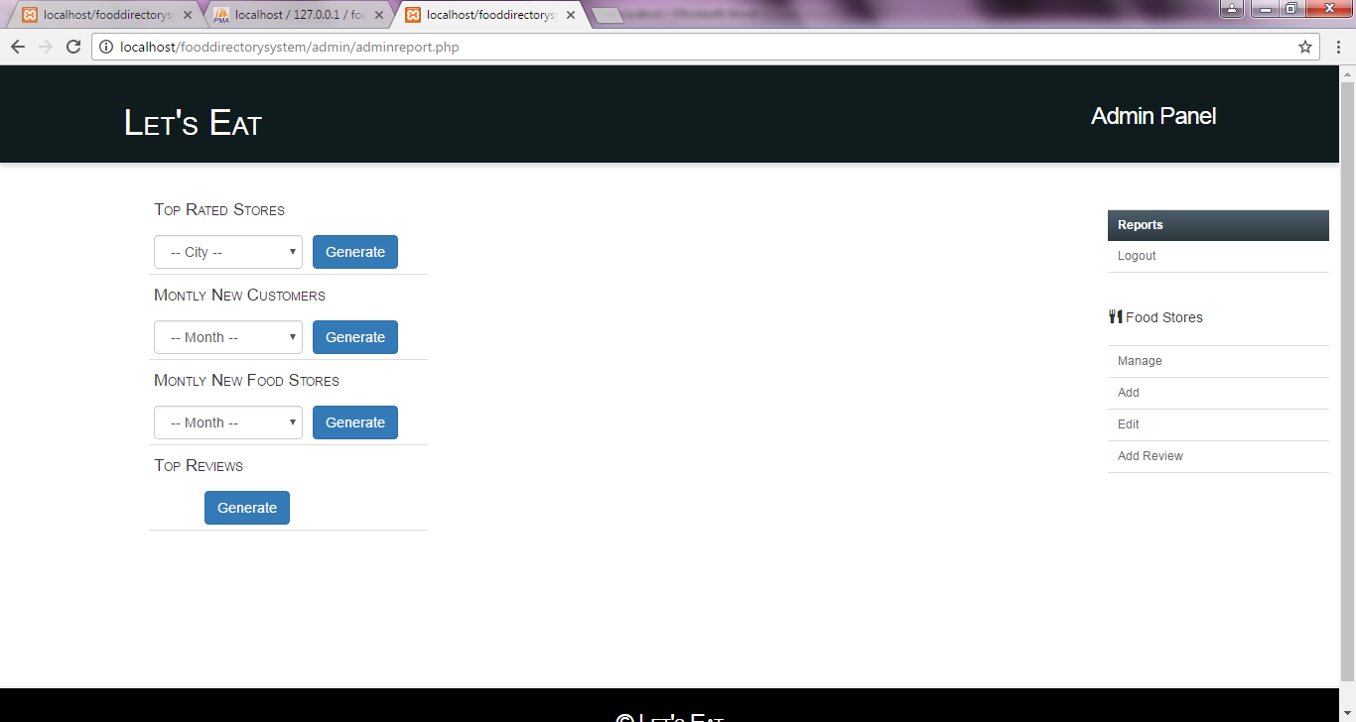

This is the report page. In this page, the admin can be able to generate the report from the system.

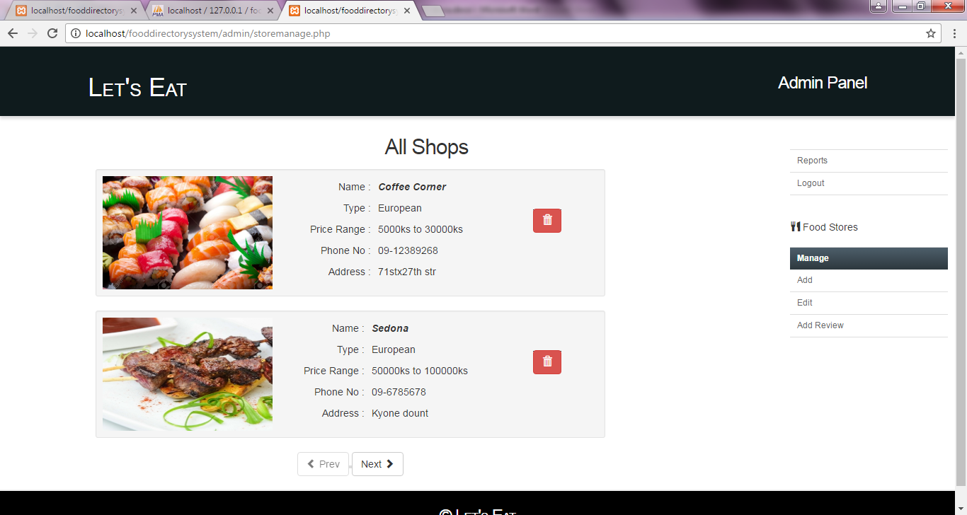

This is the ‘Manage Store’ Page. In this page, the admin can be able to delete inactive shops or shops with wrong data.

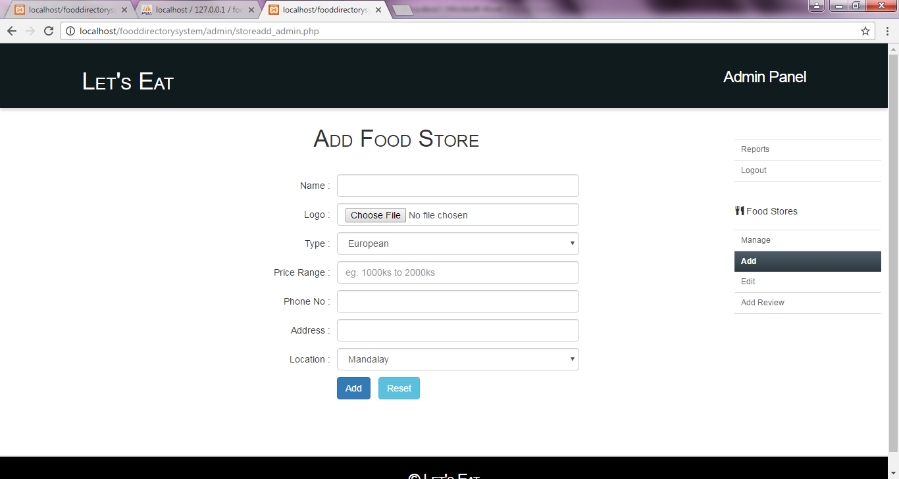

This is the ‘Add Store’ page. From this page, the admin can be able to add new stores.