 

STUDENT MANAGEMENT APPLICATION



**Thank for Teacher Guider Nguyen Quoc Nguyen, Center Softech-Aptech and members of group helped to complete successfully this project !**

* Batch 106 – Group 4 .
* Guider : Mr. Nguyen Quoc Nguyen .
* Member : Nguyen Huynh Tanh (Leader) .

Truong Thanh Than .

Hoang Trong Bin .

Table Content

1. Definition of the Problem ………………………………………………………………………………………3
   1. Need ……………………………………………………………………………………………………………….3
   2. Overview of the solution ……………………………………………………………………………….3
2. Requirement analysis ……………………………………………………………………………………………..3
   1. List of inputs to the system …………………………………………………………………………….3
   2. List of outputs expected from the system ………………………………………………………4
   3. Overview of process involved in the system ……………………………………………………4
   4. Use case and Actors …………………………………………………………………………………………5
   5. Hardware and software required for implementing the project …………………….9
3. Design ………………………………………………………………………………………………………………………9
   1. Design Database ………………………………………………………………………………………………9
   2. Design Interface, function modules, code criteria …………………………………………11
   3. Design GUIs …………………………………………………………………………………………………….11
4. Task sheet ………………………………………………………………………………………………………………30
5. Summary …………………………………………………………………………………………………………………30
6. Definition of the Problem :
   1. Need :

At the Softech - Aptech programmer training center, the number of students with a large volume of information is increasing and management increasingly difficult. The need for a software to manage information related to students are essential. The Application of new technologies to solve the problem brings many advantages compared to a system of the present paper, ensuring a smooth and consistent flow of information in the system .

* 1. Overview of the solution :
* Modeling the objects of the issue into Database follow direction with the Real-World .
* Easily manipulate , handle, caculator, add new, edit, update, storage, ...
* Manage your data in the relational model is based on the table to bring the integrity and synchronization of data .
* Encapsulation data, and authorization access to solve issues of data security.
* Design each Modul of each object type and function offer easly maintenance and repair later.
* Interface optimized and is suitable for the use and management .
* Optimize new technology to bring a quality product with reasonable price.

1. Requirement analysis :
   1. List of inputs to the system :
   * Student information : Name, DoB, Address, Gender , Phone number, Email, Image, …
   * Account information : UserName, Password, DoB, Gender, Email, Last login,…
   * Program information : ID, Name .
   * Batch information : ID, Name, Start date, End date, Schedule …
   * Faculty information : ID, Name, DoB, Address, Gender, Phone number …
   * Score information: StudentID, CourseID, E-test, R-test,…
   * Course information : CourseID, Name, Semester, Theory hour, Lab hour, …
   * Lab Information : LabID, Name, Status .
   * Schedule information : ID, Start date, End date, Batch, Lab, Faculty, …
   * FeedBack information : ID, Student, Date, Subject, Note, …
   1. List of outputs expected from the system :
   * Tables data of process Add, Update, Delete, Search, … information .
   * Fields data of process Add, Update, Delete, Search, … information .
   1. Overview of process involved in the system :
   * Add .
   * Update .
   * Delete .
   * Search .
   * Login .
   * Logout .
   * FeedBack .
   * Change Password .
   * Permission .

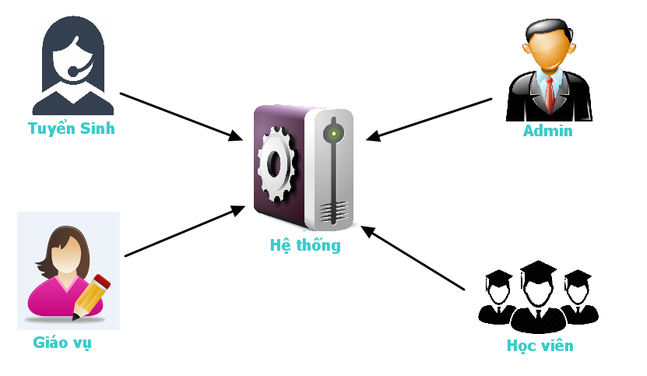

* 1. Use case and Actors :

1. Entollment :

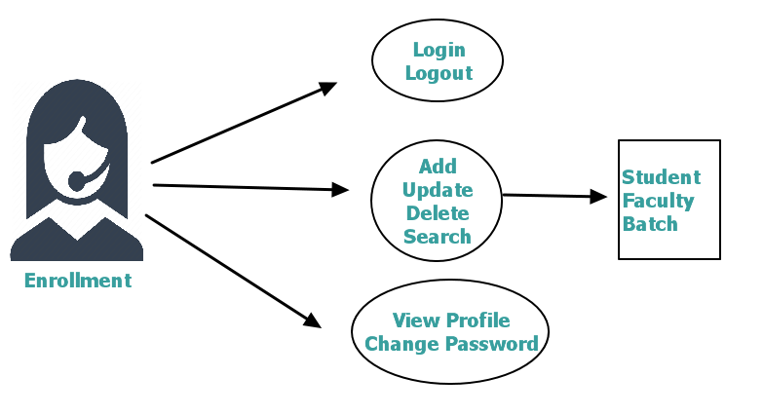

**.** **Describe process :**

* The first : Enrollment login into system with UserName and Password of oneself, what allocated by Admin and use only function of Enrollment .
* After login into system, Enrollment can only Add, Update, Delete, Search information of Student , Batch, Faculty .
* Next Enrollment allocate for Student an Account to login into system .
* Enrollment can view profile of oneself .
* The end, Enrollment can change password if essential, and logout system .

1. Bursary :

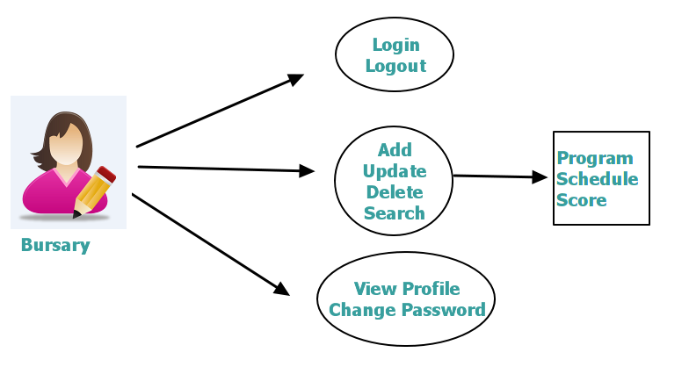

**. Describe process :**

* The first : Bursary login into system with UserName and Password of oneself, what allocated by Admin and use only function of Bursary .
* After login into system, Bursary can only Add, Update, Delete, Search information of Program , Schedule, Score .
* Bursary can view profile of oneself .
* The end, Bursary can change password if essential, and logout system .

1. Student :

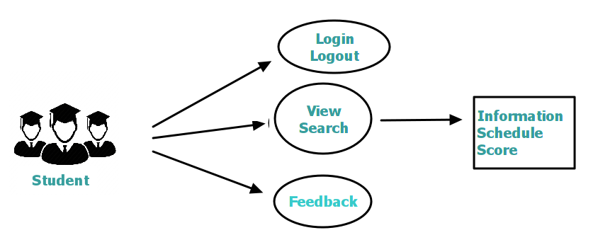

**. Describe Process :**

* The first : Student login into system with UserName and Password of oneself, what allocated by Enrollment and use only function of Student.
* After login into system, Student can only View, Search information, Schedule, Score of oneself .
* Student can send Feedback to Admin with permission Public, Private, Alias .
* The end, Student can change password if essential, and logout system .

1. Admin :

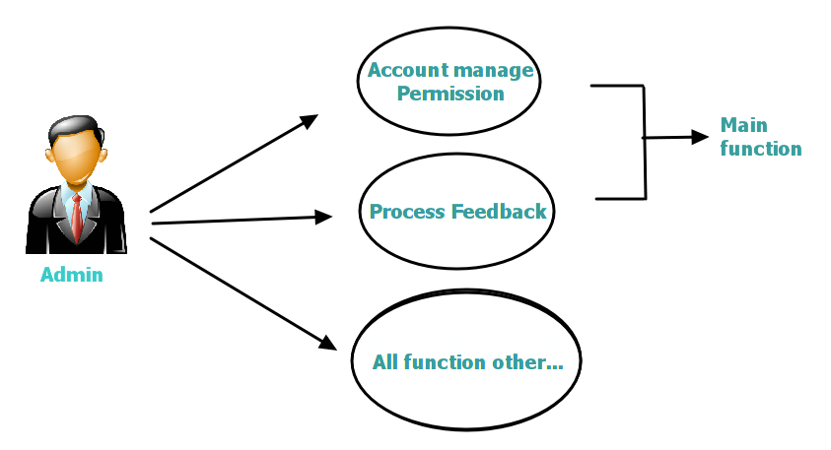

**. Describe Process :**

* The first : Admin login into system with UserName and Password of oneself .
* After login into system, Admin can View, Search information Account, Feedback of all actor in system . ( main function )
* Also, Admin can handle all function other in system .( sub function )
* The end, Admin can change password if essential, and logout system .
  1. Hardware and software required for implementing the project .

1. Hardware :

* Compatible with almost all computer config type present .

1. Sofware :

* Here is java application, therefore it can run on all platform, but it required install JVM ( Java Virtual Machine ) .
* Over SQL server 2012 .

1. Design :

3.1 Design Database :

* Database comprisse 10 tables, what constrainted by Foreign-key constraints .
* Every table is a entity set of objects in system, comprise a Primary-key and properties .

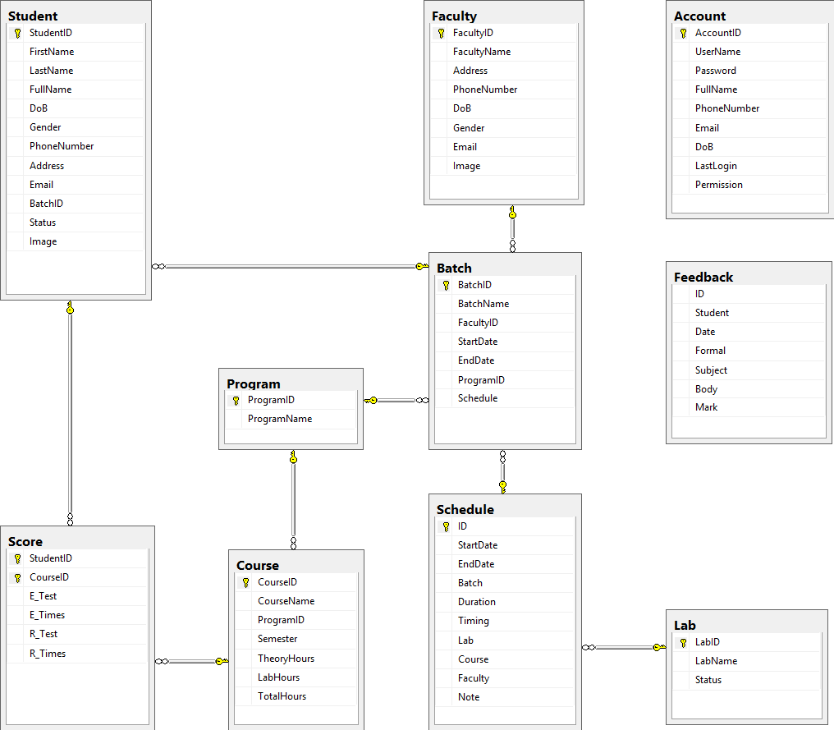

3.2 Design Interface, Function modules, Code criteria :

- Inherit Interfaces of J2SE .

- Functions divided three modules : Function, Gui, Image .

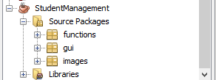

* Code criteria : . Method name and variant name follow rule unite .

. Name easy remember .

3.3 Design GUIs :

a. Form login :

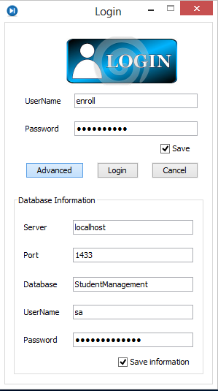

1. Form Welcome :

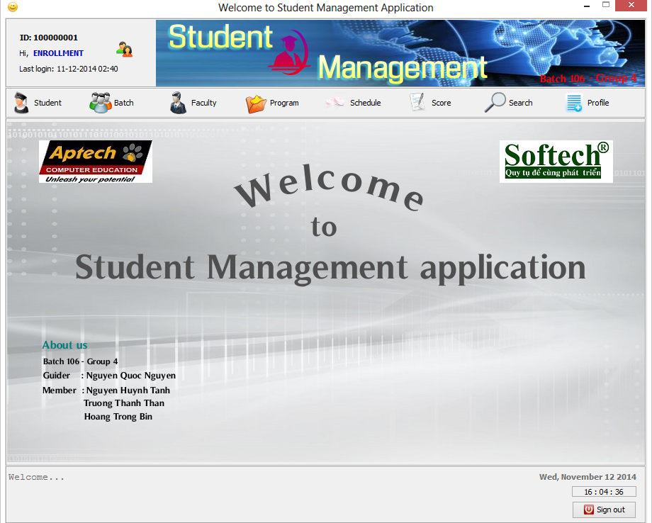

1. Form Add Student Enrollment :

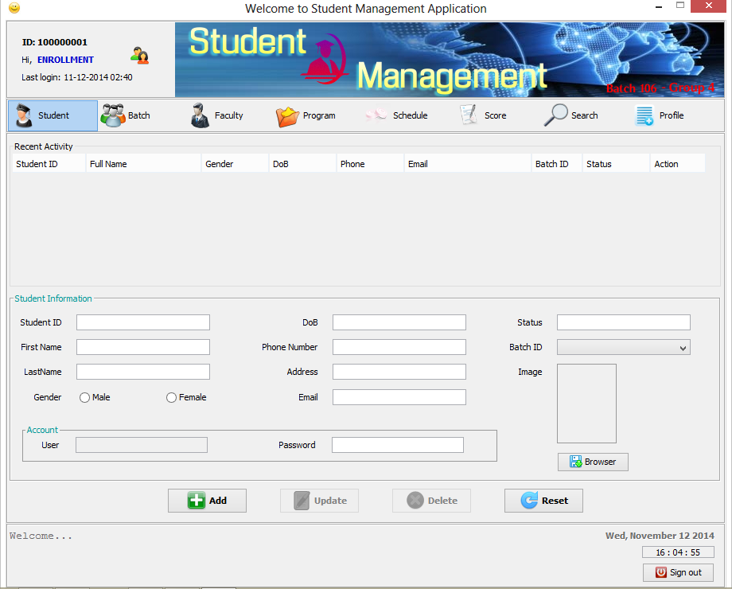

1. Form Batch Enrollment :

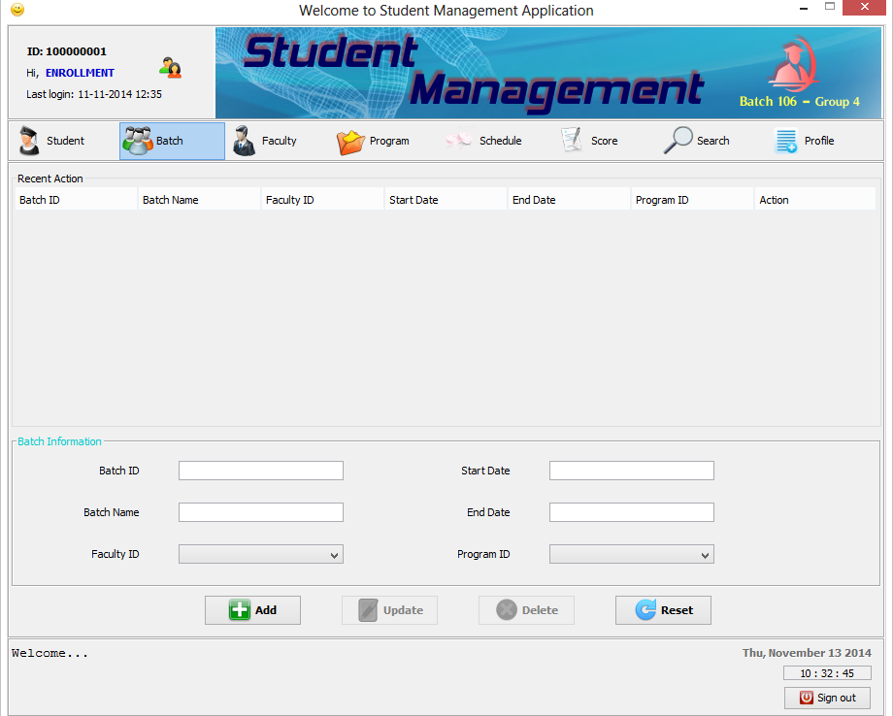

1. Form Faculty Enrollment :

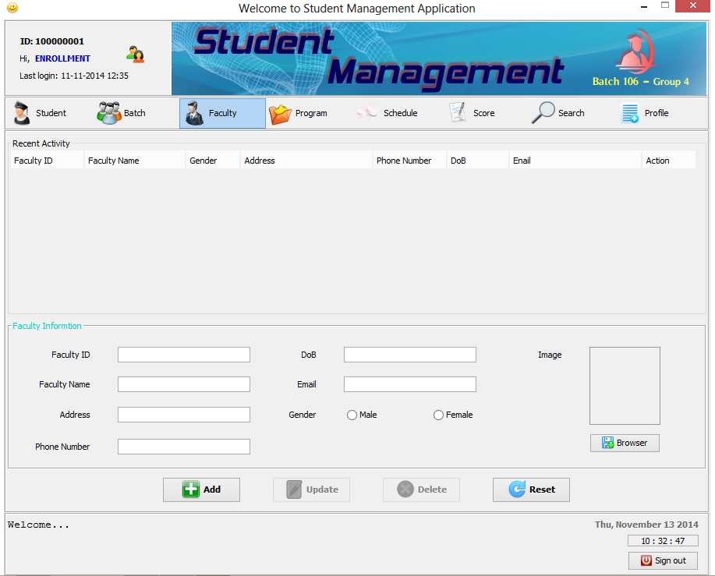

1. Form program Bursary :

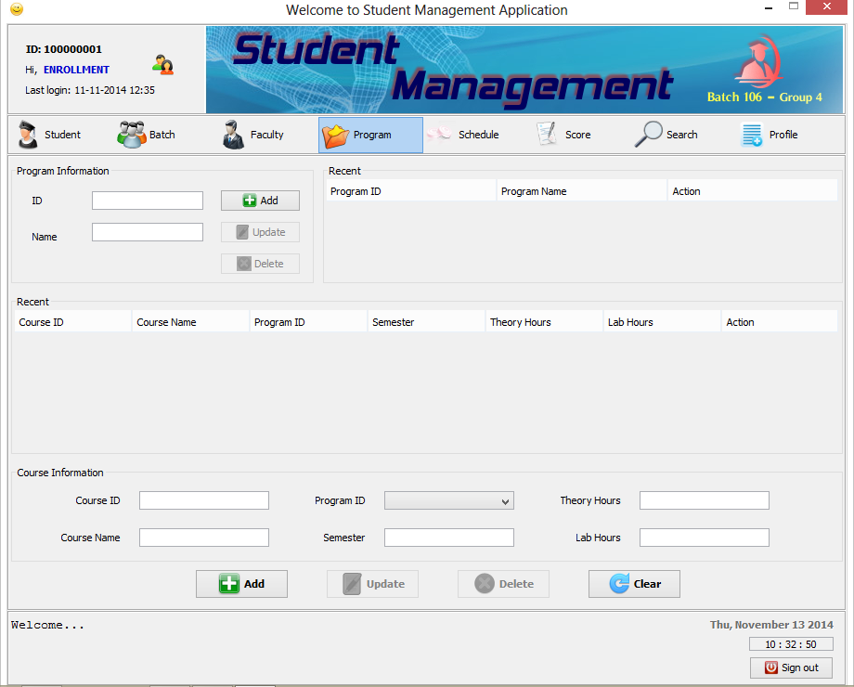

1. Form Schedule Bursary :

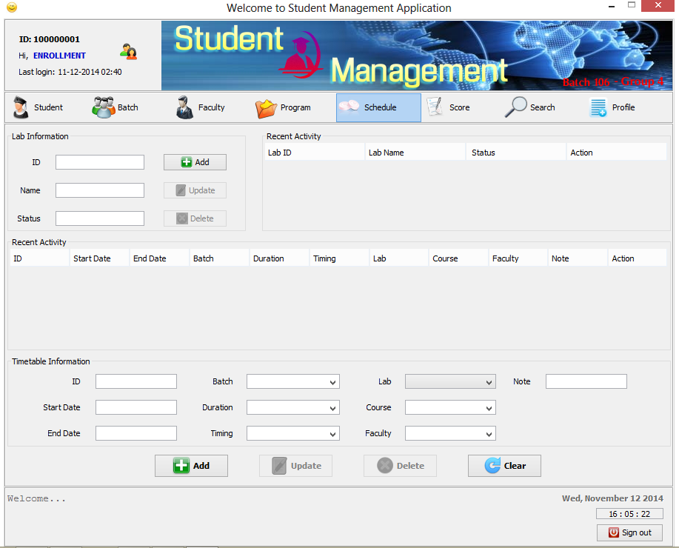

1. Form Score Bursary :

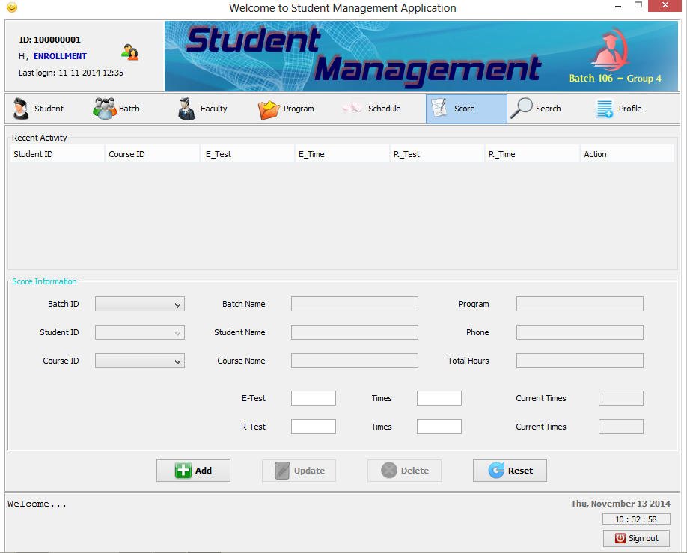

1. Form Search Enrollment, Bursary :

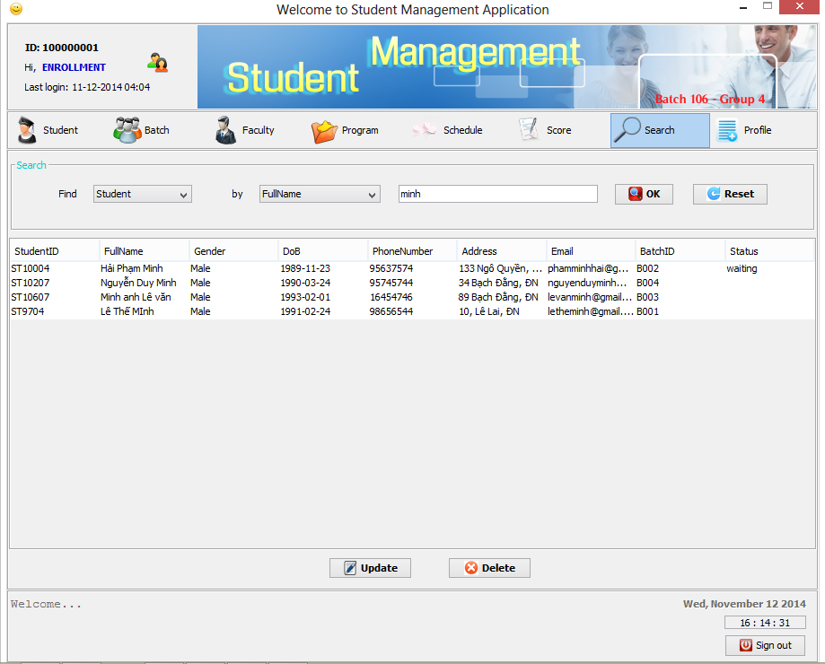

1. Form Profile Enrollment, Bursary :

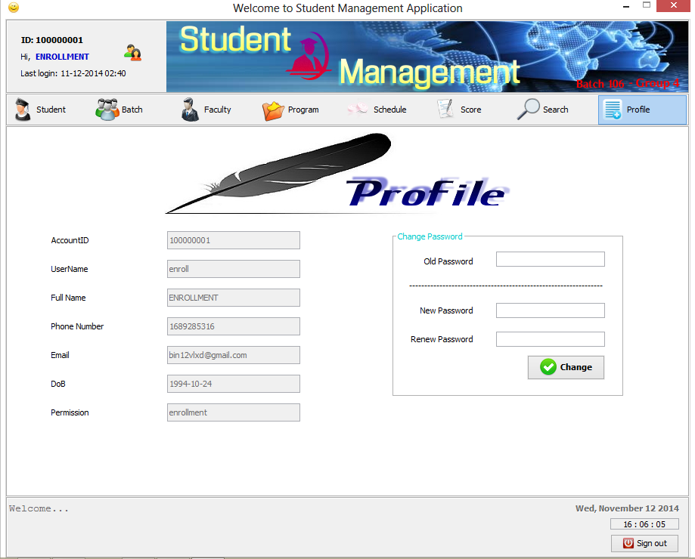

1. Form Information Student :

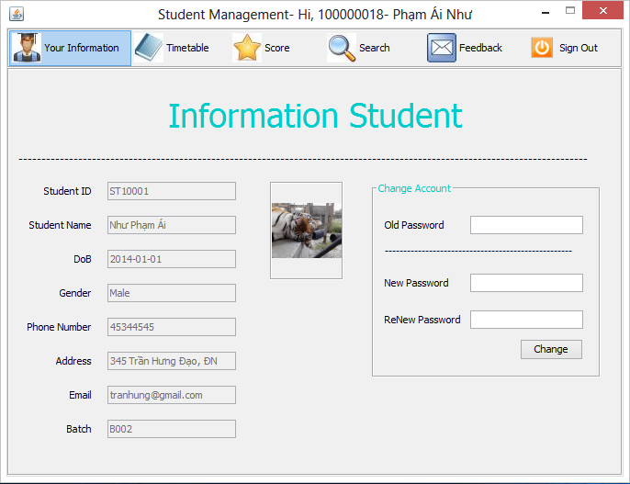

1. Form Timetable Student :

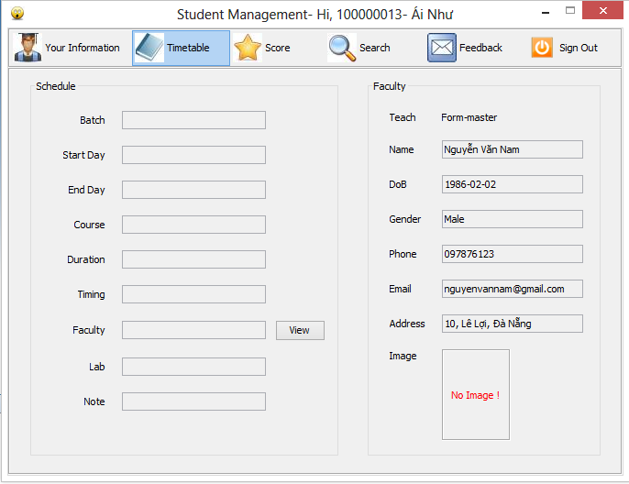

1. Form Score :

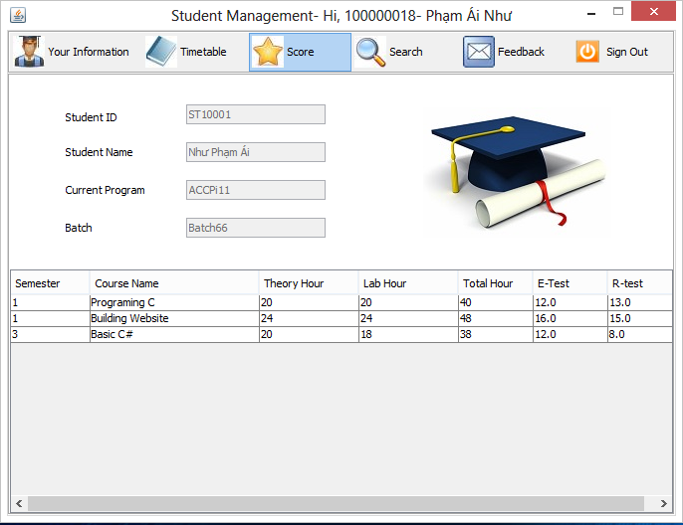

1. Form Search Student :

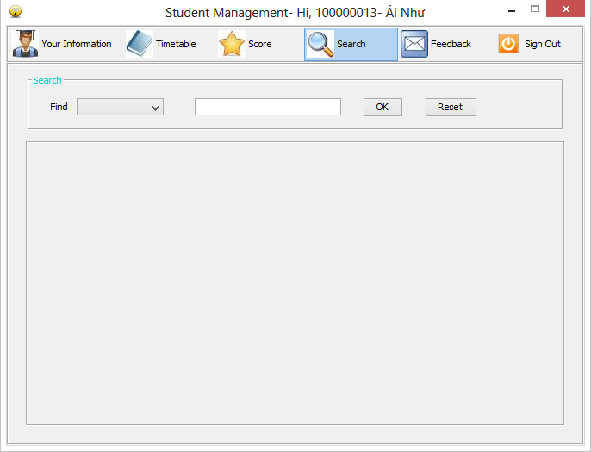

1. Form Feedback Student :

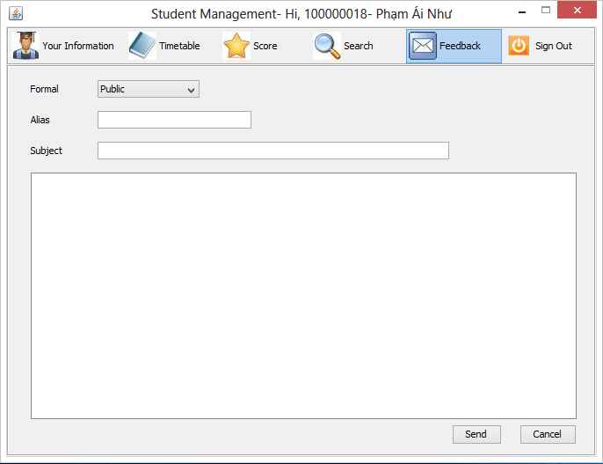

1. Form Information Admin :

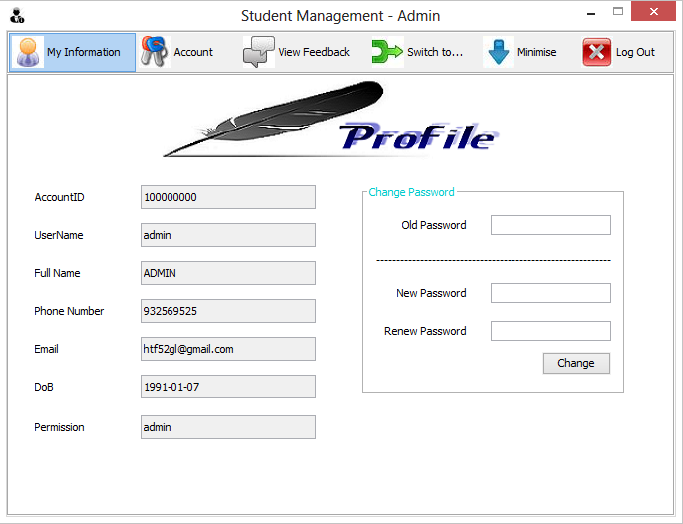

1. Form Account Admin :

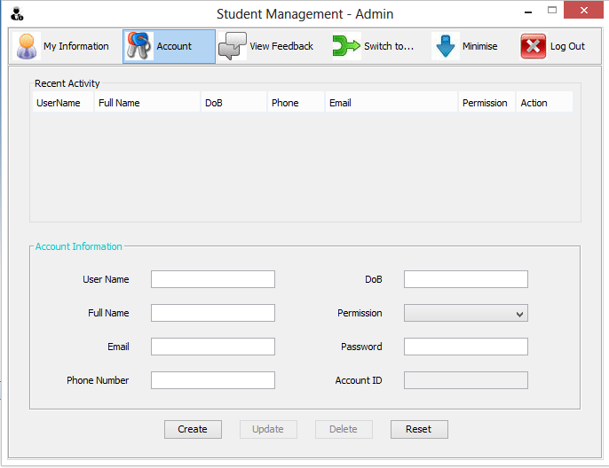

1. Form Feedback Admin :

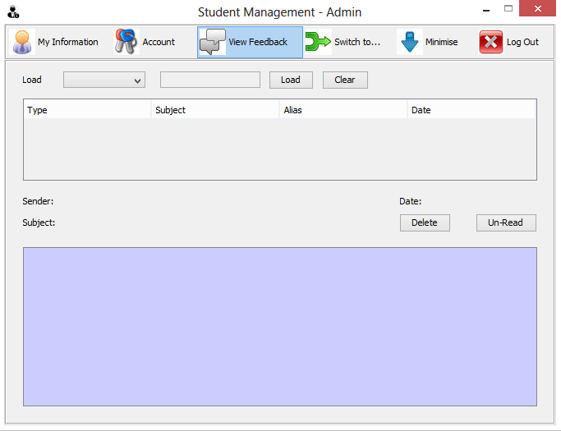

1. Task sheet :

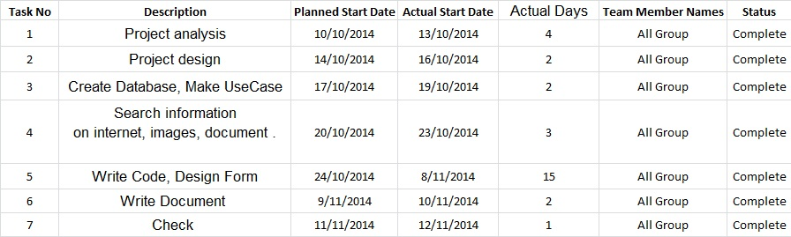

1. Summary :

* With this application Student Management, we hope help work information student manage easier, faster, effctive .
* If have problem of this application, we available maintain and upgrade follow expected .
* This application is the result of a concentrated effort of Guider and Members, but still dificients .
* We will be glad to receive your suggestions to application better .

Thank you teacher and all everyone followed this presentation !