## DFU设置

### sdk_config.h配置

使用DFU需要使能的选项

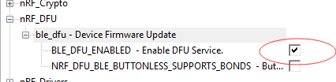

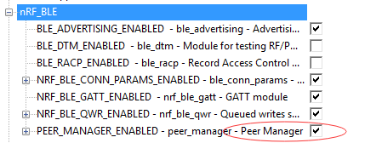

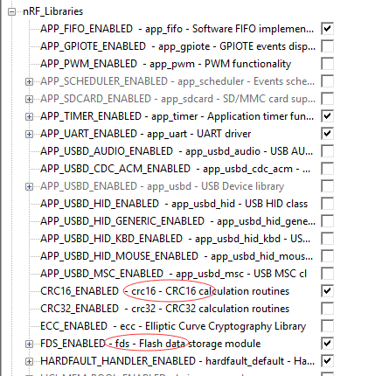

由于DFU服务采用私有UUID，需要配置协议栈，注意每增加一个VS_UUID，应用RAM起始地址增加0x10

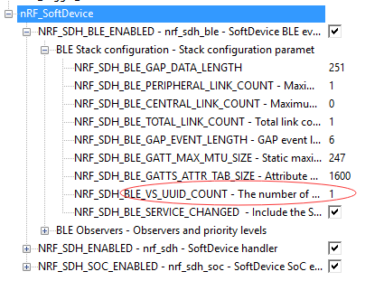

### 工程文件添加

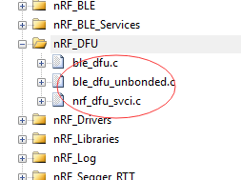

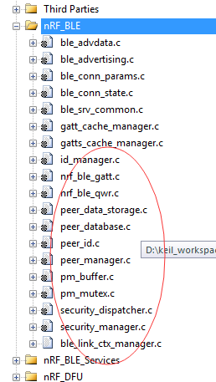

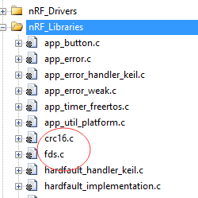

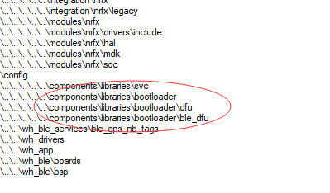

### 工程服务代码添加

采用全局宏定义DFU_SUPPORT作为应用层DFU功能的编译总开光

所需头文件

#if defined (DFU_SUPPORT)

#include "nrf_dfu_ble_svci_bond_sharing.h"

#include "nrf_svci_async_function.h"

#include "nrf_svci_async_handler.h"

#include "ble_dfu.h"

#include "nrf_power.h"

#include "nrf_bootloader_info.h"

#endif

应用层添加服务相关代码：

#ifdef DFU_SUPPORT

// 进入DFU，应用关机之前的一些操作，注册到power manager电源管理中

static bool app_shutdown_handler(nrf_pwr_mgmt_evt_t event)

{

switch (event)

{

case NRF_PWR_MGMT_EVT_PREPARE_DFU:

NRF_LOG_INFO("Power management wants to reset to DFU mode.");

// YOUR_JOB: Get ready to reset into DFU mode

break;

default:

// YOUR_JOB: Implement any of the other events available from the power management module:

// -NRF_PWR_MGMT_EVT_PREPARE_SYSOFF

// -NRF_PWR_MGMT_EVT_PREPARE_WAKEUP

// -NRF_PWR_MGMT_EVT_PREPARE_RESET

return true;

}

NRF_LOG_INFO("Power management allowed to reset to DFU mode.");

return true;

}

// 注册应用关机事件处理函数（常用于关机前需要进行的一些操作：如flash操作，控制模块的关闭等）

NRF_PWR_MGMT_HANDLER_REGISTER(app_shutdown_handler, 0);

static void buttonless_dfu_sdh_state_observer(nrf_sdh_state_evt_t state, void * p_context)

{

if (state == NRF_SDH_EVT_STATE_DISABLED)

{

NRF_LOG_INFO("NRF_SDH_EVT_STATE_DISABLED to DFU mode.");

// Softdevice was disabled before going into reset. Inform bootloader to skip CRC on next boot.

nrf_power_gpregret2_set(BOOTLOADER_DFU_SKIP_CRC);

//Go to system off.

nrf_pwr_mgmt_shutdown(NRF_PWR_MGMT_SHUTDOWN_GOTO_SYSOFF);

}

}

/* nrf_sdh state observer. */

NRF_SDH_STATE_OBSERVER(m_buttonless_dfu_state_obs, 0) =

{

.handler = buttonless_dfu_sdh_state_observer,

};

#endif

#ifdef DFU_SUPPORT

/**@brief Function for handling dfu events from the Buttonless Secure DFU service

*

* @param[in] event Event from the Buttonless Secure DFU service.

*/

static void ble_dfu_evt_handler(ble_dfu_buttonless_evt_type_t event)

{

switch (event)

{

case BLE_DFU_EVT_BOOTLOADER_ENTER_PREPARE:

NRF_LOG_INFO("Device is preparing to enter bootloader mode.");

// YOUR_JOB: Disconnect all bonded devices that currently are connected.

// This is required to receive a service changed indication

// on bootup after a successful (or aborted) Device Firmware Update.

break;

case BLE_DFU_EVT_BOOTLOADER_ENTER:

// YOUR_JOB: Write app-specific unwritten data to FLASH, control finalization of this

// by delaying reset by reporting false in app_shutdown_handler

NRF_LOG_INFO("Device will enter bootloader mode.");

break;

case BLE_DFU_EVT_BOOTLOADER_ENTER_FAILED:

NRF_LOG_ERROR("Request to enter bootloader mode failed asynchroneously.");

// YOUR_JOB: Take corrective measures to resolve the issue

// like calling APP_ERROR_CHECK to reset the device.

break;

case BLE_DFU_EVT_RESPONSE_SEND_ERROR:

NRF_LOG_ERROR("Request to send a response to client failed.");

// YOUR_JOB: Take corrective measures to resolve the issue

// like calling APP_ERROR_CHECK to reset the device.

APP_ERROR_CHECK(false);

break;

default:

NRF_LOG_ERROR("Unknown event from ble_dfu_buttonless.");

break;

}

}

#endif

/**@brief Function for initializing services that will be used by the application.

*

* @details Initialize the Heart Rate, Battery and Device Information services.

*/

static void services_init(void)

{

ret_code_t err_code;

nrf_ble_qwr_init_t qwr_init = {0};

// Initialize Queued Write Module.

qwr_init.error_handler = nrf_qwr_error_handler;

err_code = nrf_ble_qwr_init(&m_qwr, &qwr_init);

APP_ERROR_CHECK(err_code);

// 添加GPS_NB_TAG服务

ble_gnts_init_t gnts_init;

memset(&gnts_init, 0, sizeof(gnts_init));

gnts_init.data_handler = gnts_data_handler;

err_code = ble_gnts_init(&m_gnts, &gnts_init);

APP_ERROR_CHECK(err_code);

#ifdef DFU_SUPPORT

ble_dfu_buttonless_init_t dfus_init = {0};

// Initialize the async SVCI interface to bootloader.

err_code = ble_dfu_buttonless_async_svci_init();

APP_ERROR_CHECK(err_code);

dfus_init.evt_handler = ble_dfu_evt_handler;

err_code = ble_dfu_buttonless_init(&dfus_init);

APP_ERROR_CHECK(err_code);

#endif

}

## 调试小笔记

1.nRF52832 — NFC脚（P9/P10）配置为普通GPIO口

需添加宏定义 CONFIG_NFCT_PINS_AS_GPIOS （可在system_nrf52.h文件中#define CONFIG_NFCT_PINS_AS_GPIOS

或全局宏定义添加CONFIG_NFCT_PINS_AS_GPIOS）

2.使用NRF_DRV驱动之前，需要在nrf_drv_config.h中进行配置，同时有些参数也需要设置

如：使用nrf_drv_saadc驱动，需要#define SAADC_ENABLED 0改为#define SAADC_ENABLED 1

同时驱动层同时添加nrf_drv_saadc.c（驱动）和nrf_saadc.c（频道配置）

3.按键中断标志位主要PUSH和RELEASE分别设置，否则会发生按键触发两次事件；

4.SDK15的FreeRTOS例程功耗无法下降的问题？

原因：空闲任务没有调用协议栈低功耗管理，采用协议栈时最好不要直接采用操作寄存器方式；

解决：空闲任务休眠函数修改如下：

#endif // (NRFFOSDK-11174)

{

/* No SD - we would just block interrupts globally.

* BASEPRI cannot be used for that because it would prevent WFE from wake up.

*/

do{

// __SEV(); //发送事件

// __WFE(); //休眠并且在发生事件时被唤醒

sd_app_evt_wait();

} while (0 == (NVIC->ISPR[0] | NVIC->ISPR[1])); //等待中断

}

5.串口功耗问题？

原因：由于SDK15默认采用了UARTE使用了DMA功能，使得功耗为2.2mA左右。

解决：取消DMA，功耗下降至0.6mA

文件nrf52832_peripherals.h,注释掉222行的//#define UARTE_PRESENT 同时sdk_config.h配置#define NRFX_UARTE_ENABLED 0

6.按键初次不触发问题？

原因：按键使能状态没有设置，针对不同按按键需要不同设置。当外部有分压/下拉时，不使用上拉下拉，以免影响功能

解决：{BSP_BUTTON_0, APP_BUTTON_ACTIVE_LOW, BUTTON_PULL, bsp_button_event_handler},

{BSP_BUTTON_1, APP_BUTTON_ACTIVE_HIGH, NRF_GPIO_PIN_PULLDOWN, bsp_button_event_handler},

{BSP_BUTTON_3, APP_BUTTON_ACTIVE_HIGH, NRF_GPIO_PIN_NOPULL, bsp_button_event_handler},